**CPIT210**

**Assignment 1**

**Due Date: 11/10/2020**

|  |
| --- |
| **Name:** Elaf Yousef Aloufi |
| **ID:** 1911265 |
| **Section:** VAR |

**Problem 1**

Given the Boolean function:

F(w,x,y,z) = xy’z + x’y’z + w’xy + wx’y + wxy

* Obtain the truth table of the function.



**T****he indices respectively:** {13,5,9,1,7,6,11,10,15,14}.

|  |  |  |  |  |  |  |  |  |  |
| --- | --- | --- | --- | --- | --- | --- | --- | --- | --- |
| W | X | Y | Z | XY’Z | X’Y’Z | W’XY | WX’Y | WXY | F |
| 0 | 0 | 0 | 0 | 0 | 0 | 0 | 0 | 0 | 0 |
| 0 | 0 | 0 | 1 | 0 | 1 | 0 | 0 | 0 | 1 |
| 0 | 0 | 1 | 0 | 0 | 0 | 0 | 0 | 0 | 0 |
| 0 | 0 | 1 | 1 | 0 | 0 | 0 | 0 | 0 | 0 |
| 0 | 1 | 0 | 0 | 0 | 0 | 0 | 0 | 0 | 0 |
| 0 | 1 | 0 | 1 | 1 | 0 | 0 | 0 | 0 | 1 |
| 0 | 1 | 1 | 0 | 0 | 0 | 1 | 0 | 0 | 1 |
| 0 | 1 | 1 | 1 | 0 | 0 | 1 | 0 | 0 | 1 |
| 1 | 0 | 0 | 0 | 0 | 0 | 0 | 0 | 0 | 0 |
| 1 | 0 | 0 | 1 | 0 | 1 | 0 | 0 | 0 | 1 |
| 1 | 0 | 1 | 0 | 0 | 0 | 0 | 0 | 0 | 1 |
| 1 | 0 | 1 | 1 | 0 | 0 | 0 | 1 | 0 | 1 |
| 1 | 1 | 0 | 0 | 0 | 0 | 0 | 0 | 0 | 0 |
| 1 | 1 | 0 | 1 | 1 | 0 | 0 | 0 | 0 | 1 |
| 1 | 1 | 1 | 0 | 0 | 0 | 0 | 0 | 1 | 1 |
| 1 | 1 | 1 | 1 | 0 | 0 | 0 | 0 | 1 | 1 |

* 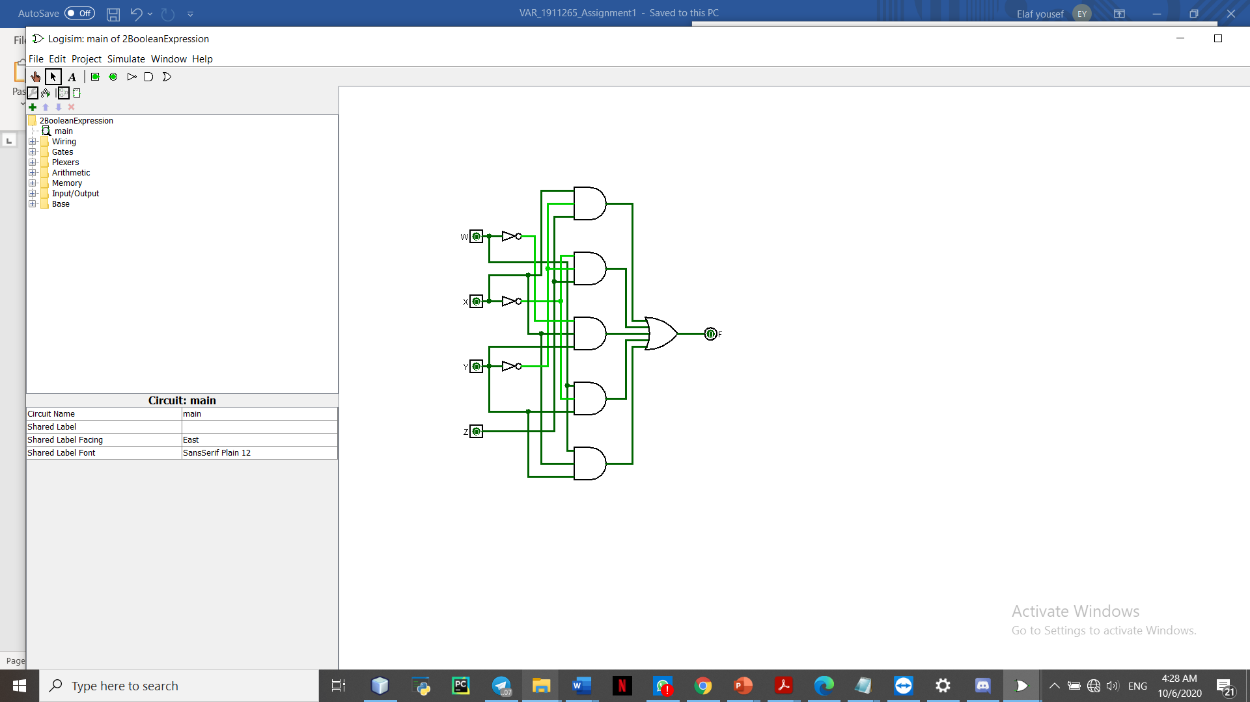Draw the logic diagram using the original Boolean expression using the simulator.
* Simplify the function to a minimum number of literals using Boolean algebra. (If simplification done using simulator and algebra 1point bonus)

1. **XY’Z + X’Y’Z + W’XY + WX’Y + WXY** + WXY
2. Y’Z(X + X’) + XY( W+ W’) + WY(X+ X’)
3. Y’Z.1 + XY.1 + WY.1
4. Y’Z + XY + WY

* Obtain the truth table of the function from the simplified expression and show that it is the same as

the one in part (a)

**The indices are the same.** {13,5,9,1,7,6,11,10,15,14}

|  |  |  |  |  |  |  |  |
| --- | --- | --- | --- | --- | --- | --- | --- |
| W | X | Y | Z | Y’Z | XY | WY | F |
| 0 | 0 | 0 | 0 | 0 | 0 | 0 | 0 |
| 0 | 0 | 0 | 1 | 1 | 0 | 0 | 1 |
| 0 | 0 | 1 | 0 | 0 | 0 | 0 | 0 |
| 0 | 0 | 1 | 1 | 0 | 0 | 0 | 0 |
| 0 | 1 | 0 | 0 | 0 | 0 | 0 | 0 |
| 0 | 1 | 0 | 1 | 1 | 0 | 0 | 1 |
| 0 | 1 | 1 | 0 | 0 | 1 | 0 | 1 |
| 0 | 1 | 1 | 1 | 0 | 1 | 0 | 1 |
| 1 | 0 | 0 | 0 | 0 | 0 | 0 | 0 |
| 1 | 0 | 0 | 1 | 1 | 0 | 0 | 1 |
| 1 | 0 | 1 | 0 | 0 | 0 | 1 | 1 |
| 1 | 0 | 1 | 1 | 0 | 0 | 1 | 1 |
| 1 | 1 | 0 | 0 | 0 | 0 | 0 | 0 |
| 1 | 1 | 0 | 1 | 1 | 0 | 0 | 1 |
| 1 | 1 | 1 | 0 | 0 | 1 | 1 | 1 |
| 1 | 1 | 1 | 1 | 0 | 1 | 1 | 1 |

**F in table (A) is the same as F in the simplified expressions table**

Simplified Expression

**Y’Z + XY + WY**

* Draw the logic diagram, using simulator from the simplified expression and compare the total number of gates with the diagram of part (b).

**The original function:** has 9 gates 5 AND gates, 3 NOT gates and one OR gate.

**The simplified function:** has 5 gates 3 AND gates, 1 NOT gate and one OR gate.

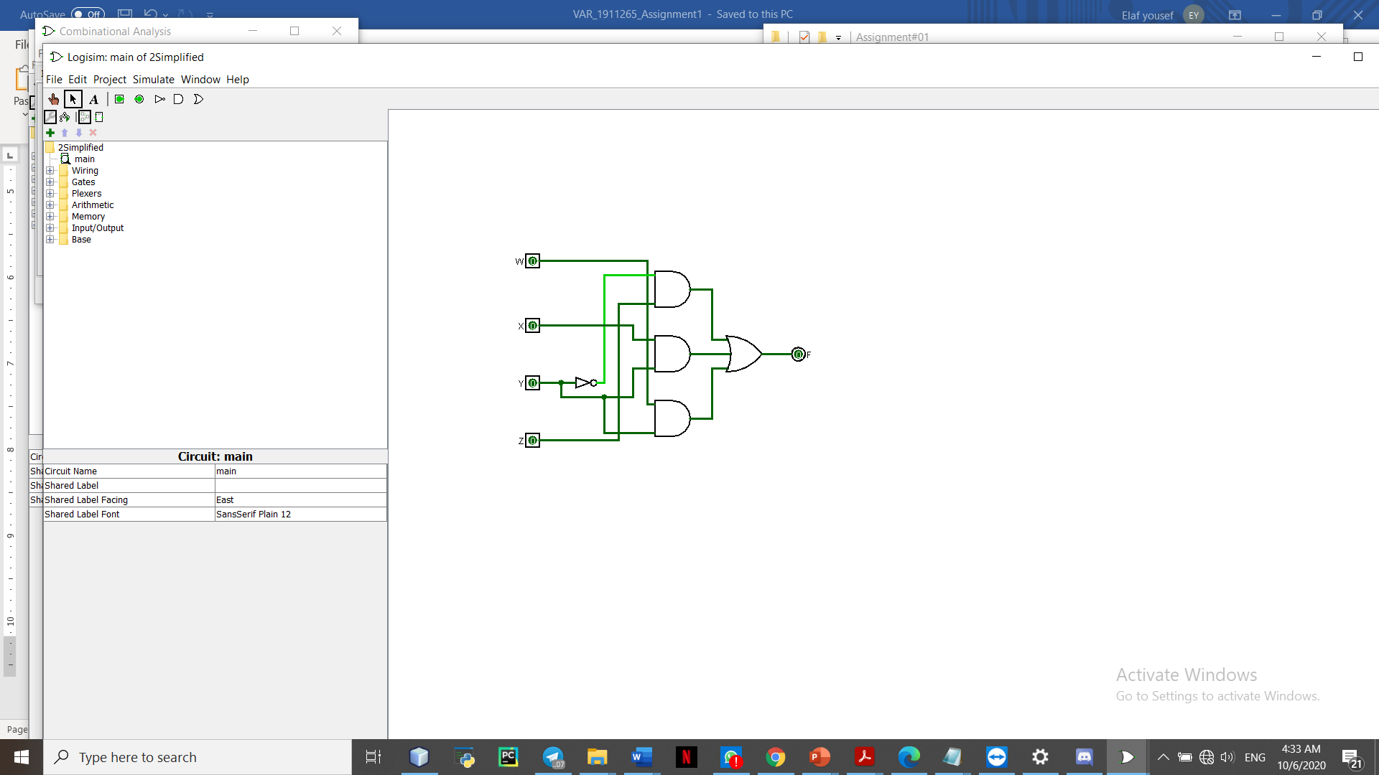

**Problem 2**

1. **Consider the following circuit: F= X'Y' +YZ'+XYZY'**

a. Represent the circuit as Sum Of Product.

= X’Y’ + YZ’

= X’Y’ (Z+Z’) + YZ’ (X+X’)

∑(0,1,2,6) = + X’Y’Z’ + X’Y’Z + X’YZ’ + XYZ’

b. Represent the circuit as Product Of Sum

= X’YZ + XY’Z’ + XY’Z + XYZ

∏(3,4,5,7) = (X+Y’+Z’) (X’+Y+Z) (X’+Y+Z’) (X’+Y’+Z’)

c. Find the complement of the circuit.

= (X+Y) (Y’+Z) (X’+Y’+Z’+Y)

2. **Convert each of the following to the other canonical form:**

* 1. F(x,y,z)= ∑(1,3,6)

F(x,y,x)= ∏(0,2,4,5,7)

* 1. F(A, B,C,D)= ∏ (0,2,4,7,9,13)

F(x,y,x)= ∑(1,3,5,6,8,10,11,12,14,15)