**CPIT210**

**Homework1**

**Due Date: 11/10/2020**

|  |
| --- |
| **Name:** Elaf Yousef Aloufi |
| **ID:** 1911265 |
| **Section:** VAR |

**(A + B + C + D) ( A + B + C’ + D ) ( A’ + B + C + D’ ) (A + B’ + C + D) (A’ + B’ + C + D)?**

* Use a karnaugh map to minimize the following expression in:

1. Product of Sum expression.

C

CD

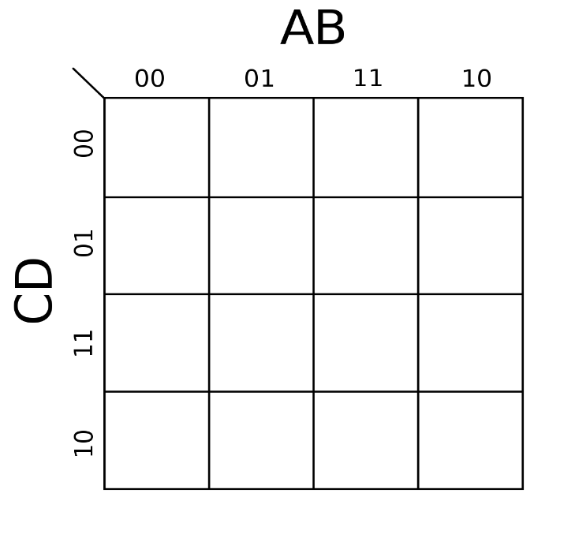

0 1 1 0

0 1 1 1

0 1 1 1

1 0 1 1

A

AB

**F(A,B,C,D) = A’B’D’ + BC’D’ + AB’C’D**

B

**F(A,B,C,D) = (A+B+D) (B’+C+D) (A’+B+C+D’)**

D

1. Sum of product expression

C

CD



0 1 1 0

0 1 1 1

0 1 1 1

1 0 1 1

A

AB

B

**F(A,B,C,D)= BC + AC + A’D + BD + AB’D’**

D

1. Draw the S.O.P and P.O.S After the minimization **using the simulator using basic gates (AND, OR and NOT)**

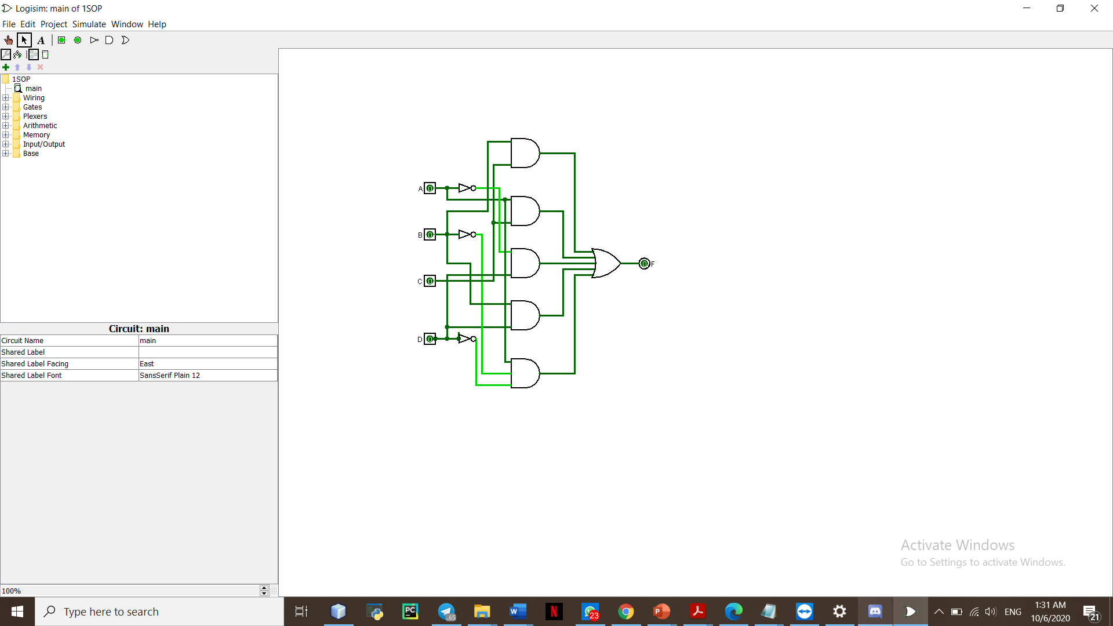 **SOP POS**

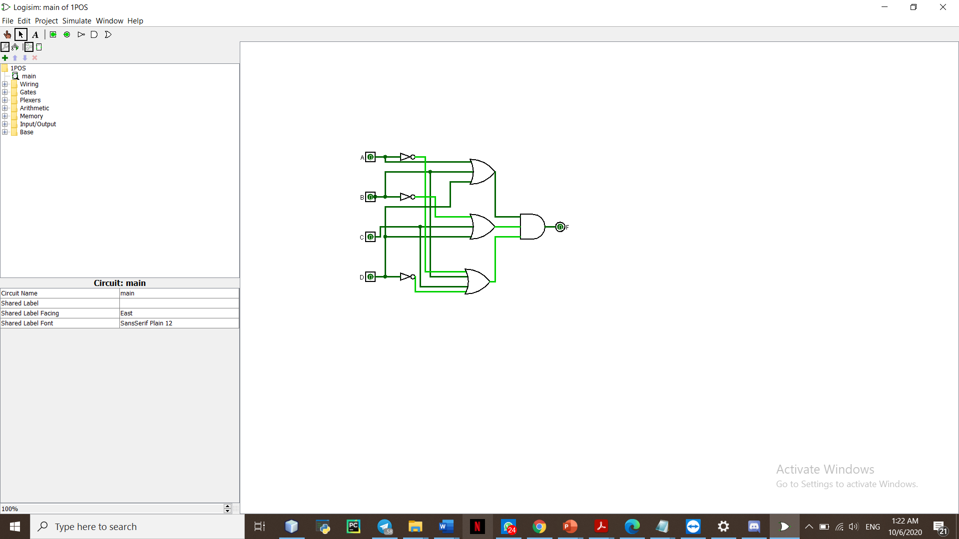

1. implement the expression using NAND only (by the simulator)

**F(A,B,C,D) = (A’B’D’)’ (BC’D’)’ (AB’C’D)’**

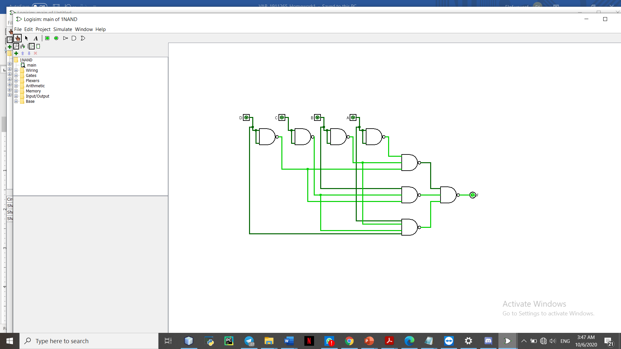

1. implement the expression using NOR only (by the simulator)

**F(A,B,C,D)= (B’+C’)’ + (A’+C’)’ + (A+D’)’ + (B’+D’)’ + (A’+B+D)’**

