Software Economics

CPIT-456

Exercise #01



|  |
| --- |
| Elaf Yousef Aloufi |
| 1911265 |

**Section:** DAR

* **Gantt chart view**

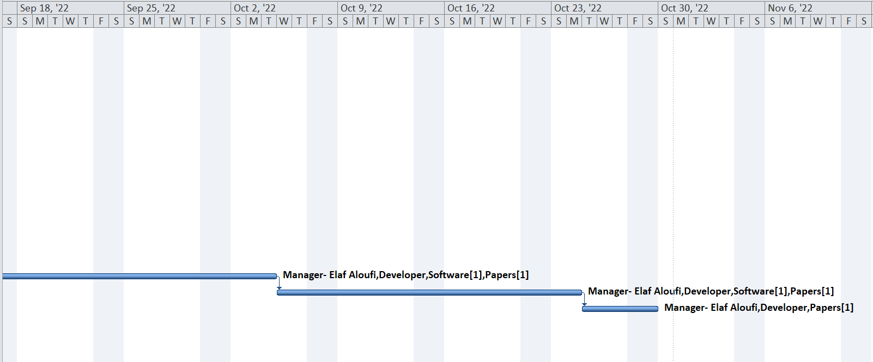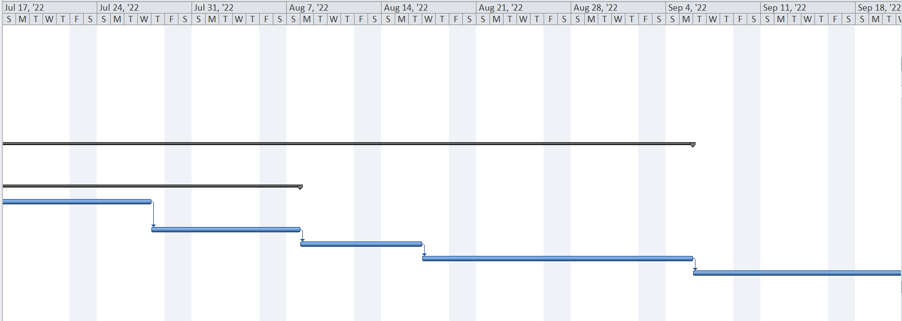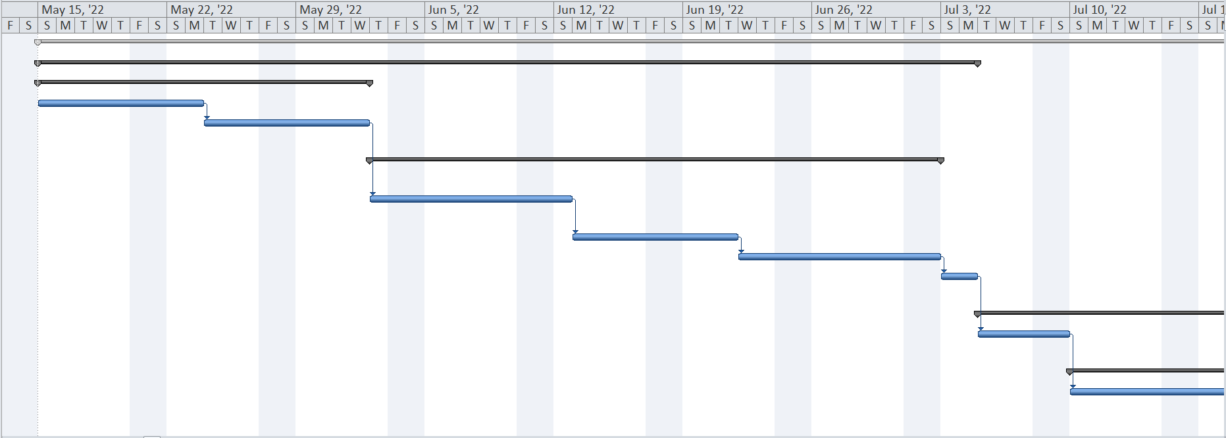

* **Tasks, start and end date, duration, WBS, resources, total cost for this project**

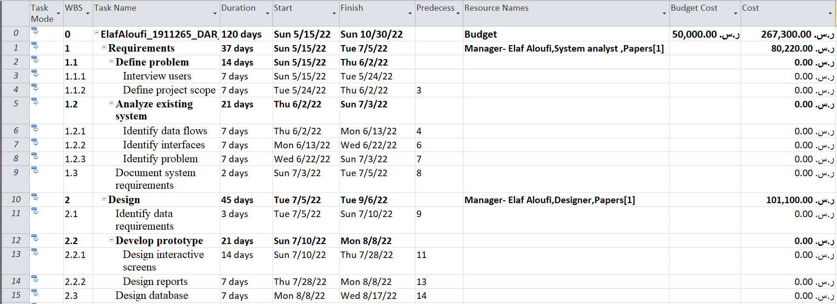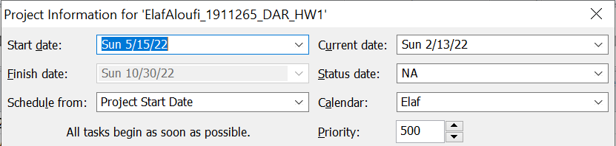

* **Your project calendar**

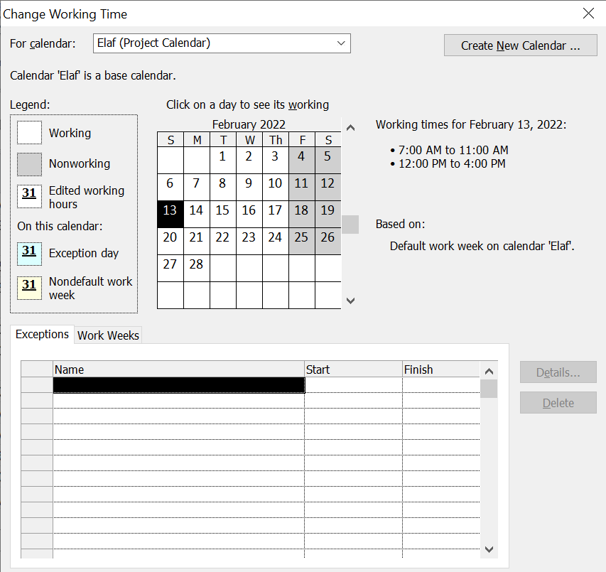

* **Project statistics**

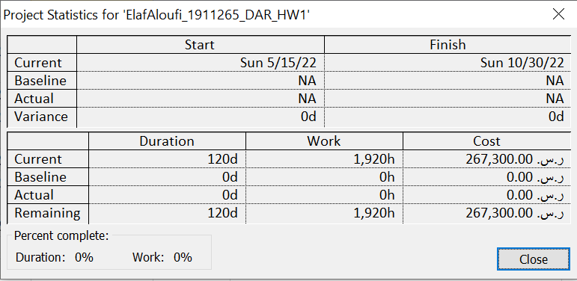

* **Resource sheet**



