Software Economics

CPIT-456

Exercise #02



|  |
| --- |
| Elaf Yousef Aloufi |
| 1911265 |

**Section:** DAR

You are required to estimate the effort needs to develop (*Employee Attendance System*) for small company (20 to 60 employees) using COCOMOII Post-Architecture model. The project has Collaborative team members and they worked before on a similar project. Moreover, they have a high-level experience of the programming language and the software tool (*LTEX*).

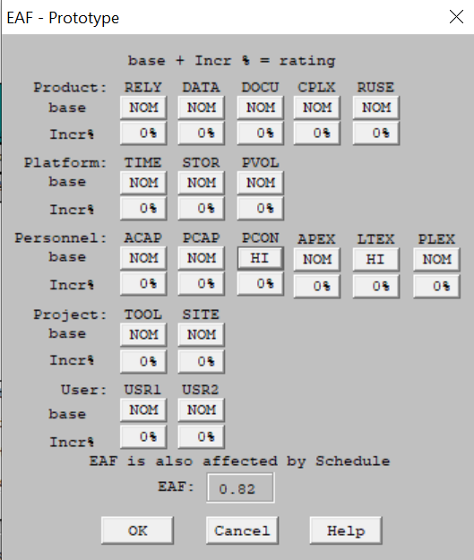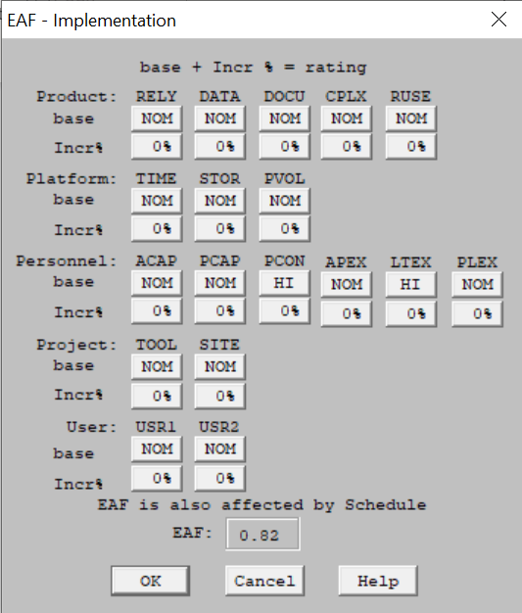

First, a simple prototype will be designed for the system using Visual Basic with 2500 SLOC and 10 REVL.

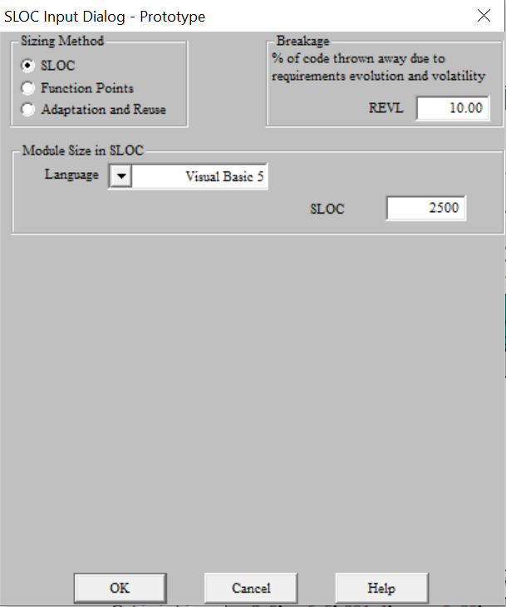

Then the system will be developed using Java programing language. The system has 2 internal logical files (*simple*). Also, the system receives inputs (*simple*) from employees and human resources unit. In addition, the system should generate responses to queries (*simple*) and some reports and outputs (*medium*).

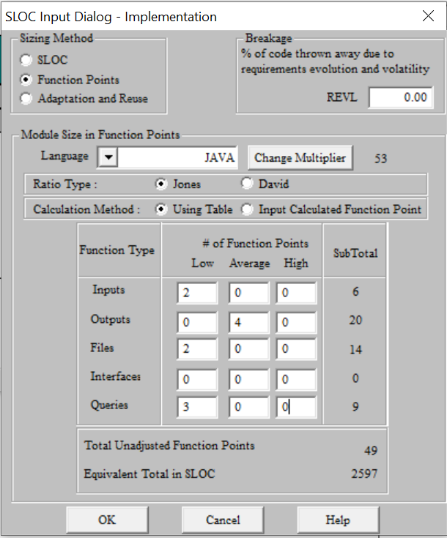

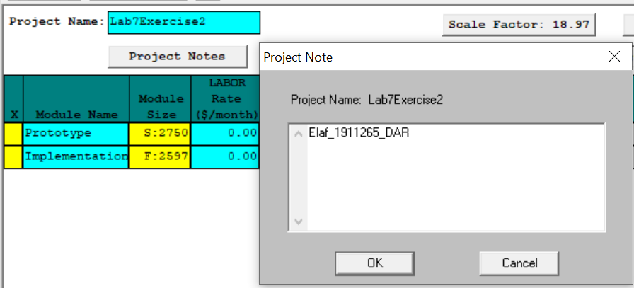Write your *Name_ID_Section* as a project note in the CoCoMo tool.

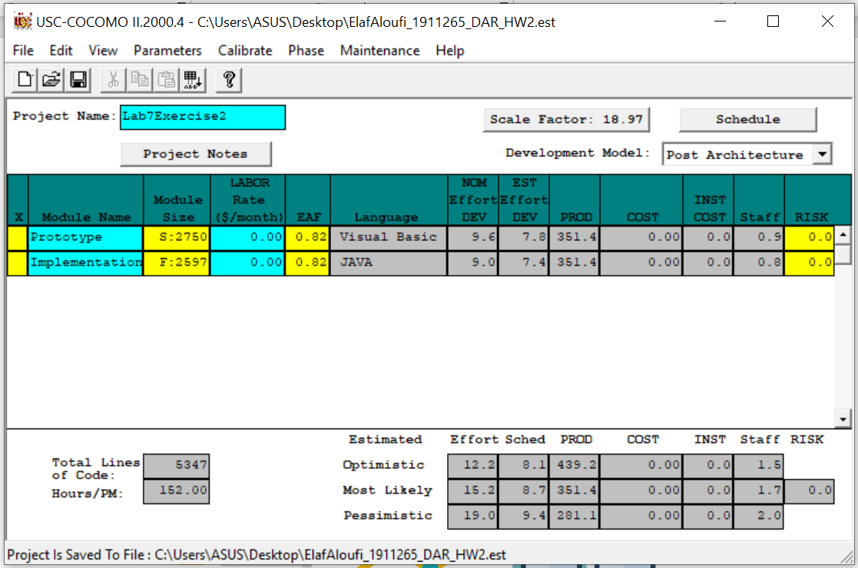

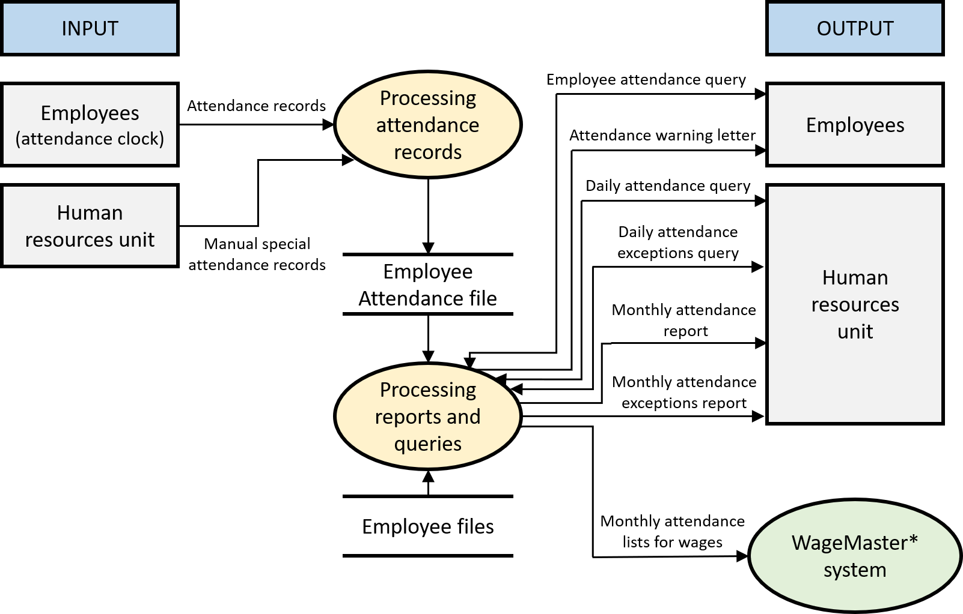**Data flow diagram:**

* **Wagemaster** is a desktop, networkable, integrated payroll and human resource management software.