# Customer Churn Analysis | Power BI, SQL & Machine Learning
This project demonstrates a **complete end-to-end churn analysis pipeline** integrating **SQL Server**, **Power BI**, and **Python (Machine Learning)**.
It follows a real-world data analytics workflow — from **data extraction and cleaning** to **predictive modeling and dashboard visualization**.

The goal is to identify and visualize **customer churn patterns**, predict potential churners, and provide **actionable insights** for business decisions through interactive Power BI dashboards.

---

## 🧩 Tools & Technologies Used
- **SQL Server** – Data extraction (ETL), cleaning, and transformation
- **Power BI** – Data modeling, DAX measures, and dashboard visualization
- **Python (Jupyter Notebook)** – Machine Learning (Random Forest Classifier)
- **Anaconda** – Environment & dependency management

---

## 🚀 Project Workflow
1. **ETL Process in SQL Server** – Extract, transform, and load raw customer data
2. **Data Cleaning** – Handle missing values, duplicates, and inconsistent data types
3. **Power BI Data Modeling** – Create relationships and calculated measures
4. **Power BI Visualization** – Develop interactive dashboards and insights
5. **Machine Learning Model (Python)** – Build a Random Forest Classifier for churn prediction
6. **Churn Prediction Dashboard** – Import predicted churn results into Power BI for visualization
---

## 🧠 Machine Learning Component
- **Algorithm:** Random Forest Classifier
- **Objective:** Predict customer churn using behavioral and demographic features
- **Integration:** Predictions imported into Power BI for business visualization

---

## 📈 Power BI Dashboard Features

### 1️⃣ **Churn Analysis - Summary Page**
![Churn Analysis Summary](ChurnAnalysis-Summary.png)
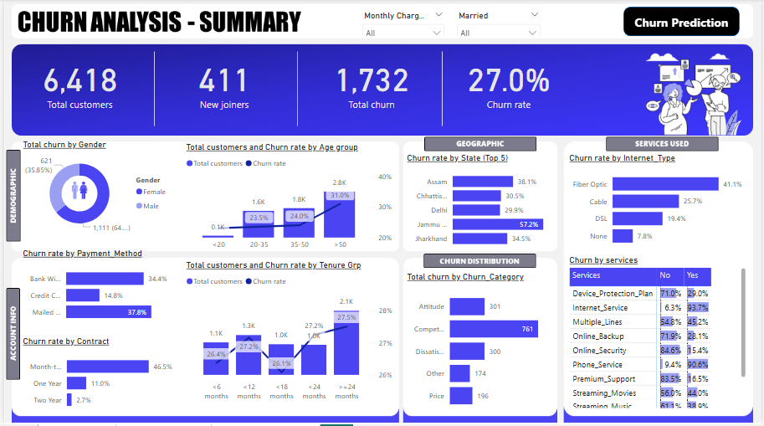
**Key Insights:**
- Displays overall churn metrics such as total customers, churn count, churn rate, and new joiners
- Visualizes churn patterns by **gender**, **age group**, **payment method**, and **contract type**
- Includes geographic churn rate by **state** and service-based churn insights (e.g., Internet type, plan type)
- Helps identify **key churn drivers** and retention opportunities

---

### 2️⃣ **Churn Analysis - Prediction Page**
![Churn Analysis Prediction](ChurnAnalysis-Prediction.png)
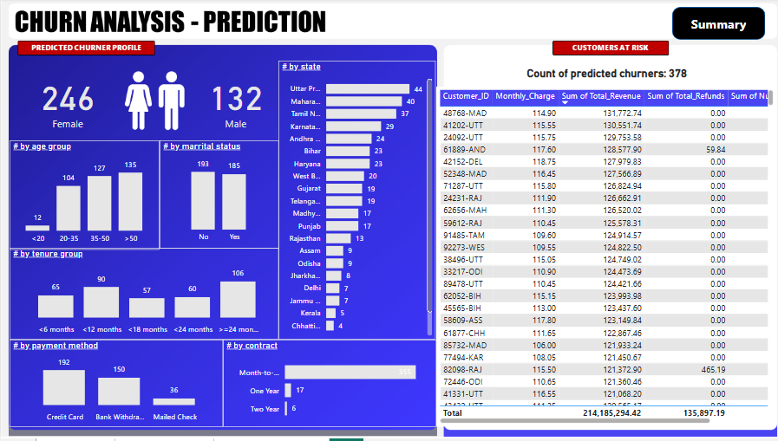
**Key Insights:**
- Presents a detailed profile of **predicted churners** using the Random Forest model
- Segments churners by **state**, **tenure**, **contract**, **payment method**, and **age group**
- Displays total count of predicted churners and allows filtering to identify **high-risk customers**
- Enables data-driven strategies for **targeted retention campaigns**

## 💡 Key Skills Demonstrated
- Data preprocessing and transformation using **SQL Server**
- Data modeling, **DAX measures**, and Power BI dashboarding
- Machine learning model building with **Python (Random Forest)**
- Integration of predictive results into **interactive business dashboards**

