# Fraud Detection Analysis & Prediction App

This project demonstrates an **end-to-end fraud detection pipeline** using Python, pandas, scikit-learn, and Streamlit. It includes **data exploration, preprocessing, model training, evaluation, and a web-based prediction app**.

---

## **Dataset**

- The dataset used: `AIML Dataset.csv`
- Contains transaction information including:
- Transaction type (`type`)
- Amounts (`amount`, `oldbalanceOrg`, `newbalanceOrig`, `oldbalanceDest`, `newbalanceDest`)
- Fraud labels (`isFraud`, `isFlaggedFraud`)

---

## **Key Steps**

1. **Exploratory Data Analysis (EDA)**
- Checked missing values, distributions, and correlations.
- Visualized fraud patterns by transaction type, amount, and time steps.
- Analyzed top senders and receivers for fraudulent transactions.

2. **Feature Engineering**
- Created `balanceDiffOrig` and `balanceDiffDest`.
- Dropped irrelevant columns like `nameOrig`, `nameDest`, `step`, `isFlaggedFraud`.

3. **Data Preprocessing**
- Categorical features encoded using `OneHotEncoder`.
- Numerical features scaled using `StandardScaler`.

4. **Model Training**
- Used **Logistic Regression** with `class_weight='balanced'` to handle class imbalance.
- Evaluated using classification report, confusion matrix, and accuracy score.
- Pipeline saved with `joblib` for Streamlit app integration.

5. **Streamlit Web App**
- Users can input transaction details.
- Predicts whether a transaction is **fraudulent** or **legitimate**.
- Provides interactive visualization of predictions.
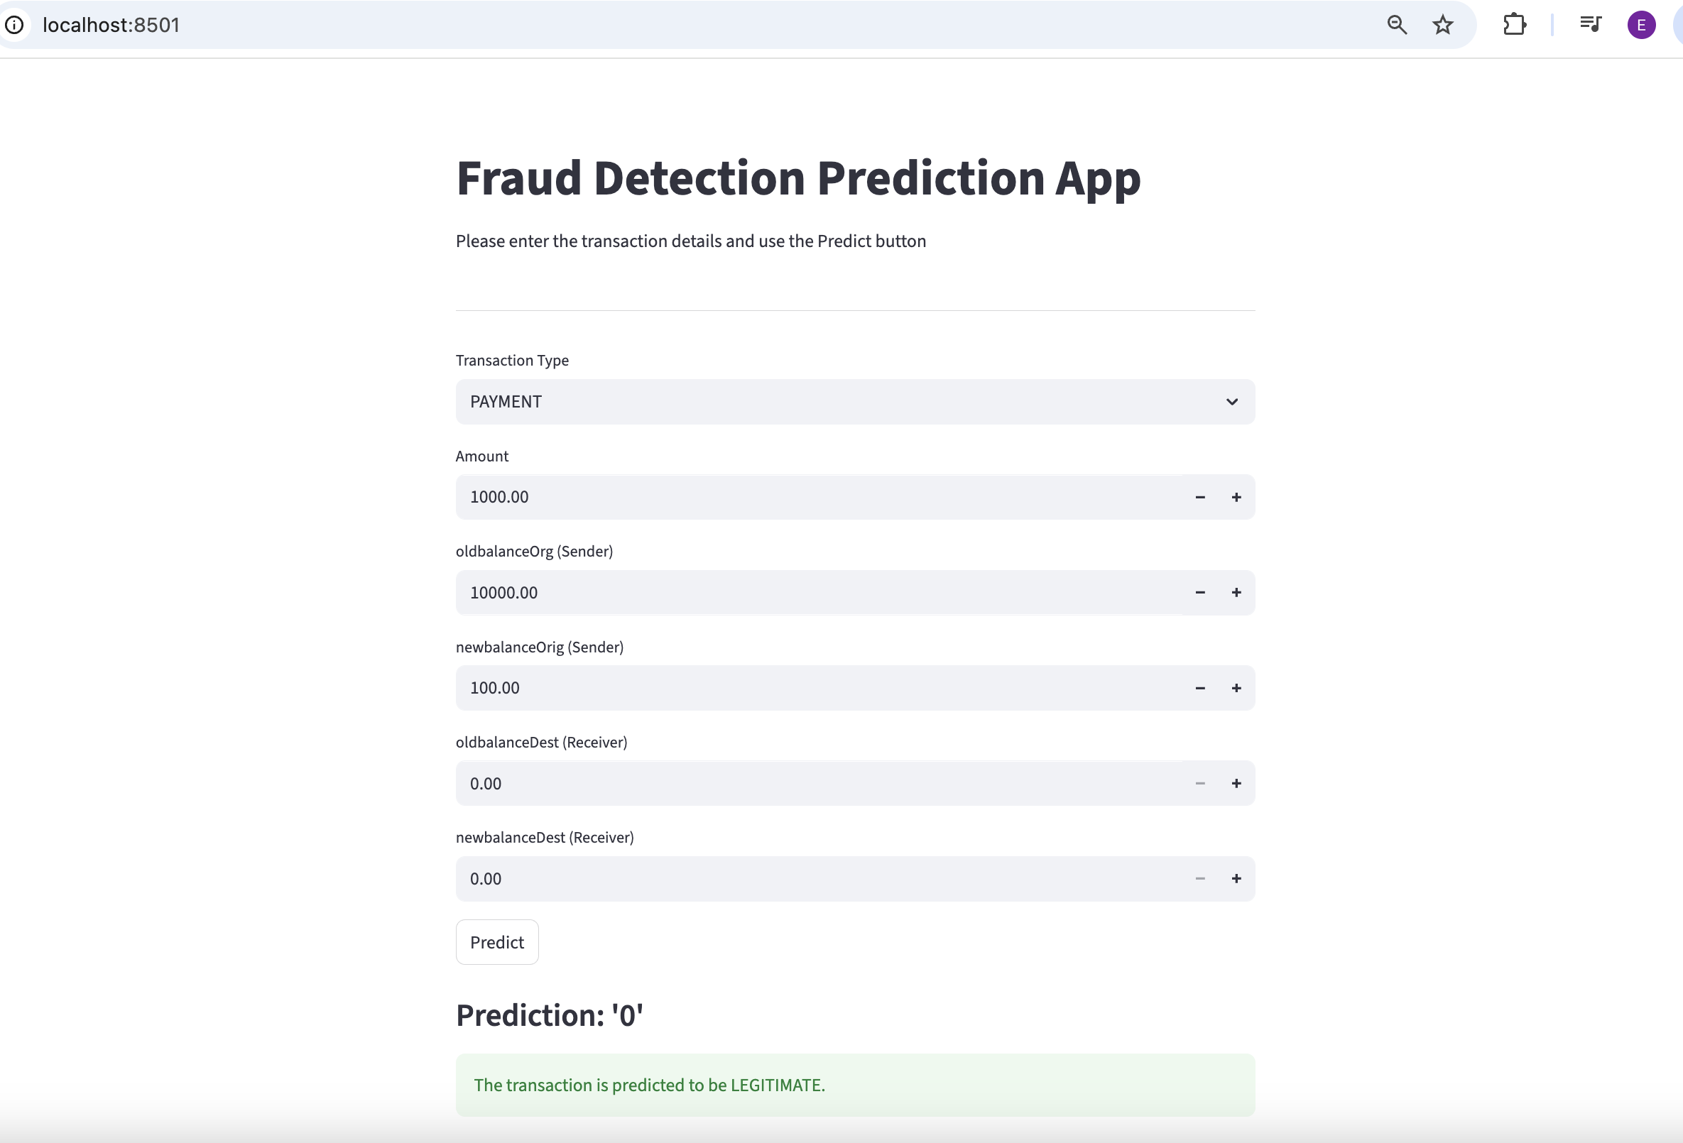

---

## **How to Run**

1. Install dependencies:

```bash
pip install pandas numpy scikit-learn matplotlib seaborn streamlit joblib

streamlit run fraud_detection.py

