First Brand: Cameron’s Brewery Second Brand: Clorox Pet Urine Remover

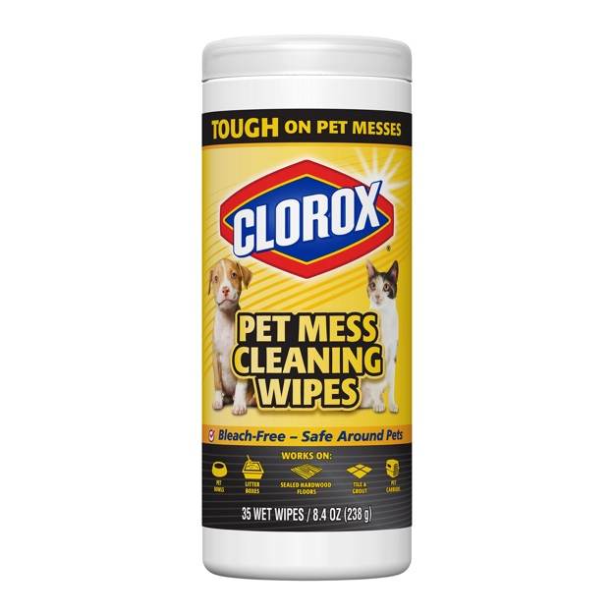

Brand Mash Up: Scenario 2

­­­­­