MVC / Scaffolding

Goal is to build a simple podcast site

**Meta:**

* <http://weblogs.asp.net/scottgu/archive/2011/05/05/ef-code-first-and-data-scaffolding-with-the-asp-net-mvc-3-tools-update.aspx>
* <http://channel9.msdn.com/Events/MIX/MIX11/FRM13>
* <http://blog.stevensanderson.com/2011/01/13/scaffold-your-aspnet-mvc-3-project-with-the-mvcscaffolding-package/>
* <http://blog.stevensanderson.com/2011/04/07/mvcscaffolding-creating-custom-scaffolders/>
* <http://blog.stevensanderson.com/2011/04/06/mvcscaffolding-overriding-the-t4-templates/>

**Steps:**

1. New MVC3 Web Site
   1. CTRL + Shift + N -> DeveloperSmackdown
      1. ASP.NET MVC 3 Web Application
      2. Empty Site
      3. Razor
      4. HTML5

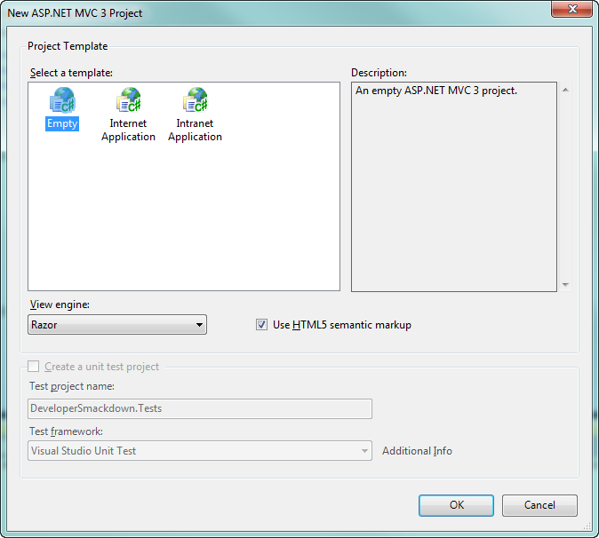

1. Update Current Packages
   1. At this point we have a few packages installed by default which happen to be NuGet packages
   2. From the package manager console window lets update the current list of packages

Get-Pacakage | Update-Package

Update-Package jQuery.vsdoc

1. Create a new default controller
   1. Add a new HomeController
   2. Create the view from the index action.
      1. This is the built in scaffolding
2. Install new Packages
   1. At this point we need to install
      1. MVCScaffolding project
      2. EFCodeFirst.SqlServerCompact, we will use this for the DB rather than using SQLExpress

Install-Pacakge MVCScaffolding

Install-Package EFCodeFirst.SqlServerCompact

1. Create the models of which will have a relationship
   1. Podcast

public class Podcast

    {

        public int PodcastId { get; set; }

        public string Name { get; set; }

        public string Artist { get; set; }

        public virtual ICollection<Show> Shows { get; set; }

    }

* 1. Show

 public class Show

    {

        public int ShowId { get; set; }

        public int PodcastId { get; set; }

        public string Title { get; set; }

        public string Description { get; set; }

        public string ShowNotes { get; set; }

        public virtual Podcast Podcast { get; set; }

    }

1. Scaffold
   1. Now that we have our model(s) created we can scaffold out the controllers.
      1. Podcast
      2. Show

Scaffold Controller Podcast

Scaffold Controller Show

1. Re-Scaffold with a repository
   1. If we look at the controller you will see the database logic is in the controller. We can rescaffold with a repository pattern.

Scaffold Controller Podcast –Repository –Force

Scaffold Controller Show –Repository –Force

1. Re-Scaffold with validation
   1. Add the **Required Attribute** to something on the controller and re-scaffold
2. Custom Scaffold
   1. Create a custom template for the repository

Scaffold CustomTemplate Repository Repository

* 1. Make a change and re-scaffold

Scaffold Controller Show -Repository -Force

1. Glimpse , let’s play with NuGet, and the MVC Project
   1. Let’s install a couple of packages
      1. Install-Package Elmah
      2. Install-Package Glimpse
   2. Add some Tracing statements

Trace.TraceWarning(“Something is about to happen”);

* 1. Run and Browse to /glimpse/config -> turn on config
  2. Look at trace and views tabs
  3. Clear the view engines in Application_Start

ViewEngines.Engines.Clear();

ViewEngines.Engines.Add( new RazorViewEngine());

1. App_Start and WebActivator
   1. Create a new class, WHOA.cs
   2. Add the Assembly Attribute

[assembly: WebActivator.PreApplicationStartMethod(typeof(DeveloperSmackdown.App_Start.WHOA), "Start")]

* 1. Add the supporting method

        public static void Start()

        {

            Trace.TraceError("Bad stuff happened");

        }