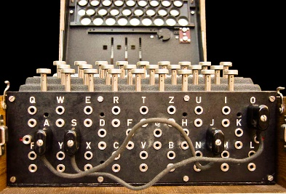 **ENIGMA GAME**

**{Elaine Mach}**

**THE PROJECT:**

My Something Awesome Project was to create a game that explores how the Enigma code was broken in World War 2.

The game explores the efforts in history that contributed towards cracking the Enigma code. It starts from the moment the existence of the Enigma was known to when the Enigma is cracked for the first time and secretly used against the Germans.

To do this, I developed a text-based game that runs in the console, similar to a choose-your-own-adventure type of game. It explores events and contributions in WW2 that led to the decryption of the Enigma.

The game involves several aspects of security engineering. For example, social engineering, codes and ciphers, secrets, security through obscurity, Kerkckhoff’s principle and more.

The player will be prompted with multi-choice questions (and more) where they will need to input the answer.

The game also serves as an educational tool, teaching players on the strengths and weakness of the Enigma system in WW2 as well as how these weaknesses were exploited.

Research was conducted online and mostly through two books; The Battle for the code by Hugh Sebag-Monteflore and The Code Book by Simon Singh.

<https://www.openlearning.com/u/elainemach-q5y592/blog/SomethingAwesomeProposal/>

**WHAT I LEARNED:**

The Something Awesome project was a major learning experience for me. My original goal of understanding how the Enigma works and how it was cracked was completed. I read books with in-depth explanations of the methods and techniques used to decrypt Enigma messages. I then mimicked the explanation style to ensure that the players would also understand Enigma. I realised that adding diagrams and examples for most processes promotes much more understanding.

<https://www.openlearning.com/u/elainemach-q5y592/blog/SomethingAwesomeGameFormat/>

Using the two books mentioned above, I learnt how the Enigma messages were decoded. Especially how the cryptographers stumbled across the solution and their thought process.

<https://www.openlearning.com/u/elainemach-q5y592/blog/SomethingAwesomeHowEnigmaWasCracked/>

On the technical side, I learnt to create a console game in a choose-your-own-adventure style, using the most appropriate data structures to old the story and determine the simplest way for players to interact with the game.

<https://www.openlearning.com/u/elainemach-q5y592/blog/SomethingAwesomeBuildingTheEnigmaGame/>

As the pressure built up towards the end of the term. I learnt to work under pressure and compromise what material to include in the game by creating a timeline and organising the information.

<https://www.openlearning.com/u/elainemach-q5y592/blog/SomethingAwesomeEnigmaTimeline/>

The history behind the Enigma is jam-packed with security concepts. I learnt how to identify and analyse them through the lectures.

<https://www.openlearning.com/u/elainemach-q5y592/blog/SomethingAwesomeSecurityConcepts/>

**REFLECTIONS**:

When creating the Something Awesome proposal for this project, I didn’t realise how vast and complicated the history behind the Enigma was. I had to compromise what information to explore in the game.

I used a bunch of websites and books to compile information on the Enigma before starting the project. Extensive research was needed as most sites skipped over important details. Looking into proper books cleared up the missing information.

While creating the Something Awesome project, I realised that understanding the Enigma wasn’t the difficult part. The methods used to decode Enigma messages were extremely complex and summing them all up into a short game wouldn’t be possible.

<https://www.openlearning.com/u/elainemach-q5y592/blog/SomethingAwesomeTimeManagement/>

Overall, I had a lot of enjoyment creating my Something Awesome project