**Question 2**

**A) How many orders were shipped by Speedy Express in total?**

SELECT COUNT(OrderID) AS "Amount of Orders Shipped by Speedy Express"

FROM Orders JOIN Shippers USING(ShipperID)

WHERE ShipperName="Speedy Express"

**Answer:** 54

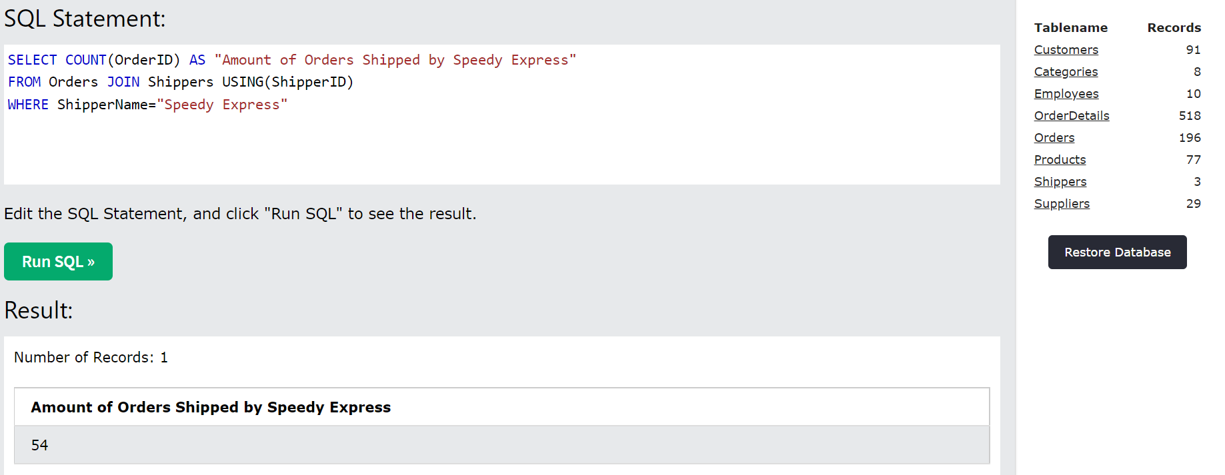

**B) What is the last name of the employee with the most orders?**

SELECT LastName AS "Last Name"

FROM (SELECT Max(OrdersTotal),LastName

FROM (SELECT COUNT(OrderId) AS OrdersTotal, EmployeeID, LastName

FROM ORDERS JOIN Employees USING(EmployeeID)

GROUP BY EmployeeID))

**Answer:** Peacock

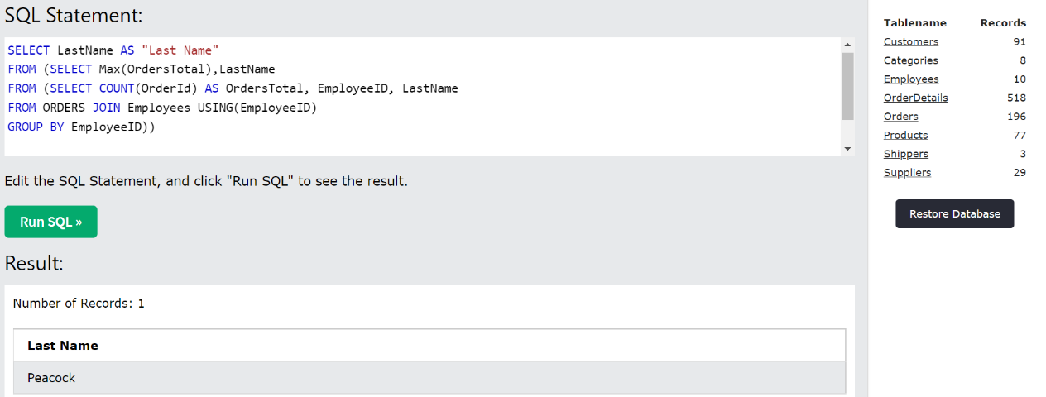

**C) What product was ordered the most by customers in Germany?**

SELECT ProductName AS "Product Name"

FROM (SELECT Max(Total), ProductName

FROM (SELECT ProductID, SUM(Quantity) AS Total, ProductName

FROM (SELECT * FROM Customers JOIN (SELECT OrderID, ProductID, Quantity, CustomerID

FROM Orders JOIN OrderDetails USING (OrderID))

USING (CustomerID)

WHERE (Country) LIKE "Germany")

JOIN Products USING (ProductID)

GROUP BY ProductID))

**Answer:** Boston Crab Meat

