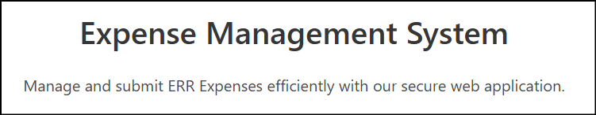
March 2026
ERR!!!: Full Stack Expenses Web App with ROS API Integration for Enhanced Reporting Requirements (ERR)
Project Report
Name: | Elaine Rice
Student ID: | 20108879
Programme: | Higher Diploma in Computer Science (NFQ Level 8)
Institution: | SETU Waterford – Department of Computing & Mathematics
Module: | Project (ICT Placement Skills)
Project Supervisor: | Sonya Hogan (Sonya.Hogan@setu.ie)

Declaration of Authenticity
I declare that the work presented in this report is my own, and that any quotations from any sources (e.g. books, journals, the internet) are clearly identified as such. All quotations and paraphrases are accompanied by in-text citations (author, year) and a full reference in the bibliography. I confirm that I have not submitted the work represented in this report in any other course of study leading to an academic award.
Student: ____ Elaine Rice ____________________ Date: ____ 21/03/2026_______

Acknowledgements
I acknowledged the guidance and feedback provided by my project supervisor Sonya Hogan, my workplace colleagues, for their support in the planning, implementation, and evaluation of this project. I also acknowledged the maintainers of the open-source tools and documentation used throughout development. My partner, who supported me wholeheartedly over the last two years while completing the course.
Version History
Version | Description | Author | Date
1.0 | Interim Report | Elaine Rice | 15/02/2026
2.0 | Final Report | Elaine Rice | 21/03/2026

Table of Contents
Declaration of Authenticity 1
Acknowledgements 1
1. Abstract 6
2. Introduction 6
2.1 Problem Statement 6
2.2 Project Aim 6
2.3 Scope 6
2.4 Deliverables 7
2.5 Acronyms 7
3. Research and Analysis 7
3.1 Research 7
3.2 Analysis 8
3.3 Existing Solutions (Internal and External) 8
3.4 POC Functional Requirements 9
3.5 Technology Choices 9
3.6 ROS API Integration Considerations 9
4. Methodology and Project Planning 10
4.1 Agile Scrum Methodology 10
4.2 Planning and Tracking (Trello) 10
5. System Design 11
5.1 Architecture Model 11
5.2 Data Model 12
5.3 UI Designs and Workflow 13
5.3.1 Home Screen (/home) 15
5.3.2 About hyperlink (/about) 15
5.3.3 Log in Screen (/login) 16
5.3.4 Initial log in for the Processor Role (/processor) 16
5.3.5 Employee Management (/processor/employees) 18
5.3.6 Element Management (/processor/elements) 20
5.3.7 Company Management (/processor/company) 21
5.3.8 Submissions (/processor/submissions) 22
5.3.9 Processor Reports (/processor/reports) 24
5.3.10 Initial log in for the Admin Role (/admin) 25
5.3.11 Redirect to Processing Functionality (/processor (admin role)) 25
5.3.12 Revenue Integration (/admin/revenue) 26
5.3.13 Admin Reports (/admin/reports) 29
5.3.14 Logout Menu Option (logout() → /login) 30
5.4 Security and Privacy by Design 30
6. Implementation 31
6.1 Backend Architecture and Security (see Appendix A diagram) 31
6.2 Frontend Architecture and User Interface 31
6.3 Claims Processing and Business Logic 32
6.4 ROS API Integration Layer 32
6.5 ERR Submission Schema Design 32
6.6 Submission Modelling Integration 32
6.7 ERR Submission Generation Engine 33
6.8 Data Normalisation and End-to-End Validation 33
6.9 Conditional Revenue Field Handling 33
6.10 Design of the .NET Signing Microservice 33
6.11 Revenue ROS Certificate Cryptographic Signing Engine Implemented 34
6.12 Revenue PIT3 handshake fully operational using .NET signing microservice 34
6.13 ERR Submission Lifecycle and ROS API Integration 34
6.14 ERR Submission Lifecycle from UI 38
6.15 Employee Management from UI 39
6.16 Element Management from UI 40
6.17 Company Configuration from UI 40
6.18 System Reporting and Governance Layer 41
6.19 Edit Functionality for Employees, Elements and Claims (CRUD Completion) 42
7. Testing and Validation 43
7.1 Test Strategy 43
7.2 Sample Test Cases 43
8. Results and Evaluation 43
9. Critical Self-Review, Reflection and Future Improvements 44
9.1 What Was Achieved 44
9.2 What Was Learned 44
9.3 Problems Encountered and Solutions 44
9.3.1 Certificate Handling Limitations in Node.js 44
9.3.2 Password Handling Discrepancies 44
9.3.3 OpenSSL Extraction Attempts 45
9.3.4 Architectural Misalignment Between Node.js and Revenue PIT3 45
9.3.5 Decision to Introduce a Minimal .NET Signing Microservice 46
9.4 What I Would Do Differently 46
9.5 Future Improvements 46
10. Conclusion 46
References 47
Appendices 49

Table of Figures
Figure 1: Agile Sprint Planning 10
Figure 2: Architecture Model 11
Figure 3: Database Collection 12
Figure 4: System User Flow 14
Figure 5: UI Landing Page 15
Figure 6: About Hyperlink 15
Figure 7: About URL 15
Figure 8: Login Screen 16
Figure 9: Back to Home Button 16
Figure 10: Expense Claims Menu Button (displaying logged in user) 16
Figure 11: Processing Claims Dashboard 17
Figure 12: Select Claim for Editing 17
Figure 13: Editing Pending Claim 17
Figure 14: Employee Management Dashboard 18
Figure 15: Select Employee for Viewing / Editing 18
Figure 16: Edit Employee Option 19
Figure 17: Editing Employee Record 19
Figure 18: Elements Management Dashboard 20
Figure 19: Select Element for Editing 20
Figure 20: Edit Element Option 21
Figure 21: Company Details Dashboard 21
Figure 22: Submission Dashboard 22
Figure 23: Display Pending Submission Line Items 22
Figure 24: Send Submission Button 22
Figure 25: Submission Acknowledgement: “Submitted” 23
Figure 26: Submission Acknowledgement: “Failed” 23
Figure 27: Processing Reporting Dashboard 24
Figure 28: User Management Dashboard 25
Figure 29: Admin Redirect to Processing Functionality 25
Figure 30: Dynamic Admin Menu Button 25
Figure 31: Revenue Integration Dashboard 26
Figure 32: Successful ROS Handshake 26
Figure 33: Cert Issues; Revenues Confirmation 27
Figure 34: Unsuccessful ROS Handshake 27
Figure 35: Signing Service Health Check Output 27
Figure 36: ROS Cert Metadata and Base64 Encoding Output 28
Figure 37: ROS Certificate RSA-SHA512 Signing Output 28
Figure 38: Admin Reports Dashboard; Claims Activity 29
Figure 39: Admin Reports Dashboard; Submission Activity 29
Figure 40: Logout Button 30
Figure 41: Logout Redirect to Login Screen 30
Figure 42: Successful ROS Submission Acknowledgement 37
Figure 43: System Architecture Diagram: High-Level 49
Figure 44: Architecture Diagram: Client Layer 50
Figure 45: Architecture Diagram: Application Layer 50
Figure 46: Architecture Diagram: Data Layer 51
Figure 47: Architecture Diagram: Cryptographic Service Layer 52
Figure 48: Architecture Diagram: ROS Integration Layer 52

1. Abstract
This project delivers a proof-of-concept (POC) full-stack Expenses web application that captures, manages, and prepares employee expense records for Enhanced Reporting Requirements (ERR) submission to Revenue.
In Ireland, ERR reporting is mandated under Section 897C of the Finance Act 2022 (Finance Act 2022, s.897C; Revenue, 2024). These rules require employers to report non-taxable benefits and expenses such as travel, subsistence, and the small benefit exemption, to Revenue on or before the payment date via the Revenue Online Service (ROS).
This POC project aims to integrate with ROS API to demonstrate an end-to-end ERR submission workflow. The application is designed as a standalone SaaS-style web product. The implemented solution provides user authentication, RBAC and secure storage of data, while operating entirely on a dummy dataset to avoid processing personal or sensitive information. The project followed an iterative agile approach with short sprints.

2. Introduction
This report documents the design and implementation of the POC web application. The project was completed as a work-based project and targeted a transition from a desktop application to a modern cloud based SaaS web application.

2.1 Problem Statement
The organisation’s payroll desktop application, MegaPay, supports ERR submissions. However, feedback indicated that the workflow was difficult to navigate and required multiple steps that were not aligned with modern user expectations. This project produced a standalone web application that simplified the ERR process while maintaining the essential reporting workflow and statutory compliance. This aligned with the organisations strategic shift from on-premise software to a cloud-based SaaS offerings.

2.2 Project Aim
The project aimed to demonstrate that a web application could capture and manage expense data and integrate directly with the ROS API to submit ERR compliant payloads as part of an auditable submission workflow.

2.3 Scope
The scope was a POC using a dummy dataset. No live personal data was processed. The system implemented core workflows: user authentication, RBAC, expense capture, categorisation, ERR payload preparation, ROS API submission integration, and submission reporting. Non-functional requirements such as encryption were incorporated as design decisions and partially implemented where appropriate for a POC (European Union, 2016).

2.4 Deliverables
The project deliverables include:
- A full-stack web application prototype with a ROS API integration layer to submit ERR payload submission and capture responses.
- A final project report documenting: models, analysis, design, iteration plans, implementation details, reflection.
- A project website: with links to all deliverables.
- A GitHub project Repo.
- A showcase entry.
- A record of project planning.
- A demonstration video.
- Presentation to a judging panel.

2.5 Acronyms
Acronyms | Description
ERR | Enhanced Reporting Requirements
ROS | Revenue Online Services
RBAC | Role-Based Access Control
PPSN | Personal Public Service Number
JWT | JSON Web Token
REST | Representational State Transfer
API | Application Programming Interface
SPA | Single Page Application
POC | Proof of Concept
CRUD | Create, Read, Update, Delete
GDPR | General Data Protection Regulation
UTC | Coordinated Universal Time
TAIN | Tax Agent Identification Number
X.509 | Public Key Infrastructure Certificate Standard
PKCS#12 | Public Key Cryptography Standard #12

3. Research and Analysis

3.1 Research
Research activities focused on three primary areas: regulatory requirements, existing systems, and technology evaluation. Revenue documentation and technical schema specifications were reviewed to understand mandatory submission structures and conditional reporting rules (Revenue, 2024a; Revenue, 2024b). This provided clarity on the data elements required for compliant ERR payloads and the role of the ROS API in the submission process. Technical research evaluated frontend and backend frameworks, and database technologies suitable for a SaaS-style application.

3.2 Analysis
The analysis stage translated research findings into planning and system requirements. Functional requirements were identified for user authentication, RBAC, expense claim capture and management, ERR payload generation, ROS API submission generation, and submission status reporting. These requirements were expressed as user stories to support iterative development.

3.3 Existing Solutions (Internal and External)
Within SD Worx, the standard SaaS development stack consists of Angular for frontend application development, ASP.NET Core for backend API and service construction, and C# as the primary programming language. This enterprise level stack supports large scale, production ready payroll and HR systems. For the purposes of this POC project, it was agreed that the application would be developed using a technology stack with which I had greater familiarity e.g. Svelte for frontend, Node.js for backend and MongoDB. The primary objective of the project was to explore and model the ROS ERR integration process, rather than replicate the organisation’s enterprise framework. This ensured that the learning focus remained on regulatory modelling and system architecture rather than on mastering a new technology stack.
Within the SD Worx ecosystem, ERR processing is implemented as an embedded component of the existing payroll platform (MegaPay), rather than as a standalone system. The ERR workflow is tightly coupled with payroll execution, whereby expense data is captured during the timesheet creation process and subsequently included in the statutory submission cycle, this integrated approach simplifies processing by combining expense payments with payroll payments. However, this design inherently restricts ERR processing to payroll professionals. In contrast, a standalone expense management solution allows a broader range of users to manage and submit expense data independently of payroll.
Externally, the Irish payroll market contains a number of established platforms that support ERR compliance. These solutions can broadly be categorised into three groups: direct API submission platforms, automated file generation systems, and integrated accounting ecosystems. Direct API platforms such as Parolla, SimplePay and BulletHQ (Revenue, 2024b; Vendor documentation, 2025) submit ERR data directly to Revenue via REST API integration, abstracting authentication, certificate handling and submission validation from the end user. In contrast, systems such as Strandum, Capture Expense and ERR Bridge generate ROS-compliant XML files which must be manually uploaded through the ROS portal. Mainstream accounting platforms such as Xero and QuickBooks typically rely on specialised Irish payroll add-ons to manage the ERR submission process.
Based on these internal and external considerations, the solution adopted in this project was a standalone, web-based application designed specifically to model the ERR submission lifecycle. This approach enables separation from payroll processing and supports broader user interaction.
While not representative of SD Worx’s production architecture, this design choice is appropriate for a POC, as it prioritises modelling the submission lifecycle within a layered RESTful web application. By concentrating on schema construction, employee identification rules, and submission reference generation, the project demonstrates the architectural and integration principles required to support compliant ERR reporting.

3.4 POC Functional Requirements
Key functional requirements implemented in the prototype were:
- User registration/login and session management.
- RBAC (e.g., processor, admin).
- Create/read/update (CRUD) for employee, elements, company details and expense claims.
- ERR submission generation from pending claim records.
- ROS API integration to submit ERR payloads and capture response status.
- Reporting and audit trail of submissions.

3.5 Technology Choices
Prior to selecting specific technologies, a set of non-functional requirements was established to guide the architectural decisions. The system required:
- Support for secure API integration with external services (ROS)
- Ability to handle asynchronous communication and signing workflows
- Rapid development capability suitable for a POC
- A flexible data model to accommodate evolving schemas
- A lightweight, responsive UI
- Clear separation of concerns between frontend, backend, and external services
Based on these requirements, the following technology stack was selected. Svelte was chosen for frontend development due to its lightweight reactive architecture and minimal runtime overhead, enabling rapid development of a responsive user interface (Svelte, n.d.). Node.js was selected for the backend as its non-blocking I/O model is well suited to handling asynchronous operations, including external API communication and interaction with the signing microservice (Node.js, n.d.).
MongoDB was chosen as the database solution due to its document-oriented structure, which supports flexible schema design. This was particularly beneficial for modelling ERR payload structures during the prototyping phase, where requirements evolved iteratively (MongoDB, n.d.).
Overall, the selected technologies align with the defined non-functional requirements by supporting integration-focused processing, rapid iteration, and modular system design.

3.6 ROS API Integration Considerations
The initial ROS Handshake was implemented first and later developments integrated the submission payload creation and response handling.

4. Methodology and Project Planning

4.1 Agile Scrum Methodology
An Agile Scrum methodology was adopted for the project. Requirements were captured as user stories and delivered in six two-week sprints. This approach supported incremental delivery, continuous feedback, and early risk reduction.
Scrum was selected due to the exploratory nature of the project. The iterative sprint-based approach enabled functionality to be developed, tested, and refined incrementally. Additionally, the modular architecture of the system (frontend, backend, and signing microservice) aligned well with Scrum practices within the project timeframe.

4.2 Planning and Tracking (Trello)
Project planning and task tracking were managed using Trello. User stories and technical tasks were represented as cards and organised into sprint-based columns.
The Trello board provided visibility of progress, realistic workload management and enabled effective monitoring of progress.
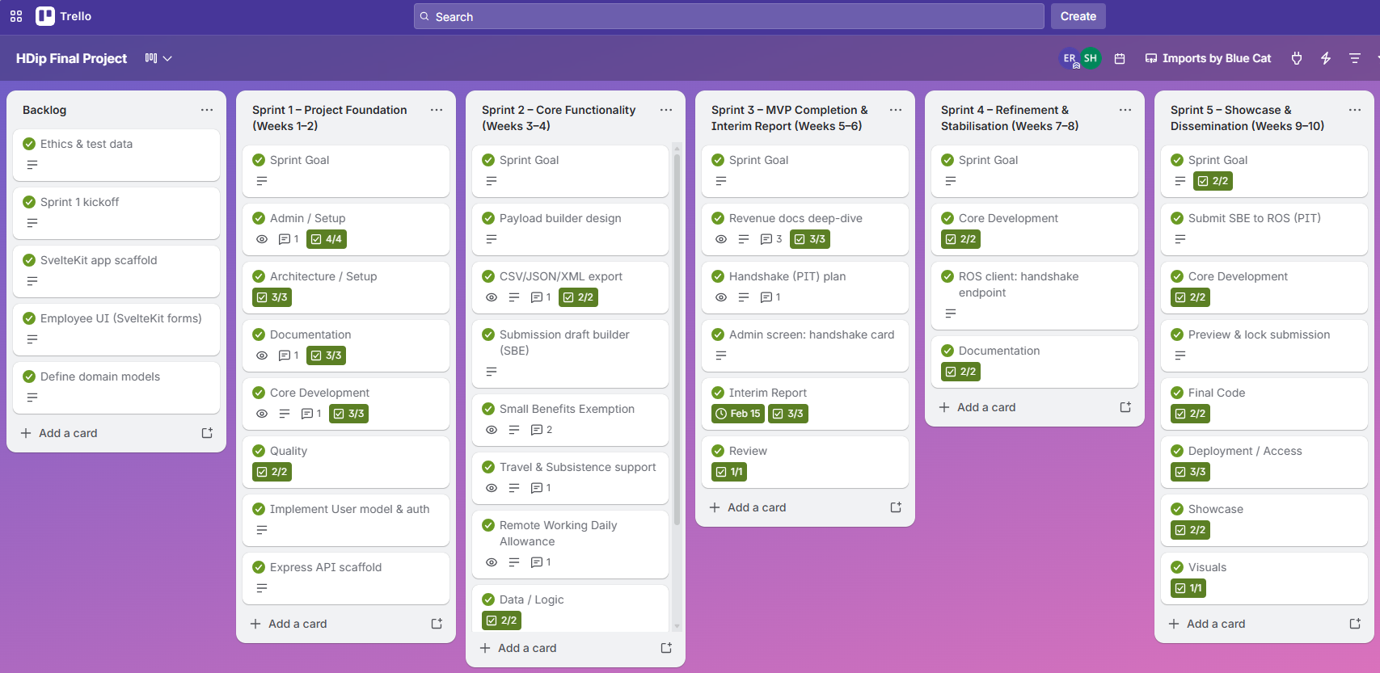
Figure 1: Agile Sprint Planning

5. System Design

5.1 Architecture Model
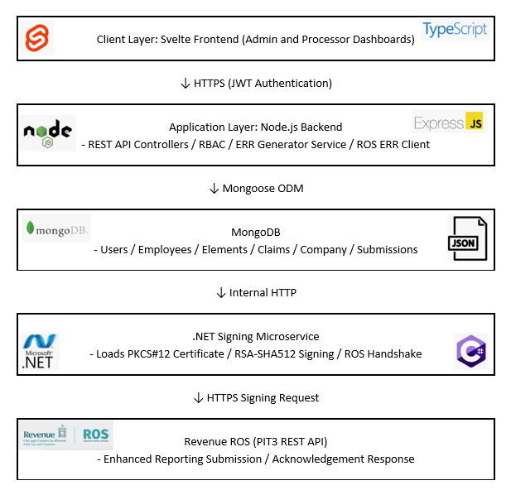
The system followed a tiered architecture: Svelte SPA for the UI, Node.js REST API for business logic, and MongoDB database for persistence. The ROS API was accessed via a dedicated integration service within the Node.js backend.
Figure 2: Architecture Model



Client Layer: Svelte Frontend (Admin and Processor Dashboards)

↓ HTTPS (JWT Authentication)


Application Layer: Node.js Backend
- REST API Controllers / RBAC / ERR Generator Service / ROS ERR Client

↓ Mongoose ODM


MongoDB
- Users / Employees / Elements / Claims / Company / Submissions

↓ Internal HTTP


.NET Signing Microservice
- Loads PKCS#12 Certificate / RSA-SHA512 Signing / ROS Handshake

↓ HTTPS Signing Request

Revenue ROS (PIT3 REST API)
- Enhanced Reporting Submission / Acknowledgement Response

5.2 Data Model
The data model was designed to support the generation of compliant submission payloads. A key challenge of the project was aligning data structures with Revenue defined schemas, which impose strict requirements on formatting.
To address this, a document-based data model using MongoDB was implemented for schema flexibility during prototyping, unlike a relational model, MongoDB allows incremental adaptation of document structures, making it suitable for a POC.
The data model was centred around the Claim entity. Claims capture expense data at the point of entry and are later transformed into submission payloads. A key design decision was the separation of audit fields (createdAt, updatedAt) from the statutory reporting field (payDate). This ensured the system could maintain an immutable audit history while generating submissions based on reporting dates required by Revenue.
Collections were designed to reflect distinct functional responsibilities:
- Employees store identity, address data, conditional identification logic whereby employees may be identified using a PPSN or alternative identifiers.
- Elements define expense categories and rates, aligning with Revenue classifications.
- Companies store employer-level data required for submissions.
- Users manage authentication and RBAC.
In addition, a dedicated Submission collection was introduced to persist the outcome of submission attempts. This includes generated payload data, acknowledgement responses, and trace identifiers.
Overall, the data model was designed to balance regulatory compliance and audit requirements, ensuring that internal data structures could accurately map to external ERR submission schemas.
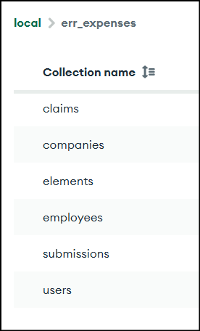
Figure 3: Database Collection

Collections and Key Fields (MongoDB Document Model):
- claims
_id (ObjectId), processor (ObjectId), amount (Number), description (String), payDate (Date), status (String), employee (ObjectId), element (ObjectId), days (Number), createdAt (Date), updatedAt (Date)
- companies
_id (ObjectId), employerRegistrationNumber (String), payrollReference (String), taxYear (Number), softwareUsed (String), softwareVersion (String), rosCertPath (String), rosCertPassword (String), agentTain (String), active (Boolean), createdAt (Date), updatedAt (Date)
- elements
_id (ObjectId), category (String), subCategory (String), description (String), active (Boolean), rate (Number), createdAt (Date), updatedAt (Date)
- employees
_id (ObjectId), firstName (String), familyName (String), employmentID (String), employeePpsn (String), employerReference (String), dateOfBirth (Date), address (Embedded Object), active (Boolean), createdAt (Date), updatedAt (Date)
- submissions
_id (ObjectId), employerRegistrationNumber (String), taxYear (Number), enhancedReportingRunReference (String), submissionID (String), payDate (Date), claims (ObjectId[]), submittedBy (ObjectId), lineItemCount (Number), totalAmount (Number), expensesBenefits (Array<Object>), acknowledgementStatus (String), acknowledgementID (String), revenueResponse (Object), traceId (String), createdAt (Date), updatedAt (Date)
- users
_id (ObjectId), name (String), email (String), password (String), role (String), createdAt (Date), updatedAt (Date)

5.3 UI Designs and Workflow
The system follows a structured user workflow that reflects the lifecycle of ERR processing, from data entry through to submission and acknowledgement. The primary user journeys are role-based and can be summarised as follows:
Processor Workflow:
- User logs via the login screen
- User creates expense claims by pay date, employee, element and amount
- Claims are stored with a pending status
- System generates an ERR compliant payload
- Acknowledgement response is received, stored and claim statuses are updated to submitted
- User can manage employees, elements and company setup
- User can monitor submission history

Admin Workflow:
- User logs in with administrative privileges
- User can operate as a Processor (see Processor Workflow)
- User can manage user accounts
- User can monitor claim and submission activities
- User can test Revenue integration (handshake, signing service)
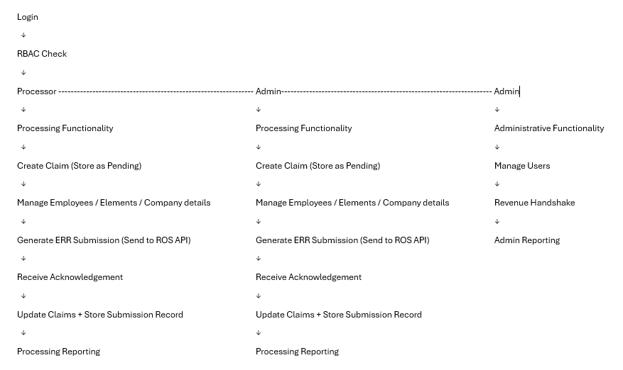

Figure 4: System User Flow

5.3.1 Home Screen (/home)
Being the initial landing page upon app launch, giving basic information about the app, containing log in button and “about” hyperlink (redirecting to the SD Worx Ireland website).
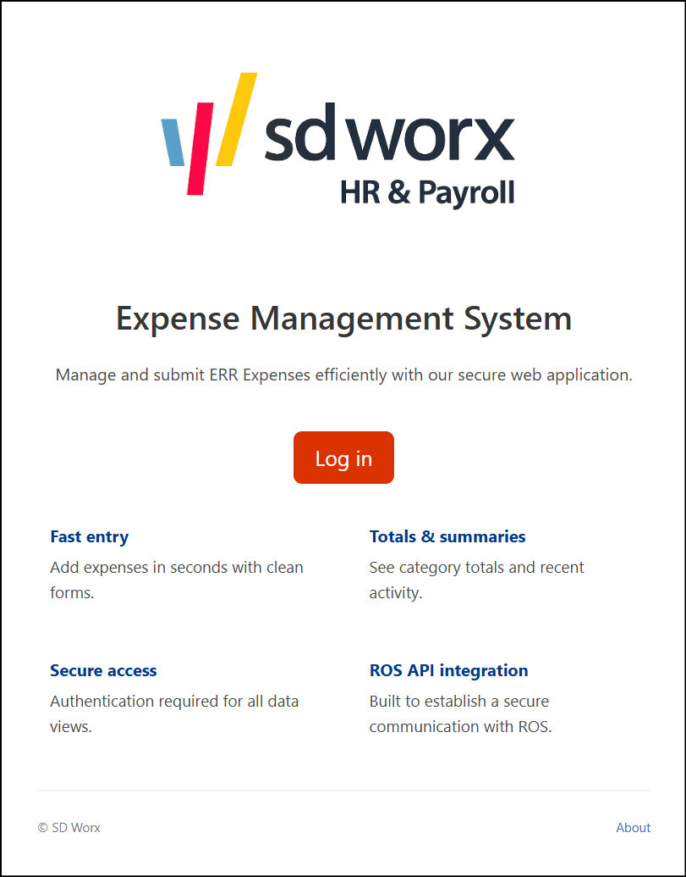
Figure 5: UI Landing Page

5.3.2 About hyperlink (/about)
The about hyperlink redirects to the main SD Worx Ireland website:

Figure 6: About Hyperlink

Redirect URL:
Figure 7: About URL

5.3.3 Log in Screen (/login)
The log in page where user credentials are entered, which also contains a hyperlink back to the home screen. Seeded log in credentials for two user roles:
Processor; processor@test.com / Processor123!
Admin; admin@test.com / Admin123!
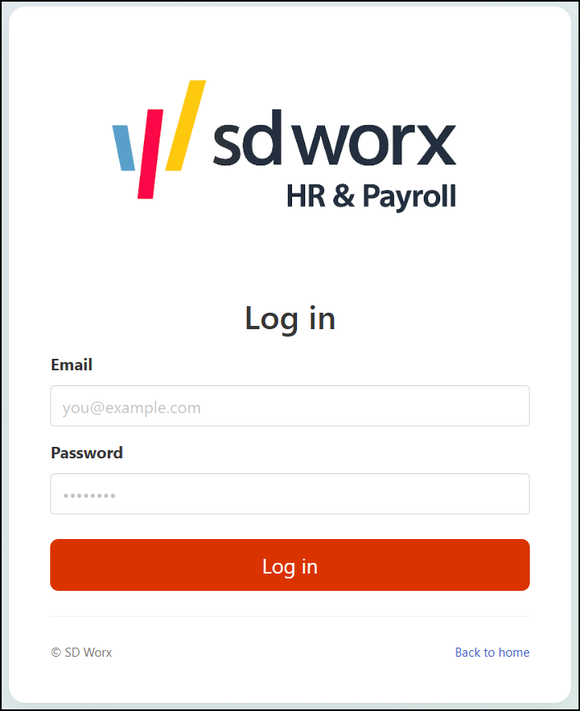
Figure 8: Login Screen

Redirect button to return to /home
Figure 9: Back to Home Button

5.3.4 Initial log in for the Processor Role (/processor)
Upon successful authentication, users with the processor role are redirected to the main claims dashboard. This page serves as the central workspace for entering new claims, viewing or editing pending claims.
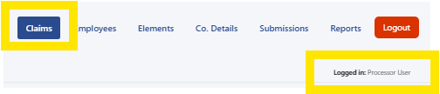
Figure 10: Expense Claims Menu Button (displaying logged in user)
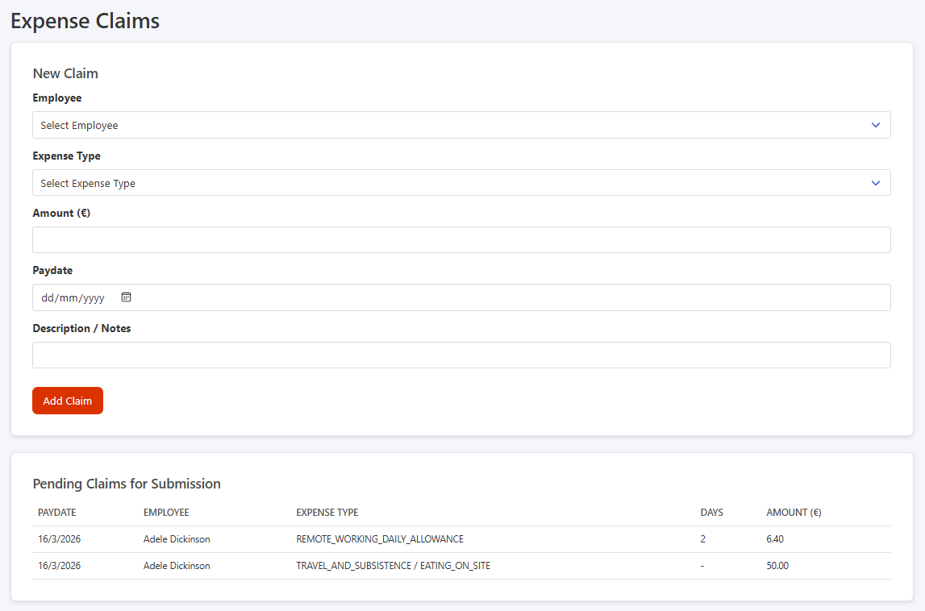
Figure 11: Processing Claims Dashboard

Edit pending claims; highlight and click on claim for editing:
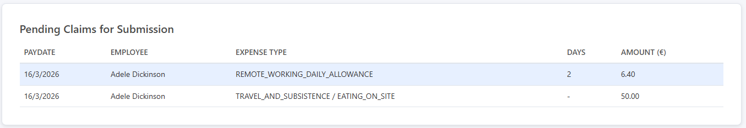
Figure 12: Select Claim for Editing
Edit pending claims; amend the necessary field/s and Save Changes or Cancel out of editing mode:
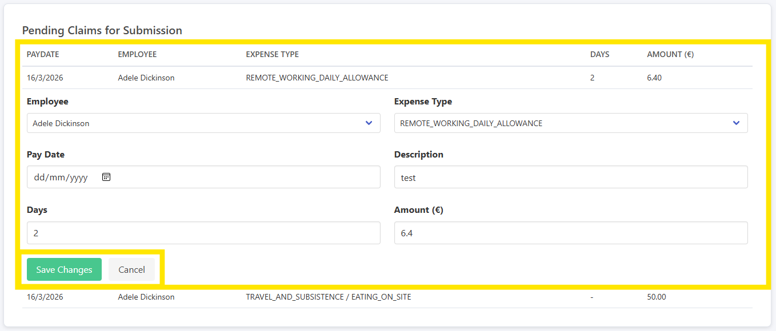
Figure 13: Editing Pending Claim

5.3.5 Employee Management (/processor/employees)
This dashboard provides functionality for managing employee records. Users can create new employees or select an existing record for editing. The fields captured are the minimum mandatory employee identifiers for the submission record.
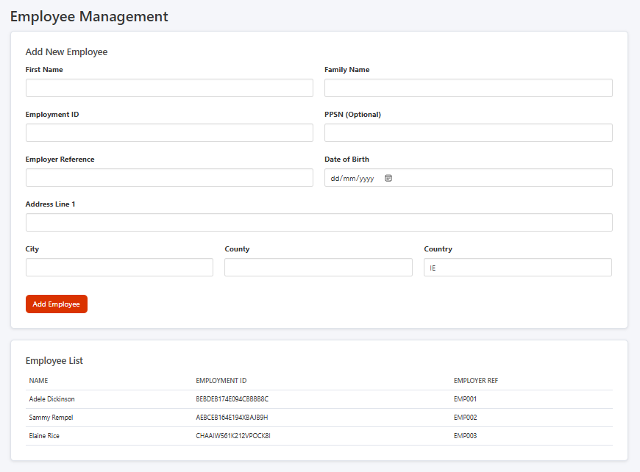
Figure 14: Employee Management Dashboard
View / Edit employee record; highlight and click on employee for viewing / editing:
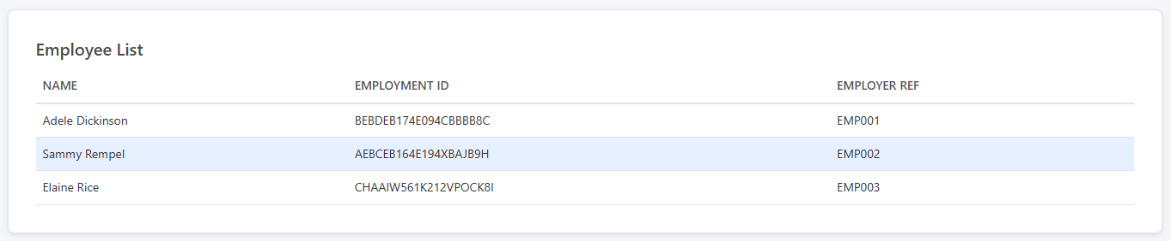
Figure 15: Select Employee for Viewing / Editing

When the relevant employee record is selected, the record details are displayed, and the Edit Employee button becomes available:
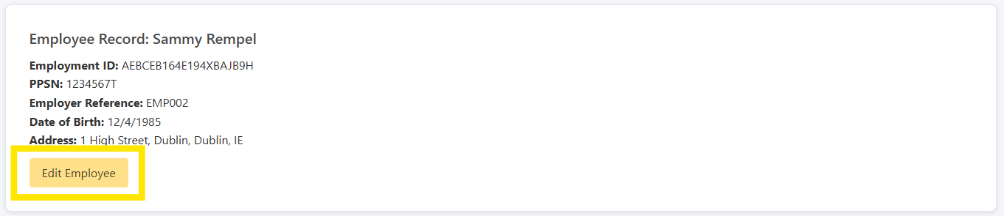
Figure 16: Edit Employee Option

Edit an employee record; amend the necessary field/s and Save Changes or Cancel out of editing mode:
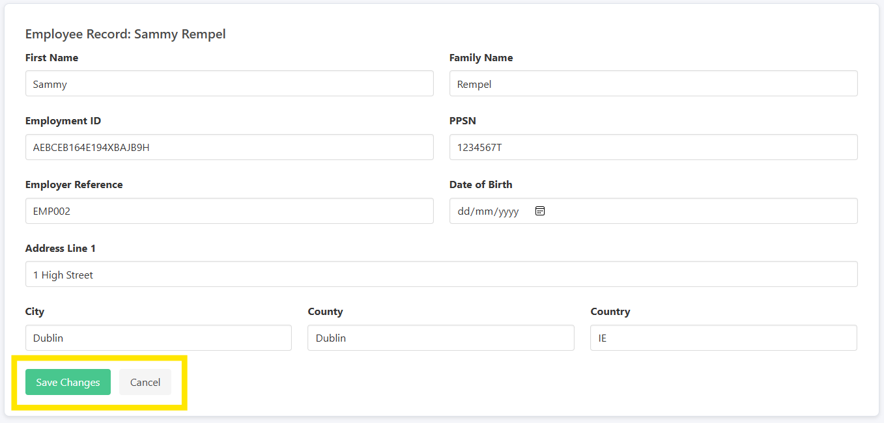
Figure 17: Editing Employee Record

5.3.6 Element Management (/processor/elements)
This dashboard provides functionality for managing expense elements. Users can create new elements or edit existing records. Elements define the category, subcategory and days (where applicable) for compliant submission generation
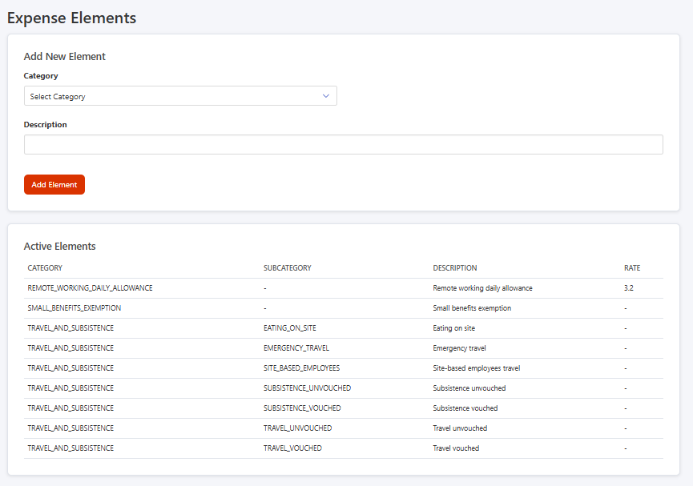
Figure 18: Elements Management Dashboard

Edit element record; highlight and click on element for editing:
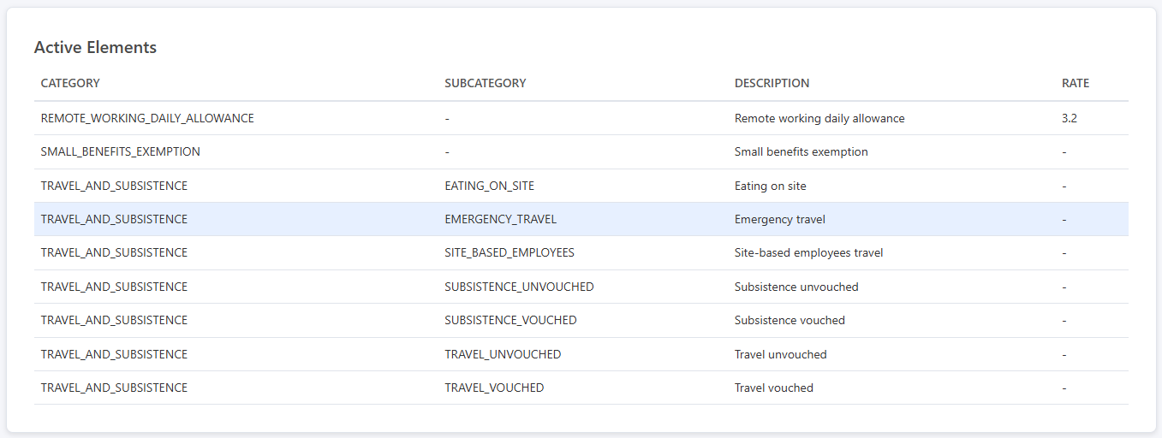
Figure 19: Select Element for Editing
The element record details are displayed and available for amending. Amend the necessary field/s and Save Changes or Cancel out of editing mode:
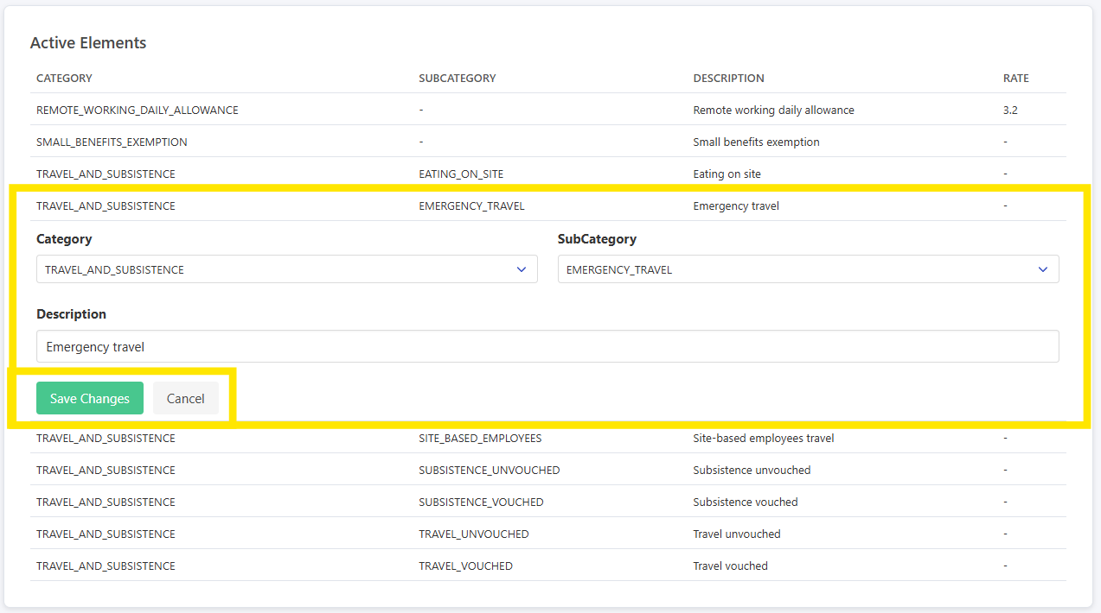
Figure 20: Edit Element Option

5.3.7 Company Management (/processor/company)
This dashboard provides functionality for saving / editing company configuration data. It captures employer identifiers and parameters used in constructing submission payloads. For the purposes of this POC, certificate path and password fields are exposed in the UI; however, these would be securely managed in a production environment
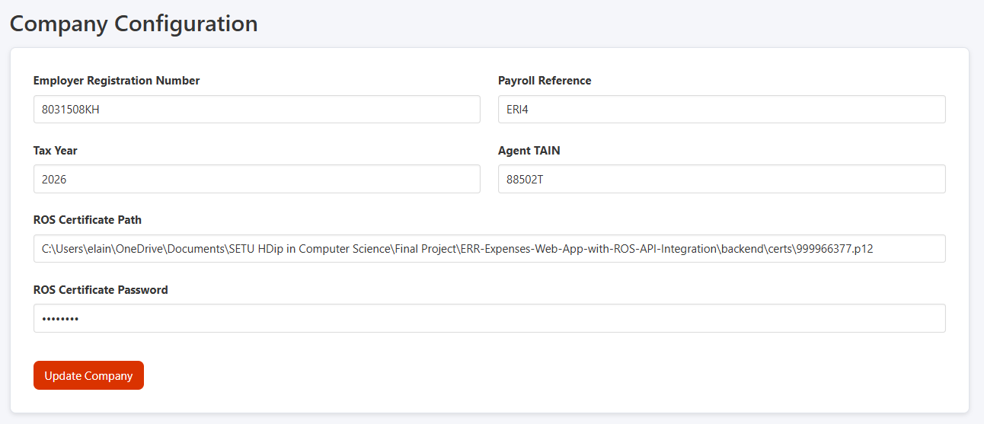
Figure 21: Company Details Dashboard

5.3.8 Submissions (/processor/submissions)
This dashboard provides a view of pending claims grouped by pay date. Users can select a reporting pay date to review the associated claims prior to submission.
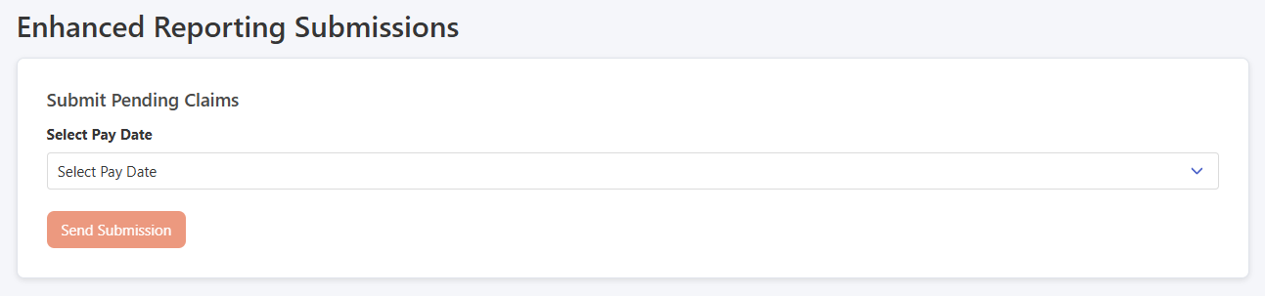
Figure 22: Submission Dashboard

Select the relevant expense payment date to display the pending submission records:
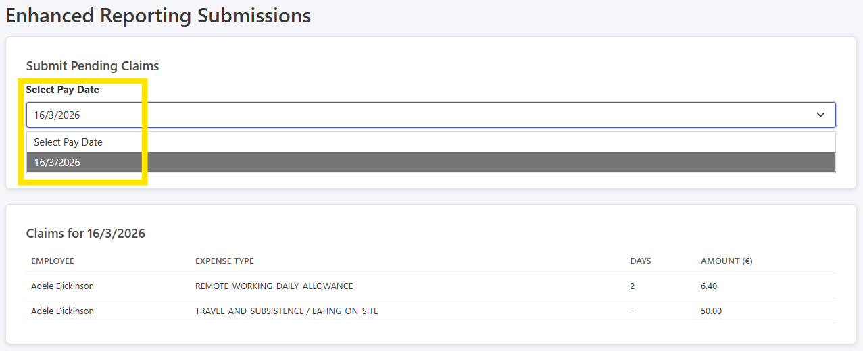
Figure 23: Display Pending Submission Line Items

Submitting pending claims: if the outstanding claims are ready for submission, click Send Submission otherwise return to the Claims dashboard to amend the submission record:
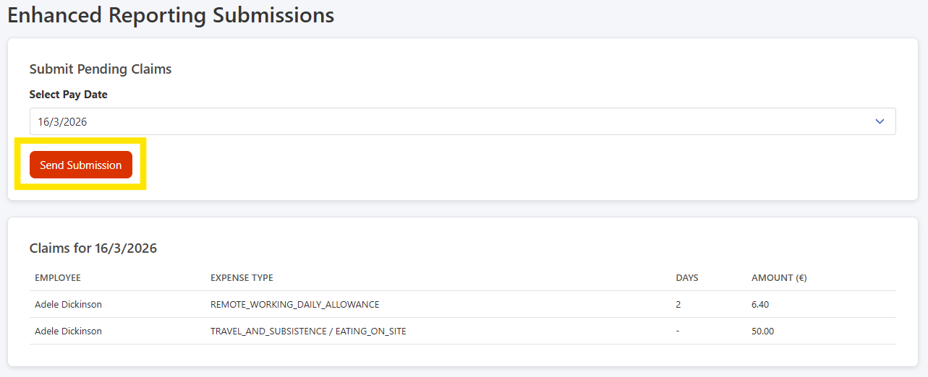
Figure 24: Send Submission Button
Submission success / failure: after clicking Send Submission, ROS will return either a successful (Submitted) or unsuccessful (Failed) status response. “Submitted” submission records are returned with an acknowledgment ID and “Failed” submission records are returned with the relevant validation error message:
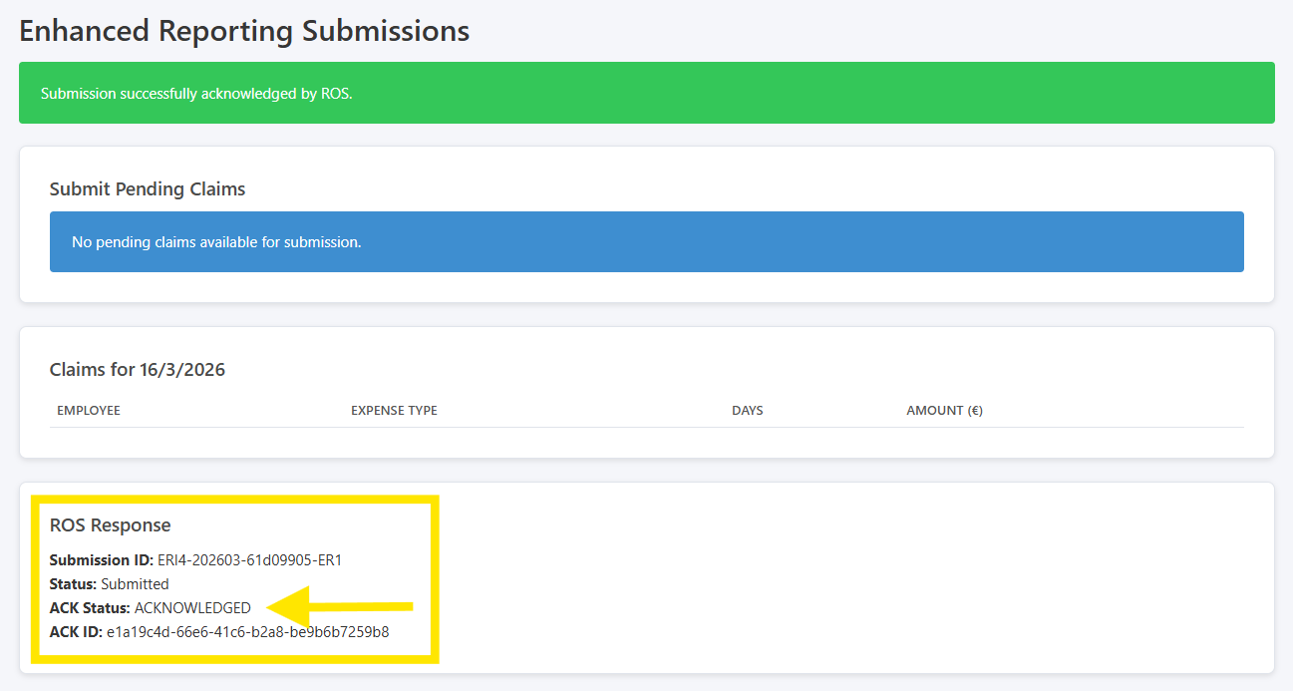
Figure 25: Submission Acknowledgement: “Submitted”

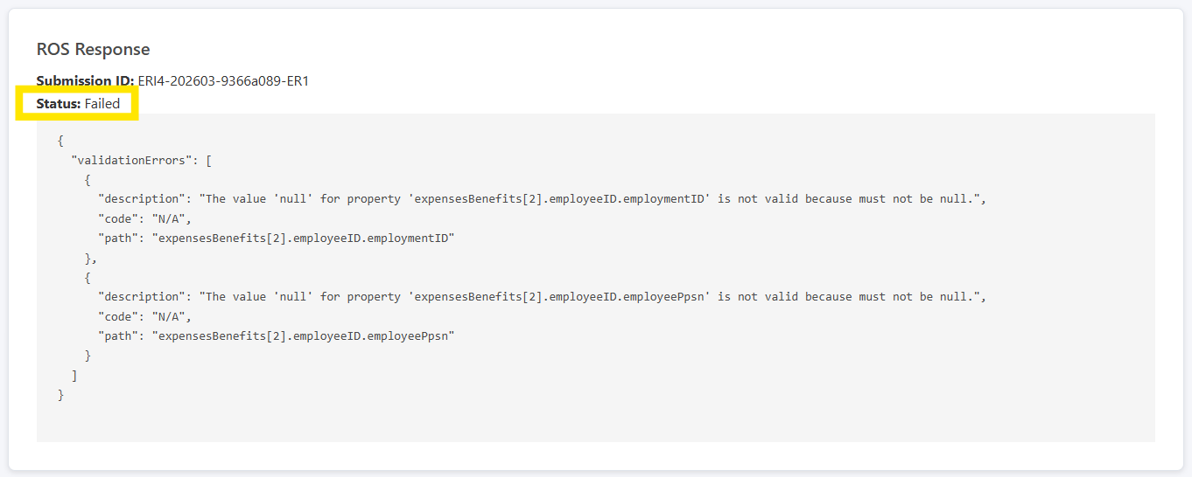
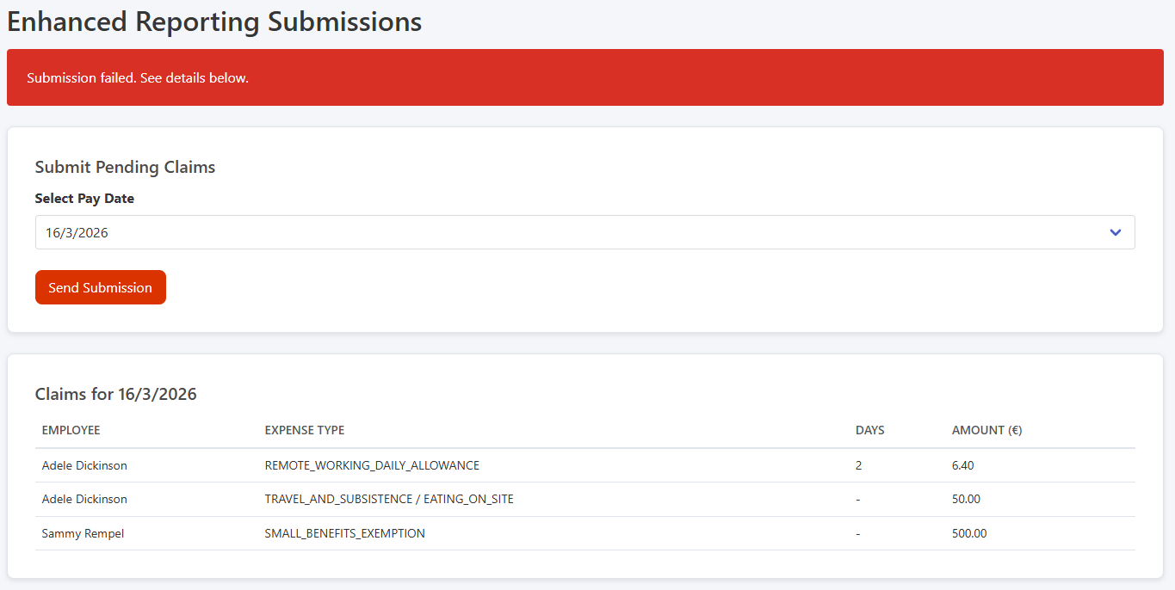
Figure 26: Submission Acknowledgement: “Failed”

In the current POC implementation, ERR submissions are processed as a single transactional unit. If any line item within a submission fails, the entire submission is rejected. As a result, all associated claims remain in a “pending” state. This simplifies error handling for the prototype. Future iterations would introduce line-item level validation and allow submission of valid records while isolating failures.

5.3.9 Processor Reports (/processor/reports)
This dashboard provides reporting functionality for submissions based on a selected pay date range (reset filter available). Metrics include total submissions, acknowledged / rejected submissions, and total monetary value submitted. A detailed submission history table is displayed. Future iterations would display the detailed line-items of each submission.
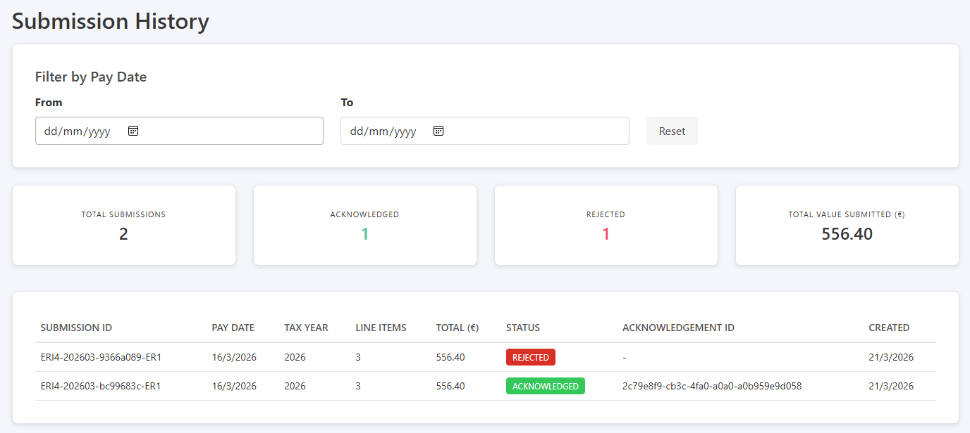
Figure 27: Processing Reporting Dashboard

5.3.10 Initial log in for the Admin Role (/admin)
Upon successful authentication, users with the admin role are redirected to the user management dashboard. This page includes creating, viewing, and updating user accounts (for future development). It provides oversight of roles and access levels within the application.
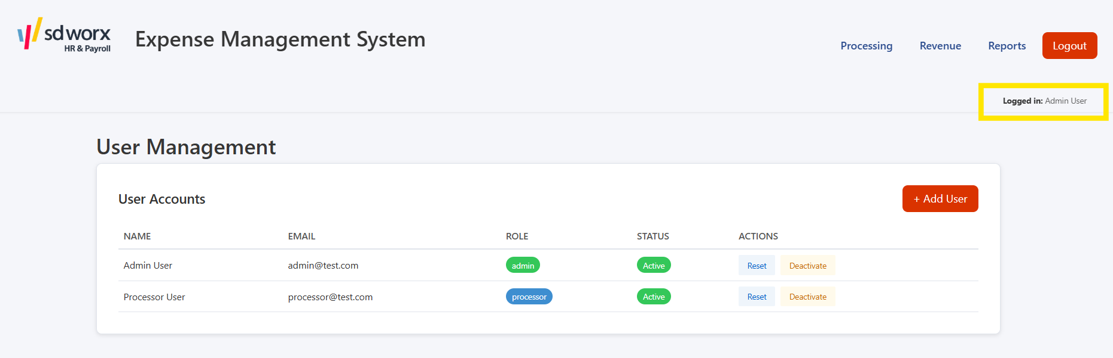
Figure 28: User Management Dashboard

5.3.11 Redirect to Processing Functionality (/processor (admin role))
This menu option allows an admin user to access the processor claims dashboard, providing full processing functionality.
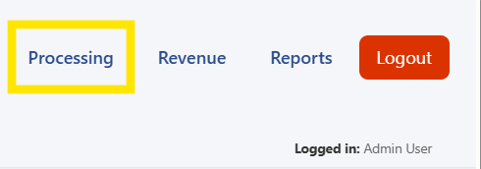
Figure 29: Admin Redirect to Processing Functionality
From there, the admin user can navigate back to admin functionality:
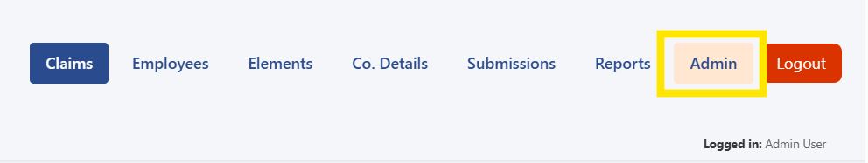
Figure 30: Dynamic Admin Menu Button

5.3.12 Revenue Integration (/admin/revenue)
This screen provides a dedicated interface for testing and validating the system’s integration with ROS, specifically focusing on the cryptographic signing and handshake processes required for submissions. This screen exposes a set of controlled test actions that interact with both the Node.js backend and the .NET signing microservice. The Handshake function triggers the full backend-driven Revenue handshake process (/api/revenue/handshake), validating end-to-end communication with ROS.
The Health Check, Certificate Info, and Sign Test Data functions interact directly with the signing microservice. These endpoints isolate and verify critical components of the integration:
- Health Check (/health) confirms service availability.
- Certificate Info (/cert-info) exposes certificate metadata and Base64 encoding, supporting validation of certificate loading and configuration.
- Sign Test Data (/sign) validates the RSA-SHA512 signing process independently of the full ROS workflow.
Overall, this component acts as a diagnostic layer within the architecture, enabling verification of individual integration steps and reducing the risk associated with Revenue submission failures.
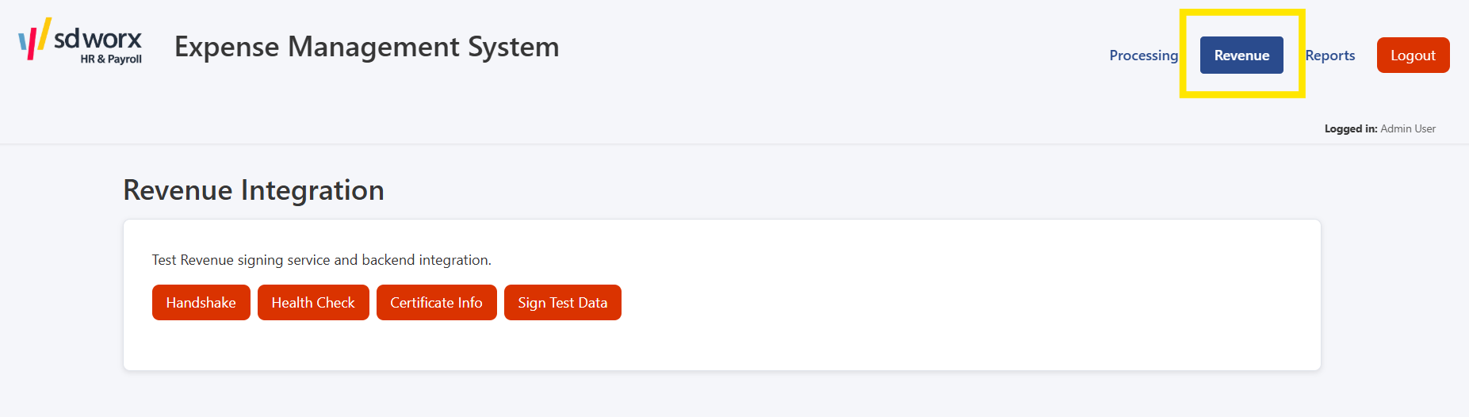
Figure 31: Revenue Integration Dashboard
Output screens for ROS Handshake attempts:
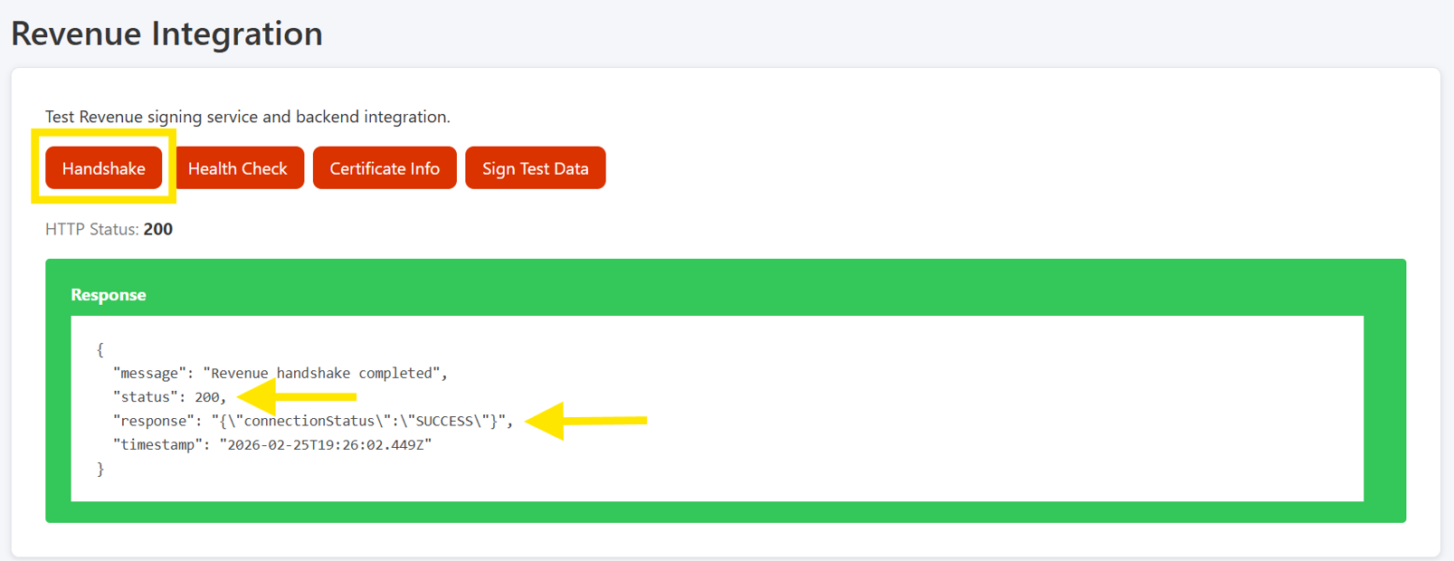
Figure 32: Successful ROS Handshake
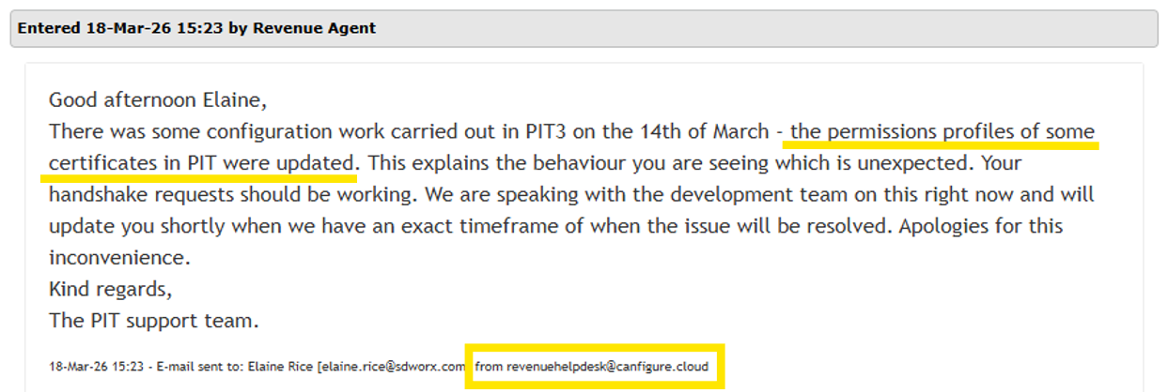
Figure 33: Cert Issues; Revenues Confirmation
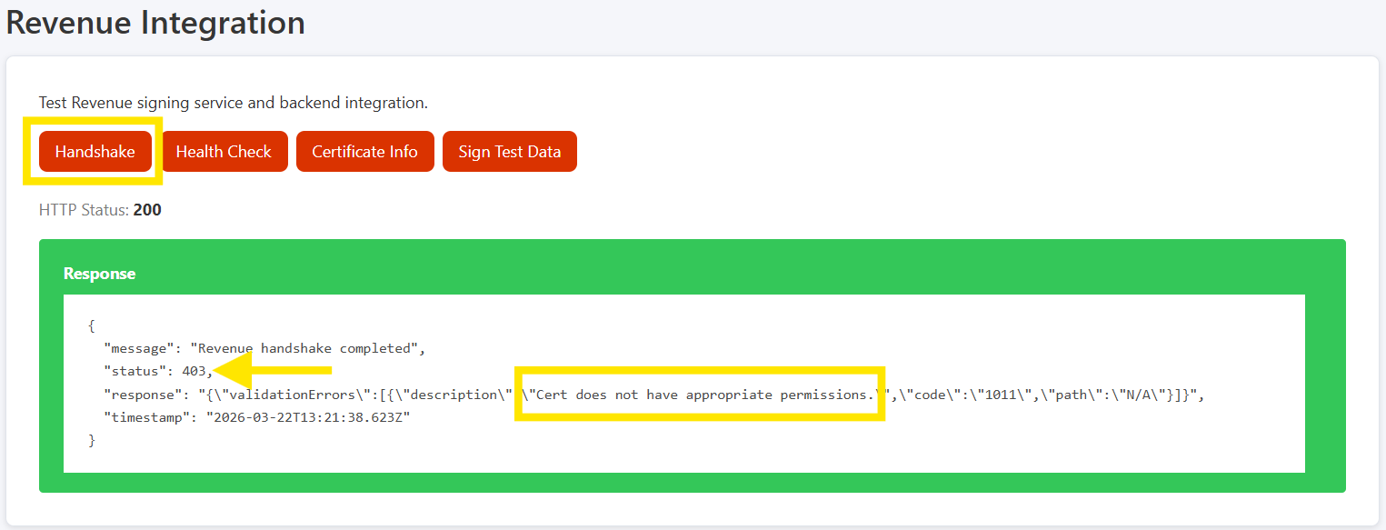
Figure 34: Unsuccessful ROS Handshake

Output screen for Health Check:
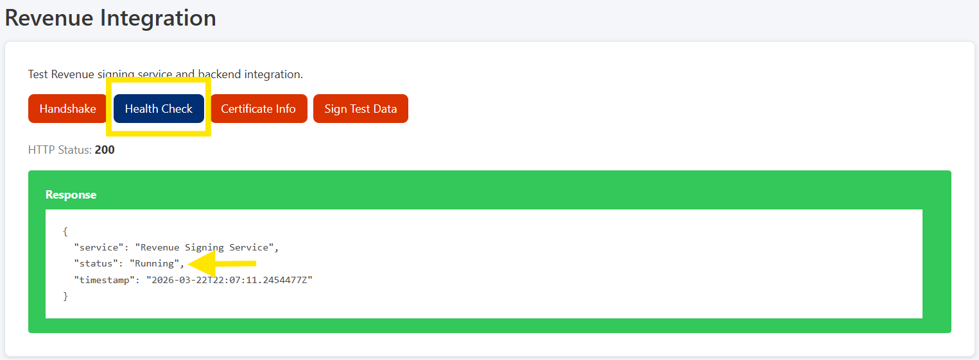
Figure 35: Signing Service Health Check Output
Output screen for ROS Certificate Metadata and Base64 Encoding Information:
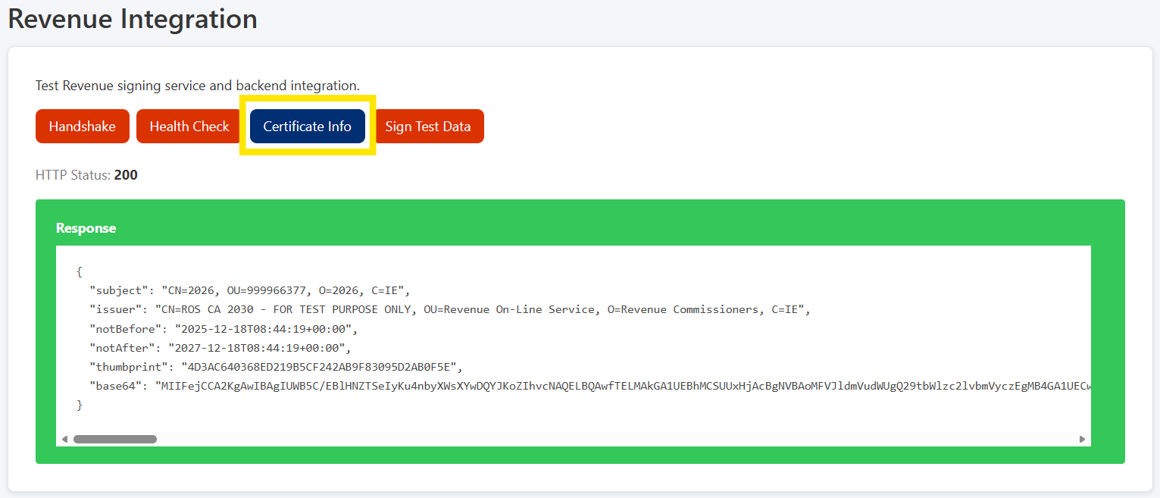
Figure 36: ROS Cert Metadata and Base64 Encoding Output

Output screen for ROS Certificate RSA-SHA512 Signing:
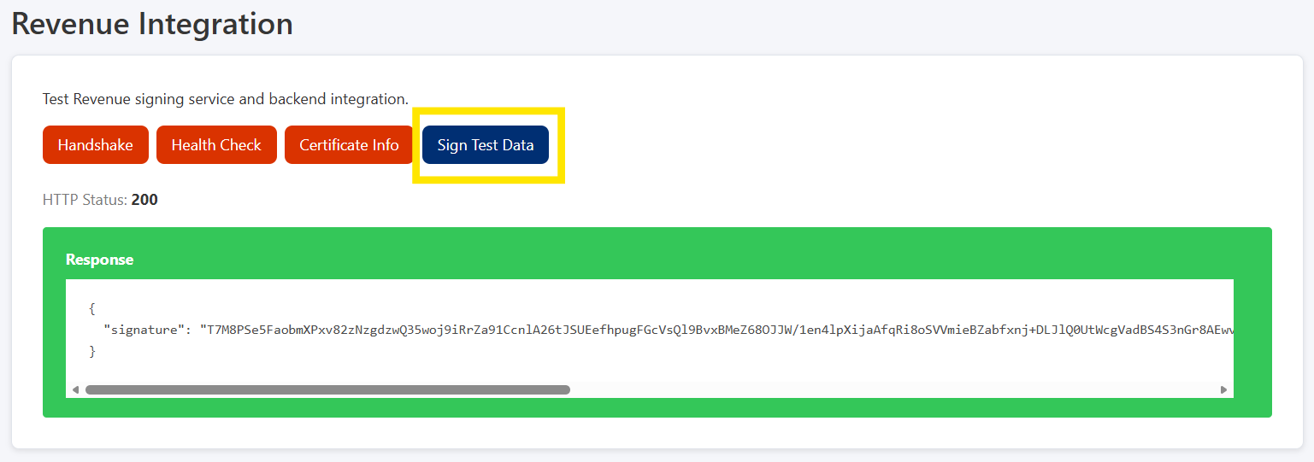
Figure 37: ROS Certificate RSA-SHA512 Signing Output

5.3.13 Admin Reports (/admin/reports)
This dashboard provides administrative oversight of both claim and submission activity across all users in the system (with filter resets). It supports filtering by user, status, and date ranges (both audit and statutory), enabling detailed analysis of system usage and processing.
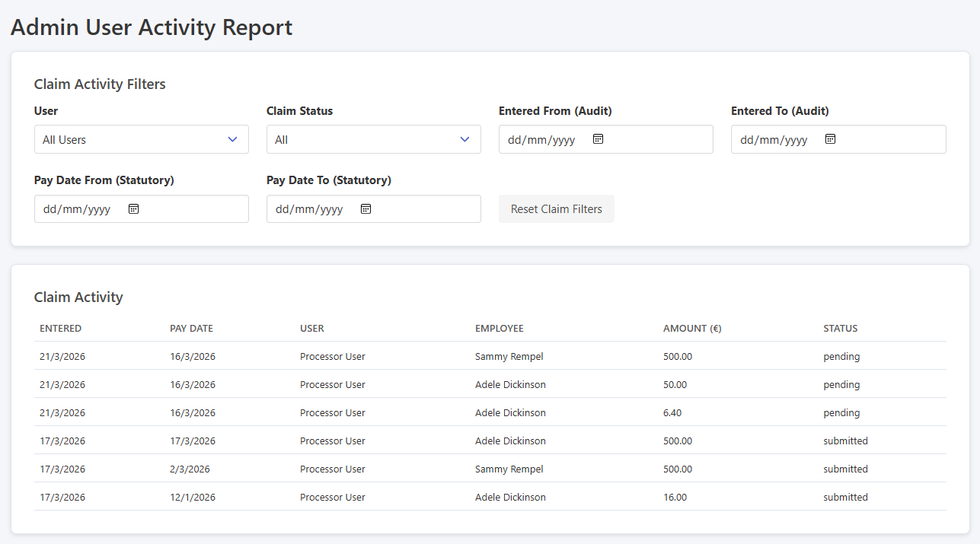
Figure 38: Admin Reports Dashboard; Claims Activity
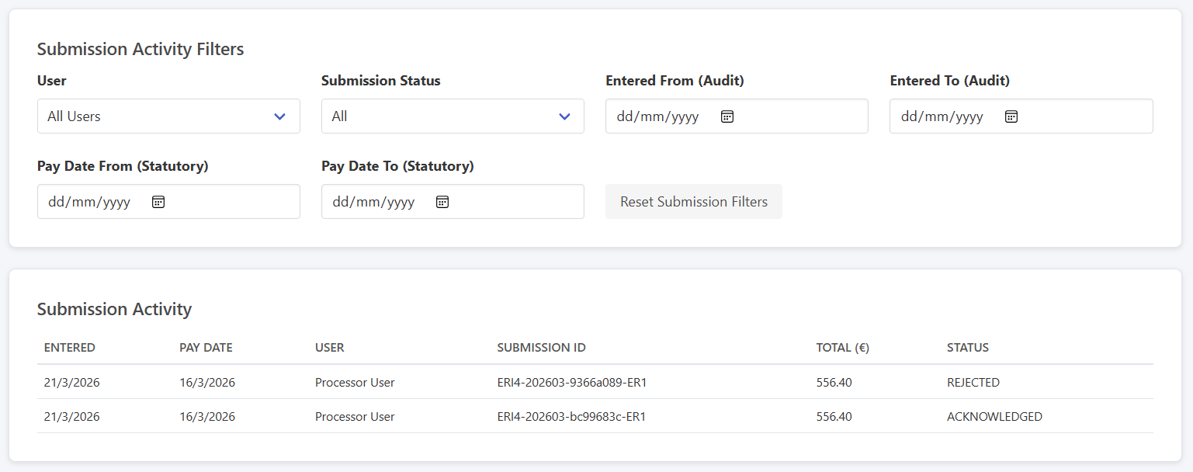
Figure 39: Admin Reports Dashboard; Submission Activity

5.3.14 Logout Menu Option (logout() → /login)
The logout option terminates the user session by clearing stored authentication credentials and redirects the user to the login page. This ensures that protected routes are no longer accessible without re-authentication. It supports basic session security and enforces RBAC within the application.
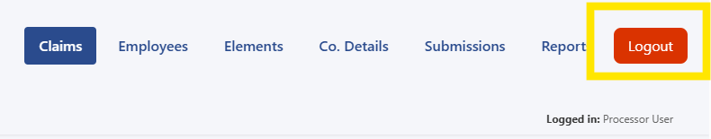
Figure 40: Logout Button
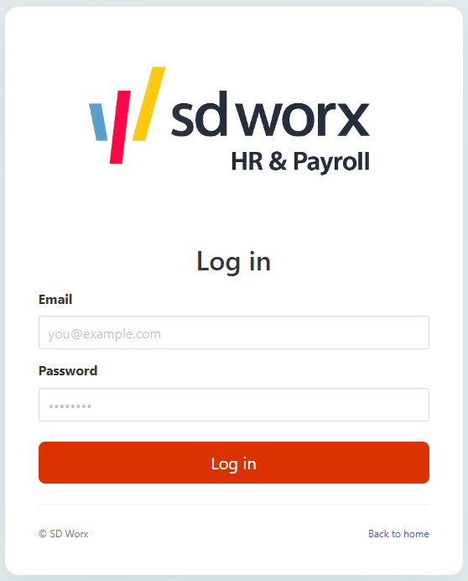
Figure 41: Logout Redirect to Login Screen

5.4 Security and Privacy by Design
Although the prototype uses non-sensitive test data, the system design incorporates controls aligned with production security practices. Authentication is implemented using JWT-based token handling with hashed passwords (bcrypt), and all protected routes enforce RBAC at middleware level. Input validation is applied at API level to reduce the risk of malformed data, consistent with OWASP secure coding principles (OWASP, 2021).
The architecture separates concerns by isolating cryptographic operations within a dedicated .NET signing microservice, ensuring secure handling of private keys and preventing exposure within the main application layer. Communication between components assumes HTTPS in a production environment, with secure certificate-based authentication required for ROS integration.

6. Implementation

6.1 Backend Architecture and Security (see Appendix A diagram)
The backend was implemented using Node.js and Express, structured modularly into controllers, middleware, services, and data models to ensure separation of concerns. Environment configuration is managed via dotenv, securing database credentials and JWT secrets. A dedicated database module establishes and verifies MongoDB connectivity at startup. Authentication uses JWT to support stateless sessions (Node.js, n.d.). On login, the server issues a signed token containing the user ID and role, which must be included in all protected requests. RBAC is enforced through middleware that validates JWTs and restricts role-specific endpoints.
Key REST endpoints include:
- /api/auth → authentication
- /api/admin → admin control
- /api/processor/claim → claim management
- /api/processor/submissions → ERR submission
- /api/employees → employee management
- /api/elements → element management
- /api/company → company configuration
- /api/revenue → revenue integration
- /api/reports → reporting
- /api/reports/submissions → submission reporting
- /api/admin/reports → admin reporting
- /api/users → user management
- /api/revenue/handshake → ROS handshake
- /api/submissions/generate → submission generation

6.2 Frontend Architecture and User Interface
The frontend was developed using SvelteKit, enabling a structured SPA with clear separation between routes, layouts, and reusable components. Routing is defined within the /routes directory and includes:
- /login (public)
- /admin (protected)
- /processor (protected)
Users are redirected dynamically after authentication based on role. A centralised design system inspired by SD Worx branding was implemented using CSS variables in app.css. Reusable .sdw-* classes standardise layout, forms, notifications, and tables. This approach avoids hard-coded styling and improves maintainability.

6.3 Claims Processing and Business Logic
Claims were designed to meet statutory ERR requirements. Each claim stores:
- createdAt timestamp (audit trail)
- payDate (statutory reporting date)
This separation ensures audit integrity while supporting Revenue’s requirement that submissions be made on or before the pay date. Claims reference:
- Submitting user (audit traceability)
- Employee
- Payment categorisation
Validation ensures required fields (including pay date) are present before persistence.

6.4 ROS API Integration Layer
A dedicated backend service manages communication with the ROS API. The integration layer:
- Constructs ERR-compliant payloads
- Generates deterministic identifiers (run reference, submission ID, line IDs)
Employees with and without PPSNs are handled according to Revenue specifications (Revenue, 2024b; Revenue, 2024c).

6.5 ERR Submission Schema Design
A core objective was designing an ERR submission schema compliant with ROS specifications. Identifiers such as run reference, submission ID, and line item ID are generated deterministically from employer configuration and sequencing logic (Revenue, 2024c). Conditional employee identification rules were modelled explicitly:
- With PPSN: employment ID + PPSN
- Without PPSN: employer reference + address + date of birth
Structured seed datasets were introduced for employees, elements, company configuration, and submission metadata. This schema-first approach reduced integration risk and allowed submission logic to be validated independently of the UI.

6.6 Submission Modelling Integration
Claims were refined to support statutory reporting:
- Audit timestamp retained
- Pay date used for submission grouping
Claims were normalised to reference employees and elements. This improves data integrity and supports transformation into payloads.
Submission output is:
- Returned via API
- Persisted to disk as JSON
UI enhancements were intentionally deferred until submission logic was validated.

6.7 ERR Submission Generation Engine
Development focus shifted to the submission engine due to its regulatory and technical significance. A dedicated service assembles ERR payloads by combining claim, employee, element, and company data. Submissions are scoped to a single pay date. Conditional reporting logic enforces:
- PPSN-based vs non-PPSN employee rules
- Category/sub-category specific requirements

6.8 Data Normalisation and End-to-End Validation
Earlier claims created, before the schema refinement, required realignment with updated employee and element references. Date handling was normalised during submission generation to account for MongoDB UTC timestamps while producing Revenue compliant date only values (per ISO 8601 standards – ISO, 2019). End-to-end submission testing confirmed deterministic identifier generation and valid ERR payload structure.

6.9 Conditional Revenue Field Handling
Revenue requires category specific conditional fields. For example:
- REMOTE_WORKING_DAILY_ALLOWANCE requires numberOfDays and amount
- Other categories require amount only
Submission logic was extended to enforce conditional fields. Invalid conditional data prevents submission generation. Claims were enhanced to support optional day counts without affecting other expense types. The system now correctly generates mixed category submissions within a single pay date.

6.10 Design of the .NET Signing Microservice
The purpose of the .NET Signing Microservice is to handle Revenue ROS cryptographic operations that cannot be reliably implemented in Node.js. Specifically, the microservice is responsible for:
- Loading the Revenue-issued ROS X.509 certificate (PKCS#12)
- Applying Revenue specific password handling
- Performing RSA-SHA512 signing operations
- Returning cryptographic artefacts to the Node.js backend
All business logic, data modelling, and submission generation remain within the Node.js application. The .NET service is intentionally stateless, minimal, and isolated. This separation mirrors enterprise payroll systems where cryptographic operations are delegated to trusted components.

6.11 Revenue ROS Certificate Cryptographic Signing Engine Implemented
Initial attempts to handle the ROS PKCS#12 certificate directly within Node.js exposed compatibility and cryptographic parsing limitations, a minimal ASP.NET Web API microservice was designed and implemented to act as a dedicated cryptographic signing service. The ROS PIT3 certificate (01536466V.p12) was successfully loaded using X509Certificate2 with Revenue’s required Base64(MD5(password)) transformation.
A secure /sign endpoint was implemented that performs RSA-SHA512 signing using the certificate’s private key and returns a Base64 signature compliant with the Revenue HTTP Signature specification. Testing via Postman confirmed correct generation of RSA-SHA512 signatures, demonstrating a fully functional signing engine aligned with the PIT3 API documentation.

6.12 Revenue PIT3 handshake fully operational using .NET signing microservice
Initial handshake attempts with the Revenue ROS PIT3 environment returned validation error code 1011 (“Cert does not have appropriate permissions”), indicating that the certificate was valid cryptographically but not authorised for web service access. Consultation with ROS Developer Support confirmed that the issue was related to certificate registration and associated employer and agent identifiers rather than the signing implementation.
A new Revenue PIT3 certificate (999966377.p12) was issued, associated with Employer Registration Number 8031508KH and Agent TAIN 88502T. The certificate credentials were updated within the system configuration. The handshake request parameters were amended to include the correct employer registration number and agent TAIN, ensuring alignment between certificate ownership and submission metadata.
Following these updates, the handshake process returned a successful authenticated response with connectionStatus = SUCCESS. This confirms that the certificate permissions, RSA-SHA512 signature generation, canonical request construction, HTTP signature header formation, and ROS PIT3 endpoint authentication are all functioning correctly. The .NET signing microservice successfully performs Revenue-compliant cryptographic operations, and the Node.js backend correctly generates and signs authenticated requests.

6.13 ERR Submission Lifecycle and ROS API Integration
Following successful implementation of the PIT3 handshake, the next stage involved designing and validating the full ERR submission lifecycle.

A real world lifecycle would comprises multiple status transitions, reflecting both internal processing and external acknowledgement by Revenue:
Status | Meaning | Trigger
pending | Claim entered in system | Processor action
generated | ERR JSON payload file created for manual upload to ROS | automatic (export function)
acknowledged | Revenue confirmed receipt (re JSON file) | ROS response (ROS System)
submitted | Successfully transmitted to ROS API | API call
acknowledged | Revenue confirmed receipt (API) | ROS response (API)
For the purposes of this POC, a simplified workflow was implemented:
When a user selects “Submit to ROS”, the system performs the following sequence (initially simulated on postman):
- Generates JSON file with submission payload
- Persists JSON file to disk (manual upload fallback)
- Attempt ROS API submission
- If API succeeds, update claims status to “submitted”
- If API fails, claims remain pending (JSON file is available for manual upload)
This ensures that a JSON file is always produced, the API submission is attempted, and the claim status is only updated upon success.
This separation of responsibilities was implemented using two distinct backend services:
Service 1 – Generate Submission Service
- Builds ERR compliant JSON payload
- Validates schema structure
- Exports file to /exports directory
- Returns payload to caller
- Does not modify database state

Service 2 – Submit to ROS Service
- Constructs HTTP request in accordance with Revenue PIT3 REST requirements
- Applies SHA-512 hashing and Base64 encoding for the Digest header
- Applies RSA-SHA512 signature via .NET signing microservice
- Submits request to ROS endpoint
- On HTTP 200 response → updates claim status to “submitted”
Build and Test Stages
The implementation progressed in four structured stages:
- ROS configuration and environment variables (Server starts)
  - Certificate registration
  - Environment variables configured
  - Server startup validation
- ROS client service (Node → .NET signing microservice) (Manually test endpoint)
  - Canonical string construction
  - Signature generation validation
  - Header formation testing
- ROS submission service (Node → ROS API) (Mock submission)
  - Mock submissions
  - Simulated success responses
  - Controlled database update testing
- Integrate ROS submission into ERR workflow (Full submission)
  - End-to-end submission
  - Status transitions validated
  - Error handling scenarios tested
Digest Mismatch Error Investigation
During live API testing, the following error was returned:
“Digest header must match digest that has been regenerated from request body content.”
Revenue recalculates the SHA-512 hash of the received byte sequence and compares it to the transmitted Digest header (as specified in the PIT3 REST API documentation), this mismatch indicated that the transmitted body and hashed content were not identical at byte level.
Initial triage included:
- Verification of payload length
  - ROS request payload: 791 bytes
  - Exported JSON file: 1411 bytes
Confirmed they were different representations and not directly related
- Digest debugging
- Canonical signature reconstruction analysis
- Header validation
- Date header correction (RFC-7231 format required rather than ISO-8601)
- Byte-level comparison of signed payload
After three days of analysis and corrections, the remaining issue was configuration related rather than cryptographic. The employer registration number embedded in the submission metadata did not match the employer registration number associated with the newly issued PIT3 certificate resulting in the byte difference and caused ROS to reject the request.
After updating the database Company configuration document to:
- Employer Registration Number: 8031508KH
- Agent TAIN: 88502T
- Certificate: 999966377.p12
The submission request returned a successful authenticated response:
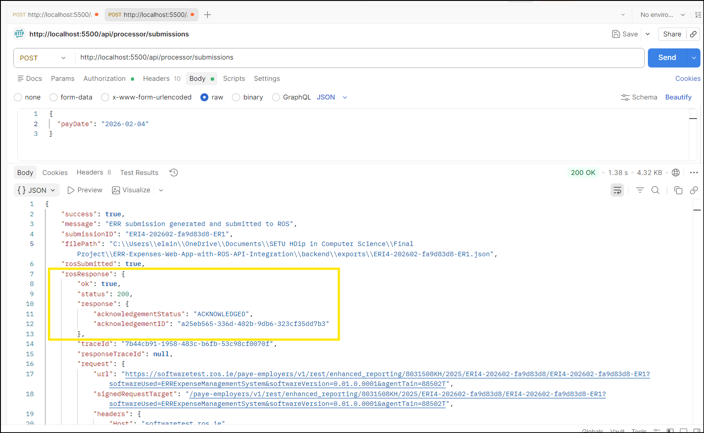
Figure 42: Successful ROS Submission Acknowledgement

This phase confirmed that:
- ERR JSON generation conforms to Revenue’s schema
- SHA-512 digest generation aligns with HTTP Digest header requirements
- RSA-SHA512 signature creation is compliant with ROS HTTP Signature specification
- Canonical request construction is valid
- The .NET signing microservice and Node.js backend operates correctly as an integrated system

6.14 ERR Submission Lifecycle from UI
While the ERR submission workflow was completed and tested from postman, the next focus was on ensuring end-to-end submission capability and data persistence from within the system.
ERR Submission Generation
The backend service responsible for generating ERR submissions was refined to:
- Dynamically generate unique enhancedReportingRunReference and submissionID values
- Aggregate pending claims by pay date
- Calculate submission summary metrics including:
  - LineItemCount
  - totalAmount
- The system now ensures that duplicate submissions are prevented through unique identifier generation.
Database Persistence & Audit Trail
Implemented during this session was the persistence of submission records in MongoDB. A Submission model was finalised to store:
- Employer Registration Number
- Tax Year
- Enhanced Reporting Run Reference
- Submission ID
- Associated Claim IDs
- Line item count
- Total submission value
- Full snapshot of expensesBenefits payload
- Revenue acknowledgement details
- Revenue trace ID
- Complete ROS response object
The design ensures that each submission attempt is audit-safe and traceable, supporting compliance and future reporting requirements.

Claim Workflow State Management
The claim lifecycle logic was finalised:
- Claims with status "pending" are included in submission generation
- Claims are updated to "submitted" only upon successful ROS acknowledgement
- Failed submissions do not alter claim status
This guarantees data integrity between claim state transitions.
Frontend Integration
A frontend submission interface was implemented allowing:
- Selection of claims by pay date
- Display of ROS acknowledgement response
- Confirmation of submission status to the user
This completes the functional workflow from claim entry to ROS submission and response.

6.15 Employee Management from UI
The system was extended to support employee management rather than relying on pre-seeded database records.
Backend Enhancements
A new REST endpoint (POST /api/employees) was implemented to allow users create employee records. The controller performs validation of required fields:
- First name
- Family name
- Employment ID
- Employer reference
- Date of birth
- Structured address object
Validated employee records are persisted to MongoDB using the Employee model.
Frontend UI Improvements
The employee management interface was designed to align with existing forms, applying Bulma styling to ensure visual consistency.

6.16 Element Management from UI
The system was extended to support users creating element records, replacing the previously seeded configuration approach.
Backend Enhancements
A new REST endpoint (POST /api/elements) was implemented to allow authenticated users to create reporting elements directly from the UI. The controller performs validation of required fields:
- Category (supporting Revenue enum values)
- Description (UI facing label)
- Optional subcategory (applicable to TRAVEL_AND_SUBSISTENCE)
- Optional rate (applicable to REMOTE_WORKING_DAILY_ALLOWANCE)
New element records are persisted to MongoDB using the Element model. Elements are retrieved via GET /api/elements and sorted hierarchically by category and subcategory.
Frontend UI Improvements
A new processor facing interface (/processor/elements) was developed to enable:
- Creation of new reporting elements
- Display of elements in a structured table
- Conditional rendering of the daily rate field when the category is REMOTE_WORKING_DAILY_ALLOWANCE
- Conditional rendering of sub-categories field when the category is TRAVEL_AND_SUBSISTENCE
A controlled dropdown was implemented for sub-category selection to enforce compliance with Revenue-defined enum values. Bulma styling was applied to ensure visual consistency.

6.17 Company Configuration from UI
The system was extended to support dynamic management of company configuration data, replacing the previously database seeded configuration. This enhancement ensures that organisational metadata can be maintained directly through the user interface.
Backend Enhancements
New REST endpoints were implemented:
- GET /api/company
- POST /api/company
- PUT /api/company/:id

The controller manages a single active company configuration and performs validation of required fields:
- Employer Registration Number
- Payroll Reference
- Tax Year
- ROS Certificate Path
- ROS Certificate Password
Validated company configuration records are persisted to MongoDB using the Company model, stored in the companies collection.
This configuration is used at runtime for:
- ERR run reference generation
- Tax year assignment
- Software metadata inclusion
- Agent TAIN submission logic
- ROS certificate digital signature handling
Frontend UI Improvements
A new processor-facing interface (/processor/company) was developed to allow:
- Viewing existing company configuration
- Creating a new configuration (if none exists)
- Updating existing configuration
Sensitive fields such as the ROS certificate password were handled using a masked input field (type="password").
Bulma styling was applied to ensure visual consistency.

6.18 System Reporting and Governance Layer
Reporting functionality was implemented:
For processors, the /processor/reports interface focuses on submission history. An interface was developed to display all submissions stored in the submissions collection. Each record includes submission identifiers, pay date, tax year, line item count, total value submitted, acknowledgement status, acknowledgement ID and the date the submission was sent. Date range filtering was implemented based on pay date, allowing processors to review reporting activity for specific payroll periods.
For administrators, a more governance reporting layer was introduced. The /admin/reports interface provides user activity visibility across two distinct domains: claim activity and submission activity. Claims represent operational transactions entered by processors, whereas submissions represent statutory filings sent to Revenue. Importantly, rejected submissions are excluded from acknowledged value totals to ensure financial summaries reflect only successfully submitted statutory amounts.
Each section includes independent filtering controls:
- User based filtering (to identify activity by individual system users)
- Status filtering (claim workflow status or submission acknowledgement status)
- Audit date filtering (Entered From → Entered To, based on createdAt)
- Statutory date filtering (Pay Date From → Pay Date To)
The distinction between audit dates and statutory pay dates was a deliberate design decision. Audit dates enable administrators to review when records were created within the system. Statutory pay dates reflect the legal reporting period associated with submissions.
To support accountability, the Submission schema was extended to include a submittedBy reference to the User model enabling traceability of which user triggered each submission. Combined with the existing processor reference on claims, the system now provides a complete audit trail linking users to both individual transactions and statutory filings.

6.19 Edit Functionality for Employees, Elements and Claims (CRUD Completion)
The system was extended to support update capability for Employees, Elements, and Claims. This enhancement completes the Create / Read / Update lifecycle for operational records.
Backend Enhancements
New RESTful PUT endpoints were introduced to allow users update existing records. For Employees, the system uses findByIdAndUpdate.
For Elements, update functionality dynamically reapplies sub-category specific validations:
- Subcategory selection remains for TRAVEL_AND_SUBSISTENCE only.
- Rate values remain for REMOTE_WORKING_DAILY_ALLOWANCE only.
For Claims, the update functionality was intentionally restricted to claims with a status of pending only. Claims that have been generated or submitted cannot be modified. This safeguards against retrospective alteration of statutory data.
Frontend Enhancements
The user interface was enhanced to support inline editing within tables rather than redirecting to separate pages. Functionality:
- Select the relevant record and click “Edit Employee” to activate edit mode (for employees).
- Select the relevant record to activate edit mode (for elements and claims).
- Form fields are pre-populated with existing values.
- Updates are persisted via authenticated PUT requests.
- Lists refresh dynamically after successful updates.
Future development would address stronger validations around editing.

7. Testing and Validation

7.1 Test Strategy
Testing focused on validating the end-to-end submission workflow. The strategy combined API-level testing of REST endpoints, UI-level testing of user walkthroughs, and integration testing of the ROS submission process. Particular emphasis was placed on verifying the correctness of payload generation and HTTP signature construction. Security testing included validation of authentication (JWT), RBAC, and restricted endpoint access.

7.2 Sample Test Cases
ID | Scenario | Expected Result | Outcome
TC-01 | User logs in with valid credentials | JWT issued; user redirected based on role | Pass
TC-02 | Create new expense claim | Claim persisted and visible in pending list | Pass
TC-03 | Edit existing claim | Updated values saved and reflected in UI | Pass
TC-04 | Generate ERR submission | JSON payload generated with correct totals and structure | Pass
TC-05 | Submit ERR to ROS (test endpoint) | Signed request accepted; acknowledgement returned | Pass
TC-06 | ROS submission failure | Submission stored; claims remain in “pending” state | Pass
TC-07 | Signing service health check | Service responds with status “Running” | Pass
TC-08 | Certificate retrieval | Certificate metadata returned successfully | Pass
TC-09 | Signature generation test | Valid RSA-SHA512 signature returned | Pass
TC-10 | Unauthorized endpoint access | Access denied; redirect or error response | Pass

8. Results and Evaluation
The prototype successfully demonstrates an end-to-end workflow from expense capture, payload generation, and submission processing. Core user journeys were validated across both processor and administrator roles.
From an architectural perspective, the system achieves a clean separation of concerns through a layered design, with a stateless REST API, a dedicated cryptographic signing microservice, and a decoupled frontend. This modular approach aligns with SaaS deployment models, isolating complex ROS integration logic from core business functionality.
A key outcome of the project is the successful implementation of the submission generation engine and production of Revenue compliant payloads, with signed requests successfully processed and acknowledgement responses captured and persisted.
Overall, the results demonstrate that the proposed architecture is capable of supporting compliant ERR reporting workflows and provides a good foundation for future enhancements.

9. Critical Self-Review, Reflection and Future Improvements

9.1 What Was Achieved
A functional POC was successfully developed to demonstrate end-to-end ERR submission workflow. The solution enables users create and manage expense claims and generate Revenue compliant payloads. Integration with ROS was implemented, with responses captured and persisted to provide status visibility and a complete audit trail of submission activity.

9.2 What Was Learned
The project provided practical experience across the full-stack development lifecycle, including the implementation of reactive user interfaces using Svelte, the design of RESTful APIs in Node.js, and document-based data modelling in MongoDB. It also involved the integration of an external API, requiring an understanding of HTTP signatures, cryptographic signing, and structured payload generation. In addition, the project reinforced key security and architectural principles.

9.3 Problems Encountered and Solutions
During the implementation, a technical challenge arose from the interaction between Node.js, cryptographic certificate handling, and Revenue’s PIT3 security requirements. The matter was investigated in depth to ensure the project aligned as closely as possible with real world software architecture.

9.3.1 Certificate Handling Limitations in Node.js
Revenue issues certificates in PKCS#12 (.p12) format containing:
- RSA private key
- Public certificate
- Associated password (Revenue generated)
Initial attempts were made to load and use the .p12 certificate directly in Node.js using the built-in crypto module, this resulted in repeated runtime errors:
- Property 'options.type' is invalid. Received 'pkcs12'
- DECODER routines::unsupported
- Cannot read properties of undefined (reading 'import')
These errors stemmed from the fact that Node.js does not natively support PKCS#12 parsing, nor does it expose the OS-level cryptographic providers required for Revenue issued certificates.

9.3.2 Password Handling Discrepancies
The solution SD Worx Developers implemented (C#) in production systems performed the following transformation on the certificate password:
- Convert password to ASCII
- Apply MD5 hash
- Base64 encode the result
- Use the transformed password to load the certificate
This logic was replicated for this project in Node.js, however, Node’s cryptographic stack does not support applying this password transformation within PKCS#12 loading routines.

9.3.3 OpenSSL Extraction Attempts
To work around Node limitations, OpenSSL was used to extract the private key and certificate from the .p12 file (SSL.com, 2020):
- openssl pkcs12 -in cert.p12 -nocerts -nodes -out private-key.pem
- openssl pkcs12 -in cert.p12 -clcerts -nokeys -out cert.pem
Despite multiple attempts using:
- Original ROS password
- MD5-hashed password
- Base64(MD5) password
- Legacy OpenSSL flags (-legacy)
All attempts failed with the error “Mac verify error: invalid password?”.

9.3.4 Architectural Misalignment Between Node.js and Revenue PIT3
Revenue’s PIT3 REST API specification assumes that cryptographic operations are performed using X.509 certificates and RSA private keys managed by secure system-level cryptographic providers. The specification requires signing operations using certificates installed in the operating system and protected by non-exportable private keys (Revenue, 2024a; Revenue, 2024b).
The PIT3 documentation further specifies that submissions must be digitally signed using RSA-SHA512 and that private keys should remain securely stored and protected within the host operating system’s certificate infrastructure (Revenue, 2024c).
Node.js, by design, provides a cross-platform cryptographic abstraction layer built on OpenSSL and does not natively integrate with the Windows Certificate Store or other OS-level key management providers (Node.js, n.d.). As a result, Node.js cannot directly access non-exportable private keys protected by the operating system, nor does it provide native support for interacting with hardware-backed certificate stores (OpenSSL Project, n.d.).
While Node.js supports loading PKCS#12 (.p12) certificate files via OpenSSL bindings, this requires exporting the private key into application space, which conflicts with Revenue’s security model that assumes system-managed, non-exportable keys (Node.js, n.d.; Revenue, 2024b).
This represents an architectural incompatibility rather than a coding defect. The Revenue PIT3 specification is designed around enterprise cryptographic frameworks (e.g., .NET, Java) that interface directly with operating system certificate providers. Node.js, being runtime-isolated and OpenSSL-dependent, does not meet these assumptions without introducing additional architectural components.

9.3.5 Decision to Introduce a Minimal .NET Signing Microservice
Given the above constraints, a design decision was made to introduce a minimal .NET signing microservice, responsible for:
- Loading the Revenue issued certificate using the Windows Cryptographic API
- Signing canonical request strings using RSA-SHA512
- Returning signatures to the Node.js application

9.4 What I Would Do Differently
The implementation of a structured validation framework (e.g. Joi) would have been used to validate input. Greater consideration should have been given to the technical constraints of cryptographic signing within Node.js. The initial approach assumed PKCS#12 certificates could be handled natively, which proved to be a time consuming mistake, earlier evaluation would have reduced the time spent triaging and introducing the .NET microservice.

9.5 Future Improvements
Future development would focus on enhancing validation, security, error handling for partial submission failures, and introducing secure secrets management and finer grained reporting.

10. Conclusion
This project successfully demonstrated the design and implementation of a POC system for managing and submitting ERR data in line with Revenue specifications. The solution integrates frontend, backend, database, and external API components to model the full submission lifecycle, including payload generation, cryptographic signing, and ROS interaction.

References
European Union (2016) Regulation (EU) 2016/679 (General Data Protection Regulation). Available at: https://eur-lex.europa.eu/eli/reg/2016/679/oj (Accessed: 15 January 2026).

Finance Act 2022 (Ireland), Section 897C. Available at: https://www.irishstatutebook.ie/eli/2022/act/44/enacted/en/html (Accessed: 15 January 2026).

Fielding, R. et al. (2014) RFC 7231: Hypertext Transfer Protocol (HTTP/1.1): Semantics and Content. IETF. Available at: https://datatracker.ietf.org/doc/html/rfc7231 (Accessed: 03 March 2026).

IETF (2013) RFC 3230: Instance Digests in HTTP. Available at: https://datatracker.ietf.org/doc/html/rfc3230 (Accessed: 04 March 2026).

IETF (2015) RFC 7616: HTTP Digest Access Authentication. Available at: https://datatracker.ietf.org/doc/html/rfc7616 (Accessed: 03 March 2026).

Klyne, G. and Newman, C. (2002) RFC 3339: Date and Time on the Internet — Timestamps. IETF. Available at: https://www.rfc-editor.org/rfc/rfc3339 (Accessed: 05 March 2026).

Microsoft (n.d.) Windows Certificate Store Architecture. Available at: https://learn.microsoft.com/en-us/windows/win32/seccrypto/cryptography-portal (Accessed: 03 March 2026).

MongoDB (n.d.) MongoDB Manual. Available at: https://www.mongodb.com/docs/ (Accessed: 14 January 2026).

Node.js (n.d.) Node.js Documentation. Available at: https://nodejs.org/docs/latest/api/ (Accessed: 14 January 2026).

Node.js (n.d.) Crypto Module Documentation. Available at: https://nodejs.org/api/crypto.html (Accessed: 03 March 2026).

OpenSSL Project (n.d.) OpenSSL Documentation. Available at: https://www.openssl.org/docs/ (Accessed: 03 March 2026).

OWASP (2021) OWASP Top Ten Web Application Security Risks. Available at: https://owasp.org/www-project-top-ten/ (Accessed: 01 March 2026).

Revenue Commissioners (2024a) PAYE Employers – Enhanced Reporting Requirements (ERR) Overview. Available at: https://www.revenue.ie/en/employing-people/becoming-an-employer-and-ongoing-obligations/err-jan-2024/index.aspx (Accessed: 15 January 2026).

Revenue Commissioners (2024b) PAYE Employers REST API (PIT3) Documentation. Available at: https://revenue-ie.github.io/paye-employers-documentation/PIT3/rest/paye-employers-rest-api-pit3.html (Accessed: 06 March 2026).

Revenue Commissioners (2024c) Enhanced Reporting Schema – PIT3 (XSD). Available at: https://revenue-ie.github.io/paye-employers-documentation/PIT3/soap/v1/enhanced_reporting/enhanced_reporting-schema-pit3.xsd (Accessed: 05 March 2026).

SSL.com (2020) How to Export Certificates and Private Key from a PKCS#12 File with OpenSSL. Available at: https://www.ssl.com/how-to/export-certificates-private-key-from-pkcs12-file-with-openssl/ (Accessed: 04 March 2026).

Svelte (n.d.) Svelte Documentation. Available at: https://svelte.dev/docs (Accessed: 20 January 2026).

SD Worx colleagues (2026) Internal discussions on ROS handshake implementation (Accessed: 22 February 2026).

OpenAI (2026) ChatGPT – debugging and development support tool. Available at: https://chat.openai.com (Accessed: 07 March 2026).

Appendices
Appendix A:
System Architecture Diagram: High-Level
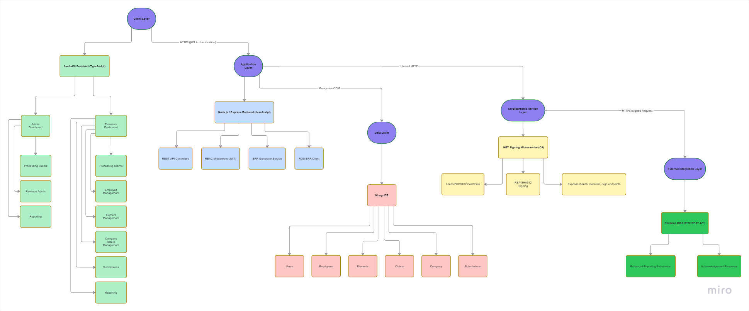
Figure 43: System Architecture Diagram: High-Level

System Architecture Diagram: Low-Levels
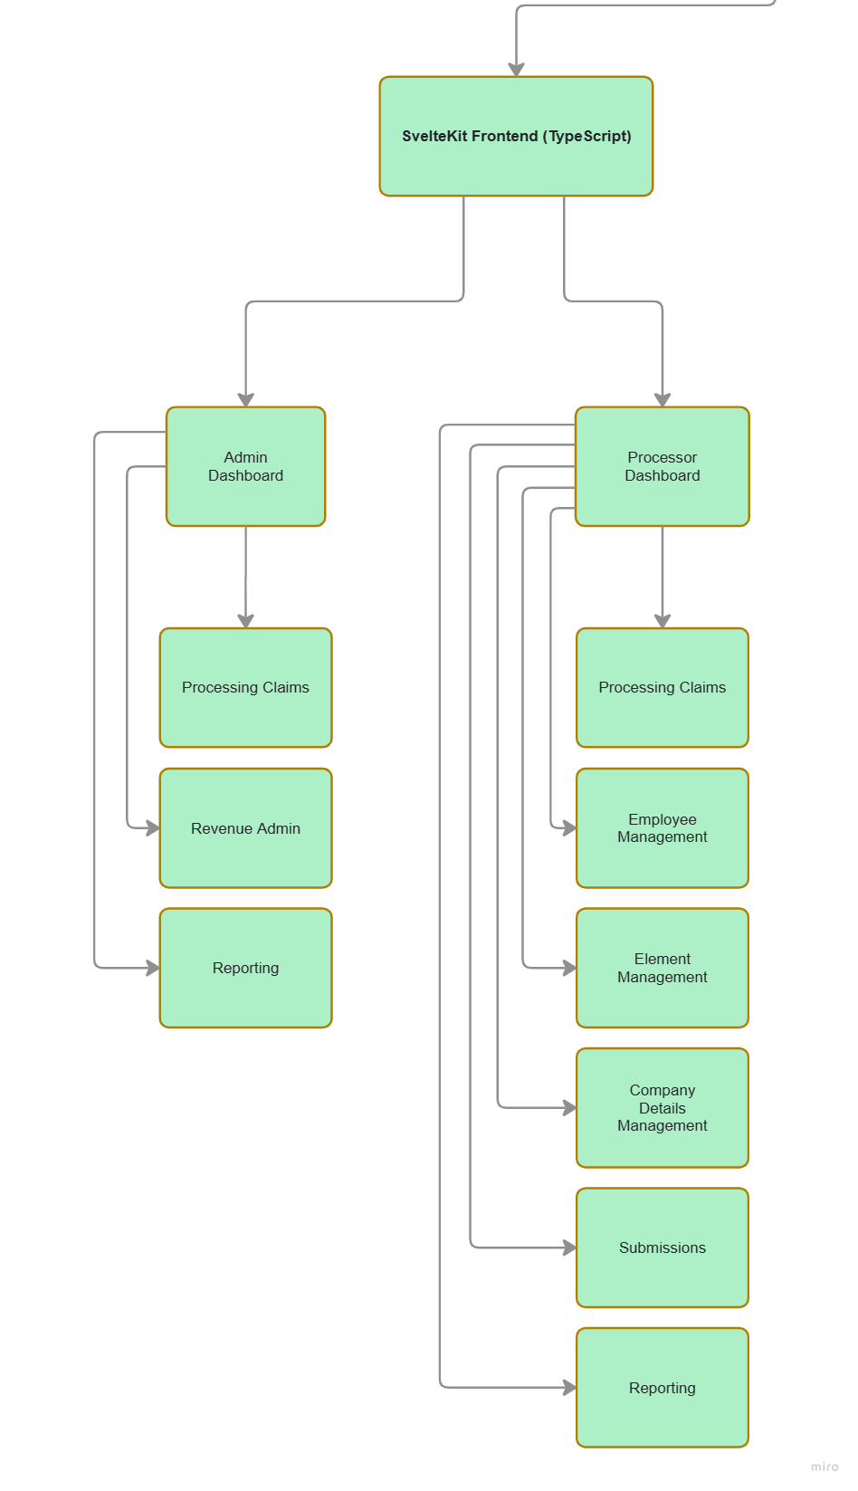
Frontend Client Layer Backend Application Layer
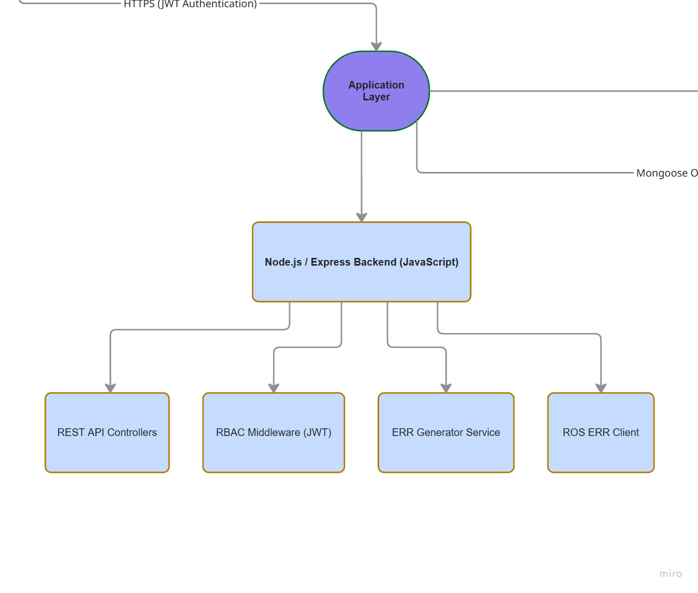
Figure 44: Architecture Diagram: Client Layer
Figure 45: Architecture Diagram: Application Layer

Data Layer

System Architecture Diagram: Low-Levels
Data Layer
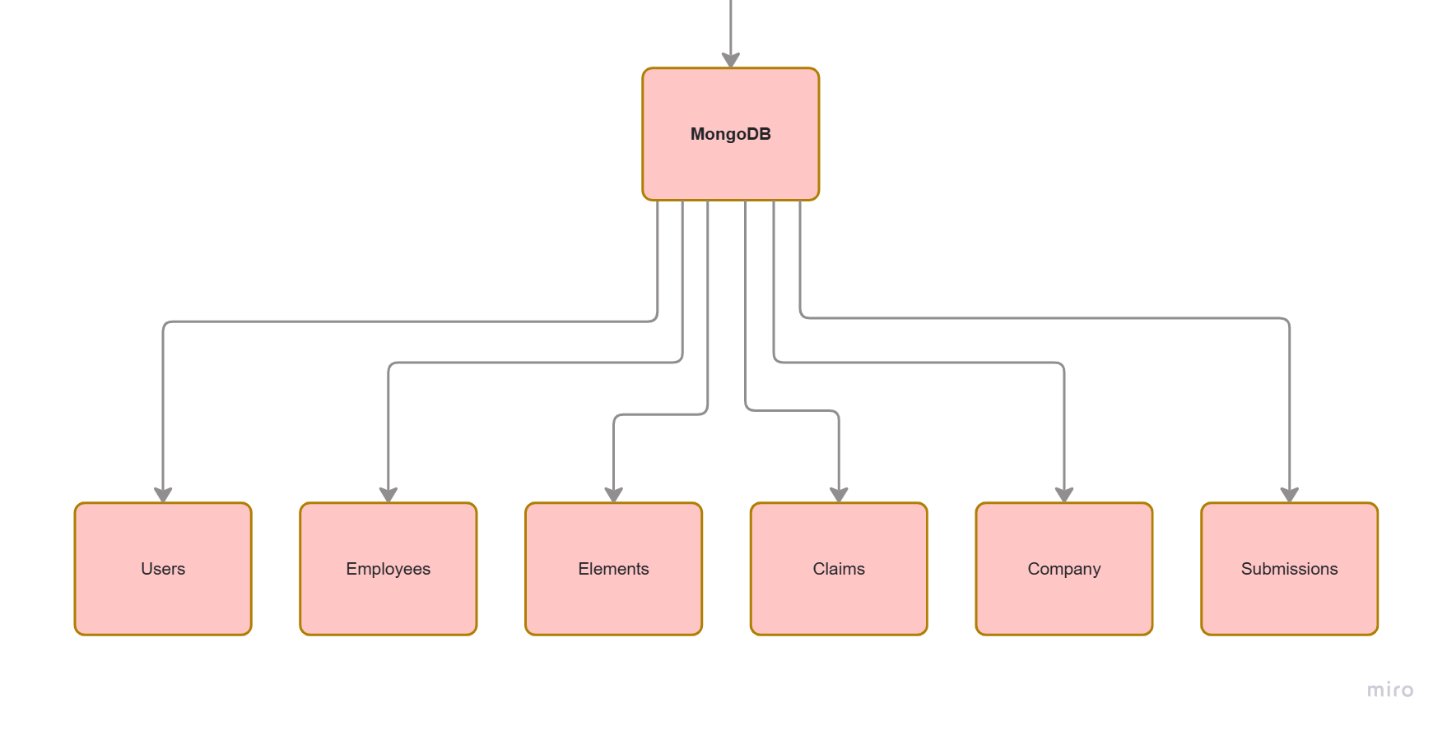
Figure 46: Architecture Diagram: Data Layer

System Architecture Diagram: Low-Levels
Cryptographic Service Layer External Integration Layer
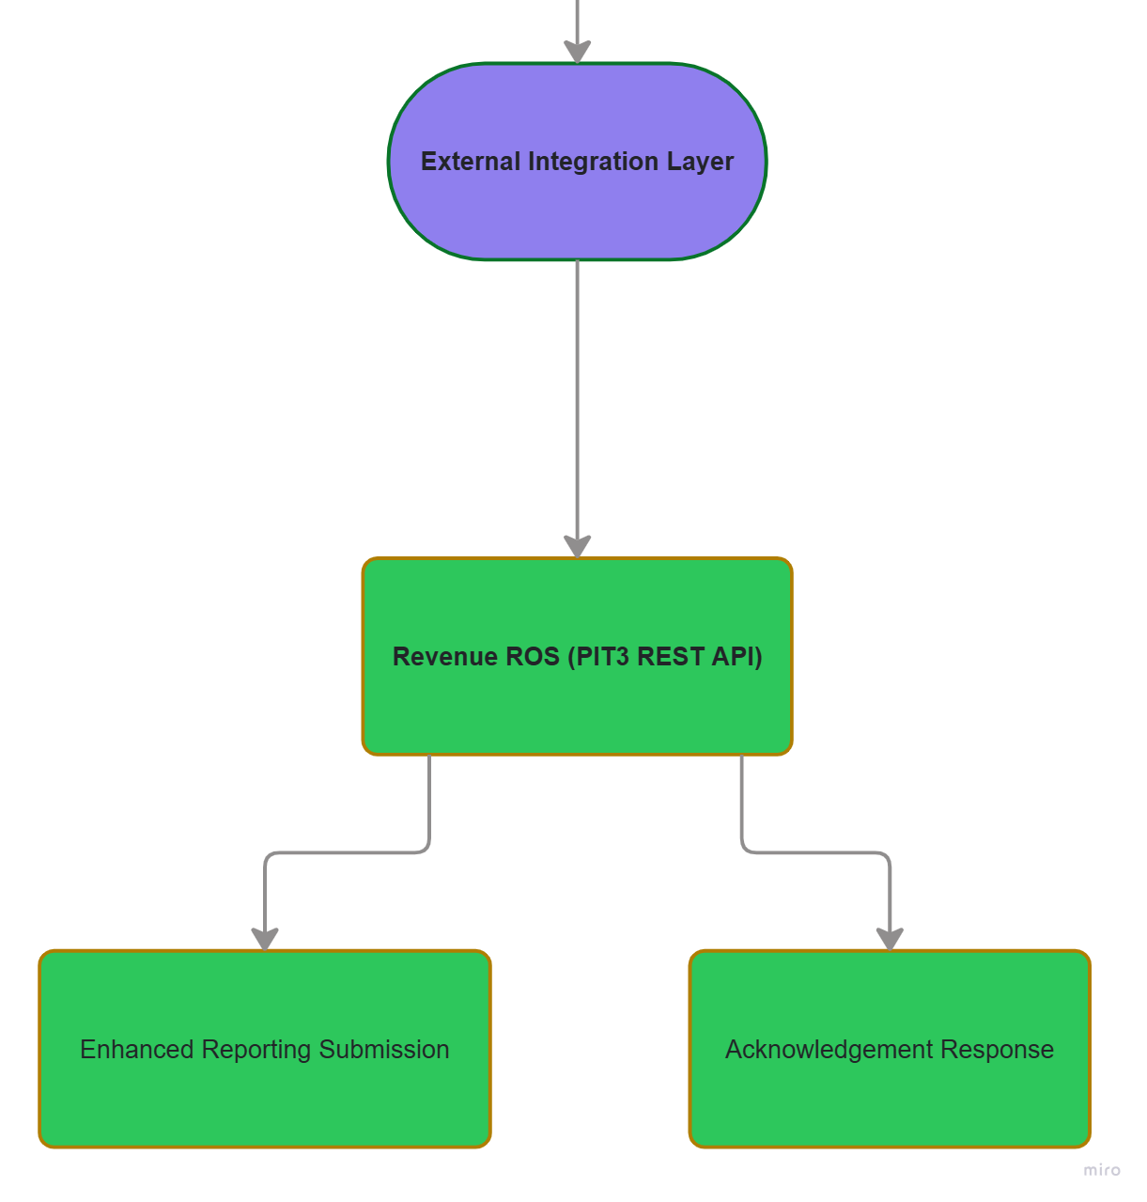
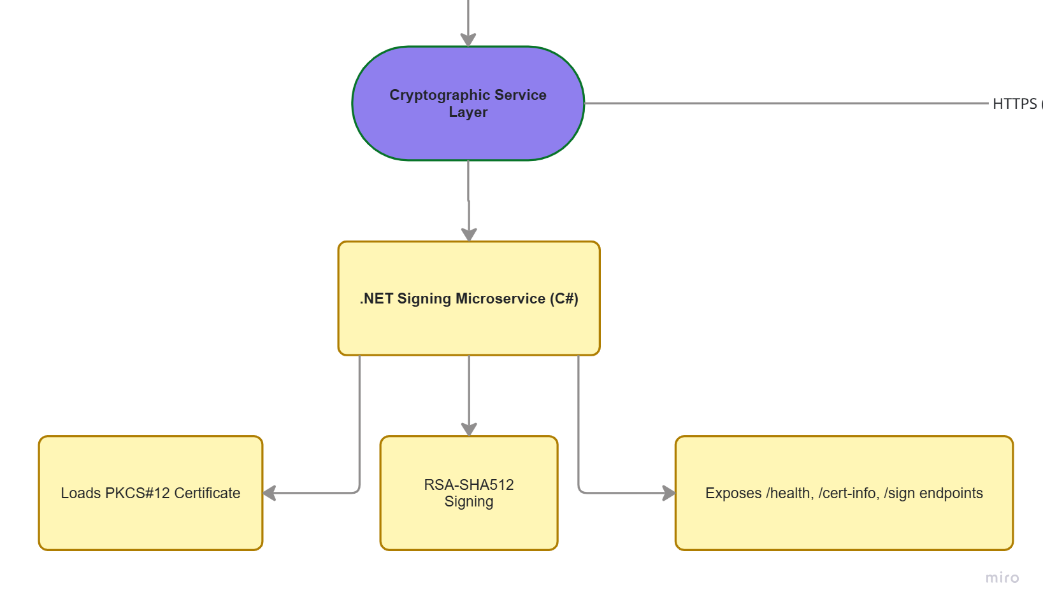

Figure 47: Architecture Diagram: Cryptographic Service Layer
Figure 48: Architecture Diagram: ROS Integration Layer

Appendix B: File Tree
# File Tree: ERR-Expenses-Web-App-with-ROS-API-Integration
├── 📁 Documentation
├── 📁 RevenueSigningService
├── 📁 Webpage
├── 📁 backend
│ ├── 📁 certs
│ ├── 📁 config
│ ├── 📁 controllers
│ ├── 📁 middleware
│ ├── 📁 models
│ ├── 📁 routes
│ ├── 📁 services
│ ├── 📁 tools
│ ├── 📁 utils
│ └── 📄 server.js
├── 📁 frontend
│ ├── 📁 src
│ │ ├── 📁 lib
│ │ │ ├── 📁 components
│ │ │ │ ├── 📁 icons
│ │ ├── 📁 routes
│ │ │ ├── 📁 admin
│ │ │ │ ├── 📁 reports
│ │ │ │ ├── 📁 revenue
│ │ │ ├── 📁 home
│ │ │ ├── 📁 login
│ │ │ ├── 📁 processor
│ │ │ │ ├── 📁 company
│ │ │ │ ├── 📁 elements
│ │ │ │ ├── 📁 employees
│ │ │ │ ├── 📁 reports
│ │ │ │ ├── 📁 submissions
│ ├── 📁 static
└── 📝 README.md

_Generated by FileTree Pro Extension_

