KPR INSTITUTE OF ENGINEERING AND TECHNOLOGY
ARTIFICIAL INTELLIGENCE AND DATA SCIENCE

PROJECT REPORT
BANK MARKETING CAMPAIGN ANALYSIS AND SUBSCRIPTION PREDICTION
Exploratory Data Analysis, Visualization and Deep Learning

Submitted by: Elakiya M
Roll Number: 24AD034
Submission Date: 15 October 2026

Abstract
This project applies exploratory data analysis (EDA), visualization, and a TensorFlow/Keras multilayer perceptron (MLP) to the UCI Bank Marketing dataset. The objective is to examine historical direct-marketing campaign patterns and classify whether a contacted client subscribed to a term deposit. The supplied output shows a target distribution of 36,548 non-subscriptions (88.73%) and 4,640 subscriptions (11.27%), demonstrating substantial class imbalance. The displayed test confusion matrix contains 4,809 true negatives, 674 false positives, 251 false negatives, and 445 true positives. From those counts, test accuracy is approximately 85.03%, precision 39.77%, recall 63.94%, and F1-score 49.10%. The displayed ROC curve reports an AUC of 0.8003 for MLP_A. The results indicate useful ranking ability, while precision and class imbalance remain important considerations.
Keywords: Bank Marketing, EDA, Visualization, Deep Learning, MLP, Classification, ROC-AUC.

1. Introduction
Direct marketing is used by banks to promote financial products such as term deposits. Historical campaign records can help analysts understand customer and contact patterns and assess whether input attributes help distinguish subscription outcomes. This project combines descriptive analysis and visual exploration with a neural-network classification workflow. Findings describe associations in historical data and should not be interpreted as causal effects.

1.1 Problem Statement
The task is to analyze bank marketing campaign records and predict whether the client subscribed to a term deposit. The target variable y has two classes: yes and no.

1.2 Objectives
- Inspect the dataset and summarize its target distribution and attributes.
- Explore age, campaign timing, previous outcomes, and numerical correlations.
- Create static and interactive visualizations.
- Train and compare MLP configurations using validation performance.
- Evaluate the selected model using confusion matrix, ROC curve, and classification metrics.
- Use permutation importance to identify features that influence model predictions.

2. Dataset Description
The code is designed to load bank-additional-full.csv from the UCI Machine Learning Repository. The standard full dataset contains 41,188 rows and 21 columns (20 input attributes plus target y). The screenshots show the expected 21-column table structure. The first five displayed rows contain customer and campaign attributes such as age, job, marital status, education, contact method, month, campaign, previous outcome, and economic indicators.
Item | Description
Dataset | UCI Bank Marketing — bank-additional-full.csv
Expected standard size | 41,188 records × 21 columns
Target | y: yes / no
Observed target distribution | No: 36,548 (88.73%); Yes: 4,640 (11.27%)
Official source | https://archive.ics.uci.edu/dataset/222/bank+marketing

3. Data Understanding and Preprocessing
The provided code checks data types, numerical and categorical summaries, missing values, exact duplicates, unknown categorical labels, and potential outliers using the interquartile-range rule. Unknown category values are retained as categories, and potential outliers are flagged for inspection rather than removed automatically.
The model workflow is intended to impute and scale numerical features, impute and one-hot encode categorical features, and fit preprocessing on the training data. Call duration is used for EDA but should be excluded from predictive features because it is only known after the call and may create post-call target leakage.
The screenshots supplied here do not show the complete missing-value, duplicate, outlier, or train/validation/test summary outputs. Those counts should be copied from the notebook if required in the final submission.

4. Exploratory Data Analysis

4.1 Subscription Target Distribution
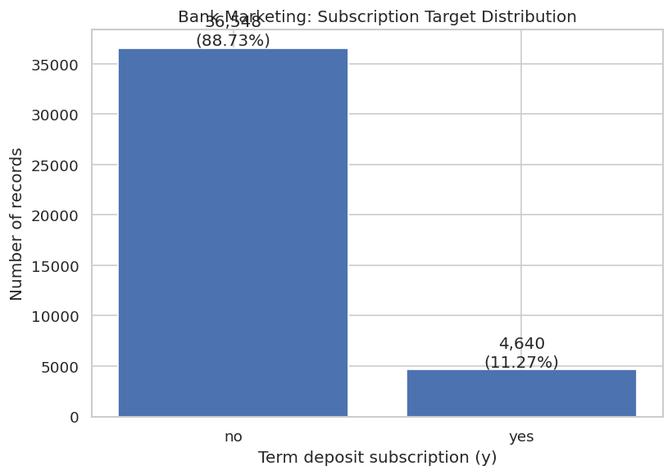
Figure 1. Subscription target distribution
The chart shows 36,548 clients (88.73%) did not subscribe, while 4,640 (11.27%) subscribed. The target is strongly imbalanced. Therefore, accuracy alone can hide poor detection of the minority subscribed class; precision, recall, F1-score, and ROC-AUC should also be examined.

4.2 Client Age Distribution
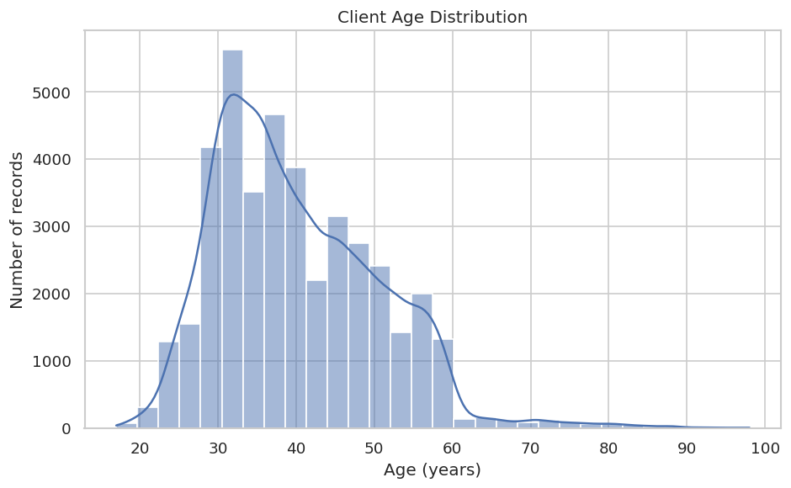
Figure 2. Client age distribution
The histogram indicates that most clients are concentrated roughly between their late twenties and early fifties, with a peak in the early thirties and a right-skewed tail toward older ages. This is a visual interpretation; exact mean and median age values should be taken from the notebook’s descriptive-statistics output.

4.3 Subscription Rate by Contact Month
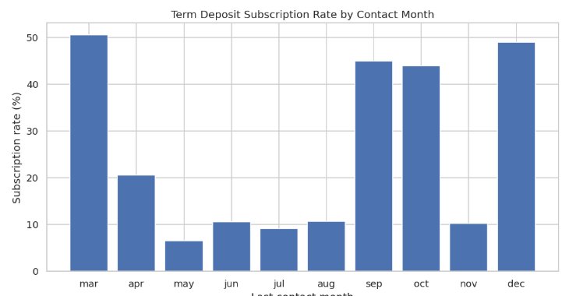
Figure 3. Subscription rate by contact month
The plotted rates vary noticeably by month. March and December appear among the highest-rate months in the displayed chart, while May is visibly lower. These are observed historical differences and may be influenced by campaign schedules and the number or type of contacts in each month; they do not establish that the month itself causes subscription.

4.4 Correlation Heatmap
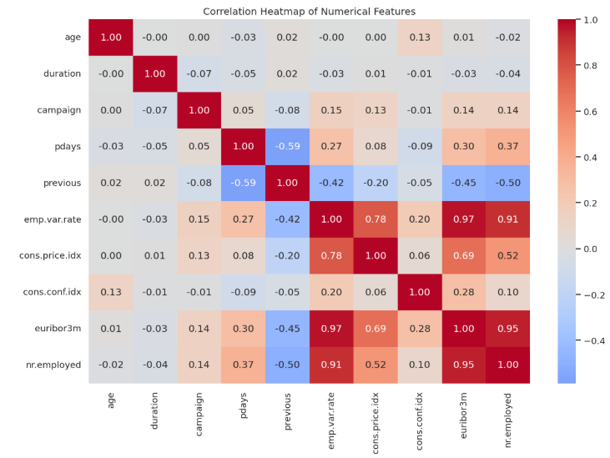
Figure 4. Correlation heatmap of numerical features
The strongest displayed positive correlations include emp.var.rate with euribor3m (0.97), euribor3m with nr.employed (0.95), and emp.var.rate with nr.employed (0.91). Previous and pdays have a negative correlation of approximately -0.59, while previous and nr.employed show approximately -0.50. Strongly correlated economic indicators may contain overlapping information. Correlation does not imply causation.

4.5 Subscription Rate by Previous Campaign Outcome
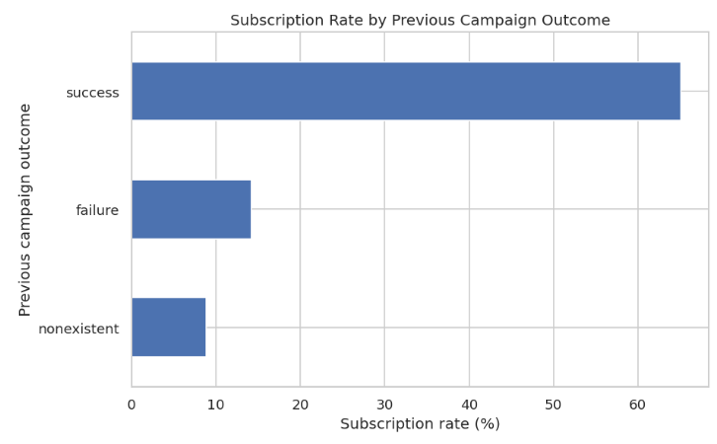
Figure 5. Subscription rate by previous campaign outcome
The chart shows the highest subscription rate for the previous outcome category success, at roughly 65%, compared with approximately 14% for failure and 9% for nonexistent. Previous campaign success is strongly associated with the current subscription outcome in this dataset. Category sizes should be considered before generalizing these percentages.

4.6 Interactive Age vs Campaign Contacts
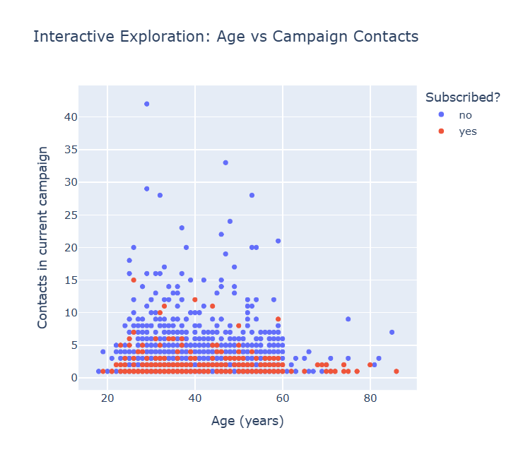
Figure 6. Interactive age-versus-campaign-contact exploration
The Plotly scatter plot explores age against the number of contacts during the current campaign, with points colored by the target class. Many observations cluster at lower contact counts across a broad age range. The visual does not suggest a simple linear relationship between age and contact count; hover data supports inspection of job, education, month, and previous outcome.

4.7 Additional EDA Figures
The supplied screenshots do not include the call-duration distribution or campaign-contact distribution charts. These are generated by the pasted code and can be inserted from outputs/figures after execution.

5. Seven Stages of Visualization
Stage | Application
Acquire | Download the dataset from UCI.
Parse | Read the semicolon-separated CSV and inspect its structure.
Filter | Review data quality and exclude duration from prospective prediction inputs.
Mine | Calculate descriptive statistics, target rates, and correlations.
Represent | Use distributions, group-rate charts, and a correlation heatmap.
Refine | Apply chart titles, labels, and readable scales.
Interact | Create an interactive Plotly scatter plot with hover information.

6. Deep Learning Model
The supplied training plots refer to MLP_A. Its loss curves show training loss declining from approximately 0.585 to 0.540, while validation loss remains near 0.49–0.50. The accuracy plot shows training accuracy increasing from approximately 0.73 to 0.825 and validation accuracy around 0.84–0.85. Validation accuracy is higher than training accuracy in these plots; this can occur with dropout or training-time regularization, but the training configuration should be checked before drawing a firm conclusion.
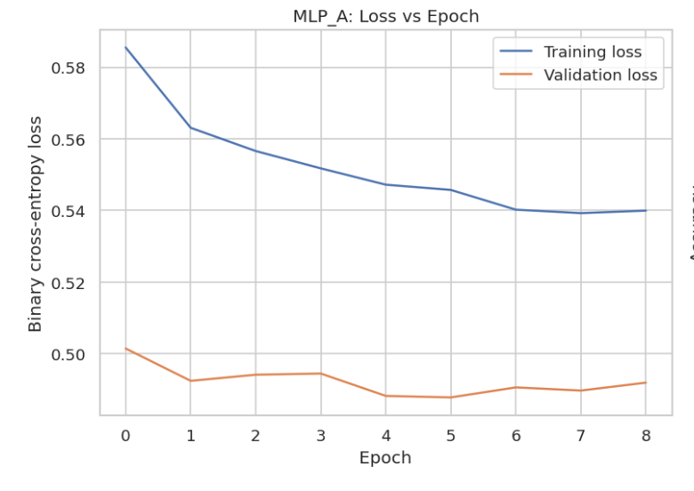
Figure 7. MLP_A training and validation loss
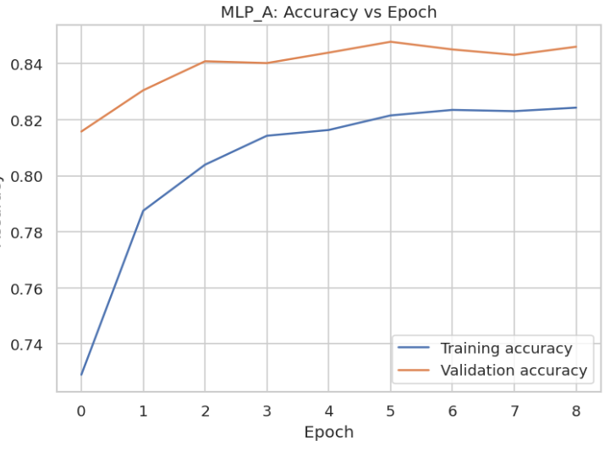
Figure 8. MLP_A training and validation accuracy
The screenshots do not show the full model-comparison table or selected hyperparameters. The report therefore identifies the displayed model as MLP_A and does not invent its hidden-layer configuration or learning rate.

7. Model Evaluation
The confusion matrix provides enough information to calculate accuracy, precision, recall, and F1-score. These metrics are derived from the displayed matrix (class order: No, Yes). ROC-AUC is read directly from the supplied ROC chart.
Metric | Value | Interpretation
Accuracy | 0.8503 (85.03%) | Share of all test cases classified correctly.
Precision (Yes) | 0.3977 (39.77%) | Of predicted subscriptions, the fraction that were actual subscriptions.
Recall (Yes) | 0.6394 (63.94%) | Of actual subscriptions, the fraction detected.
F1-score (Yes) | 0.4904 (49.04%) | Harmonic mean of precision and recall.
ROC-AUC | 0.8003 | Ranking discrimination across thresholds, as labelled on the supplied ROC plot.
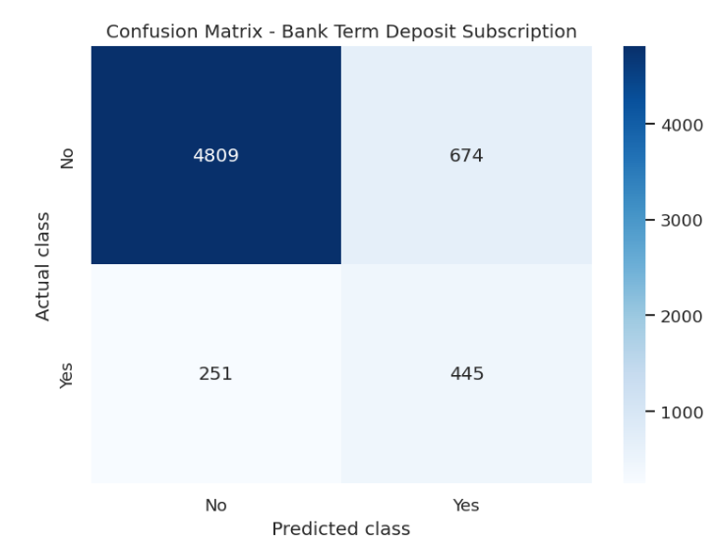
Figure 9. Confusion matrix on the test set
The confusion matrix contains 4,809 true negatives, 674 false positives, 251 false negatives, and 445 true positives. The model correctly identifies many non-subscribers, but precision for the subscribed class is about 39.77%, so many clients predicted as subscribers did not subscribe. Recall is about 63.94%, meaning the model detects roughly two-thirds of actual subscribers at the 0.50 threshold.
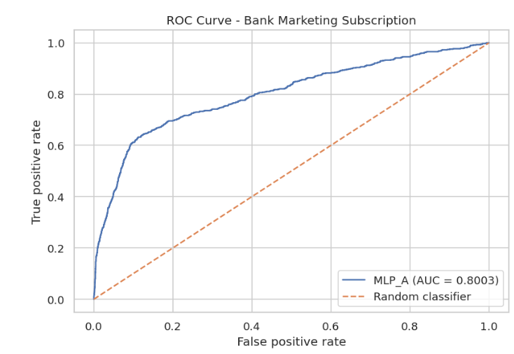
Figure 10. ROC curve on the test set
The ROC curve reports AUC = 0.8003, indicating useful ability to rank positive cases above negative cases compared with random ranking. The ROC-AUC does not by itself specify an optimal operating threshold or guarantee campaign profitability.

8. Permutation Feature Importance
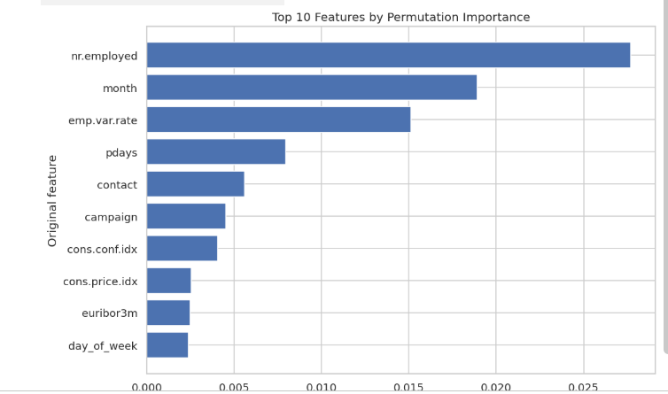
Figure 11. Top ten permutation-importance features
The displayed ranking places nr.employed highest, followed by month and emp.var.rate. pdays and contact also contribute, followed by campaign, cons.conf.idx, cons.price.idx, euribor3m, and day_of_week. The bars represent the decrease in validation ROC-AUC after shuffling a feature. These values indicate model reliance, not causal effects. Because some economic features are strongly correlated, importance can be distributed across related variables.

9. Discussion
The dataset has a substantial target imbalance, with only 11.27% of records representing subscriptions. The observed rates vary across contact months and previous campaign outcomes. Numerical correlation results show strong relationships among economic indicators. MLP_A has test ROC-AUC 0.8003 and recall of approximately 63.94%, while precision for the positive class is approximately 39.77%. This suggests a practical trade-off: the model finds a meaningful portion of subscribers but also produces a considerable number of false-positive predictions at the selected threshold.
The model should not be used as an automated targeting rule without further validation. Threshold selection should consider the cost of contacting a client who will not subscribe versus missing a likely subscriber. Temporal validation, calibration, fairness and privacy review, and monitoring for data drift would be needed before operational deployment.

10. Limitations
- Only some notebook outputs were provided as screenshots; missing-value, duplicate, outlier, split-size, and full model-comparison outputs are not available here.
- The supplied figures show historical associations, not causal effects.
- The target is imbalanced, so performance depends on the selected threshold and metric.
- The screenshots do not show the full MLP configuration or all training logs.
- External or temporal validation is needed before applying these results to current campaigns.

11. Future Scope
- Compare the MLP with logistic regression and tree-based models.
- Choose a decision threshold using campaign costs and precision-recall trade-offs.
- Use repeated stratified cross-validation and validate on newer data.
- Check probability calibration, fairness, privacy, and explainability.
- Report complete data-quality statistics and all model-comparison results in a future iteration.

12. Conclusion
This project explored the Bank Marketing dataset using EDA, visualization, and an MLP classifier. The target distribution was 88.73% non-subscription and 11.27% subscription. Based on the provided confusion matrix, the displayed model achieved 85.03% accuracy, 39.77% precision, 63.94% recall, and 49.04% F1-score for the positive-class calculations described above; the ROC plot reports AUC = 0.8003. The most prominent permutation-importance features shown are nr.employed, month, and emp.var.rate. The results are promising for exploratory prediction but the low positive-class precision, historical nature of the data, and lack of external validation must be considered.

References
Moro, S., Rita, P., & Cortez, P. (2014). Bank Marketing [Dataset]. UCI Machine Learning Repository. https://doi.org/10.24432/C5K306
Moro, S., Cortez, P., & Rita, P. (2014). A data-driven approach to predict the success of bank telemarketing. Decision Support Systems, 62, 22–31. https://doi.org/10.1016/j.dss.2014.03.001
Fry, B. (2008). Visualizing Data: Exploring and Explaining Data with the Processing Environment. O’Reilly Media.
Keras. TensorFlow Keras API documentation. https://keras.io/
scikit-learn developers. Model evaluation and permutation importance documentation. https://scikit-learn.org/stable/

Appendix: Results verification
The target counts were transcribed from the target-distribution chart. Confusion-matrix metrics were calculated from the displayed cell counts: TN=4809, FP=674, FN=251, TP=445. ROC-AUC=0.8003 was read from the supplied ROC chart. Exact descriptive statistics, validation AUC comparison, model configuration, and complete data-quality outputs should be added from the notebook if required.

