**UIT 1611 WEB PROGRAMMING LABORATORY**

**Exercise 12**

**Name:** Elakkiya S

**Register No.:** 195002036

**Aim:**

To create a RESTful web service for Calculator Application.

**Procedure:**

* Initialise our Angular JS applications using ‘ng-app’ and use ‘ng-controller’ directive to control the the data (operand and operator ) of angular application
* REST- represents the architectural styles for implementing web service using http protocol
* We identify each RESTful web service using an unique URL
* We cache the result of particular operation using the GET method - app.get("/add", (req, res) {}
* We use HTTP methods like get,post,put to implement the concept of rest architecture.
* Use URI- uniform resource identifier which provides resource representation such as JSON and set of HTTP methods.
* Use JSON.stringify() method to convert a JavaScript object or value to a JSON string.

**Code:**

**calcHost.js**

const express = require("express");

const app = express();

app.use(express.static("public"));

app.get("/", (req, res) => {

res.sendFile(__dirname + "/calc.html");

});

app.get("/add", (req, res) => {

var first = req.query.first;

var second = req.query.second;

var value = Number(first) + Number(second);

var result = { result: value };

res.send(result);

});

app.get("/subtract", (req, res) => {

var first = req.query.first;

var second = req.query.second;

var value = Number(first) - Number(second);

var result = { result: value };

res.send(result);

});

app.get("/multiply", (req, res) => {

var first = req.query.first;

var second = req.query.second;

var value = Number(first) * Number(second);

var result = { result: value };

res.send(result);

});

app.get("/divide", (req, res) => {

var first = req.query.first;

var second = req.query.second;

var value = Number(first) / Number(second);

var result = { result: value };

res.send(result);

});

app.listen(7000);

**calc.html**

<!DOCTYPE html>

<html lang="en">

  <head>

    <meta charset="UTF-8" />

    <title>Calculator</title>

    <link rel="stylesheet" href="styles.css" />

  </head>

  <body>

    <script src="https://ajax.googleapis.com/ajax/libs/angularjs/1.3.14/angular.min.js"></script>

    <center>

      <h3 id="bordering" style="background-color: #87ceeb; width: 300px">

        <br />

        SIMPLE CALCULATOR<br /><br />

      </h3>

      <div

        ng-app="CalculatorApp"

        ng-controller="CalculatorController"

        id="bordering"

        style="background-color: #87ceeb; width: 300px"

      >

        <br />

        <p>Operand 1</p>

        <p><input type="number" ng-model="first" /></p>

        <p>Operand 2</p>

        <p><input type="number" ng-model="second" /></p>

        <p>Choose operation</p>

        <p>

          <select ng-model="operator">

            <option value="add">+</option>

            <option value="subtract">-</option>

            <option value="multiply">*</option>

            <option value="divide">/</option>

          </select>

        </p>

        <button ng-click="calculate()">CALCULATE</button>

        <p>ANSWER</p>

        <p ng-model="answer">{{answer}}</p>

        <br />

      </div>

    </center>

    <script>

      angular

        .module("CalculatorApp", [])

        .controller("CalculatorController", function ($scope, $http) {

          $scope.calculate = function () {

            ops = $scope.operator;

            $http

              .get(ops, {

                params: {

                  first: $scope.first,

                  second: $scope.second,

                },

              })

              .success(function (res) {

                console.log("Exit status " + JSON.stringify(res));

                $scope.answer = res.result;

              });

          };

        });

    </script>

  </body>

</html>

**Output:**

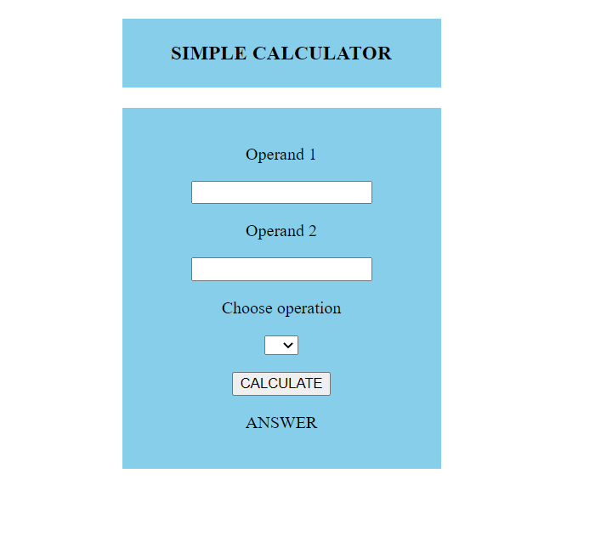

**Addition:**

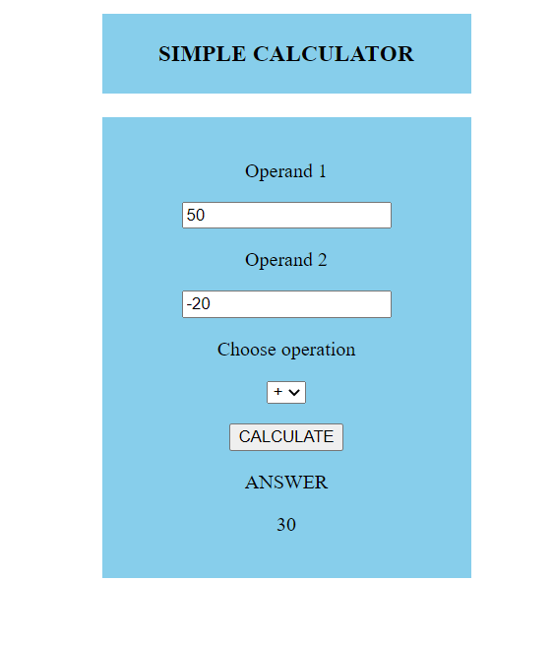

**Subtraction:**

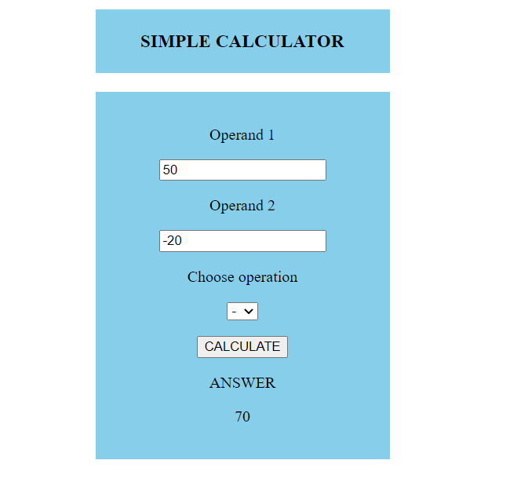

**Multiplication:**

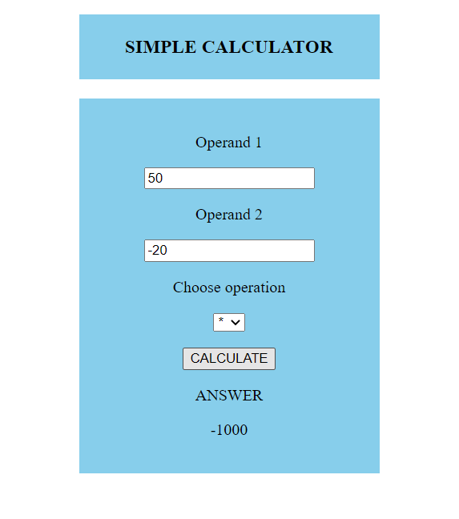

**Division:**

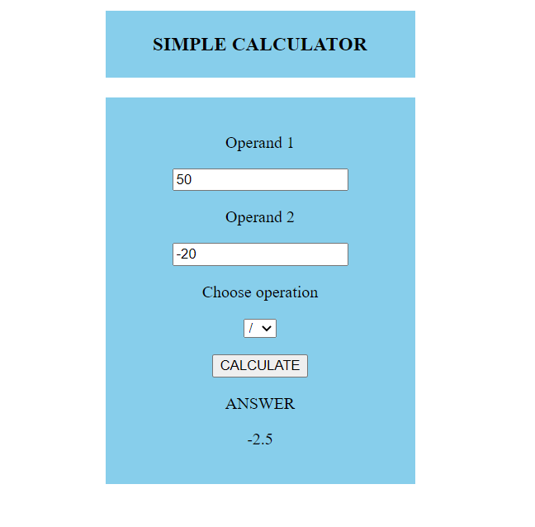

**Result:**

Thus above code was successfully executed to implement simple calculator using RESTFUL web services .