**UIT 1611 WEB PROGRAMMING LABORATORY**

**Exercise 03**

**Name:** Elakkiya S

**Register No.:** 195002036

**1.Simple calculator using Angularjs:**

**Code:**

<!DOCTYPE html>

<head>

<title>Simple calculator</title>

<script src= "https://cdnjs.cloudflare.com/ajax/libs/angular.js/1.8.3/angular.min.js"></script>

<script>

angular.module('CalculatorApp', [])

.controller('CalculatorController', function($scope) {

$scope.result = function() {

if ($scope.operator == '+') {

return $scope.a + $scope.b;

}

if ($scope.operator == '-') {

return $scope.a - $scope.b;

}

if ($scope.operator == '*') {

return $scope.a * $scope.b;

}

if ($scope.operator == '/') {

return $scope.a / $scope.b;

}

};

});

</script>

</head>

<body>

<h1>SIMPLE CALCULATOR</h1>

<div ng-app="CalculatorApp" ng-controller="CalculatorController">

<p>Enter a number: <input type="number" ng-model="a"></p>

<p>Enter a number:<input type="number" ng-model="b"></p>

<p>Select an operation: <select ng-model="operator">

<option>+</option>

<option>*</option>

<option>-</option>

<option>/</option>

</select></p>

<p><strong>Result: </strong>{{ result() }}</p>

</div>

</body>

</html>

**Output:**

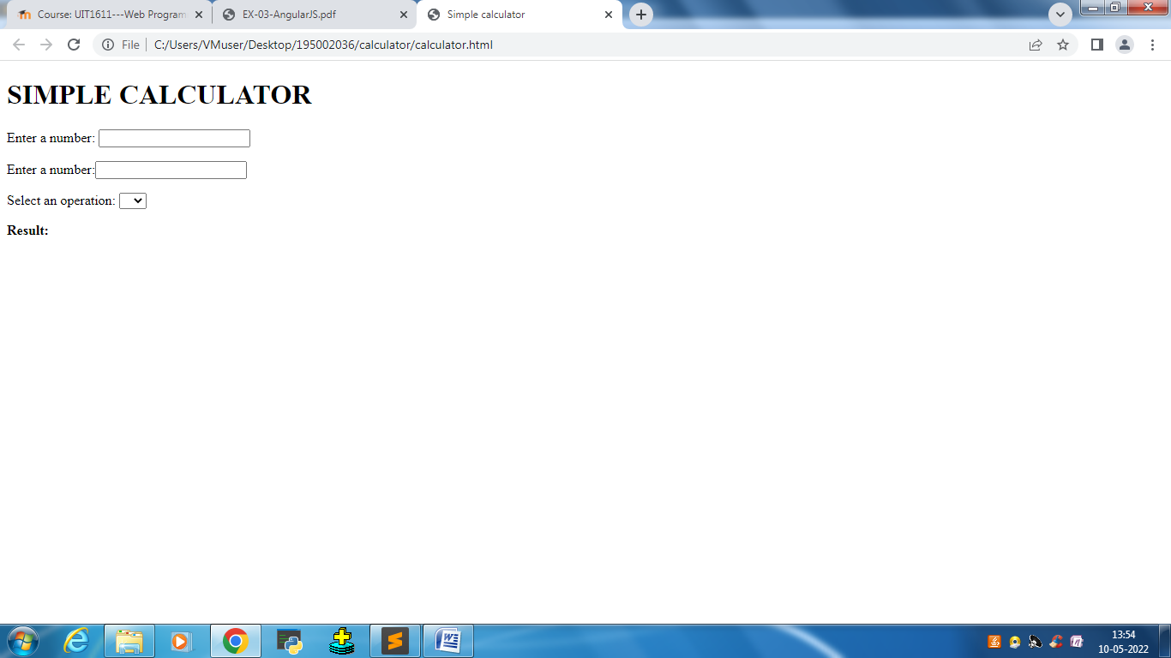

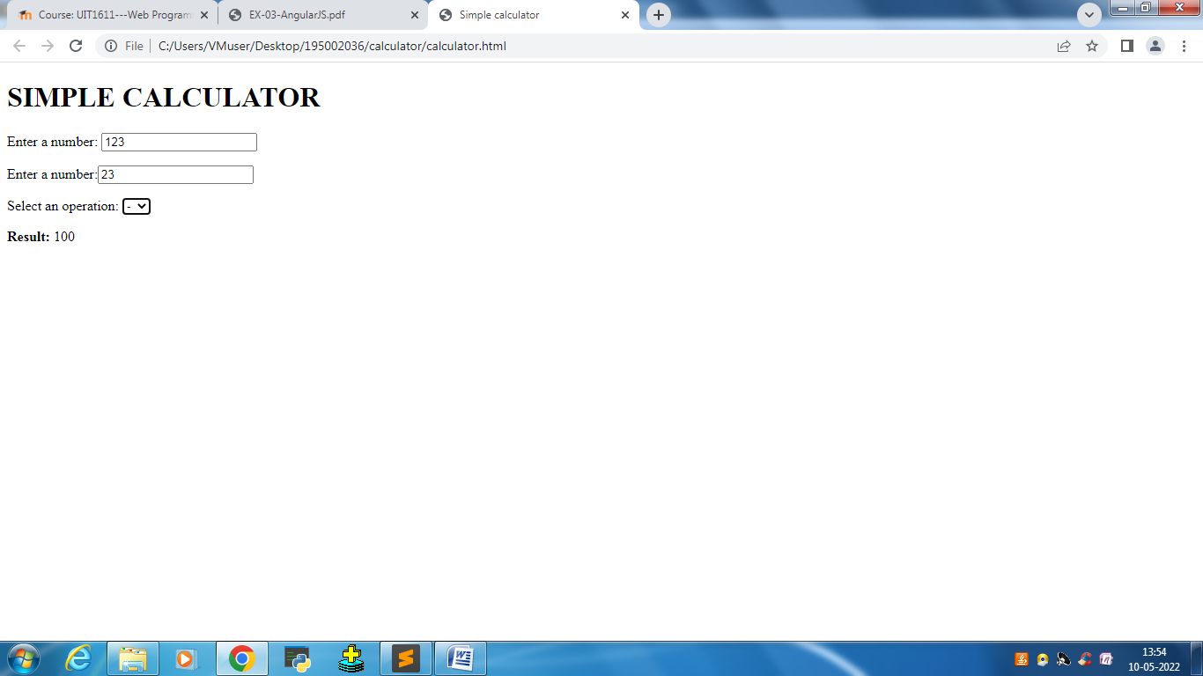

**2.Write an Angular program to implement Components, Service, and Controllers.**

**Components:**

**index.html:**

<!DOCTYPE html>

<html ng-app="newApp">

<head>

    <title>Component Creation</title>

    <script src="https://ajax.googleapis.com/ajax/libs/angularjs/1.6.9/angular.min.js"></script>

    <script src="app.js"></script>

    <script src="component.js"></script>

</head>

<body>

    <new-list></new-list>

</body>

</html>

**app.js**

angular.module('newApp', []);

**component.js**

angular.module('newApp').

  component('newList', {

    template:

        '<ul>' +

          '<li ng-repeat="item in $ctrl.names">' +

            '<span>{{item.name}}</span>' +

            '<p>{{item.department}}</p>' +

          '</li>' +

        '</ul>',

    controller: function newListController() {

      this.names = [

        {

          name: 'Nandana R',

          department: 'Electronics and Communications Engineering '

        }, {

          name: 'Reshma A',

          department: 'Chemical Engineering'

        }, {

          name: 'Barath R',

          department: 'Mechanical Engineering'

        }, {

            name: 'Manickam L',

            department: 'Computer Science Engineering'

          }

      ];

    }

  });

**Output:**

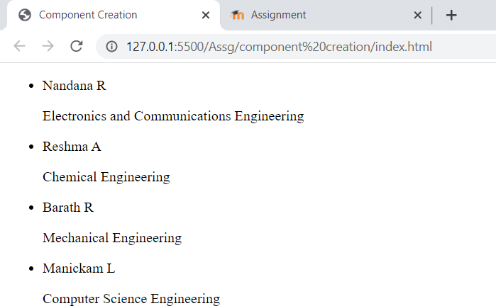

**Controller:**

<!DOCTYPE html>

<html>

<script src="https://ajax.googleapis.com/ajax/libs/angularjs/1.6.9/angular.min.js"></script>

<body>

    <h2>ng-controller directive</h2>

    <div ng-app="myApp" ng-controller="myCtrl">

        Full Name: {{firstName + " " + lastName}}

    </div>

    <script>

        var app = angular.module('myApp', []);

        app.controller('myCtrl', function ($scope) {

            $scope.firstName = "Elakkiya";

            $scope.lastName = "Selvaraj";

        });

    </script>

</body>

</html>

**Output:**

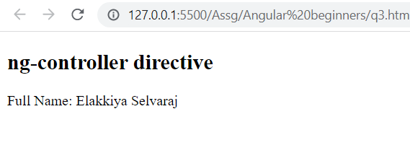

**Services:**

**Creating a custom service:**

**Code:**

<!DOCTYPE html>

<html>

<script src="https://ajax.googleapis.com/ajax/libs/angularjs/1.6.9/angular.min.js"></script>

<body>

    <div ng-app="myApp" ng-controller="myCtrl">

        <p>The hexadecimal value of 255 is:</p>

        <h1>{{hex}}</h1>

    </div>

    <p>A custom service with a method that converts a given number into a hexadecimal number.</p>

    <script>

        var app = angular.module('myApp', []);

        app.service('hexafy', function () {

            this.myFunc = function (x) {

                return x.toString(16);

            }

        });

        app.controller('myCtrl', function ($scope, hexafy) {

            $scope.hex = hexafy.myFunc(255);

        });

    </script>

</body>

</html>

**Output:**

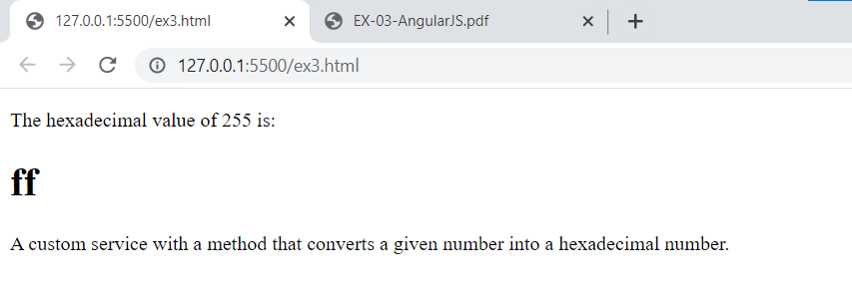

**3)Write an Angular program to implement search to filter items.**

**Code:**

<!DOCTYPE html>

<html xmlns="http://www.w3.org/1999/xhtml">

<head>

    <title>AngularJs filter Example</title>

    <script src="http://ajax.googleapis.com/ajax/libs/angularjs/1.4.8/angular.min.js"></script>

    <script>

        var app = angular.module("AngularfilterApp", []);

        app.controller("filterctrl", function ($scope) {

            $scope.users = [{

                name: "Sriprada",

                age: 11

            }, {

                name: "Kavin Malone",

                age: 29

            }, {

                name: "Yazhisai",

                age: 29

            }, {

                name: "Prathipa",

                age: 24

            }];

        });

    </script>

</head>

<body ng-app="AngularfilterApp">

    <div ng-controller="filterctrl">

        Enter Name to Filter:<input ng-model="searchtxt" type="text" placeholder="Flter key">

        <table>

            <tr>

                <th>Name</th>

                <th>Age</th>

            </tr>

            <tr ng-repeat="user in users | filter : searchtxt">

                <td>{{user.name}}</td>

                <td>{{user.age}}</td>

            </tr>

        </table>

    </div>

</body>

</html>

**Output:**

