**UIT 1602 WEB PROGRAMMING LABORATORY**

**Exercise 04 – Switch and Animations**

**Name:** Elakkiya S

**Register No.:** 195002036

**1.Animations**

**Code:**

<!DOCTYPE html>

<html>

<head>

    <title>Animations</title>

    <style>

        div {

            transition: all linear 0.5s;

            background-color: lightblue;

            height: 100px;

        }

        .ng-hide {

            height: 0;

        }

    </style>

    <script src="https://ajax.googleapis.com/ajax/libs/angularjs/1.6.9/angular.min.js"></script>

</head>

<body ng-app="myApp">

    <h1>Angular animations</h1>

    <h2>Click Here! <input type="checkbox" ng-model="myCheck"></h2>

    <div ng-hide="myCheck"></div>

    <script>

        var app = angular.module('myApp', ['ngAnimate']);

    </script>

</body>

</html>

**Output:**

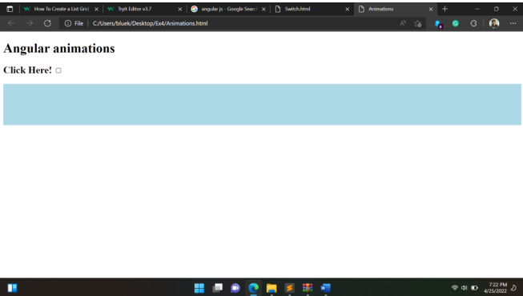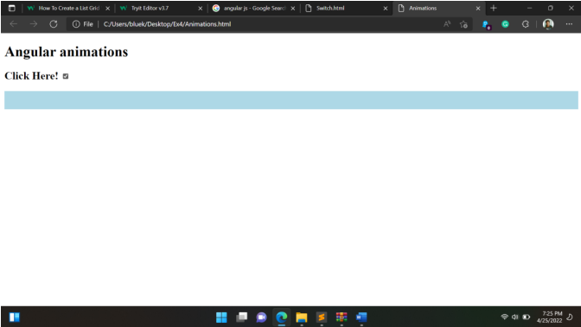

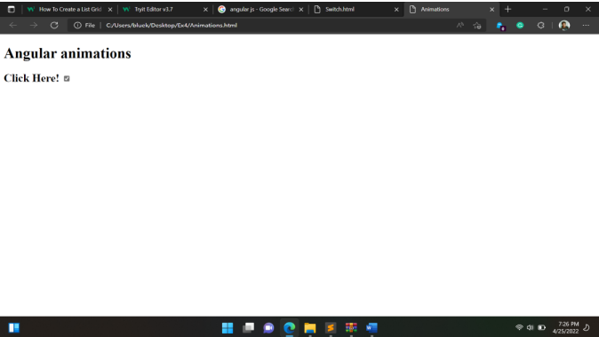

**2.Switch**

**Code:**

<!DOCTYPE html>

<html>

<head>

    <link rel="stylesheet" href="https://cdnjs.cloudflare.com/ajax/libs/font-awesome/4.7.0/css/font-awesome.min.css">

    <style>

        * {

            box-sizing: border-box;

        }

        .column {

            float: left;

            width: 50%;

            padding: 10px;

        }

        .row:after {

            content: "";

            display: table;

            clear: both;

        }

        .btn {

            border: none;

            outline: none;

            padding: 12px 16px;

            background-color: #f1f1f1;

            cursor: pointer;

        }

        .btn:hover {

            background-color: #ddd;

        }

        .btn.active {

            background-color: #666;

            color: white;

        }

    </style>

</head>

<body>

    <h2>List View or Grid View</h2>

    <p>Click on a button to choose list view or grid view.</p>

    <div id="btnContainer">

        <button class="btn" onclick="listView()"><i class="fa fa-bars"></i> List</button>

        <button class="btn active" onclick="gridView()"><i class="fa fa-th-large"></i> Grid</button>

    </div>

    <br>

    <div class="row">

        <div class="column" style="background-color:#aaa;">

            <h2>Html </h2>

            <p>The HyperText Markup Language or HTML is the standard markup language for documents designed to be

                displayed in a web browser. </p>

        </div>

        <div class="column" style="background-color:#bbb;">

            <h2>CSS</h2>

            <p>Cascading Style Sheets is a style sheet language used for describing the presentation of a document

                written in a markup language such as HTML.</p>

        </div>

    </div>

    <div class="row">

        <div class="column" style="background-color:#ccc;">

            <h2>JS</h2>

            <p>JavaScript, often abbreviated JS, is a programming language that is one of the core technologies of the

                World Wide Web, alongside HTML and CSS.</p>

        </div>

        <div class="column" style="background-color:#ddd;">

            <h2>Angular Js</h2>

            <p>AngularJS was a JavaScript-based open-source front-end web framework for developing single-page

                applications.</p>

        </div>

    </div>

    <script>

        var elements = document.getElementsByClassName("column");

        var i;

        function listView() {

            for (i = 0; i < elements.length; i++) {

                elements[i].style.width = "100%";

            }

        }

        function gridView() {

            for (i = 0; i < elements.length; i++) {

                elements[i].style.width = "50%";

            }

        }

        var container = document.getElementById("btnContainer");

        var btns = container.getElementsByClassName("btn");

        for (var i = 0; i < btns.length; i++) {

            btns[i].addEventListener("click", function () {

                var current = document.getElementsByClassName("active");

                current[0].className = current[0].className.replace(" active", "");

                this.className += " active";

            });

        }

    </script>

</body>

</html>

**Output:**

