**FORM WITH REAL-TIME (PHP)**

**Aim:**

To design a real-time webpage using forms and PHP.

**Code:**

**Index.php**

<!DOCTYPE html>

<html>

<head>

<title>Webslesson Tutorial | Submit Form Data by using AngularJS with Validation using PHP</title>

<link rel="stylesheet" href="https://maxcdn.bootstrapcdn.com/bootstrap/3.3.6/css/bootstrap.min.css" />

<script [src="http://ajax.googleapis.com/ajax/libs/angularjs/1.4.8/angular.min.js"></script>](http://ajax.googleapis.com/ajax/libs/angularjs/1.4.8/angular.min.js)

</head>

<body>

<br /><br />

<div class="container" style="width:750px;">

<h3 align="center">Submit Form Data by using AngularJS with Validation using PHP</h3>

<br /><br />

<div ng-app="myapp" ng-controller="formcontroller">

<form name="userForm" ng-submit="insertData()">

<label class="text-success" ng-show="successInsert">{{successInsert}}</label>

<div class="form-group">

<label>First Name <span class="text-danger">*</span></label>

<input type="text" name="first_name" ng-model="insert.first_name" class="form-control" />

<span class="text-danger" ng-show="errorFirstname">{{errorFirstname}}</span>

</div>

<div class="form-group">

<label>Last Name <span class="text-danger">*</span></label>

<input type="text" name="last_name" ng-model="insert.last_name" class="form-control" />

<span class="text-danger" ng-show="errorLastname">{{errorLastname}}</span>

</div>

<br />

<div class="form-group">

<input type="submit" name="insert" class="btn btn-info" value="Insert"/>

</div>

</form>

</div>

</div>

</body>

</html>

<script>

var application = angular.module("myapp", []); application.controller("formcontroller", function($scope, $http){

$scope.insert = {};

$scope.insertData = function(){

$http({ method:"POST", url:"insert.php", data:$scope.insert,

}).success(function(data){ if(data.error)

{

$scope.errorFirstname = data.error.first_name;

$scope.errorLastname = data.error.last_name;

$scope.successInsert = null;

}

else

{

$scope.insert = null;

$scope.errorFirstname = null;

$scope.errorLastname = null;

$scope.successInsert = data.message;

}

});

}

});

</script>

**Insert.php:**

<?php

//insert.php

$connect = mysqli_connect("localhost", "root", "", "testing");

$form_data = json_decode(file_get_contents("php://input"));

$data = array();

$error = array();

if(empty($form_data->first_name))

{

$error["first_name"] = "First Name is required";

}

if(empty($form_data->last_name))

{

$error["last_name"] = "Last Name is required";

}

if(!empty($error))

{

$data["error"] = $error;

}

else

{

$first_name = mysqli_real_escape_string($connect, $form_data->first_name);

$last_name = mysqli_real_escape_string($connect, $form_data->last_name);

$query = "

INSERT INTO tbl_user(first_name, last_name) VALUES ('$first_name', '$last_name') ";

if(mysqli_query($connect, $query))

{

$data["message"] = "Data Inserted...";

}

}

echo json_encode($data);

?>

**OUTPUT:**

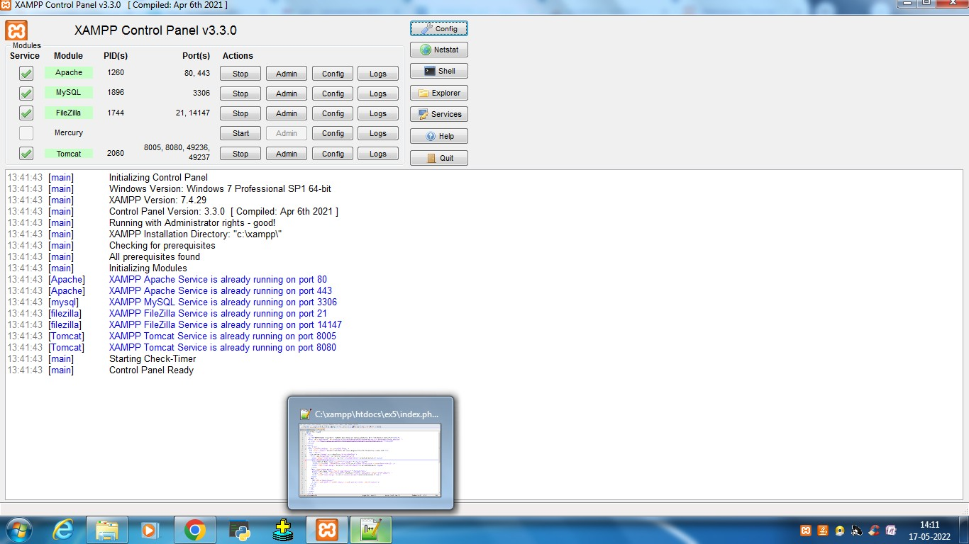Started apache and mysql:

Created database name testing and created table “tbl_user” under the database testing**:**

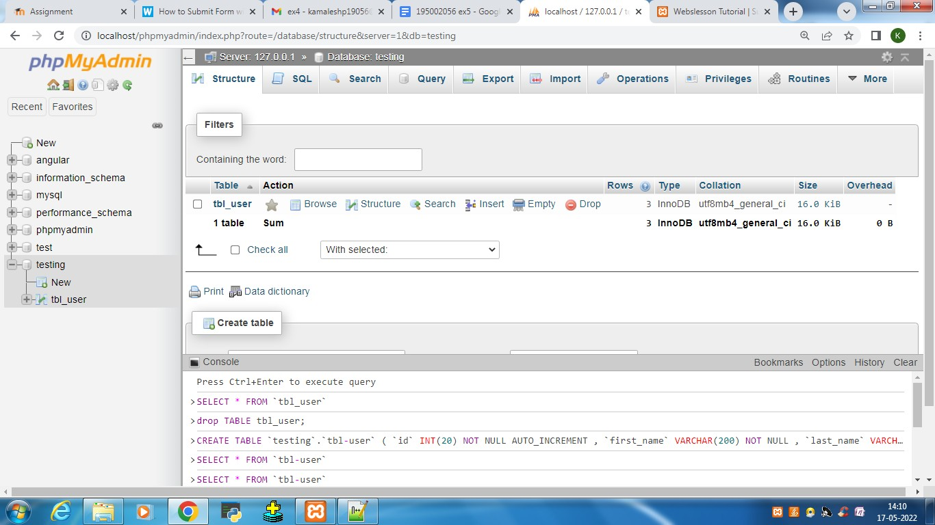

Table contains id, firstname and lastname.

Form validation using angularJS and PHP

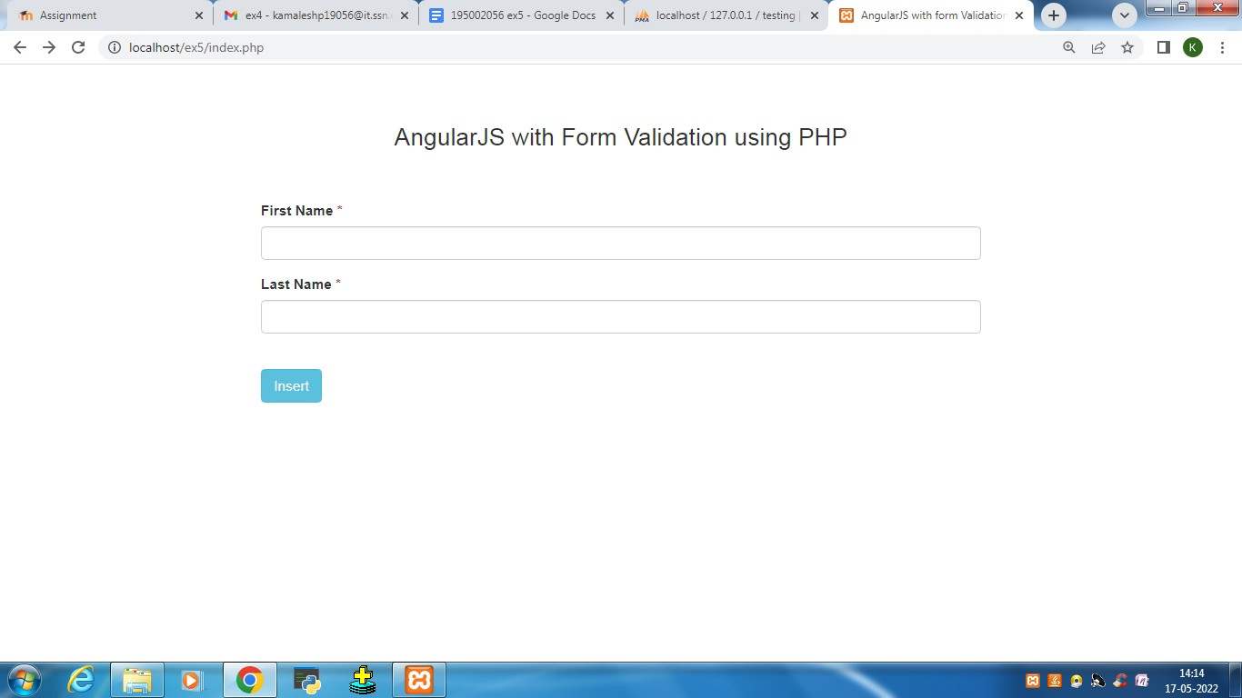

Rows in table tbl_user:

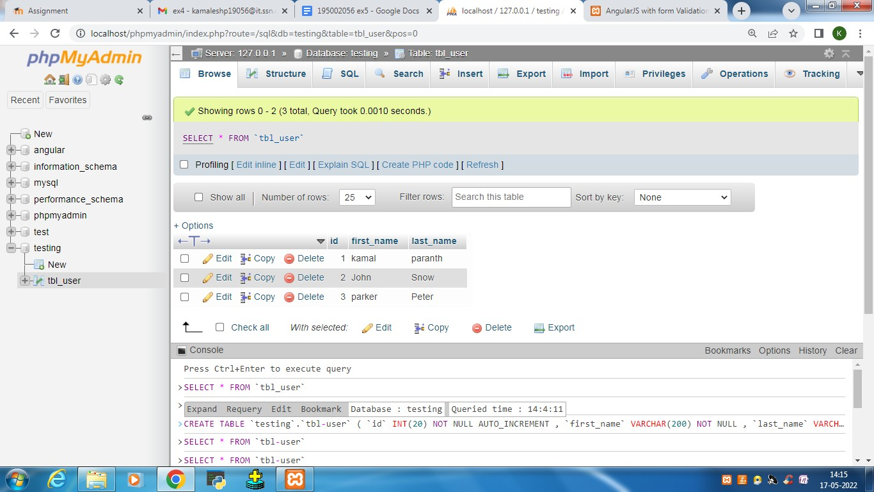

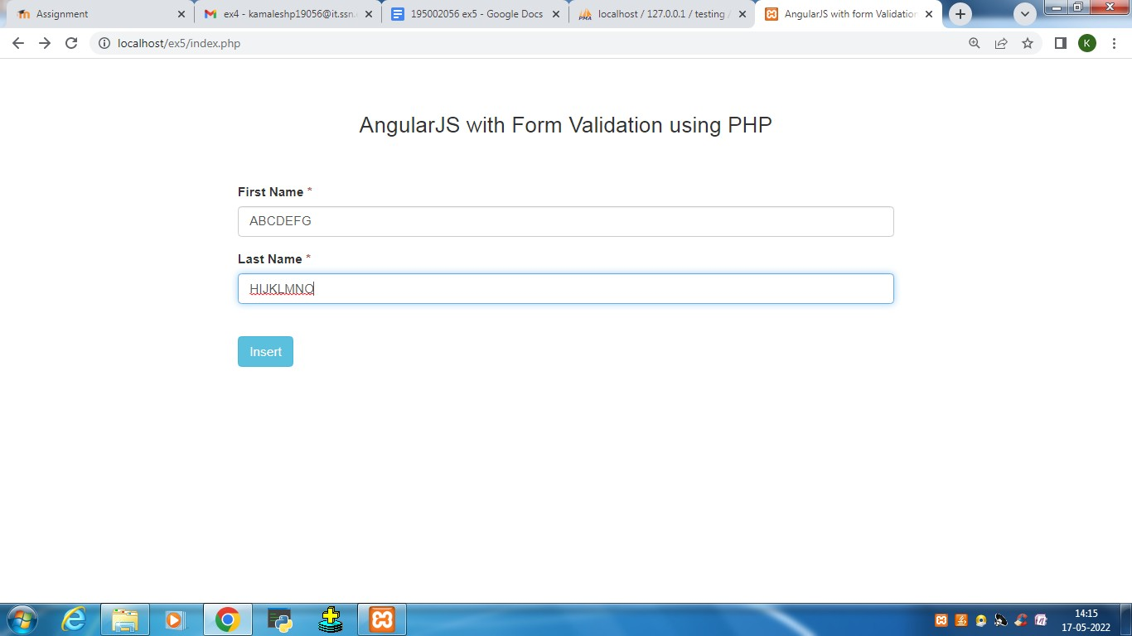

After insertion:

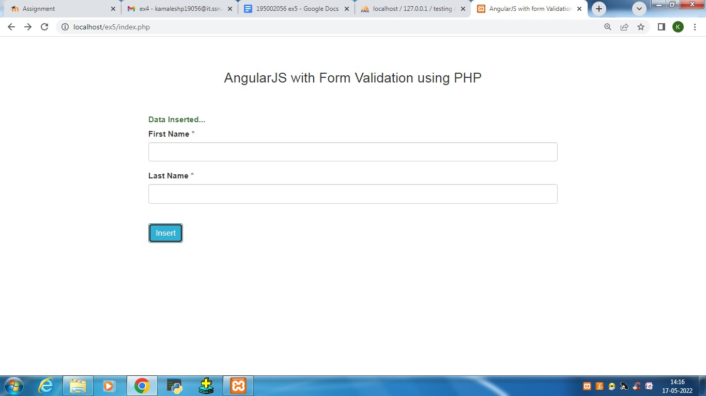

Record inserted in the table “tbl_user”:

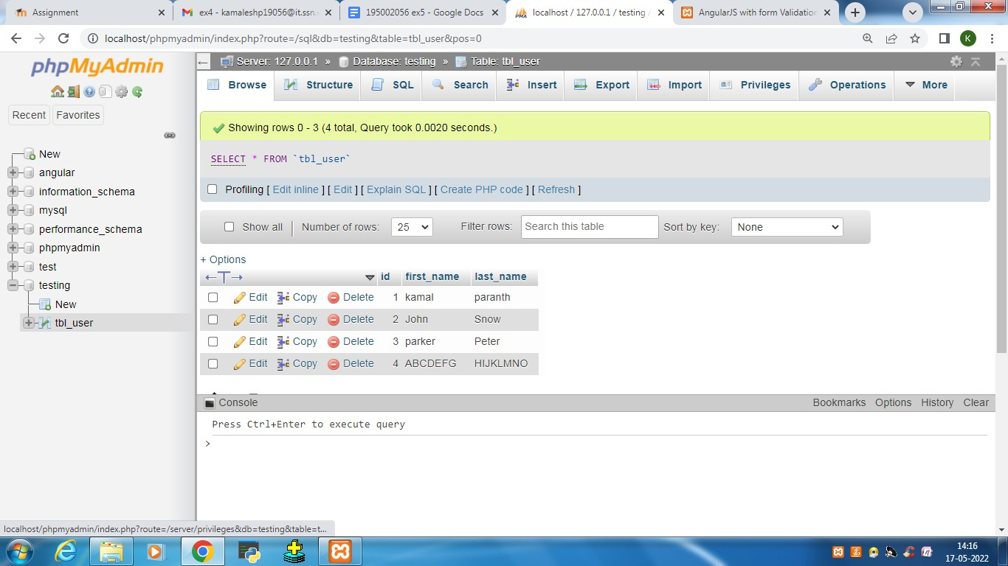

**RESULT:**

The real-time form with PHP has been designed and working properly and their outputs were verified.