VisionInspect AI - Technical Report
Manufacturing Defect Detection & Quality Inspection System
Table of Contents

VisionInspect AI — Technical Documentation
Manufacturing Defect Detection & Quality Inspection System · Version 1.0 · Milestones 1–4

1. Overview
VisionInspect AI is a web platform that inspects product images, detects and localises defects, classifies them, scores their severity and produces a pass / review / rework / reject decision, with dashboards for production quality.
Layer | Technology
Frontend | React 18, Vite, Tailwind CSS, Recharts, React Router (route-level code splitting)
Backend | Python 3.12, FastAPI, SQLAlchemy 2, PyJWT
Computer vision / ML | OpenCV, NumPy, scikit-learn
Database | SQLite (default, zero setup) or PostgreSQL (DATABASE_URL)
Deployment | Docker, Docker Compose, nginx; guides for AWS and Azure
Quality | pytest (engine + API), GitHub Actions CI

2. Architecture
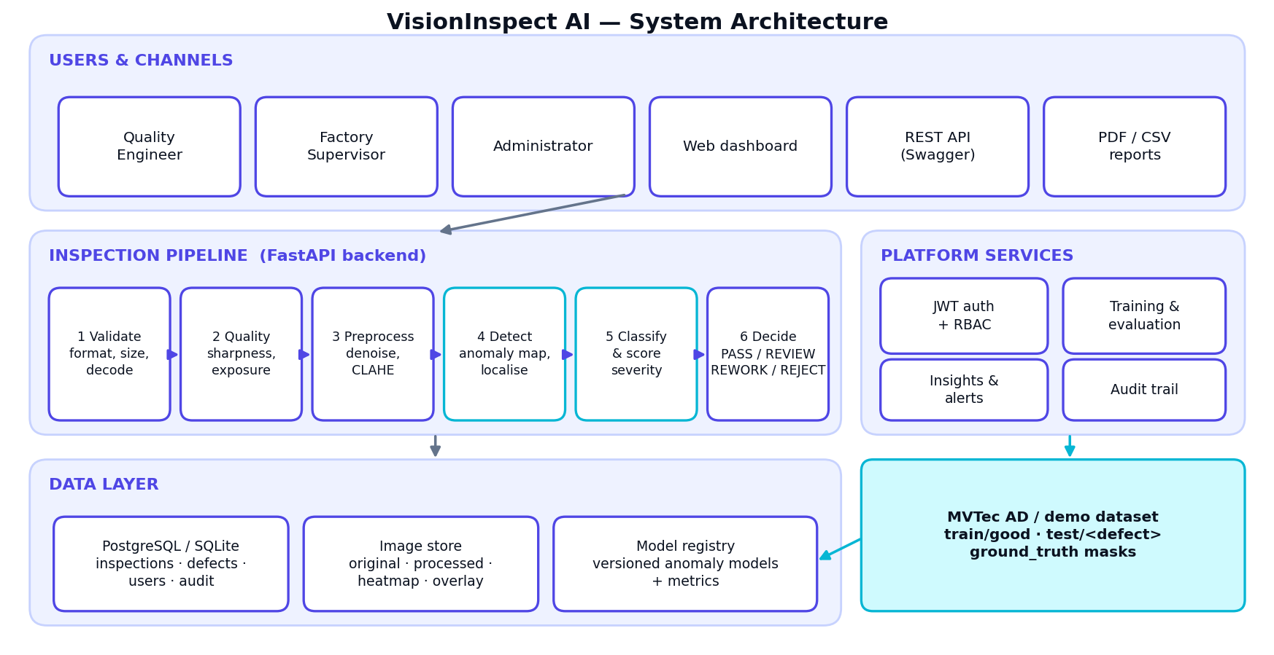
Architecture
- Browser → nginx → FastAPI. nginx serves the built React app and proxies /api to the backend.
- Inspection pipeline runs synchronously per request (≈ 140 ms/image); batch uploads use a thread pool.
- Training jobs and sample-inspection jobs run in background threads; the UI polls /api/dataset/jobs/{id}.
- Model registry: every training run is stored as a versioned .npz file plus a database row with its metrics; one version per category is active and cached in memory.
- Images are stored on disk per inspection (original, processed, heatmap, overlay); the browser fetches them through authenticated endpoints.

3. Modules (mapping to the project brief)
# | Brief module | Implementation
1 | User management | routers/auth.py, routers/users.py, deps.py; roles admin, quality_engineer, factory_supervisor
2 | Image acquisition | routers/inspections.py (upload, batch ≤ 50, camera simulation), services/validation.py
3 | Image processing | services/preprocessing.py (resize, non-local-means denoise, CLAHE, global features), services/quality.py
4 | Defect detection | services/anomaly.py (trainable patch-statistics model + baseline detector), region extraction
5 | Defect classification | services/classification.py, services/severity.py
6 | Quality control | services/severity.py::decide, review workflow, services/reports.py (PDF certificate, CSV)
7 | Analytics dashboard | routers/analytics.py, services/insights.py, React pages Dashboard / Analytics

4. Detection method
- Preprocess to 256 × 256: area resize → non-local-means denoising → CLAHE on the L channel.
- Features: dense patch statistics at two scales (11 px and 31 px windows, stride 4): mean L/a/b, local contrast, gradient magnitude, Laplacian energy and horizontal/vertical gradient energy (16 features per patch).
- Model (trained mode): patches from defect-free images are standardised and clustered (k-means, k = 1–8); each cluster gets a Gaussian with shrinkage covariance. The anomaly score of a patch is its minimum Mahalanobis distance to any cluster. The threshold is calibrated on held-out good images (max(mean + 3.5σ, 1.1 × max) of their peak scores), so a normalised score of 1.0 equals the detection threshold.
- Baseline mode: with no trained model the image is compared with its own robust statistics (median/MAD + iteratively trimmed Mahalanobis), so the platform works from the first upload.
- Localisation: threshold the smoothed map at 1.0, merge fragments, refine each blob to a tight mask using the local colour residual, then measure shape and appearance (elongation, solidity, circularity, lightness/colour contrast, edge excess, darkness, boundary sharpness).
- Classification: rule scores for Scratch, Crack, Hole/Missing material, Dent/Deformation, Stain/Contamination, Discoloration (fallback Surface Anomaly). Confidence = 0.75 × detection confidence + 0.25 × type confidence, where detection confidence = 0.5 + 0.5·tanh(3·(peak − 1)).

5. Severity scoring and decisions
Severity = Size × 30% + Location × 25% + Defect type × 25% + Confidence × 20% (each 0–100)
Score | Level | Decision
80–100 | Critical | REJECT — reject product, trigger inspection workflow
60–79 | High | REWORK — repair / rework
40–59 | Medium | REVIEW — manual inspection review
0–39 | Low | PASS (minor cosmetic) — becomes REVIEW if any detection has < 70 % confidence
none | None | PASS
Size score = min(100, 20 + 80·√(area/4%)); location score = 95 − 60·d where d is the distance of the defect centre from the image centre (0 = centre, 1 = edge); type score table: crack 95, hole 90, dent 65, surface anomaly 50, stain 40, scratch 30, discoloration 30. The part-level score is the maximum over its defects.
The brief’s worked example (85, 90, 95, 92) gives 90.2 with these weights, not the 88 printed in the brief. The code and unit test follow the formula; the level (Critical) is the same.

6. Database schema
Table | Key columns
users | id, email (unique), full_name, role, hashed_password, is_active, created_at, last_login
inspections | id, code (INS-000001), user_id, filename, source (upload/batch/camera/dataset), batch_id, category, status, width, height, validation, quality, features, preprocessing (JSON), model_name, model_mode, anomaly_score, severity_score, severity_level, decision, needs_review, recommendation, root_cause, processing_ms, gt_label, review_status/by/note/at, created_at
defects | id, inspection_id → inspections, type, category, bbox (normalised x,y,w,h), area_ratio, confidence, type_confidence, size/location/type/confidence scores, severity_score, severity_level
model_versions | id, category, name, version, path, metrics (JSON), active, trained_by, created_at
audit_logs | id, user_id, action, detail, created_at
Indexes: inspections.code (unique), created_at, category, decision, severity_level, batch_id; defects.inspection_id, defects.type.

7. REST API (prefix /api, interactive docs at /docs)
Method & path | Roles | Purpose
POST /auth/register, POST /auth/login, GET /auth/me | public / any | account + JWT
GET/POST /users, PATCH /users/{id}, GET /users/audit | admin | user & role management, audit trail
POST /inspections (multipart files[], category) | any | inspect 1–50 images (batch if > 1)
POST /inspections/camera | any | camera simulation
GET /inspections (filters: search, decision, severity, category, source, needs_review, date range, paging) | any | history
GET /inspections/{id} · /image/{kind} · /report.pdf | any | detail, images (original/processed/heatmap/overlay), PDF certificate
POST /inspections/{id}/review | admin, supervisor | approve / rework / reject with note
DELETE /inspections/{id} | admin | delete record and files
GET /inspections/export.csv | any | production report
GET /analytics/summary · trends · defect-types · severity · categories · insights | any | dashboards
GET /dataset/status, GET /dataset/models, GET /dataset/jobs[/{id}] | any | dataset, registry, jobs
POST /dataset/generate-demo, /dataset/train, /dataset/inspect-samples, /dataset/models/{id}/activate | admin, engineer | data & model lifecycle
GET /health | public | liveness + database check

8. Security
- Passwords: PBKDF2-HMAC-SHA256, 210 000 iterations, per-user random salt.
- Auth: signed JWT (HS256, 12 h), role checked on every protected route (require_roles).
- Login throttling: 8 failed attempts per IP + email per 15 minutes → HTTP 429.
- Uploads: extension allow-list, 20 MB limit, must decode as an image, minimum 64 px; path-traversal-safe category names.
- Images are served only through authenticated endpoints; response headers X-Content-Type-Options, X-Frame-Options, Referrer-Policy.
- Audit trail for registration, login, inspections, reviews, model training/activation and user changes.
- Production checklist: set a long random SECRET_KEY, change seeded passwords (or SEED_DEMO_USERS=false), enable HTTPS, restrict CORS_ORIGINS.

9. Optimisations (Milestone 4)
- Eager loading (selectinload) of defects in list/analytics queries (removes N+1 queries); single query for severity analytics.
- GZip responses, long-lived caching of built assets and images, route-level code splitting in the frontend.
- Batch uploads and dataset sampling use a thread pool (OpenCV/NumPy release the GIL).
- Active models cached in memory; model training/evaluation runs off the request thread.

10. Testing and validation
See VALIDATION_REPORT.md. Summary on held-out synthetic data: 90.6 % of defective parts detected, 0 / 90 good parts flagged, 88 % type accuracy among detected defects, 136 ms mean processing time per image (1 core).

11. Deployment
See DEPLOYMENT_GUIDE.md (Docker Compose, AWS, Azure, HTTPS, backups).

12. Limitations and future work
- Validated on synthetic data only — run scripts/validate_models.py --help / use real MVTec AD categories next.
- Replace the patch-statistics model with PatchCore / a U-Net / YOLO behind the same predict_map() interface for pixel-accurate segmentation; replace rules with a supervised classifier trained on labelled defect folders.
- Move background jobs to a task queue (Celery/RQ + Redis) and images to object storage (S3 / Azure Blob) to scale horizontally.
- Per-product critical-zone masks for the location score; MES/PLC integration; email/SMS alerts.

VisionInspect AI — Validation & Performance Report (Milestone 4)
Scope of evidence. All numbers below were produced by backend/scripts/validate_models.py on the synthetic MVTec-AD-style dataset shipped with the project (3 product categories × 5 defect types). They show that the pipeline works end to end and where it is weak. They are not results on the real MVTec AD dataset — re-run the script with real data before quoting accuracy figures for real products. Raw results: docs/validation/validation_results.json.

1. Method
Item | Value
Categories | demo_metal_plate (brushed metal), demo_fabric (weave), demo_ceramic_tile (speckled tile)
Defect types | scratch, crack, stain, hole, dent (with ground-truth masks)
Training data | 60 defect-free images per category (≈48 used for fitting, ≈12 held out for threshold calibration)
Test data (never used for training or tuning) | per category: 30 good + 60 defective (12 per type) = 90 images → 270 total
Random seed | 2026 (the classifier rules were tuned on a different seed, 7)
Analysis resolution | 256 × 256
Hardware for timing | 1 CPU core sandbox (a laptop will normally be faster)

2. Defect detection (image level: good vs defective)
Category | Accuracy | Precision | Recall | F1 | AUROC | False-alarm rate
metal_plate | 100.0% | 100.0% | 100.0% | 1.000 | 1.000 | 0.0%
fabric | 82.2% | 100.0% | 73.3% | 0.846 | 0.999 | 0.0%
ceramic_tile | 98.9% | 98.4% | 100.0% | 0.992 | 1.000 | 3.3%
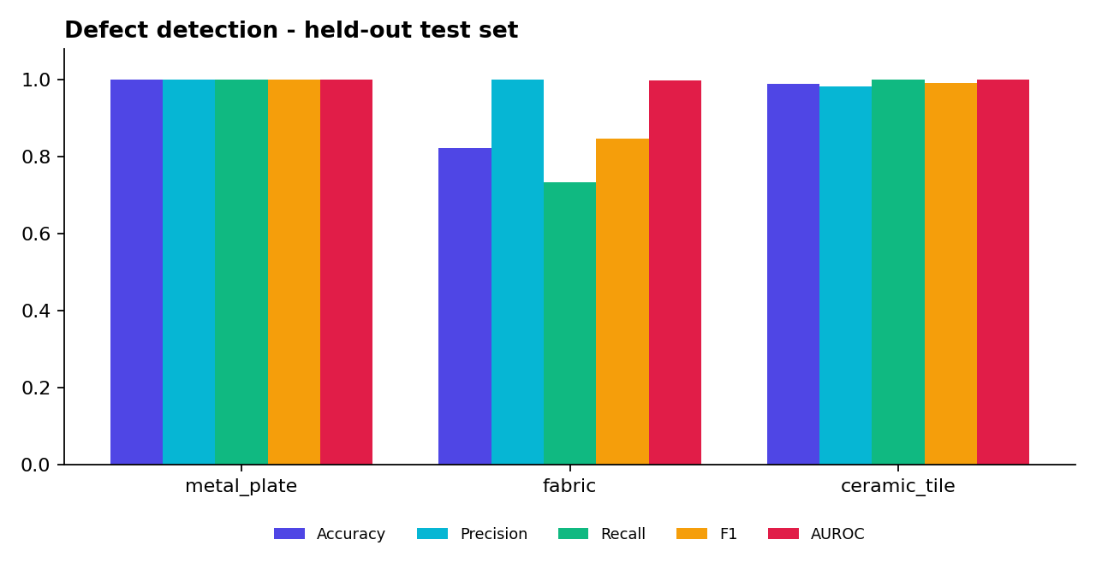
Detection metrics
Reading the results
- The model separates good from defective parts almost perfectly (AUROC ≥ 0.999 everywhere). The lower fabric accuracy is a threshold effect, not a ranking problem: low-contrast dents on the woven texture (0 of 12 caught) fall just under the calibrated threshold. The threshold is deliberately conservative to avoid false alarms.
- At pipeline level (after small-blob filtering and the full decision logic) 0 of 90 good parts were flagged. The single ceramic false alarm in the table above is a model-level count that the pipeline’s minimum-area filter removes.
- Overall, 163 of 180 defective parts (90.6 %) were detected.

3. Defect-type classification (on the 180 defective parts)
Metric | Value
Type accuracy among detected defects | 88.3 %
Type accuracy counting missed defects as wrong | 80.0 %
Previous rule set (before the Milestone-4 feature work), same 163 detected defects, re-measured | 71.8 %

True defect | Recall
Hole / Missing material | 100.0 %
Crack | 97.2 %
Scratch | 83.3 %
Stain / Contamination | 75.0 %
Dent / Deformation | 44.4 %
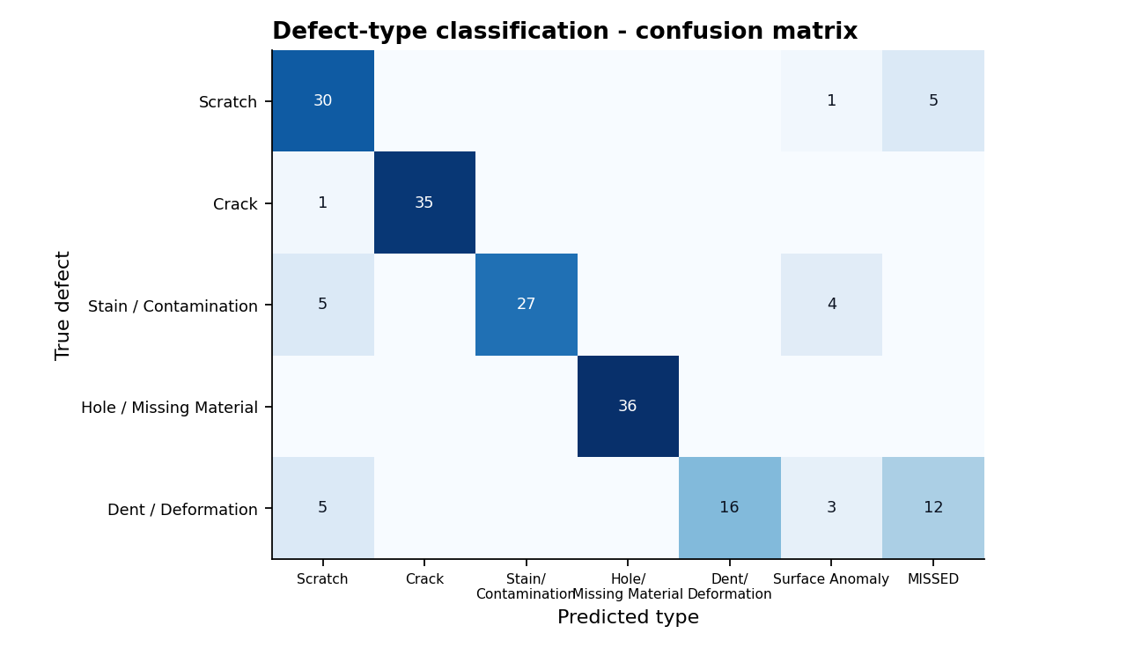
Confusion matrix
What changed in Milestone 4: the classifier now uses texture-independent features — edge density relative to the surroundings (instead of absolute edge density, which a woven fabric inflates), a near-black “void” test using the 10th-percentile lightness (separates holes from dark stains) and the compactness of the raw heat blob (soft dents). That raised type accuracy among detected defects from 72 % to 88 % on the held-out set. The rules were tuned on a different random seed (7) than the test set (2026).

4. Quality-control decisions
True condition | PASS | REVIEW | REWORK | REJECT
Good (90) | 90 | 0 | 0 | 0
Scratch (36) | 5 | 23 | 8 | 0
Crack (36) | 0 | 1 | 31 | 4
Stain (36) | 0 | 7 | 26 | 3
Hole (36) | 0 | 0 | 36 | 0
Dent (36) | 12 | 6 | 18 | 0
- No good part was rejected or sent to rework.
- Most scratches go to REVIEW because their detection confidence is below the 70 % rule — this is the designed behaviour (“confidence < 70 % requires manual review”), keeping a human in the loop for uncertain calls.
- Mean severity score by true type: crack 75.4, hole 72.7, stain 68.7, scratch 47.7, dent 43.5 — the ordering matches engineering intuition (structural defects score highest).

5. Localisation
Mean pixel IoU against ground-truth masks is ≈ 0.22. The anomaly map is smoothed (σ = 3 px at 256 px) so it marks the region of the defect rather than its exact outline; bounding boxes shown in the UI come from a refined mask and are tighter. For pixel-accurate segmentation a U-Net / PatchCore model would be needed (see Future Work).

6. Performance
Metric (256 px analysis, 1 CPU core) | Value
Mean end-to-end time per image (validate → decision → images encoded) | 136 ms
Median / 95th percentile / max | 132 ms / 166 ms / 204 ms
Sustained throughput, single worker | ≈ 7 images / second
Model training (≈48 images, includes evaluation) | 7–11 s per category
The batch endpoint processes uploads with a small thread pool (INFERENCE_WORKERS). On the single-core test machine this gave no measurable speed-up (7.0 → 7.3 img/s), as expected; the benefit on multi-core machines was not measured here. Results depend on hardware — re-run scripts/validate_models.py on the target server.

7. Software tests
Suite | Content | Status
tests/test_engine.py | severity formula (spec example), validation rules, decision rules, classifier shapes, train → evaluate (AUROC, recall, false alarms) | Passing (run during development)
tests/test_api.py | 15 end-to-end API tests: auth, RBAC, rate-limit, uploads (valid/invalid/batch/camera), detail/images/PDF, review workflow, filters/CSV/delete, analytics, dataset → train → inspect-samples jobs | Written; run with cd backend && pytest (also runs in CI)
Frontend | npm run build compiles all pages | Run in CI / locally

8. Known limitations (stated openly)
- Results are on synthetic data; real-world performance must be measured on MVTec AD or plant images.
- Dents / low-contrast defects on textured surfaces are the weakest case (recall 44 % for type, 0 / 12 detected on fabric).
- The classifier is rule-based with thresholds tuned on synthetic data; on real data it should be replaced or retrained with a supervised model using labelled defect folders.
- The “location” score assumes the part centre is the functional zone; real deployments need a per-product zone map.
- Spec note: the brief’s worked example (85/90/95/92) evaluates to 90.2, not the printed 88; the level (Critical) is unchanged.

Deployment Guide
Three ways to run VisionInspect AI, from simplest to production-style. The container images are the same everywhere.

1. Local development (no Docker)
cd backend && python -m venv .venv && .venv\Scripts\activate # Mac/Linux: source .venv/bin/activate
pip install -r requirements.txt
uvicorn app.main:app --reload --port 8000
# new terminal
cd frontend && npm install && npm run dev # http://localhost:5173
SQLite is used automatically (backend/data/visioninspect.db).

2. Docker Compose (PostgreSQL + API + nginx)
cp .env.example .env # set SECRET_KEY (long random) and POSTGRES_PASSWORD
docker compose up --build -d
docker compose ps # backend should become "healthy"
Open http://localhost:8080. Data lives in the named volumes pgdata (database) and appdata (images + models).
Useful commands
Task | Command
Logs | docker compose logs -f backend
Stop / start | docker compose stop / docker compose start
Rebuild after code change | docker compose up --build -d
Back up database | docker compose exec db pg_dump -U visioninspect visioninspect > backup.sql
Back up images & models | docker run --rm -v visioninspect-ai_appdata:/data -v "$PWD":/b alpine tar czf /b/appdata.tgz -C /data .
Wipe everything | docker compose down -v

3. Cloud deployment

3a. AWS — single EC2 instance (simplest, recommended for the internship demo)
- Launch an EC2 instance: Ubuntu 22.04/24.04, t3.medium (2 vCPU, 4 GB) or larger, 20 GB disk. Security group: inbound TCP 22 (your IP only), 80 and 443 (anywhere).
- Install Docker:
- sudo apt update && sudo apt install -y docker.io docker-compose-v2 git
sudo usermod -aG docker $USER && newgrp docker
- Copy the project (git clone <your repo> or scp -r), then:
- cp .env.example .env && nano .env # strong SECRET_KEY + POSTGRES_PASSWORD, set SEED_DEMO_USERS=false for real use
# edit docker-compose.yml: change ports: ["8080:80"] to ports: ["80:80"]
# and set CORS_ORIGINS to http://<your-domain-or-ip>
docker compose up --build -d
- Open http://<EC2 public IP>. For a domain + HTTPS, put the instance behind an Application Load Balancer with an ACM certificate, or install Caddy/nginx + Let’s Encrypt on the host and proxy to port 80.
- Scaling path: images and models → S3, database → RDS PostgreSQL (set DATABASE_URL), containers → ECS Fargate behind an ALB. Training jobs would then move to a queue (see Future Work in the technical documentation).

3b. Azure — Virtual Machine with Docker (same steps)
- Create an Ubuntu VM (Standard_B2s or larger); open ports 80/443 in the Network Security Group.
- Install Docker as above, copy the project, configure .env, run docker compose up --build -d.

3c. Azure — Container Apps (managed containers)
az group create -n visioninspect-rg -l centralindia
az acr create -g visioninspect-rg -n <uniqueAcrName> --sku Basic
az acr build -r <uniqueAcrName> -t backend:1 ./backend
az acr build -r <uniqueAcrName> -t frontend:1 ./frontend
az postgres flexible-server create -g visioninspect-rg -n <uniquePgName> --admin-user vi --admin-password '<strong-pw>' --sku-name Standard_B1ms
az containerapp env create -g visioninspect-rg -n vi-env -l centralindia
az containerapp create -g visioninspect-rg -n vi-backend --environment vi-env --image <acr>.azurecr.io/backend:1 \
--target-port 8000 --ingress internal --min-replicas 1 --max-replicas 1 \
--env-vars DATABASE_URL='postgresql+psycopg2://vi:<pw>@<pg>.postgres.database.azure.com:5432/postgres?sslmode=require' SECRET_KEY='<long-random>' DATA_DIR=/data
az containerapp create -g visioninspect-rg -n vi-frontend --environment vi-env --image <acr>.azurecr.io/frontend:1 \
--target-port 80 --ingress external
Notes: keep one backend replica (training jobs and the login throttle are in-process); mount an Azure Files share at /data for images and models; change the proxy_pass host in frontend/nginx.conf to the backend app’s internal FQDN. Names, SKUs and regions are examples — check current Azure CLI syntax before running; commands were not executed in this project.

4. Configuration reference (environment variables)
Variable | Default | Meaning
DATABASE_URL | SQLite file in DATA_DIR | e.g. postgresql+psycopg2://user:pw@host:5432/db
SECRET_KEY | insecure default (warning logged) | JWT signing key — must be changed in production
ACCESS_TOKEN_MINUTES | 720 | token lifetime
DATA_DIR | backend/data | images, models, SQLite
DATASET_ROOT | DATA_DIR/datasets/mvtec_ad | where MVTec-style categories live
MAX_UPLOAD_MB | 20 | per-image limit
INFERENCE_WORKERS | min(4, CPUs) | threads for batch inspection
CORS_ORIGINS | localhost dev ports | comma-separated allowed origins
ADMIN_EMAIL / ADMIN_PASSWORD | admin@visioninspect.ai / Admin@123 | seeded admin
SEED_DEMO_USERS | true | create the engineer + supervisor demo accounts

5. Production checklist
- ☐ Strong SECRET_KEY, changed admin password, SEED_DEMO_USERS=false
- ☐ HTTPS in front of the app; CORS_ORIGINS set to the real origin
- ☐ Backups for the database and the appdata volume
- ☐ Run one backend instance (or move jobs/throttle to Redis + a queue before scaling out)
- ☐ Monitor /api/health (used by the Docker healthcheck)

6. Troubleshooting
Symptom | Cause / fix
UI loads, login says network error | backend not healthy: docker compose logs backend
502 from nginx | backend still starting, or proxy_pass host wrong
psycopg2 build error on local install | delete it from requirements.txt when using SQLite
Large uploads fail | raise client_max_body_size in frontend/nginx.conf
Training says “Need at least 8 good training images” | category has fewer than 8 images in train/good

User Guide

Roles
Role | Can do
Administrator | everything: users & roles, audit trail, models, review, delete inspections
Quality Engineer | inspect, manage dataset & train models, analytics
Factory Supervisor | inspect, review/approve decisions, analytics
Demo accounts: admin@visioninspect.ai / Admin@123, engineer@visioninspect.ai / Engineer@123, supervisor@visioninspect.ai / Supervisor@123.

First-time setup (Engineer or Admin)
- Models & Dataset → Generate demo dataset (or copy real MVTec AD categories into backend/data/datasets/mvtec_ad/).
- Click a category card → Train & activate model (10–30 s). Accuracy, precision, recall, F1, AUROC and the false-alarm rate appear in the model registry.
- Inspect samples to fill the dashboards with realistic history (set Defective share to ~15 % for a realistic factory).

Inspecting parts
- New Inspection → Upload: drop one or many images (JPG, PNG, BMP, TIFF, WebP ≤ 20 MB). One image opens its report; several create a batch with a results list. Files that fail validation are listed with the reason.
- Camera simulation: captures simulated frames from the line and inspects them automatically.
- Pick the product category first — it selects the trained model. Without a trained model the baseline detector is used (banner shows which).

Reading a report
- Banner: decision (PASS / REVIEW / REWORK / REJECT), severity score, number of defects, processing time, recommendation.
- Image tabs: Detections (interactive boxes — hover or click to link with the table), Original, Preprocessed (model input), Anomaly heatmap.
- Severity breakdown: size 30 %, location 25 %, type 25 %, confidence 20 %.
- Quality-control action: recommendation, probable root cause, review state, PDF certificate.
- Image quality report: sharpness, brightness, contrast, noise, exposure and warnings (re-capture if the grade is D).
Severity | Score | Decision
Critical | 80–100 | REJECT
High | 60–79 | REWORK
Medium | 40–59 | REVIEW
Low | 0–39 | PASS (REVIEW if confidence < 70 %)

Reviewing (Supervisor / Admin)
Open an inspection → Approve, Rework or Reject → add a note → Confirm. The review is stored with your name and time and appears on the PDF. Inspections → Needs review lists the queue.

Analytics
- Dashboard: KPIs vs the previous period, volume & defect-rate trend, defect types, severity, insights, alerts (e.g. defect rate above 35 % in the last 20 parts, or 3 consecutive rejects), recent inspections.
- Analytics: decisions per day, defect-rate/severity trend, severity levels, quality-risk table, per-category production quality, CSV production report. If simulated/dataset samples exist it also shows decision accuracy, detection rate and false-defect rate against their known labels.

Administration
User Management: add users, change roles, disable accounts, view the audit trail.

