NAAN MUDHALVAN

NAME:Gayathri M

COURSE:SALESFORCE

NM ID:

8CD018673D1115B9A414BBAE8B2D5F8A

Task1:

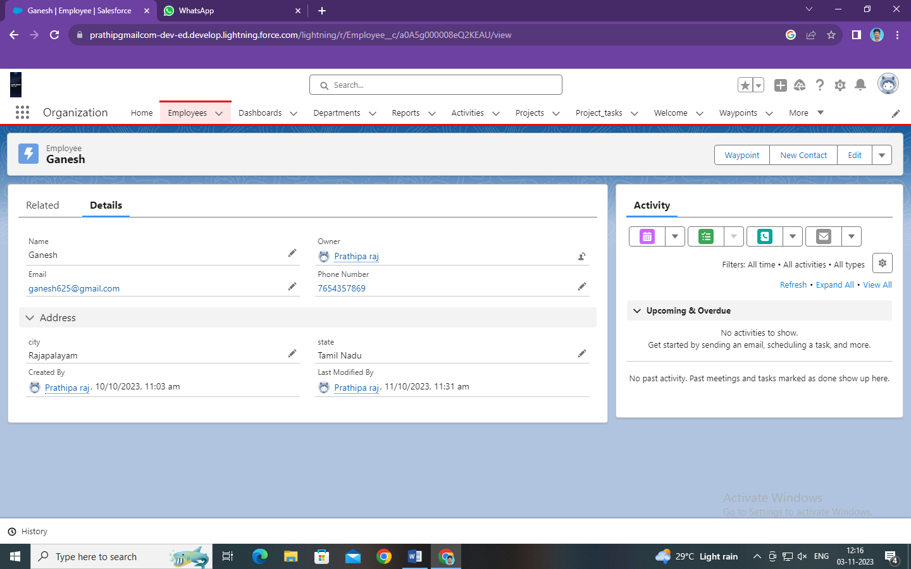

Task 2:

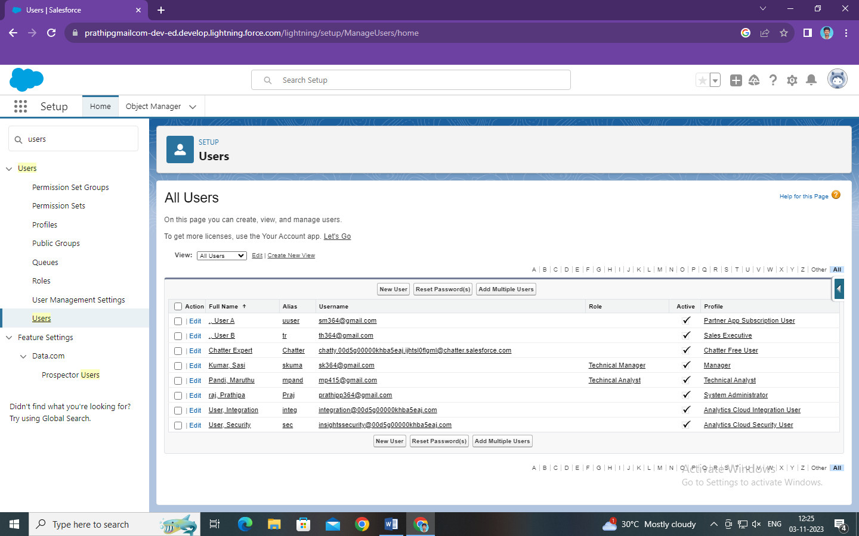

Task 3:

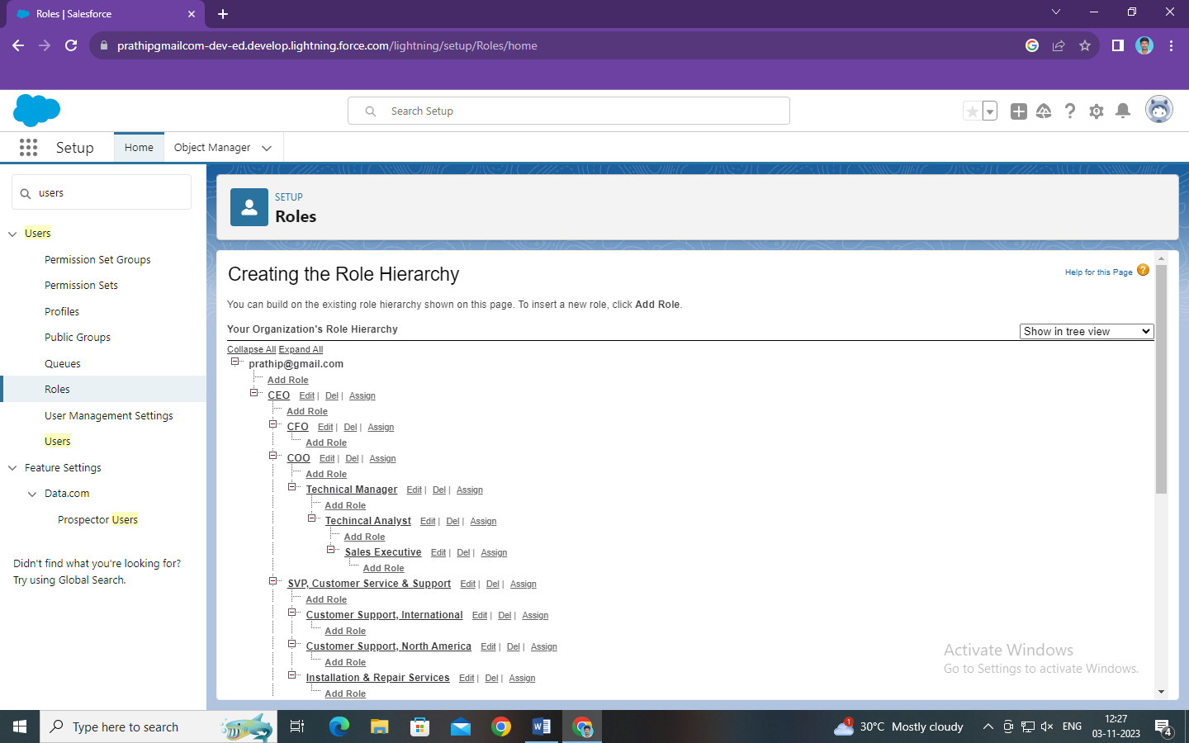

Task 4:

