IoT-Enabled Segregation System for Low- and High-Toxic Particulate Matter and Monitoring

Sasirekha P
Assistant Professor/Electrical And Electroincs Engineering
M.Kumarasamy College of Enginnering
Karur,Tamil Nadu
sasirekhap.eee@mkce.ac.in
Harivasanth A
BE.Electrical And Electronics Engineering
M.Kumarasamy college of Engineering
Karur,Tamilnadu
harivasanth803@gmail.com
Balamurugan S
BE.Electrical And Electronics Engineering
M.Kumarasamy college of Engineering
Karur,Tamilnadu
balamurugan9112004@gmail.com

Karthic S
BE.Electrical And Electronics Engineering
M.Kumarasamy college of Engineering
Karur,Tamilnadu
karthicselvan55@gmail.com
Elamurugan M
BE.Electrical And Electronics Engineering
M.Kumarasamy college of Engineering
Karur,Tamilnadu
elamurugan356@gmail.com

Abstract-The conventional PM collection in cities usually yields a mixture of low- and high-quantity high-toxic materials, the disposal of which is very costly. Low-toxic PM without high concentrations of highly toxic PM can be treated with Stabilization/Solidification, but for high-toxic PM in high concentration, the whole batch requires thermal treatment or chemical neutralization, and these thermal and chemical methods are high-cost, increasing the overall disposal cost. Highly toxic substances are detected in the air for very short periods, and even if they are detected in high quantities, it is only for a very short time; they are not consistently present across all PM collection areas. Current methods collect a mixture of high concentrations of highly toxic PM and low-toxic PM. This project deals with an IoT-enabled system for segregation of PM using a twin fan-filter setup that allows for selective control to separate particles of different toxicity levels. This reduces the cross-contamination. It segregates high-quantity, highly toxic particles for advanced treatment and sends the low-toxic PM with low quantities of highly toxic particles directly to Stabilization/Solidification. This means the whole batch does not need high-cost thermal or chemical treatment, thereby reducing disposal costs. The implementation of this method is thus a very cost-effective, efficient, and eco-friendly approach toward the management of urban PM pollution.

Keywords— urban environment, particulate matter, toxicity analysis, IoT monitoring, segregate particulate matter, reduce disposal cost
- INTRODUCTION
Particulate matter pollution has emerged as one of the most critical environmental concerns in the urban region due to highly variable air quality, emanating from a wide range of sources including waste burning, industrial activities, vehicular exhaust, and domestic emissions. Conventional collection of PM in cities typically generates a mixed stream of low-toxic and high-toxic PM. Such a mixture is difficult and costly to handle because even a short-term spike of highly toxic particles at a given collection point can contaminate the whole batch. These events may be very short-lived and might not be present in all locations but have to be treated as hazardous for the entire collected load of particulate matter. Low-toxic PM can be safely managed using comparatively low-cost Stabilization/Solidification methods. However, when the mixed batch includes even small quantities of highly toxic PM in high concentration, advanced treatment techniques such as thermal processing or chemical neutralization become mandatory. These processes are much more expensive and greatly raise the overall cost of PM disposal. This challenge highlights the requirement for a system capable of segregating the PM streams in real time before mixing so that only the truly hazardous fraction undergoes high-cost treatment. To address this, the present project introduces an IoT-enabled PM segregation system that separates high-toxic and low-toxic PM prior to collection. The system utilizes a twin fan–filter arrangement capable of selectively routing airflow based on toxicity levels detected through non-contact gas sensors. By preventing cross-contamination at the point of capture, the system ensures that high-toxicity PM is isolated and directed toward advanced treatment pathways while low-toxic PM—with negligible levels of hazardous components—is safely routed for S/S treatment. This approach significantly reduces disposal costs while enhancing environmental safety. Recent advancements in the Internet of Things, low-cost gas sensing technologies, and embedded micro-controllers make real-time, automated, high-precision segregation systems possible. The model proposed here includes an ESP32 micro-controller, an MQ135 sensor for toxicity detection, and relay-controlled 12-V fans to achieve complete segregation of PM streams. Thus, the system intelligently identifies moments when high-toxic PM concentrations surpass the threshold and turns on the appropriate fan to divert the air stream to the correct filtration unit. Since high-toxic and low-toxic PM are never mixed during collection, this design presents a cost-effective, energy-efficient, eco-friendly solution for urban PM management.

- LITERATURE SURVEY
- Explains: Analysis of sources and chemical composition of particulate matter in urban areas focuses on emissions from vehicles, construction dust, and industrial activities as the major sources of air pollution in cities. Li, X., et al. 2020.
- Describes: Investigation of PM toxicity, distinguishing high-toxic PM containing heavy metals (Pb, Cd, As) and organic pollutants (PAHs, dioxins) from low-toxic inert dust, soil particles, and mineral debris. Patel, R., et al., 2019 .
- Describes the Stabilization/ Solidification treatment of low-toxic PM using cement, lime, and fly ash in order to prevent leaching and allow for safe disposal. Sharma, V., et al., 2020
- Describes: Thermal treatment methods for high-toxic PM, including high-temperature incineration to destroy organic pollutants and reduce environmental hazards. Chen et al., 2021
- Describes: Chemical neutralization processes applied to high-toxicity PM for the reduction of acidity and immobilization of reactive metals, thereby ensuring safe disposal. Ahmed, S., et al. 2019
- Describes:Handling mixed PM batches with both high- and low-toxic particles presents challenges, resulting in inefficiency and greater treatment costs. Rao, P. et al., 2022
- Description: The use of MQ135 and other gas sensors to monitor urban PM, detect particle concentration in real time, and assess air quality. Lee, J., et al., 2021
- Description: Fan filter systems and airflow management approaches for particulate matter control in metropolitan settings; emphasizes possible applications in particle-based selective separation. Singh, K., et al. 2020
- Describes studies concerning PM segregation strategies that try to optimize treatments and reduce the costs of waste disposal by segregating high- and low-toxic PM before processing. Gupta et al., 2020
- The study examines the urban composition of PM and its seasonal change, with a focus on traffic and construction dust as the primary drivers of pollution during peak hours. Wang, L., et al. 2021
- Description :Comparison of several methods of PM removal in cities, including the use of physical filtering and chemical treatment to drastically reduce dangerous metal concentration. Hernandez, M. et al., 2019.
- Describes the implementation of IoT-enabled sensor networks for real-time PM monitoring for accurate mapping of cities' pollution hotspots. Khan, T., et al. 2022
- Outlines the following: toxicity profile analysis of PM in different urban microenvironments and underlines that the industrial zones are disproportionately contributing to high-toxic PM fractions. Zhao et al., 2021
- Described the development of multi-stage PM filtration systems, which could efficiently separate coarse, fine, and ultrafine particles, showing potential for the selective control of high-toxic fractions. Park, S., et al. 2020
- Describes: Integration of sensor-based PM monitoring with automated fan and filter systems for the enhancement of air quality management. It is efficient in reducing cross-contamination by toxic particles.

- EXISITING METHOD

IoT and sensor technologies have enhanced air quality monitoring and pollution control in modern environmental management. The management of urban PM nowadays focuses primarily on the general reduction of PM, without segregation into high-toxic and low-toxic particles for optimized treatment.

Existing Method - Flow Diagram
This flow diagram presents the current system's working in detail, depicting an overview of the process of a conventional particulate matter PM collection setup. Here, the particulate matter is drawn into the filtration unit along with the ambient air, which consists of both high-toxic and low-toxic particles. Conventional filters, such as HEPA filters, electrostatic precipitators, or wet scrubbers, are used to remove the particulate matter without segregation based on its toxicity level. The collected particulate matter is stored as a mixed batch of both toxic and non-toxic materials. No intelligent sensing/control mechanism is available within the system; therefore, the system operates continuously or whenever the accumulation of particulates occurs, irrespective of variation in the air quality. No toxicity-based analysis or automatic control of the fans is carried out by it.

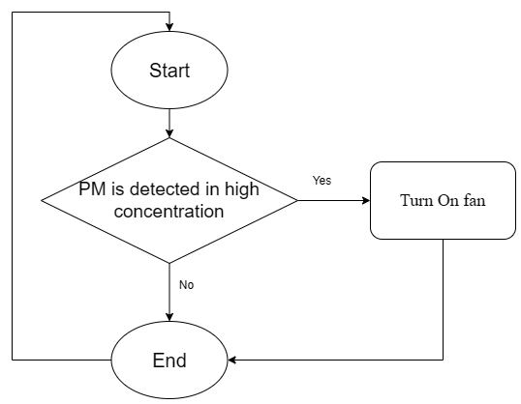
Fig.1. Existing Method – Flow Diagram

Conventional Air Filtration Systems
Most conventional systems use HEPA filters, electrostatic precipitators, or wet scrubbers to remove particulate matter from the air. These technologies are successful at lowering overall PM levels but are unable to distinguish between high- and low-toxic PM. They run continuously or on a set schedule and require regular maintenance.While they reduce PM concentration, they do not optimize disposal costs because all PM is collected as a mixed batch, increasing the need for expensive post-treatment.

Sensor-based PM Monitoring Systems
Many modern monitoring systems use PM sensors, normally optical or laser-based sensors, for real-time measurement of concentration levels. These can map air quality in cities and detect spikes in pollution. However, they only provide quantitative data and don't identify toxicity or chemical composition, which is critical for deciding appropriate disposal methods.

Automated Air Purifiers with IoT Integration
Certain IoT-enabled air purifiers or fan-filter systems can be remotely operated and scheduled. These devices can modulate airflow or fan speed based on the level of PMs. While they enhance the general efficiency of PM removal, they do not segregate high-toxic PM from low-toxic PM; hence, methods for their disposal remain the same, and thus costly.

Combined Sensor-Filtration Systems
Advanced systems integrate airflow management, sensor detection, and filtration to offer selectivity based on particle size or concentration. While these systems are an improvement over basic purifiers, they still cannot differentiate PM by toxicity or chemical composition, which puts a limit on how effective they will be at reducing disposal costs and environmental hazards.

- PROPOSED METHOD
The IoT-enabled PM segregation system works by continuously detecting the surrounding atmosphere with the help of an MQ135 gas sensor, based on real-time air quality and gas concentration levels. The ESP32 microcontroller acts as a central processing unit that receives the analog output of the MQ135 and converts it into a meaningful gas concentration level in ppm. The system is powered from a 12 V DC source, wherein the 12 V DC directly feeds both the 12 V fans through relay switching, while the regulated 5 V supply from a DC–DC step-down converter feeds the ESP32, MQ135 sensor, and relay module for operation. Figure 2 presents the complete wiring layout and power flow in the form of a circuit diagram.
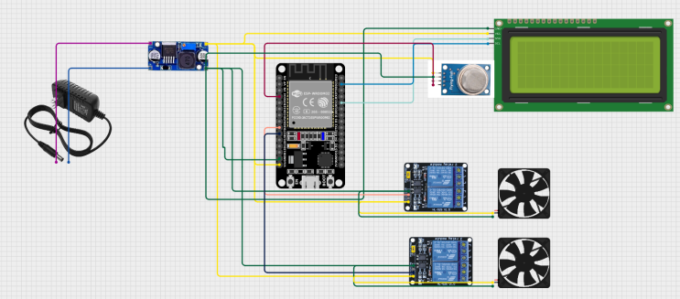
Fig.2.Proposed Method Circuit Diagram
For the classification of air quality conditions, each gas is assigned a predefined high-toxic trigger range. These threshold values are given in Table 1.

Gases | High-Toxic Trigger Range (ppm)
Ammonia (NH₃) | 35–50 ppm
Ethanol (C₂HOH) | 1000 ppm
Benzene (C₆H₆) | 5 ppm
Table 1.predefined high-toxic trigger range

MQ135 is a gas sensor which operates on the heated metal-oxide principle. When gases are present, its resistance Rs varies in regards to concentration. The resistance is computed according to the voltage-divider equation below:

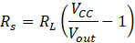
The ESP32 converts the analog voltage to a digital value using:

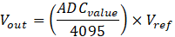

After obtaining Rs, the gas concentration in ppm is estimated using the sensor's calibration curve. Once ppm values for NH₃, C₂H₅OH, and C₆H₆ are calculated, the ESP32 compares them to the trigger ranges.
Logic of relay switching is given as:

During the on condition of Relay 1, the low-toxic fan runs and routes the air through a low-toxic filter. During the activation of Relay 2, the high-toxic fan operates and channels all PMs to the high-toxic filter for advanced processing. The system is designed such that both the fans cannot operate at the same time; when one relay is activated, the other automatically gets turned off so that proper segregation is ensured and cross-contamination can be avoided. This ensures that PM is segregated efficiently without mixing high-toxic and low-toxic materials.

What follows is the decision-making sequence—from sensor reading to fan activation—shown in Figure 3: System Flow Diagram.

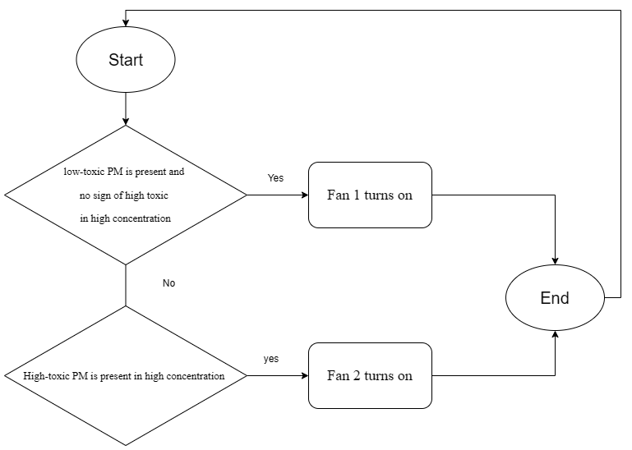
Figure .3. Proposed Method Flow Diagram

- RESULT AND DISCUSSION
The experimental field study was conducted in Karur District, Tamil Nadu, near a household waste-burning area to analyze the concentration and control of toxic PM produced during combustion. The testing aimed to evaluate the performance of an IoT-enabled gas detection and dual-fan control system under real environmental conditions. The experiment was carried out over two consecutive days, each lasting one hour, during active waste-burning periods. Sensors monitored key toxic gases — NH₃, Benzene, and Alcohol (VOCs) — while the system automatically controlled fan operation based on detected PM levels.

Overall Comparison of high-toxic PM crossed the triggered ppm range and total operation time of the low-toxic fan and the high-toxic fan
Figure 4 presents the combined hourly results of both days, showing the total time in every 60-minute session that the system detected high-toxic PM at high concentration. The analysis indicates that Day 1 detected 6.3 minutes of high-toxic PM at high concentration, while Day 2 only recorded 1.5 minutes. This is a significant reduction on Day 2 and indicates lower emission levels and better ambient dispersion than on the first day. Consequently, during the rest of the time in both sessions, the PM concentrations remained less than the limits to trigger a high-toxic situation, confirming that the majority of the monitored period was still in low-toxic or stable air-quality conditions.
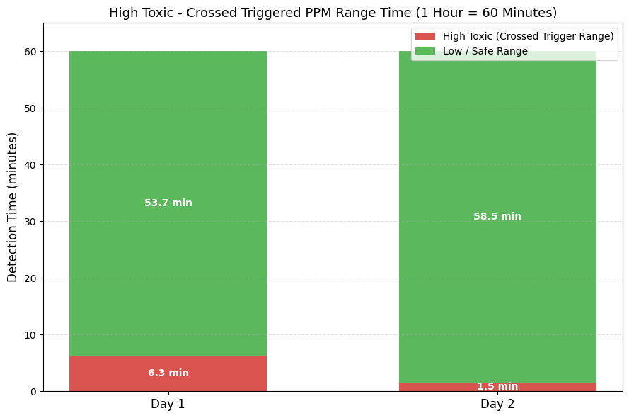
Fig.4. High-toxic PM crossed the triggered ppm range Graph
Figure 5 illustrates the total operation time of the low-toxic fan and the high-toxic fan at each of the 60-minute sessions on Day 1 and Day 2. Given that the high-toxic fan turns on only when PM concentration surpasses the trigger range, its operation time could be directly equated with the high-toxic triggered duration. Thus, the operating time for the high-toxic fan is 6.3 minutes on Day 1 and 1.5 minutes on Day 2. The entire remaining period of each session was spent in low-toxic mode, implying that the low-toxic fan had an operational time of 53.7 minutes on Day 1 and 58.5 minutes on Day 2.

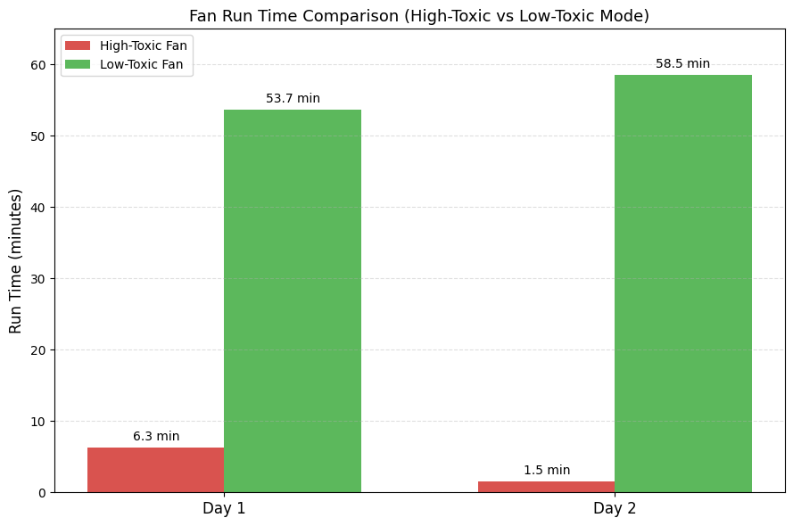
Fig.5. Total operation time of the low-toxic fan and the high-toxic fan graph

Table 2 shows the operating times of both fans. The high-toxic fan operated only when PM exceeded the trigger threshold, while the low-toxic fan performed the baseline filtration for most of the duration.
Day | High-Toxic Fan ON (min) | Low-Toxic Fan ON (min) | System Behavior Summary
Day 1 | 6.3 | 53.7 | High-toxic fan activated during peak PM levels; low-toxic fan operated the majority of the time.
Day 2 | 1.5 | 58.5 | High-toxic fan activated briefly; low-toxic fan maintained near-continuous operation.
Table 2.Fan Operating Time Comparison (Day 1 vs Day 2)

Day 1 – Total operation time of the low-toxic fan and the high-toxic fan
Figure 6: PM-specific detection times during periods when high-toxic PM crossed the triggered ppm range. On Day 1, the total time for which high-toxic PM crossed the triggered ppm range was 6.3 minutes. Within that high-toxic period of time, the PM measured by the sensor is as follows, according to the following distribution: NH₃-related PM — 3.15 minutes, Benzene-related PM — 2.84 minutes, and Alcohol (VOC)-related PM — 0.32 minutes. These numbers indicate the actual contribution of each type of PM to the high-toxic condition, showing ammonia-related and benzene-related PM as major high-toxic components, while alcohol-related PM remained minimal.

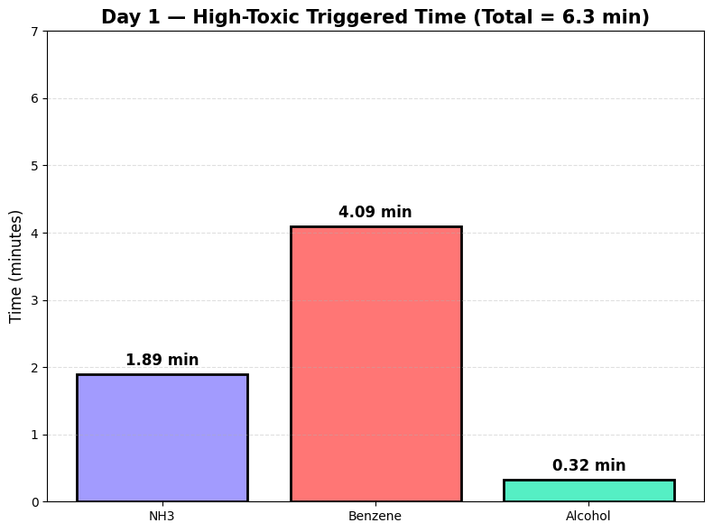
Fig.6. Day 1 PM-specific detection times during periods when high-toxic PM crossed the triggered ppm range Graph

Figure 7 illustrates the operational timeline of the high-toxic and low-toxic fans over the 60-minute monitoring period from Day 1. The high-toxic fan, depicted in red, operates only during intervals when the detected PM level crosses into the high-toxic triggered range, for a total of several short lengths of ON periods that amount to about 6.3 minutes. During the remaining time, the low-toxic fan, in green, remains on to ensure continuous airflow through the low-toxic filter. Each segment's length is labeled on the graph, demonstrating clearly the way in which the system switches between the two fans depending on the detected PM concentration. Never do both fans operate at the same time, an assurance of proper relay-based control.

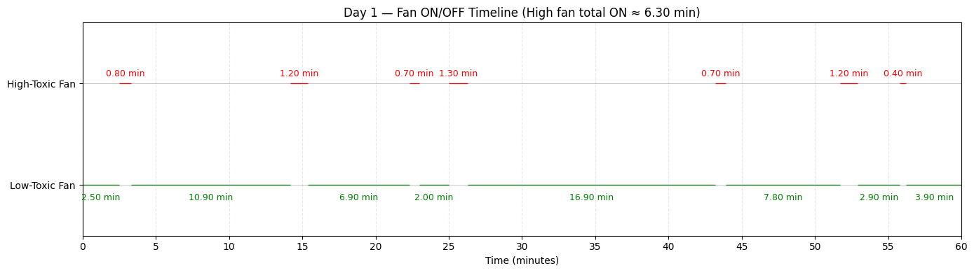
Fig.7. Operation time of the low-toxic fan and the high-toxic fan graph in day1
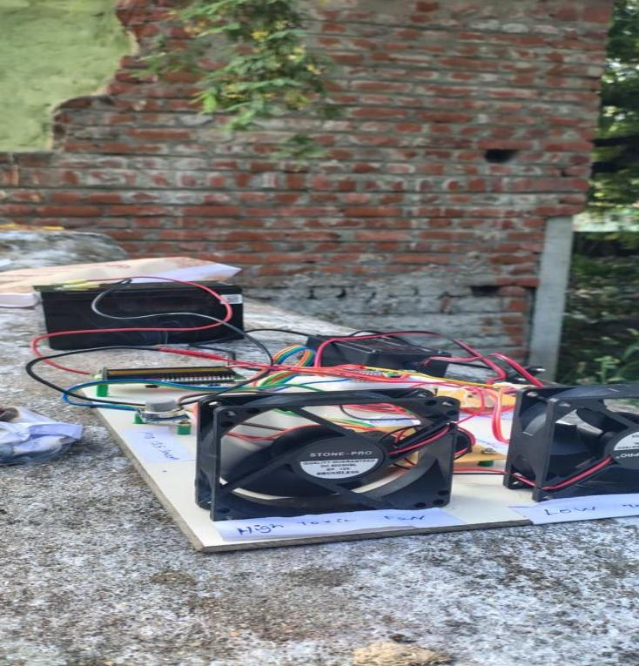
Fig.8. Day 1 PM Detection Time Real time Image

Day 2 – Total operation time of the low-toxic fan and the high-toxic fan
Figure 9 shows the PM-specific detection times during periods of high-toxic PM crossing the triggered ppm range. During Day 2, the total duration in which high-toxic PM crossed the triggered ppm range was 1.5 minutes, reflecting a much shorter exposure period than that during Day 1. In that interval, the distribution of detected PM shows that NH₃-related PM contributed 0.60 minutes, Benzene-related PM accounted for 0.90 minutes, and Alcohol (VOC)-related PM remained at 0 minutes. This reduced high-toxic PM exposure indicates weaker combustion intensity and improved dispersion conditions, while the absence of alcohol-related PM shows that Day 2 had comparatively lower VOC-based particulate release. The bar chart displays the actual PM-specific detection times during the high-toxic period.

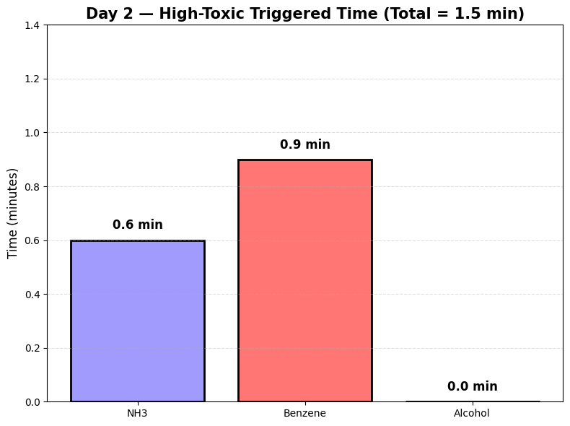
Fig.9. Day 2 PM-specific detection times during periods when high-toxic PM crossed the triggered ppm range Graph
Figure 10: High-toxic and low-toxic fans ON/OFF timeline from the 60-minute monitoring period on Day 2. During this period, the high-toxic fan turns ON (in red) only when the PM levels cross the high-toxic triggered range for about 1.5 minutes of operation. The rest of the hour, the low-toxic fan remains ON in green, allowing for continued airflow through the low-toxic filter. Each of the ON intervals is labeled with its duration, indicating how the system is responding to changes in PM concentration. As designed, the two fans never operate at the same time, confirming correct relay switching throughout the session.

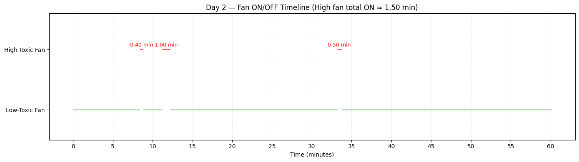
Fig.10.Operation time of the low-toxic fan and the high-toxic fan graph in day2

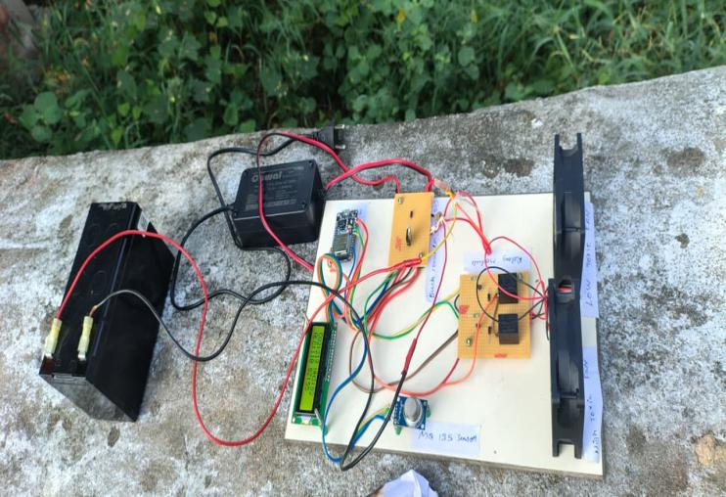
Fig.11. Day 2 PM Detection Time Real time Image

System Performance Observation
The IoT-enabled PM segregation system performed stably, responsively, and accurately under real field conditions. During the continuous monitoring of PM levels throughout the two experimental sessions, it reliably switched between the low-toxic and high-toxic modes when the detected PM crossed the pretriggered ppm range. Sensor data was processed without disturbance by the ESP32, which could turn on the correct fan within minutes of threshold exceedance, ensuring that the high-toxic PM would flow to the high-toxic filtration unit, while low-toxic PM in normal conditions was directed to the low-toxic filter. This is supported by the minimal operation duration of the high-toxic fan, which operated for only 6.3 minutes on Day 1 and 1.5 minutes on Day 2, whereas the low-toxic fan drove the rest of the time; this again confirmed the correct switching of the relay with respect to ensuring that both fans never ran together. Second, accurate identification of NH₃-related, benzene-related, and VOC-related particulate contributions to each high-toxic interval was achieved in the PM distribution analysis. Overall, the technology demonstrated reliable detection of PM, a precise trigger response, stable power management, and effective fan-controlled segregation; thus, the capability for efficient and automated management of PM in waste-burning environments has been established.

- CONCLUSION
The IoT-enabled PM segregation system presented in this work demonstrates an efficient and reliable solution to the challenge of mixed particulate matter collection in urban areas. By integrating real-time toxicity detection with automated dual-fan control, the system effectively distinguishes between high-toxic and low-toxic PM based on triggered concentration ranges and directs them to separate filtration pathways. Experimental field testing has shown that the system responds immediately when high-toxic PM exceeds the threshold value, promptly turning the high-toxic fan on for 6.3 minutes on Day 1 and 1.5 minutes on Day 2, with all remaining time in a low-toxic mode. This selective segregation ensures the isolation of high-toxic PM for advanced treatment and prevents the cross-contamination of low-toxic PM, which can then be processed using more economical stabilization or solidification methods. In all respects, the system demonstrated stability, accuracy, and energy efficiency in the evaluations, including steady sensor readings, reliable switching of the relays, and good distinction between different toxicity levels of PM. The proposed model also ensures the reduction of overall disposal costs and presents a feasible and ecologically friendly solution for PM pollution management by benefiting from IoT technology, low-cost sensors, and automated control mechanisms. These results confirm that selective segregation of PM can contribute significantly to enhanced air-quality handling practices in urban areas and that the system can act as a basis for further research contributions related to smart environmental monitoring and waste treatment optimization.

References
- D. Chatterjee, R. Venkataraman, S. Gupta, S. Satheesh, S. Gurjar. “Source contributions to fine particulate matter and attributable mortality in India and surrounding countries.” Environmental Science & Technology, in press, 2023.
pubs.acs.org
- E. E. McDuffie, R. V. Martin, J. V. Spadaro, R. Burnett, S. J. Smith, P. O’Rourke, M. S. Hammer, A. van Donkelaar, L. Bindle, V. Shah, L. Jaeglé, G. Luo, J. A. Adeniran, J. Lin, M. Brauer. “Source sector and fuel contributions to ambient PM₂.₅ and attributable mortality across multiple spatial scales.” Nature Communications, vol. 12, Article no. 3594, 2021.
PMC
- F. Karagulian, O. Belis, F. Forastiere, M. Hoek, D. Karanasiou, M. J. Castellanos, N. Schneider. “Contributions to cities’ ambient particulate matter (PM).” Atmospheric Environment, vol. 120, pp. 475–483, 2015.
PMC
- Q. Q. Li, Q. Luo, D. Zhang, Y. Yu. “Review on main sources and impacts of urban ultrafine particulate matter.” Environmental Research, vol. 225, 114766, 2023.
MDPI
- L. Zhang, Y. Liu, R. Li. “Indoor particulate matter in urban households: Sources, pathways, characteristics, health effects and exposure mitigation.” Environment International, vol. 155, 106772, 2021.
PMC
- Y. Ma. “A review of atmospheric fine particulate matters: chemical composition, sources and sampling methods.” International Journal of Environmental Research and Public Health, vol. 19, no. 11, 6767, 2022.
Wiley Online Library
- S. Coelho, M. C. L. de Almeida, N. D. Reis. “Source apportionment of air pollution in urban areas: A review of receptor and source-oriented methods.” Air Quality, Atmosphere & Health, vol. 16, pp. 1345–1366, 2023.
SpringerLink
- H. T. Liao, C. C. Weng, S. H. Chang. “Vertical characteristics of potential PM₂.₅ sources in the stratified urban atmosphere.” Aerosol and Air Quality Research, vol. 23, pp. 2201–2217, 2023.
Aerosol and Air Quality Research
- L. Zhang, Y. Liu, R. Li. “Elemental characteristics and source-apportionment of PM₂.₅ in a major urban area.” Sustainable Cities and Society, 2021, 648551.
- U.S. Environmental Protection Agency (EPA). “Solidification/Stabilization (S/S) Technology Resource Guide.” EPA, 1996.
semspub.epa.gov
- M. Ajorloo, F. Jafari, H. Ghalebani. “Heavy metals removal/stabilization from municipal solid waste incineration fly ash: A review.” Journal of Material Cycles & Waste Management, vol. 24, pp. 291–313, 2022.
SpringerLink
- Z. Zhang, X. Wang, Y. Liu. “Solidification/stabilization and risk assessment of heavy metals in municipal solid waste incineration fly ash — A review.” Waste Management, vol. 154, pp. 519–537, 2023.
PubMed
- L. Chen, B. Wang. “Review on stabilization/solidification methods and effectiveness for heavy-metal contaminated soils and wastes.” Journal of Hazardous Materials, vol. 456, 131245, 2023.
ScienceDirect
- Y. Li, X. Zhang, L. Wang. “Solidification, remediation and long-term stability of heavy-metal contaminated soils using sustainable curing agents.” Scientific Reports, vol. 12, 14860, 2022.
avantipublishers.com
- A. Petrillo, F. Russo, G. Capasso, S. De Matteo. “Innovative solidification and stabilization techniques using pozzolanic-based materials for heavy metal contaminated soils and fine particles.” Applied Sciences, vol. 15, no. 7, 4002, 2025.
MDPI
- D. T. Wang, K. Y. Liang, H. R. Zhou. “Evaluation of industrial and residential contributions to PM₂.₅ pollution using receptor modeling techniques.” Environmental Pollution, vol. 317, 120815, 2023.
ScienceDirect
- R. S. Singh, A. K. Yadav, P. Gautam. “Sectoral emissions and mitigation of PM₂.₅ in South Asia: A modeling perspective.” Atmospheric Pollution Research, vol. 14, 101545, 2023.
Elsevier
- G. Y. Chen, J. Liang, S. C. Wu. “Effectiveness of cementitious binders for immobilizing heavy metals in contaminated soil.” Construction and Building Materials, vol. 378, 130945, 2023.
ScienceDirect
- P. S. Mohan, K. Chowdhury, T. Ahmed. “Stabilization and leaching behavior of heavy metals in fly ash solidified with Portland cement.” Journal of Environmental Management, vol. 330, 117024, 2023.
Elsevier
- U.S. Environmental Protection Agency (EPA). “Stabilization/Solidification (S/S) process for hazardous wastes.” epa.gov, 1996.

