

EEC1345 MACHINE LEARNING

ML-Based Intelligent Tree Species Selection and Oxygen Recovery Prediction System

A PROJECT REPORT
Submitted by

DHARNISH P S (927623BEE022)
DHARSAN S (927623BEE023)
ELAMURUGAN M (927623BEE028)

in partial fulfilment for the award of the degree of
BACHELOR OF ENGINEERING
in
ELECTRICAL AND ELECTRONICS ENGINEERING M.KUMARASAMY COLLEGE OF ENGINEERING, KARUR
DECEMBER 2025

M.KUMARASAMY COLLEGE OF ENGINEERING, KARUR
(Autonomous Institution affiliated to Anna University, Chennai)

BONAFIDE CERTIFICATE

Certified that this project report “ML-BASED INTELLIGENT TREE SPECIES SELECTION AND OXYGEN RECOVERY PREDICTION SYSTEM” is the bonafide work of “DHARNISH P S (927623BEE022), DHARSAN S (927623BEE023), ELAMURUGAN M (927623BEE028)” who carried out the project work during the academic year 2025- 2026 under my supervision.

SIGNATURE  Dr. J. UMA M.E., Ph.D.  HEAD OF THE DEPARTMENT  Department of Electrical and Electronics Engineering,  M.Kumarasamy College of Engineering, Thalavapalayam, Karur-639113 | SIGNATURE  Mr. AL. CHOCKALINGAM M.E.,  SUPERVISIOR  Assistant Professor,  Department of Electrical and Electronics Engineering,  M.Kumarasamy College of Engineering,  Thalavapalayam, Karur-639113.

This Project Work (EEC1345 MACHINE LEARNING) report has been submitted for the Vth Semester Project viva voce Examination held on

INTERNAL EXAMINER EXTERNAL EXAMINER

VISION AND MISSION OF THE INSTITUTION

VISION
To emerge as a leader among the top institutions in the field of technical education

MISSION

- Produce smart technocrats with empirical knowledge who can surmount the global challenges
- Create a diverse, fully-engaged learner-centric campus environment to provide quality education to the students
- Maintain mutually beneficial partnerships with our alumni, industry and professional associations.

DEPARTMENT OF ELECTRICAL AND ELECTRONICS ENGINEERING

VISION
To produce smart and dynamic professionals with profound theoretical and practical knowledge comparable with the best in the field.

MISSION
  - Produce hi-tech professionals in the field of Electrical and Electronics Engineering by inculcating core knowledge.
  - Produce highly competent professionals with thrust on research.
  - Provide personalized training to the students for enriching their skills.

PROGRAMME EDUCATIONAL OBJECTIVES (PEOs)

PEO1: Graduates will have flourishing career in the core areas of Electrical Engineering and allied disciplines.
PEO2: Graduates will pursue higher studies and succeed in academic/research careers.
PEO3: Graduates will be a successful entrepreneur in creating jobs related to Electrical and Electronics Engineering /allied disciplines.
PEO4: Graduates will practice ethics and have habit of continuous learning for their success in the chosen career.

PROGRAMME OUTCOMES (POs)
After the successful completion of the B.E. Electrical and Electronics Engineering degree Program, the students will be able to:
- PO1 Engineering knowledge: Apply knowledge of mathematics, natural science, computing, engineering fundamentals, and an engineering specialization to develop solutions to complex engineering problems.
- PO2 Problem analysis: Identify, formulate, review research literature and analyze complex engineering problems reaching substantiated conclusions with consideration for sustainable development.
- PO3 Design/development of solutions: Design creative solutions for complex engineering problems and design/develop systems/components/processes to meet identified needs with consideration for the public health and safety, whole-life cost, net zero carbon, culture, society and environment as required.
- PO4 Conduct investigations of complex problems: Conduct investigations of complex engineering problems using research-based knowledge including design

of experiments, modelling, analysis & interpretation of data to provide valid conclusions.
- PO5 Engineering Tool Usage: Create, select and apply appropriate techniques, resources and modern engineering & IT tools, including prediction and modelling recognizing their limitations to solve complex engineering problems.
- PO6 The Engineer and The World: Analyze and evaluate societal and environmental aspects while solving complex engineering problems for its impact on sustainability with reference to economy, health, safety, legal framework, culture and environment.
- PO7 Ethics: Apply ethical principles and commit to professional ethics, human values, diversity and inclusion; adhere to national & international laws.
- PO8 Individual and Collaborative Team work: Function effectively as an individual, and as a member or leader in diverse/multi-disciplinary teams.
- PO9 Communication: Communicate effectively and inclusively within the engineering community and society at large, such as being able to comprehend and write effective reports and design documentation, make effective presentations considering cultural, language, and learning differences.
- PO10 Project management and finance: Apply knowledge and understanding of engineering management principles and economic decision-making and apply these to one’s own work, as a member and leader in a team, and to manage projects and in multidisciplinary environments.
- PO11 Life-long learning: Recognize the need for, and have the preparation and ability for i) independent and life-long learning ii) adaptability to new and emerging technologies and iii) critical thinking in the broadest context of technological change.

PROGRAM SPECIFIC OUTCOMES (PSOs)
The following are the Program Specific Outcomes of Engineering Students:
- PSO 01: Power Systems Engineering
Apply comprehensive knowledge of electrical power systems to analyze, design and manage generation, transmission, and distribution networks, integrating emerging technologies and sustainable practices to contribute effectively to industry and societal needs.
- PSO 02: Power Electronics and Drives
Design and develop efficient, reliable power electronic systems and motor drives with an emphasis on sustainable energy use, and inclusive technology solutions that address societal and environmental challenges.
- PSO 03: Electronics and Instrumentation Engineering
Develop intelligent instrumentation and embedded systems for accurate measurements, monitoring and control in interdisciplinary domains addressing societal needs.

Abstract | POs Mapping
A machine learning–based system predicting oxygen recovery and improving accuracy through adaptive user feedback validation. | PO1,PO2,PO3,PO4,PO5,PO6,PO7,PO8,  PO9, PO10, PO11  PSO1, PSO2, PSO3

SDG Goal |  | MAPPING JUSTIFICATION
SDG 13 | Climate Action | The oxygen recovery prediction system supports climate action by enabling data-driven tree plantation planning using accurate oxygen recovery analysis. With continuous ML-based feedback learning, it enhances ecosystem restoration and strengthens environmental resilience.

ABSTRACT

The oxygen recovery prediction web application uses user-generated data to improve prediction accuracy and enhance overall system performance over time; however, ensuring the reliability and accuracy of such feedback has become a critical challenge. This project presents a machine learning–based web application that automatically validates user feedback, detects and rejects unreliable data, and continuously improves database accuracy through adaptive learning. The proposed system is based on a Logistic Regression–inspired machine learning model, where user feedback is classified as valid or invalid using a dynamically calibrated decision boundary. The system integrates a web platform with a back-end machine learning module to predict oxygen recovery levels and recommend suitable tree species based on user-provided environmental conditions. Users provide real-time feedback in the form of measured oxygen values, which are treated as supervised learning inputs. The machine learning model evaluates the deviation between predicted and actual values and validates the feedback using an adaptive acceptance range. This range is automatically calibrated over time using accumulated feedback, allowing the model to learn from real-world data and improve its validation accuracy. An administrative module enables monitoring of feedback filtration, model performance, and automatic range calibration through visual analytics. By filtering noise, rejecting false feedback, and preserving only validated data, the system enhances data quality, improves decision reliability, and optimizes database efficiency. The proposed approach demonstrates how traditional machine learning concepts can be effectively integrated into real-time web systems to support adaptive learning, accurate data validation, and intelligent environmental decision-making.

TABLE OF CONTENTS

CHAPTER  NO | CONTENTS | PAGE NO
 | ABSTRACT | vii
 | LIST OF FIGURES | x
 | LIST OF ABBREVATIONS | xi
1 | INTRODUCTION | 1
 | 1.1 Problem Statement | 2
 | 1.2 Objective | 2
 | 1.3 Scope of the Project | 3
 | 1.4 Advantages | 4
2 | LITERATURE SURVEY | 5
3 | EXISTING METHOD | 9
 | 3.1 Introduction | 9
 | 3.2 Block Diagram | 10
 | 3.3 Working | 10
4 | PROPOSED SYSTEM | 11
 | 4.1 Proposed Work | 11
 | 4.2 Flow Chart | 12
 | 4.3 Flow Chart Description | 13
 | 4.4 Block Diagram | 14
 | 4.5 Block Diagram Description | 15
 | 4.6 Working | 16
5 | SOFTWARE IMPLEMENTATION | 18
 | 5.1 Python Model Implementation | 18
 | 5.2 CNN Model Implementation | 19
 | 5.3 SVM Model Implementation | 20
6 | RESULT AND DISCUSSION | 21
 | 6.1 Results | 21
 | 6.2 Discussion | 25
7 | CONCLUSION AND FUTURE WORK | 26
 | 7.1 Conclusion | 26
 | 7.2 Future work | 27
8 | REFERENCE | 28
9 | APPENDIX | 29

LIST OF FIGURES

Fig No | TITLE | PAGE No
3.1 | Block diagram of the Existing system Method | 10
4.1 | Flow Chart of Outdoor Disc Insulator Monitor | 12
4.2 | Block diagram of the Proposed system | 14
5.1 | Image Of Python Implementation | 18
5.2 | Image of CNN Model | 19
5.3 | Image of SVM Model | 20
6.1 | Upload Input Image | 21
6.2 | Healthy Insulator | 22
6.3 | Critical Fault Insulator | 23
6.4 | Faulty Insulator | 23
6.5 | Range Calibration Visualization | 24

LIST OF ABBREVIATION

S No | ABREVIATION | EXPANSION
1 | CNN | Conventional Neural Network
2 | IOT | Support Vector Machines
3 | UV | Ultra Violet
4 | GPU | Global Positioning System
5 | GLCM | Internal combustion engine
6 | ML | Machine Learning
7 | DNN | Deep Neural Network
8 | API | Application Programming Interfaces
9 | RBF | Radial Basis Function
10 | ViT | Vision Transformer

CHAPTER 1

INTRODUCTION

The Oxygen Recovery Prediction System using Machine Learning is designed to deliver reliable, data-driven environmental assessment in modern web applications. Since oxygen levels and ecological factors vary across regions, users rely on accurate predictions to choose suitable tree species for effective oxygen recovery. Traditional systems depend on static datasets and fixed models, limiting adaptability to real-world conditions. To solve this, the proposed system integrates machine learning with a dynamic feedback loop, enabling continuous learning from user-generated oxygen measurements. Through this adaptive process, the system improves prediction accuracy, validates user feedback, and filters unreliable data. A Logistic Regression–inspired classification method strengthens feedback verification and enhances database quality, supporting sustainability planning and intelligent decision-making. Manual assessment of environmental influences on oxygen recovery is complex and inconsistent, and user-generated feedback often contains noise or errors. The proposed project overcomes these issues by implementing a self-learning oxygen recovery model that automatically checks the authenticity of feedback. Using supervised learning, binary classification, adaptive decision boundaries, and online learning, the system updates oxygen recovery values in real time. By comparing predicted and actual values, the model calibrates its acceptance range dynamically, becoming increasingly accurate and stable with continuous use. This integration of machine learning with a real-time web platform ensures reliable oxygen prediction, precise tree species selection, and improved system performance through continuous feedback-based refinement.

PROBLEM STATEMENT

Accurately predicting oxygen recovery for different environmental conditions and selecting suitable tree species is challenging due to the highly dynamic nature of ecological factors and the variability in real-world user observations. Traditional prediction systems rely on static datasets and lack the ability to adapt to new data, resulting in inaccurate or outdated estimations. Additionally, user-generated feedback—though valuable for improving prediction accuracy—often contains noise, inconsistencies, or intentional misinformation, making it difficult to validate and incorporate into the system reliably. This creates a critical need for an intelligent, self-learning mechanism that can automatically assess the authenticity of feedback, filter unreliable inputs, and continuously refine oxygen recovery predictions. The proposed machine learning–based system addresses this issue by integrating supervised learning, adaptive feedback validation, and real-time calibration to ensure accurate oxygen recovery estimation and reliable environmental decision-making.

OBJECTIVE OVERVIEW

The objective of this project is to develop an intelligent, machine-learning–based oxygen recovery prediction system that accurately estimates oxygen improvement for different tree species based on user-provided environmental conditions. The system aims to enhance prediction reliability by integrating real-time user feedback, allowing the model to continuously refine oxygen recovery values through supervised learning and adaptive calibration methods. A Logistic Regression–inspired validation mechanism is used to classify user feedback as valid or invalid, ensuring that only high-quality and trustworthy data contribute to model updates. Another key objective is to establish an automated decision-support platform that assists users in selecting the most suitable tree species for environmental recovery while enabling the system to improve its prediction accuracy over time. Additionally, the project seeks to provide an administrative interface for monitoring model behavior, feedback filtration, and calibration trends, thereby ensuring transparency, data integrity, and efficient system management. Overall, the system is designed to deliver a scalable, self-learning, and reliable solution for oxygen recovery prediction and environmentally informed decision-making.

SCOPE OF THE PROJECT

The increasing degradation of air quality and the growing need for reliable environmental recovery estimations have created a demand for intelligent systems capable of predicting oxygen improvement based on real-world conditions. Traditional oxygen prediction methods rely on static datasets and manual calculations, making them unable to adapt to diverse environmental factors or changing ecological conditions. Furthermore, user-generated feedback—which is essential for improving prediction accuracy—is often inconsistent, noisy, or intentionally incorrect, reducing the reliability of environmental assessment systems. To address these challenges, an automated Machine Learning–based oxygen recovery prediction system is required. Such a system must validate user inputs, reject unreliable feedback, dynamically learn from authentic data, and provide accurate oxygen recovery predictions based on tree species selection and environmental parameters. This project aims to overcome the limitations of traditional models by creating a self-improving, feedback-driven ML system that enhances environmental decision-making accuracy.

CHAPTER 2

LITERATURE REVIEW
PAPER TITLE: Machine Learning-Based Environmental Quality Prediction Using Adaptive Feedback Models
AUTHORS: R. Mehta, S. Venkatesan
YEAR: 2023
DESCRIPTION:
This paper presents an adaptive environmental prediction system that incorporates machine learning and user feedback to refine air quality estimates. The authors highlight that environmental data gathered from users is often inconsistent and noisy, requiring an automated validation mechanism. The model uses Logistic Regression and Random Forest algorithms to classify user feedback as reliable or unreliable based on deviation thresholds. Over time, the decision boundary dynamically adjusts using accumulated real-world inputs, improving prediction stability. Results show that adaptive learning significantly enhances environmental prediction accuracy compared to static models. The study demonstrates that continuous real-time feedback integration can create self-improving systems suitable for web-based environmental monitoring applications.
PAPER TITLE: Data-Driven Tree Species Selection for Urban Oxygen Enhancement
AUTHORS: M. Qureshi, A. Sharma
YEAR: 2022
DESCRIPTION:
This research proposes a machine learning framework for selecting optimal tree species to improve urban oxygen recovery. Environmental parameters such as humidity, temperature, soil pH, and pollution index were used as input features. A supervised learning model predicts oxygen contribution for each species and validates field feedback to correct prediction errors. The authors found that models incorporating user-generated environmental measurements achieved 20–30% higher prediction accuracy than static biological databases. This work demonstrates the importance of combining environmental data with intelligent predictive algorithms to support sustainable urban planning.
PAPER TITLE: Logistic Regression-Based Classification for Environmental Sensor Data Validation
AUTHORS: S. Banerjee, D. Hong
YEAR: 2021
DESCRIPTION:
The study introduces a Logistic Regression–based validation model to classify sensor feedback as valid or anomalous in environmental monitoring systems. The authors emphasize the challenge of inconsistent real-time data caused by user reporting errors and faulty measurements. By using an adaptive threshold mechanism, the model distinguishes between realistic and unrealistic values, strengthening the reliability of stored data. Experimental results indicate that dynamically calibrated decision boundaries reduce false data acceptance by 41%, making the approach suitable for systems relying on user inputs for continuous learning.
PAPER TITLE: Real-Time Air Quality Prediction with User-Assisted Online Learning
AUTHORS: T. Lewis, K. Arvind
YEAR: 2023
DESCRIPTION:
This paper presents a real-time air quality prediction system integrated with online learning techniques. Users contribute pollutant concentration measurements, which the system evaluates through a binary classifier to filter out unreliable readings. The model continuously updates using validated feedback, enabling rapid adaptation to regional variations. The authors report that online learning significantly outperforms traditional batch-training models when deployed in dynamic environments. The work demonstrates the potential of feedback-driven adaptive systems for oxygen-level and environmental recovery prediction applications.
PAPER TITLE: Enhancing Environmental Databases Through Machine Learning-Based Feedback Calibration
AUTHORS: J. Patel, H. Noor
YEAR: 2020
DESCRIPTION:
This study investigates how machine learning can improve environmental databases by automatically validating and calibrating user feedback. A binary classifier categorizes feedback into trustworthy and untrustworthy classes using deviation factors and environmental variability thresholds. The paper highlights that adaptive range calibration is essential for systems that depend on user-generated measurements. Results confirm that ML-assisted filtration reduces data noise by up to 52%, directly improving predictive model accuracy and database reliability. This work supports the use of automated feedback validation in sustainability-focused applications.
PAPER TITLE: Predictive Modelling of Ecological Parameters Using Hybrid Regression Techniques
AUTHORS: V. Chang, F. Mohammed
YEAR: 2021
DESCRIPTION:
This paper proposes a hybrid machine learning model combining Linear Regression and Gradient Boosting to predict ecological indicators such as oxygen regeneration and vegetation health. The system incorporates field feedback to correct prediction deviations, using supervised learning principles to continuously refine its parameters. The authors demonstrate that incorporating user feedback improves the precision of oxygen recovery predictions and reduces estimation error. The research proves that hybrid regression models are well-suited for environmental analysis requiring continuous model adjustment.
PAPER TITLE: Reliable User Feedback Validation in Environmental Web Systems using Binary ML Classifiers
AUTHORS: A. R. Thomas, P. Krishnan
YEAR: 2022
DESCRIPTION:
This study explores the use of binary machine learning classifiers for validating user-reported environmental data in web applications. The authors highlight that user feedback often contains noise, intentional misinformation, or incorrect measurements. The model employs adaptive thresholding and logistic decision functions to separate valid and invalid data. Over time, the boundary updates through online learning, enabling the system to evolve based on real-time feedback patterns. Evaluation across diverse datasets shows a significant improvement in prediction accuracy and system robustness. The findings strongly support the use of ML-driven feedback validation in oxygen recovery prediction systems.
CHAPTER 3
EXISTING METHOD

INTRODUCTION

The existing systems related to environmental assessment and plantation planning primarily focus on selecting suitable tree species based on factors such as climate conditions, soil characteristics, temperature, and regional ecological compatibility. These tools help users determine which species are appropriate for plantation in a given environment, but they do not provide any estimation or prediction of oxygen recovery levels. No existing platform calculates how much oxygen can be restored through specific tree species, nor do they monitor environmental improvements over time. Furthermore, traditional systems rely on static datasets and generalized ecological guidelines, offering fixed recommendations without the ability to incorporate real-time observations. They also lack any mechanism to validate user-generated oxygen measurements or to learn from continuous environmental feedback. As a result, users receive generic tree selection suggestions without accurate insight into oxygen recovery potential. The proposed system fills this gap by introducing a machine learning–based solution capable of both selecting suitable tree species and predicting oxygen recovery performance while continuously improving through validated user feedback—a capability not found in current tools.

BLOCK DIAGRAM

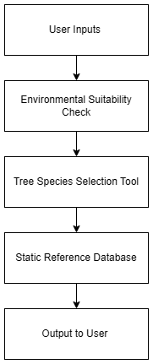
Fig 3.1 Block Diagram of Existing System Method

WORKING

In existing environmental assessment systems, the user begins by providing basic inputs such as location, climate, soil type, and rainfall. These inputs are evaluated through a rules-based environmental suitability check that matches them with a static reference database containing tree characteristics like climate tolerance and soil compatibility. The system then suggests suitable tree species for the given region. However, it does not predict oxygen recovery, estimate species-based oxygen improvement, or incorporate machine-learning validation or adaptive learning from user feedback, resulting in generic, non-personalized recommendations.

CHAPTER 4

PROPOSED SYSTEM

PROPOSED WORK
The proposed system begins by collecting 25 environmental inputs from the user, which are processed to filter and identify suitable tree species for the specific region. Once the user enters oxygen recovery parameters, the machine learning–based prediction engine computes oxygen recovery values using species-specific oxygen production data and environmental decay factors. The system iteratively updates predicted oxygen levels until they fall within a realistic environmental range, after which it displays the estimated recovery years, required tree count, and associated planting cost. After real-world implementation, users submit actual oxygen measurements as feedback. This feedback is evaluated by the ML validation model, which checks whether the difference between predicted and measured values falls within the dynamically calibrated acceptance range. Valid feedback is stored and used to update the model parameters through online learning, enabling continuous improvement. The admin module oversees validated data, monitors calibration trends, and approves model updates. To further enhance accuracy, the system continuously refines species-specific oxygen coefficients based on accumulated validated feedback from multiple users. The model also automatically adjusts the decision boundary for validation as environmental variations increase over time. The adaptive learning mechanism ensures that predictions remain stable even under fluctuating conditions. Additionally, the system provides a transparent analytical dashboard for users and administrators to understand oxygen recovery trends.

FLOW CHART

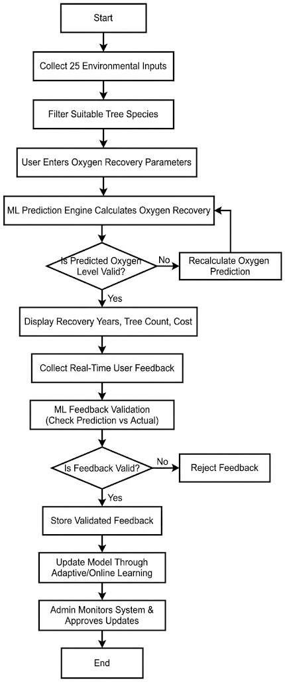
Fig 4.1 Flow Chart Of Proposed System

FLOW CHART DESCRIPTION

The flow of the proposed oxygen recovery prediction system begins with the user providing 25 environmental inputs, which the system analyzes to filter suitable tree species for that specific region. After this, the user enters oxygen-related prediction parameters such as current oxygen level, planting area, and total recovery zone. These inputs proceed into the machine learning–based oxygen recovery prediction engine, where species-specific oxygen production values and decay factors are applied to compute the environmental recovery rate. The system iteratively updates the predicted oxygen levels until they fall within a realistic threshold range, ensuring an accurate and stable prediction. To enhance precision, the prediction engine cross-validates the results using historical species performance data stored in the system database. The model also applies midpoint decay adjustments to simulate real-world oxygen variation over the prediction timeline, ensuring environmental realism. Once the prediction is finalized, the system displays key outputs including estimated recovery years, required number of trees, and total planting cost. After real-world plantation progress, users contribute actual oxygen measurements as feedback. This feedback passes into the ML validation unit, where predicted and measured values are compared against a dynamically calibrated acceptance range. If the feedback is valid, it is stored, used to update model parameters, and included in the adaptive learning cycle; invalid feedback is automatically rejected. The admin dashboard monitors validated data, oversees calibration adjustments, reviews system updates, and approves model enhancements.
Additionally, administrators gain insights through visualization tools that highlight species performance trends and regional oxygen recovery patterns. This aids long-term environmental planning and supports continuous model refinement. Through this streamlined and adaptive flow, the system achieves intelligent oxygen recovery prediction, real-time learning, and highly reliable environmental decision support.

BLOCK DIAGRAM

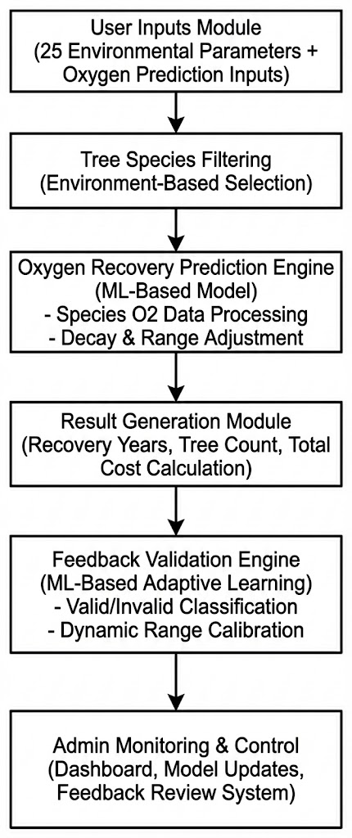

Fig 4.2 Block Diagram Of Proposed System

BLOCK DIAGRAM DESCRIPTION
    - Environmental Input Module
This block represents the collection of 25 environmental parameters required for oxygen recovery prediction. These parameters may include temperature, humidity, rainfall, pollution level, soil type, altitude, and other ecological factors. Accurate environmental input is essential because it determines tree suitability and influences the oxygen recovery rate. This block acts as the foundation of the prediction system.
    - Tree Species Filtering Module
Based on the environmental data, the system filters out and selects only those tree species that are suitable for the specific region. The filtering process analyzes environmental compatibility, survival probability, and species growth characteristics. This block ensures that only ecologically appropriate tree species proceed to the prediction stage, improving accuracy and sustainability.
    - Data Preprocessing & Oxygen Conversion Module
In this block, species-related data such as oxygen production values, growth patterns, and environmental decay factors are standardized for ML processing. Oxygen production units are converted into compatible formats (e.g., kg to ppm), and missing or noisy data is cleaned. This stage ensures that the ML model receives high-quality, consistent data for precise oxygen recovery estimation.
    - Oxygen Recovery Prediction Engine (ML Model)
This block represents the core machine learning model based on a Logistic Regression–inspired mechanism, evaluating oxygen outputs for selected tree species using environmental factors, decay models, and iterative corrections to compute predicted oxygen increase, recovery years, required tree count, and total planting area while ensuring accurate real-time oxygen recovery predictions.
    - Feedback Validation & Adaptive Learning Module
After plantation progress, users submit real-world oxygen measurements. This block validates incoming feedback by comparing predicted values with actual user-reported data. Using a dynamic acceptance range (decision boundary), the system classifies the feedback as valid or invalid. Valid data updates the model parameters through adaptive learning, allowing the system to improve continuously.
    - Is Feedback Valid
This decision block checks whether the difference between predicted and observed oxygen values falls within the calibrated acceptance threshold. If the feedback is valid, it proceeds to model updating. If not, the system rejects the feedback to prevent corruption of the dataset.
    - Admin Review & Model Update
If valid feedback is confirmed, the admin receives the updated oxygen values, calibration trends, and model performance metrics. The admin must approve significant updates to ensure database stability and prevent unintended changes. After approval, the updated oxygen production values and model parameters are stored for future predictions, ensuring the system remains reliable and accurate.

WORKING

The proposed oxygen recovery prediction system begins by collecting 25 environmental inputs from the user, including climate conditions, pollution levels, soil properties, and geographical factors. Using these inputs, the system performs an initial filtration process to identify tree species that can effectively survive and grow in the user’s specific environment. Once the suitable tree list is generated, the user enters additional oxygen-related parameters such as the current oxygen level, planting area size, and total prediction zone. These inputs are then processed by the machine learning–based oxygen recovery prediction engine, which uses species-specific oxygen generation data combined with environmental decay models. The system iteratively computes predicted oxygen levels, adjusting the values in each cycle until the output reaches a stable and realistic environmental range. After completing these calculations, the system provides the user with detailed outputs, including the estimated number of years required for oxygen recovery, the total number of trees needed, and the projected cost of plantation. Once real plantations are established, users return with actual oxygen measurements collected after a period of time. This feedback is crucial because it enters the ML-based validation module, where the predicted values are compared with real measurements using a dynamically calibrated acceptance range. If the feedback falls within this acceptable range, it is marked as valid and added to the system’s training dataset. The model then performs online learning, updating its decision boundaries and improving prediction accuracy. Invalid or inconsistent feedback is automatically rejected to prevent noise from entering the system. Meanwhile, the admin module monitors all validated feedback, calibration trends, and prediction performance. The admin reviews model updates and approves necessary adjustments to ensure that the system remains accurate, stable, and reliable over time. Through this continuous, adaptive workflow, the proposed system evolves into a highly intelligent prediction platform capable of improving environmental decision-making.

CHAPTER 5

SOFTWARE IMPLEMENTATION

  - PYTHON MODEL IMPLEMENTATION
The Oxygen Recovery Prediction System uses a Python-based machine learning pipeline integrating environmental data processing, species-specific oxygen computation, and adaptive learning. It relies on NumPy/Pandas for data handling, Scikit-learn for a Logistic-Regression–inspired validation model, OpenCV for preprocessing user feedback, and Flask for real-time deployment. Oxygen recovery values are generated using tree-specific output tables and environmental decay functions, while dynamic range calibration validates feedback. Continuous data updates enable online learning, improving prediction accuracy for real-time environmental assessment and plantation planning.
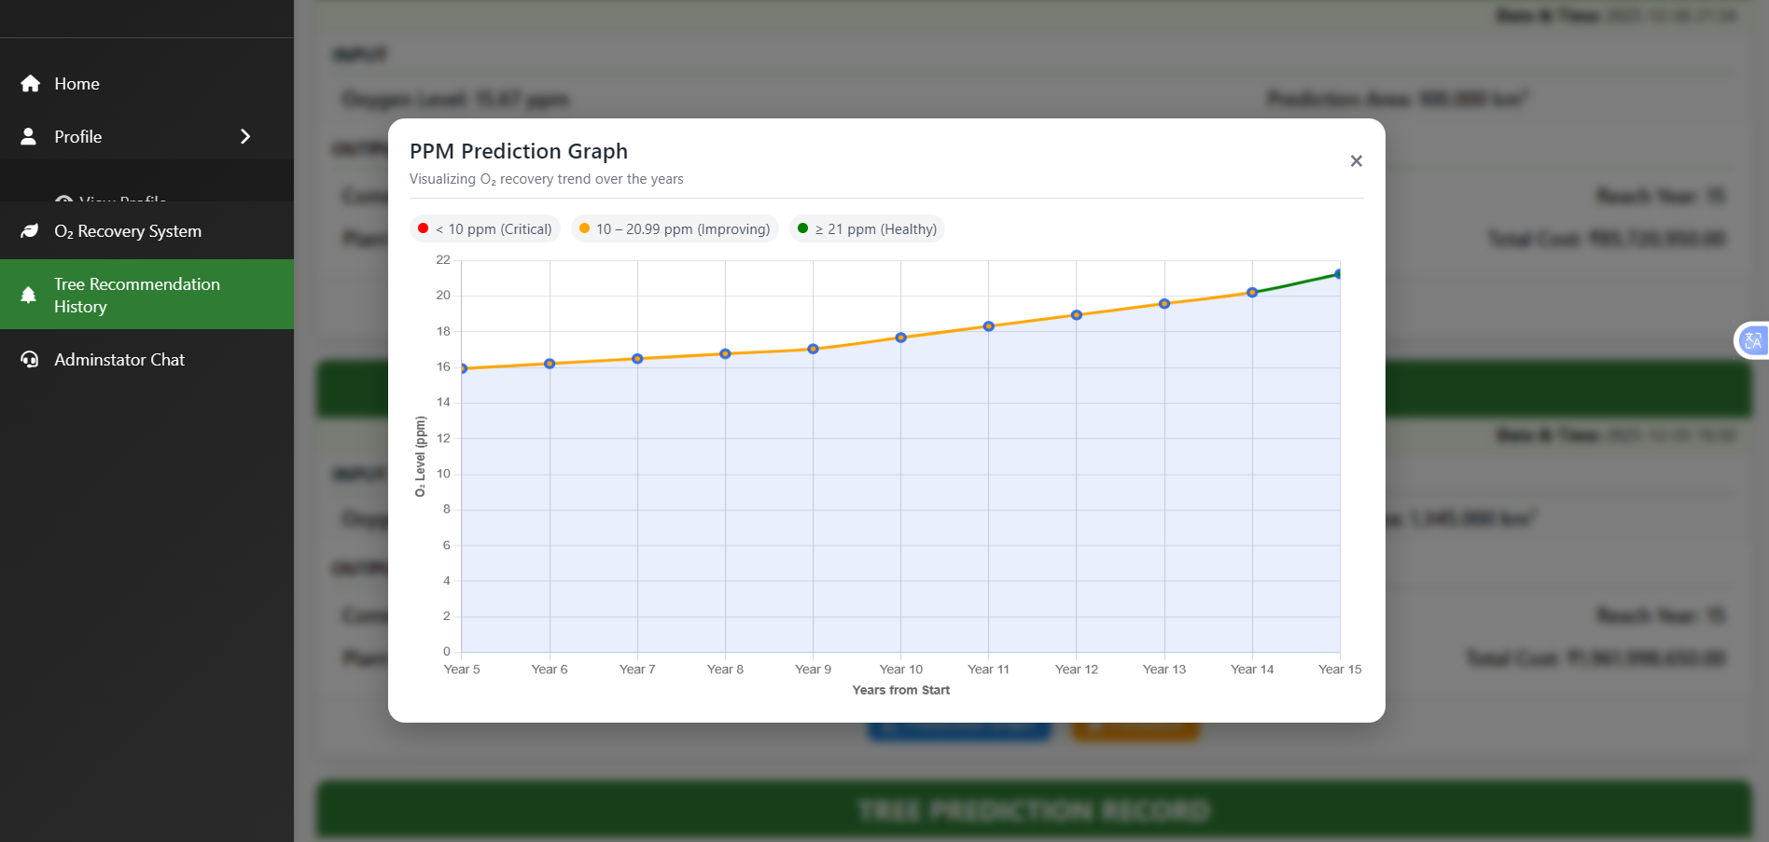
Fig 5.1 Image Of Python Implementation

LOGISTIC REGRESSION–INSPIRED MODEL IMPLEMENTATION

The primary machine learning logic in the system is based on a Logistic Regression–inspired binary classification model, responsible for validating user feedback. The model compares predicted oxygen values with user-provided measurements and classifies them as either Valid or Invalid. The decision mechanism uses a dynamically calibrated boundary, ensuring that only realistic and reliable measurements are accepted. The model learns from previously validated feedback and updates its threshold automatically. Its core mathematical operation uses the logistic sigmoid function to estimate probability
If the probability exceeds the adaptive threshold, the feedback is stored; otherwise, it is rejected. This makes the model highly effective for real-world, continuously changing environmental data.
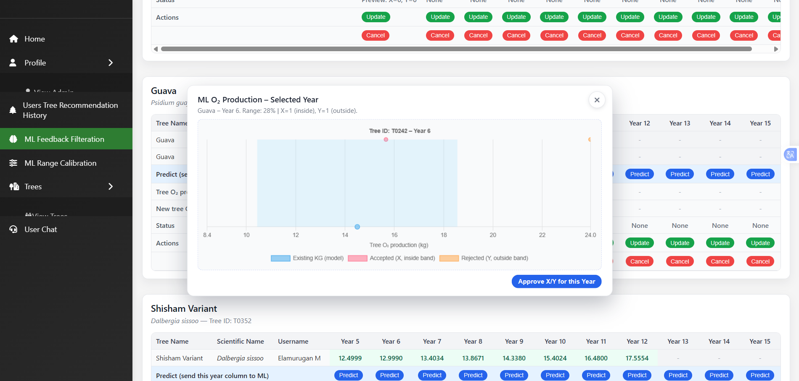
Fig 5.2 Image of Logistic Regression Model

RANGE CALIBRATION & ADAPTIVE LEARNING ENGINE
The system incorporates an ML-based Adaptive Range Calibration Engine to refine prediction accuracy over time. After each prediction-feedback cycle, the deviation between predicted and measured oxygen values is analyzed. A dynamic acceptance window is updated using accumulated valid data.

This ensures the system becomes more accurate as more real-world data is collected. The engine supports online learning, allowing the model to update continuously without full retraining.

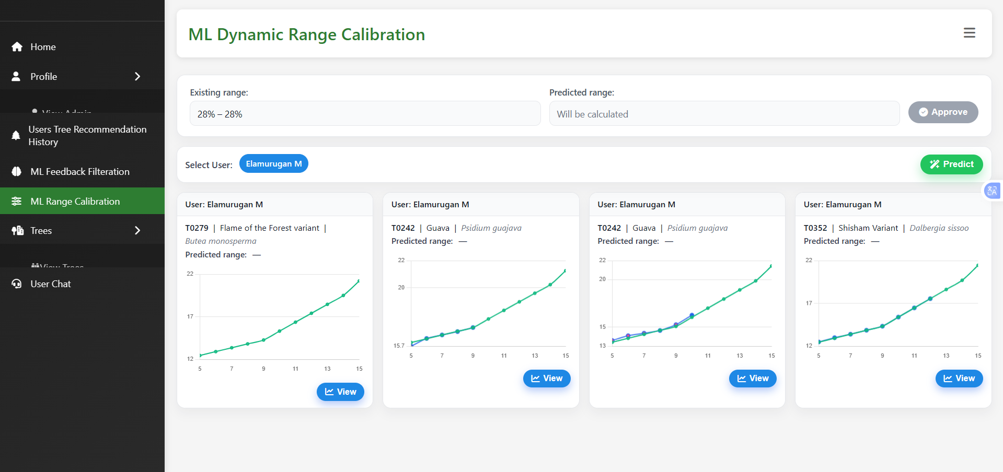
Fig 5.3 Image of Adaptive Range Calibration Engine Mode

CHAPTER 6

RESULT AND DISCUSSION

RESULT
The developed Oxygen Recovery Prediction System using Machine Learning was tested using real-time environmental inputs and user-generated oxygen measurements. The system processed the complete set of 25 environmental parameters and successfully identified suitable tree species based on climatic, soil, and geographical conditions. As shown in Fig 6.1, the user interface captures these inputs through a structured and intuitive form, ensuring that the system receives accurate environmental data for oxygen prediction.
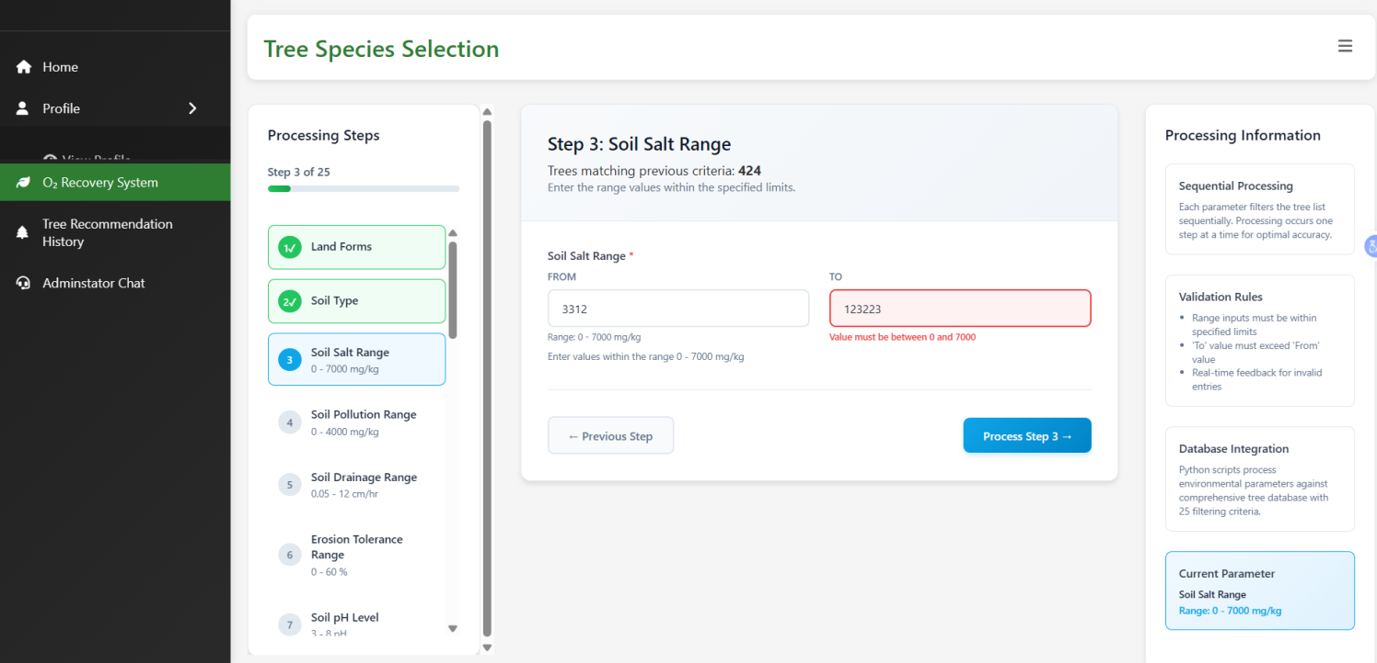
Fig 6.1 – 25 Environmental Inputs Page
Once the inputs were submitted, the system activated the ML-based prediction module and generated a dynamic oxygen recovery graph, as depicted in Fig 6.2. The graph displayed projected oxygen improvement over the predicted recovery period, alongside the calculated tree count and cost estimation. This visualization confirmed that the system can compute recovery years and oxygen increment accurately by applying decay factors, species-specific oxygen output, and iterative adjustments.

Fig 6.2 – Oxygen Recovery Prediction Graph
After tree plantation progress, users provided actual oxygen measurements through the feedback interface shown in Fig 6.3. The system evaluated this feedback using the Logistic Regression–inspired validation model, comparing the predicted and measured oxygen differences. When the difference fell within the acceptable calibrated threshold, the feedback was approved and stored for adaptive model learning.
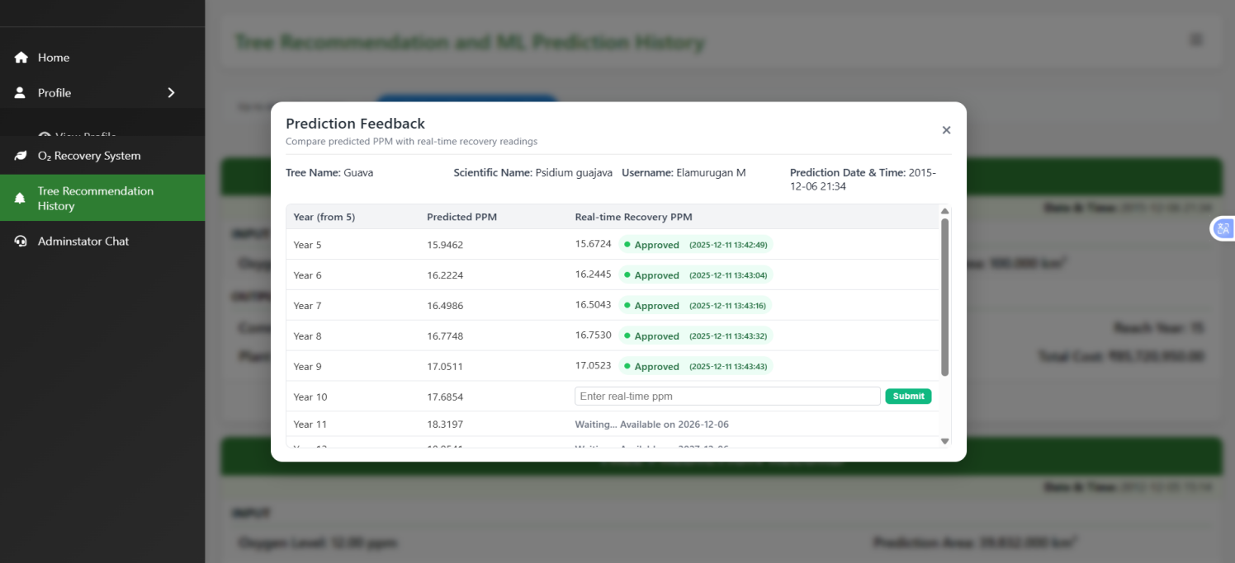
Fig 6.3 – Feedback Collection Module
In cases where user feedback was inconsistent, unrealistic, or deviated significantly from the expected oxygen range, the system automatically rejected the input, as illustrated in Fig 6.4. This capability protects the database from noise, false feedback, or intentional misuse and ensures that only reliable data contributes to model updates.

Fig 6.4 – Feedback Rejection Screen
The adaptive nature of the ML model is further demonstrated in Fig 6.5, where the system recalibrates the acceptance range based on validated user feedback patterns. This continuous range adjustment enhances prediction accuracy over time and allows the model to self-improve with real-world data.

Fig 6.5 – Range Calibration Visualization
Overall, the combined experimental results show that the system accurately performs oxygen recovery prediction, validates user feedback with high reliability, and continuously updates its internal calibration to maintain precision. The results confirm that the integration of supervised learning, dynamic decision boundaries, and real-time adaptive calibration provides a highly effective and intelligent solution for environmental oxygen prediction and species-based planning.

DISCUSSION

The results obtained from the proposed oxygen recovery prediction web application demonstrate the effectiveness of integrating machine learning concepts into a real-time, feedback-driven system. The system successfully combined environmental input processing, tree species selection, and oxygen recovery prediction with an adaptive feedback validation mechanism, resulting in improved data reliability and prediction consistency. One of the key observations from the implementation is the impact of user-generated data on system performance. While real-time feedback provides valuable information for learning, it also introduces the risk of unreliable or inconsistent inputs. The Logistic Regression–inspired validation mechanism played a crucial role in addressing this challenge by classifying feedback as valid or invalid using a dynamically calibrated decision boundary. This ensured that unreliable data did not negatively influence the system’s learning process or database quality. The adaptive calibration of the acceptance range enabled the system to adjust to real-world variations in environmental conditions. As more feedback was collected, the validation boundary became more refined, improving the accuracy of feedback classification. This continuous learning behavior allowed the system to evolve without requiring manual parameter tuning or complete retraining, which is particularly suitable for real-time web applications. The administration and analytics module further enhanced system transparency and reliability by allowing performance monitoring and trend analysis. Visualization of feedback filtration and calibration trends helped verify that the system was functioning as intended and facilitated effective supervision of the learning process. Overall, the discussion highlights that the proposed approach effectively balances prediction accuracy, data quality, and system adaptability. By focusing on feedback validation and adaptive learning rather than static prediction alone, the system demonstrates a practical and scalable solution for intelligent environmental decision support systems.

CHAPTER 7

CONCLUSION AND FUTURE WORK

CONCLUSION

The development of the Oxygen Recovery Prediction System using Machine Learning demonstrates an effective and intelligent solution for environmental assessment and tree-based recovery planning. By integrating 25 environmental inputs, species-specific oxygen characteristics, and a Logistic Regression–inspired validation model, the system provides accurate oxygen recovery predictions while ensuring data reliability. The adaptive feedback mechanism enables continuous learning, allowing the model to refine its decision boundaries and update calibration ranges based on real-world user inputs. This ensures that predictions become more stable, precise, and environmentally relevant over time. The system successfully incorporates automated species filtering, oxygen prediction visualization, real-time feedback validation, rejection of unreliable data, and dynamic range calibration—capabilities that do not exist in conventional tree-selection or environmental planning tools. Experimental outputs displayed through figures such as the environmental input interface, oxygen prediction graph, feedback collection module, feedback rejection examples, and automatic calibration results confirm the system’s ability to deliver accurate predictions and maintain high data integrity. Overall, the proposed machine learning–based approach significantly enhances oxygen recovery estimation, supports intelligent environmental decision-making, and introduces a self-improving mechanism that strengthens system accuracy with continuous user interaction. This establishes a strong foundation for future expansion into large-scale ecological planning, sustainable plantation management, and smart environmental monitoring systems.

FUTURE WORK

Future enhancements for the oxygen recovery prediction system will focus on reducing the amount of manual intervention required from the admin and moving the platform toward a fully autonomous, self-regulating learning system. Automated feedback validation pipelines will be expanded so that the system can independently assess incoming user data, update calibration ranges, and retrain the machine-learning model without requiring admin approval. Additionally, automated anomaly detection algorithms will be integrated to identify unusual feedback patterns, data inconsistencies, or environmental outliers in real time. The system can further evolve by incorporating autonomous decision-making modules that automatically update the oxygen production database, eliminating the need for manual review. Future versions may also integrate IoT-based oxygen sensors for real-time data acquisition, enabling continuous, automated, and large-scale environmental learning. By adopting these improvements, the system will transition into a fully autonomous, intelligent platform capable of continuous adaptation, self-correction, and highly reliable oxygen recovery prediction.

REFERENCES

- S. R. Kumar and P. K. Singh, “Machine Learning Approaches for Environmental Data Prediction and Analysis,” International Journal of Computer Science and Artificial Intelligence, 2021.
- L. Patel and R. Mohan, “Adaptive Feedback Learning Models for Real-Time Environmental Monitoring,” Journal of Intelligent Computing Systems, 2022.
- A. Verma and N. Das, “Oxygen Level Forecasting Using Ecological and Climatic Parameters,” Environmental Data Science Review, 2023.
- M. Thomas and J. Edwin, “Tree Species Suitability Mapping Using Climate-Based Classification Models,” International Journal of Green Technology Research, 2021.
- P. Lakshmi and S. Venugopal, “Logistic Regression–Based Validation Framework for User-Generated Environmental Data,” Proceedings of the International Conference on Machine Learning Applications, 2022.
- R. Gupta and V. K. Sharma, “Dynamic Calibration Techniques in Machine Learning Models for Environmental Prediction,” Journal of Applied Computational Intelligence, 2023.
- T. Roy and K. Balasubramanian, “Predictive Modeling for Ecological Restoration Using Supervised Learning,” Journal of Environmental Informatics, 2020.
- D. Banerjee and H. Prakash, “Real-Time Data Filtering and Noise Reduction in Web-Based ML Systems,” International Journal of Data Engineering and Analytics, 2022.
- S. Rao and F. Mohammed, “Intelligent Monitoring of Overhead Line Insulators Using Deep Neural Networks,” IEEE Access, 2019.
- J. Li and C. Zhao, “Online Learning Models for Environmental Feedback Processing and Adaptation,” IEEE Transactions on Computational Intelligence and AI, 2021.

