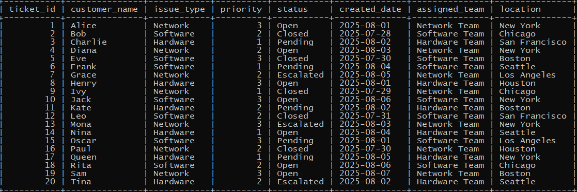

**✅ 1. Classify each ticket by urgency based on priority**

**• Priority 3 → ‘High’**

**• Priority 2 → ‘Medium’**

**• Priority 1 → ‘Low’**

select * ,

-> case priority

-> when priority<=2 then

-> case

-> when priority=1 then 'Low'

-> else 'Medium'

-> end

-> else 'High'

-> end as updated_table

-> from tickets;

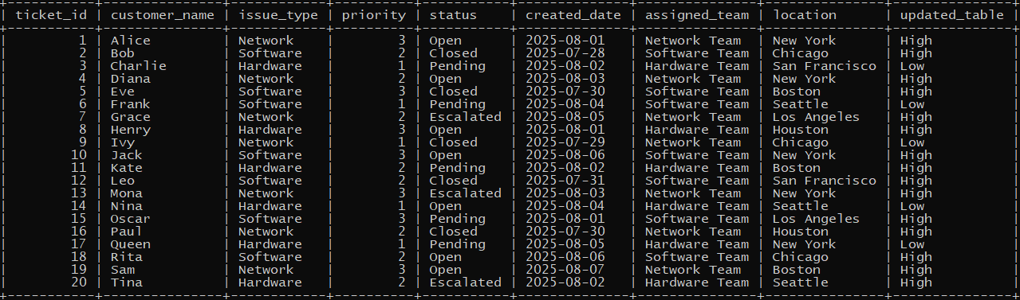

**✅ 2. Add a column to classify ticket status**

**• ‘Active’ if status = ‘Open’ or ‘Escalated’**

**• ‘Inactive’ if status = ‘Closed’**

**• ‘Waiting’ otherwise**

SELECT *,

CASE

WHEN status IN ('Open', 'Escalated') THEN 'Active'

WHEN status = 'Closed' THEN 'Inactive'

ELSE 'Otherwise'

END AS new_status

FROM tickets;

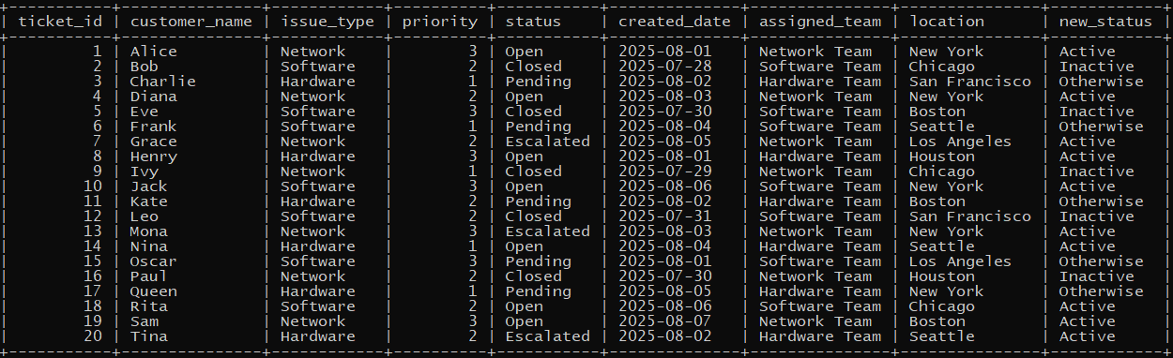

**✅ 3. List tickets and show issue category**

**• ‘Software Issue’, ‘Hardware Issue’, ‘Network Issue’, or ‘Other’**

select * ,

-> case issue_type

-> when 'software' then 'Software Issue'

-> when 'hardware' then 'Hardware Issue'

-> when 'network' then 'Network Issue'

-> else 'Other'

-> end as new_issue_type

-> from tickets;

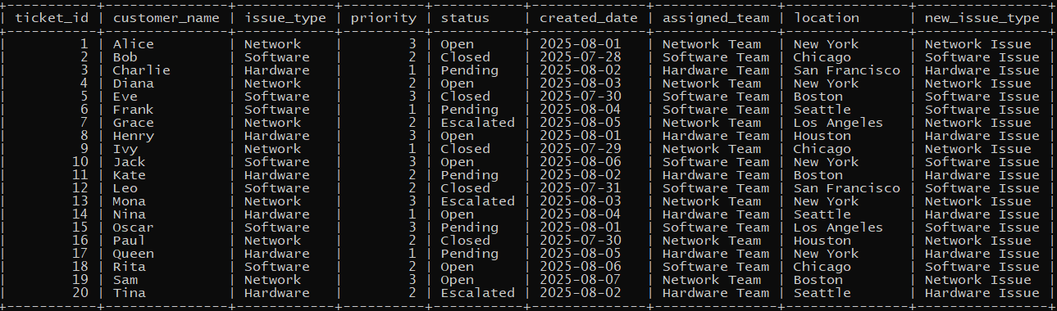

**✅ 4. Mark tickets as ‘VIP’; if customer name starts with A, E, M, or S**

select * ,

-> case

-> when customer_name like 'A%' then 'VIP'

-> when customer_name like 'E%' then 'VIP'

-> when customer_name like 'M%' then 'VIP'

-> when customer_name like 'S%' then 'VIP'

-> end as updated_name

-> from tickets ;

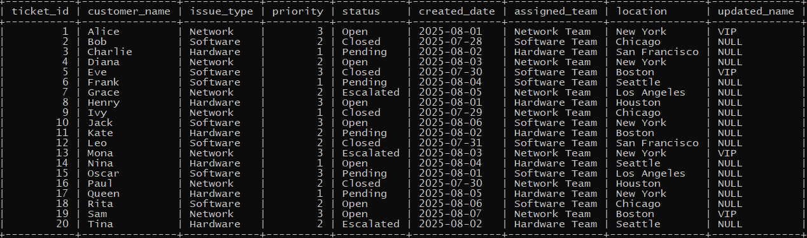

**✅ 5. Show ticket summary: ‘High Priority Open’, ‘Low Priority Closed’, or ‘Other’;**

select ticket_id,customer_name,priority,status,

-> case

-> when status ='open' and priority=3 then 'High priority open'

-> when status ='closed' and priority=1 then 'Low priority closed'

-> else 'Other'

-> end as updated_list

-> from tickets;

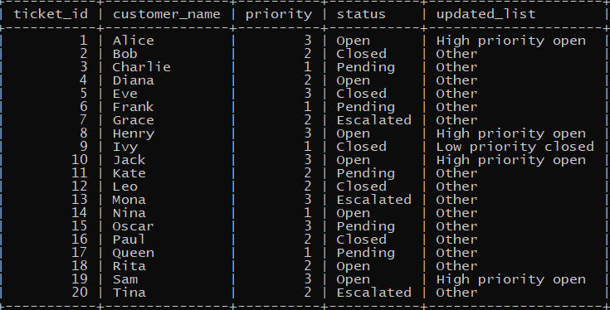

**✅ 6. Mark follow-up required if ticket is pending or priority is high.**

select ticket_id,customer_name,priority,status,

-> case

-> when status ='pending' or priority=3 then 'follow up required'

-> end as follow_up

-> from tickets;

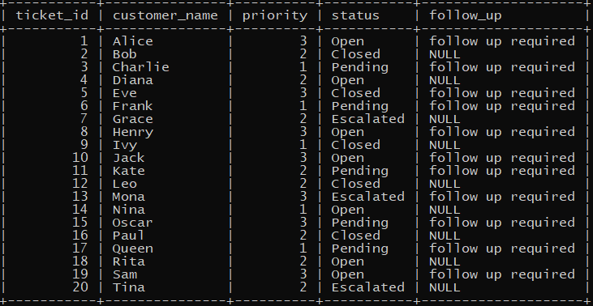

**✅ 7. Assign handling group based on issue_type**

select ticket_id,customer_name,issue_type,

-> case

-> when issue_type='network' then 'Network support'

-> when issue_type='hardware' then 'Hardware support'

-> when issue_type='software' then 'Softwareware support'

-> end as issue_handling

-> from tickets;

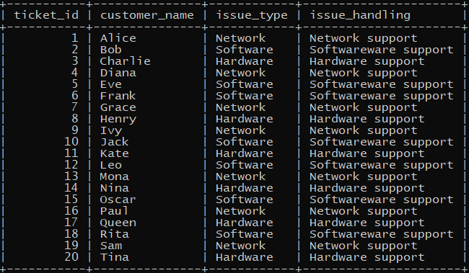

**✅ 8. Label cities as ‘HQ’ if in New York or Chicago**

select ticket_id,customer_name,location,

-> case

-> when location='New york' or location='Chicago' then 'HQ'

-> end as updated_city

-> from tickets;

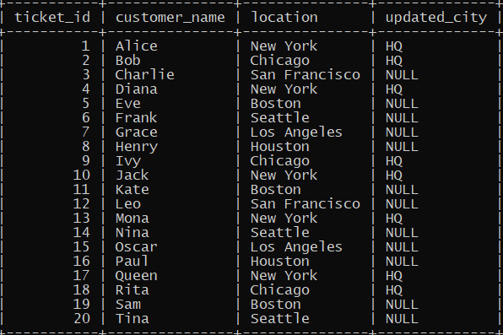

**✅ 9. Sort tickets so ‘Escalated’ come first, then ‘Open’, then others**

**✅ 10. Update status to ‘Urgent’ if priority = 3 and status is ‘Open’**

**✅ 11. Show how many tickets fall into each priority label**

SELECT priority, COUNT(*) AS ticket_count

-> FROM tickets

-> GROUP BY priority

-> ORDER BY priority;

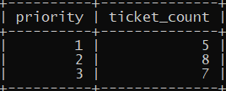

**✅ 12. Show a response plan:**

**• Immediate (High + Open)**

**• Scheduled (Medium + Pending)**

**• Escalate (Low + Escalated)**

**• Standard otherwise**

select ticket_id,customer_name,priority,status,

-> case

-> when status='open' and priority=3 then 'Immediate'

-> when status='pending' and priority=2 then 'Scheduled'

-> when status='escalated' and priority=1 then 'Escalate'

-> else 'Others'

-> end as updated_list

-> from tickets;

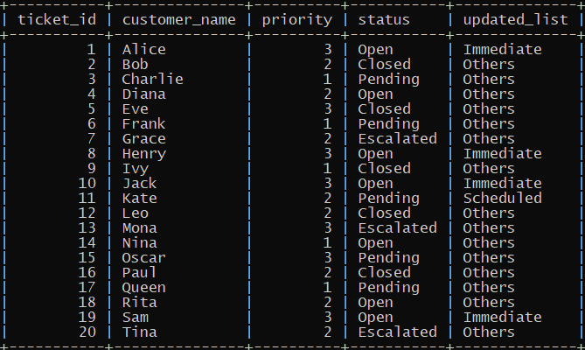

**✅ 13. Show ticket age category**

**• If created_date is today → ‘New’**

**• If more than 7 days ago → ‘Old’**

**• Else → ‘Recent’**

select ticket_id,customer_name,created_date,

-> case

-> when created_date=current_date then 'New'

-> when created_date<current_date then 'Old'

-> else 'Recent'

-> end as updated_list

-> from tickets;

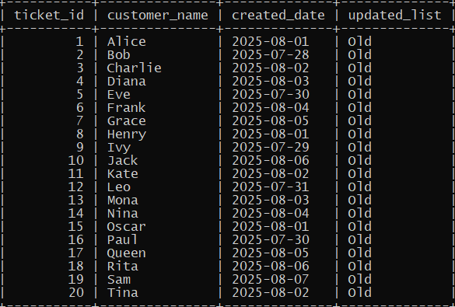

**✅ 14. Count tickets by assigned team type: Software, Hardware, Network**

**✅ 15. Create a column with nested CASE:**

**• If Open:**

**o High → ‘Critical Open’**

**o Medium → ‘Important Open’**

**o Else → ‘Minor Open’**

**• Else: ‘Not Open’**

select ticket_id,customer_name,priority,status,

-> case

-> when status='open' then

-> case

-> when priority=3 then 'Critical Open'

-> when priority=2 then 'important Open'

-> else 'Minor Open'

-> end

-> else 'Not Open'

-> end as updated_list

-> from tickets;

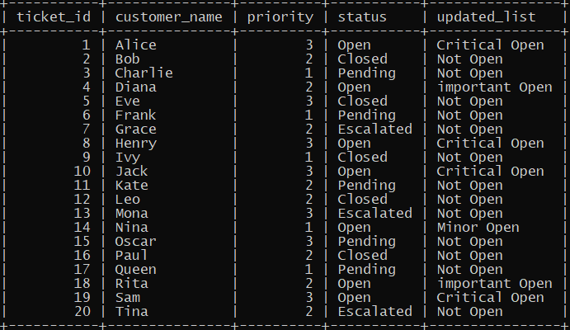

**✅ 16. Count number of Open vs. Closed vs. Other tickets**

**✅ 17. List all tickets and show ‘Assigned Team Type’**

**• If team contains ‘Software’ → ‘SW’**

**• If team contains ‘Hardware’ → ‘HW’**

**• If team contains ‘Network’ → ‘NW’**

select ticket_id,customer_name,issue_type,

-> case

-> when issue_type='Software' then 'SW'

-> when issue_type='hardware' then 'HW'

-> when issue_type='Network' then 'NW'

-> end as updated_list

-> from tickets;

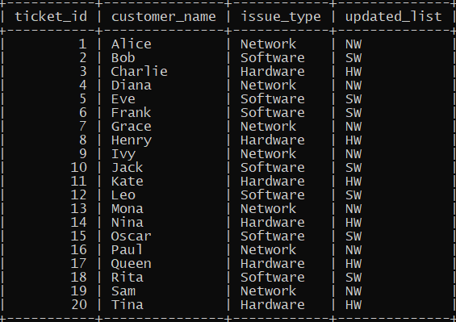

**✅ 18. Get average priority per issue type**

select issue_type,avg(priority) as avg_priority from tickets group by issue_type;

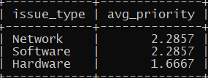

**✅ 19. Show only ‘Software’ tickets with extra labels: ‘High Risk’, ‘Normal’, etc.**

select ticket_id,customer_name,issue_type,priority,

-> case

-> when priority>=2 then 'High Risk'

-> else 'Normal'

-> end as risk_label

-> from tickets;

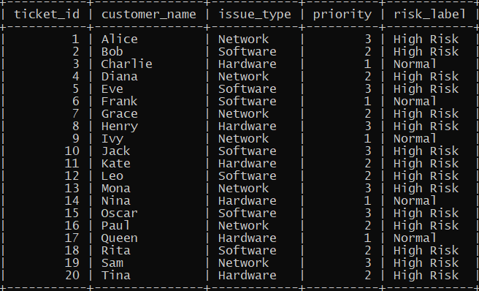

**✅ 20. Display ticket_id, issue_type, and a comment:**

**• ‘Needs Attention’ if Escalated or Pending**

**• ‘Resolved’ if Closed**

**• ‘In Progress’ otherwise**

select ticket_id,issue_type,

-> case

-> when status='escalated' and status='pending' then 'Need attention'

-> when status='closed' then 'Resolved'

-> else 'In Progress'

-> end as comment

-> from tickets;

