Building circuits

Record all measurements made as part of the lab under the relevant section. Graphs of current or resistance versus voltage when relevant are encouraged.

## Basic circuit:

1. Turn on the Raspberry pi (Rpi)
2. Connect one of the 5V pins on the Rpi to the + column on the breadboard
3. Connect one of the ground pins on the Rpi to the - column on the breadboard
4. Run a connector from the + column to one row on the main part of the breadboard
5. Run a connector from the - column to a different (but close) row on the main part of the breadboard
6. If we connected a 1Ω resistor between these two rows - so that it is in a closed loop with the 5V supply from the Rpi, how much current would this circuit attempt to draw across the resistor?

It would draw 5V / 1Ω = **5A**.

* 1. The Rpi adaptor provides 5V and up to 2 Amps, is this current sufficient?

**No.**

* 1. What do you think might happen? Please don’t actually do this.

It would fry the resistor

1. Connect a resistor of more than at least 50Ω (Why might this be enough resistance?)

We connected a 100Ω resistor. The expected current is 5mA, well below the 2A limit.

* 1. If you have a multi-meter able to measure current evaluate the current across the resistor, is it what you expected?

Initially, it was with 100Ω, but then the resistor got hotter and the current steadily decreased. We tried again with a 220Ω,

## LED in a circuit:

1. Add an LED to your circuit
   1. Put it in series with the resistor and move the +/- connectors to the RPi 5V supply as needed
      1. How does the diode need to be oriented? Which wire on the LED goes to the +5V side and which goes to the GND connector?

The short wire goes to ground, and the long wire goes to +5V.

* 1. What is the voltage drop across the resistor? Was this what you expected?

Expected: V­resistor = I * Rresistor = 5V * Rresistor / (Rresistor + RLED) = 5V * 7/(7+12) = 1.8V

Actual: 2.2V

* 1. What is the voltage drop across the LED?

Expected: VLED = I * Rresistor = 5V * RLED / (Rresistor + RLED) = 5V * 12/(7+12) = 3.2V

Actual: 2.8-2.9V

1. Try removing the resistor from the circuit, keeping the circuit closed - the LED is just in series with the 5V supply.
   1. What do you think will happen to the LED brightness?

**It will increase.** P=V2/R. The resistance of the LED is the same, but now there is no other voltage drop, so the LED accounts for the full 5V drop.

1. Try including resistors of different values - how does LED brightness change vs resistor strength?
   1. Do the voltage drops across the resistors and LED change?

**Yes**, as the resistor resistance goes up, the resistor accounts for more of the voltage drop, and the LED brightness goes down.

1. Using the configuration with the highest LED brightness now move the 5V connection on the RPi to one of the 3.3V pins.
   1. What do you expect to happen to the LED brightness?

**It should go down**, as P = V2/R. We did see the LED get a little dimmer.

1. Add a step-up circuit components to increase your RPi voltage from 5V to 10V but do not close your circuit yet
   1. Using the dimmest configuration for the LED explored previously (meaning select the appropriate resistor from those you tried previously) now
   2. How will the LED brightness change?

It will increase, as we up the voltage.

1. How would you quantify the LED brightness changes?

The LED brightness scales quadratically with the input voltage.

1. Do any of these results change with different color LEDs? Specifically do any voltage drop values change, is the relative brightness similar for different color LEDs, etc.

They will have the same behavior (i.e. quadratic brightness vs voltage), but the different colors have different resistances. Increasing the resistance will decrease the brightness:

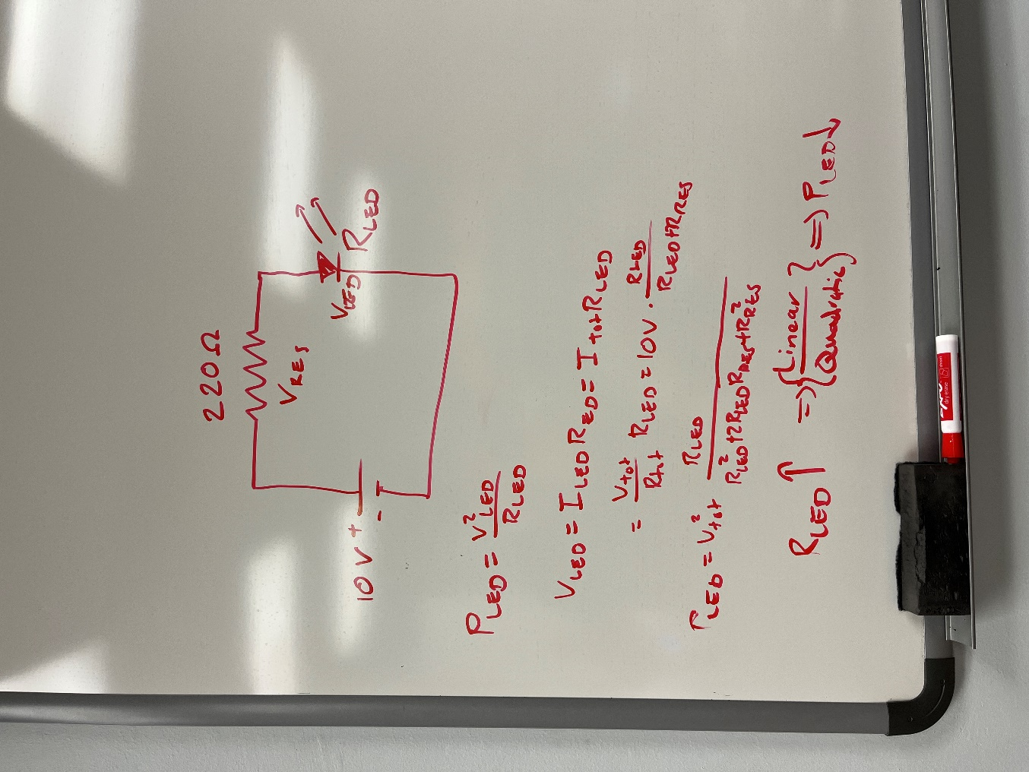

## Photo-diode:

1. Replace the LED with a photo-diode (remove the step-up component as well if you had one included previously)
   1. NOTE: photo-diodes operate in reverse bias mode so you will need to orient the diode accordingly
2. What is the voltage across the resistor when you simply connect the 5V supply to close this circuit?

We read 21.2mV.

1. What happens if you cover the photo-diode? What happens if you change the +connector to go to the 3.3V pin on the Rpi?

Covered 5 = 1.2mV. covered 3.3 = 0.3mV

* 1. What is the dark current for this photo-diode?

1.2 mV / 1kΩ = 1.2 μA

* 1. Is 5V enough supply voltage to see a signal from this diode? Is 3.3V?

Yes and yes

* 1. What happens if you attach the step-up circuit component to increase the supply up to 10V?

0.5mV covered

1. What are the dark current and saturation current for the photo-diode?

Dark current is around 1 μA. The current kept increasing as we increased the voltage, so there was no saturation current.