

**Student Performance Monitoring System**

**Database Management**

**Group-4**

RICH PICTURE(AS-IS)

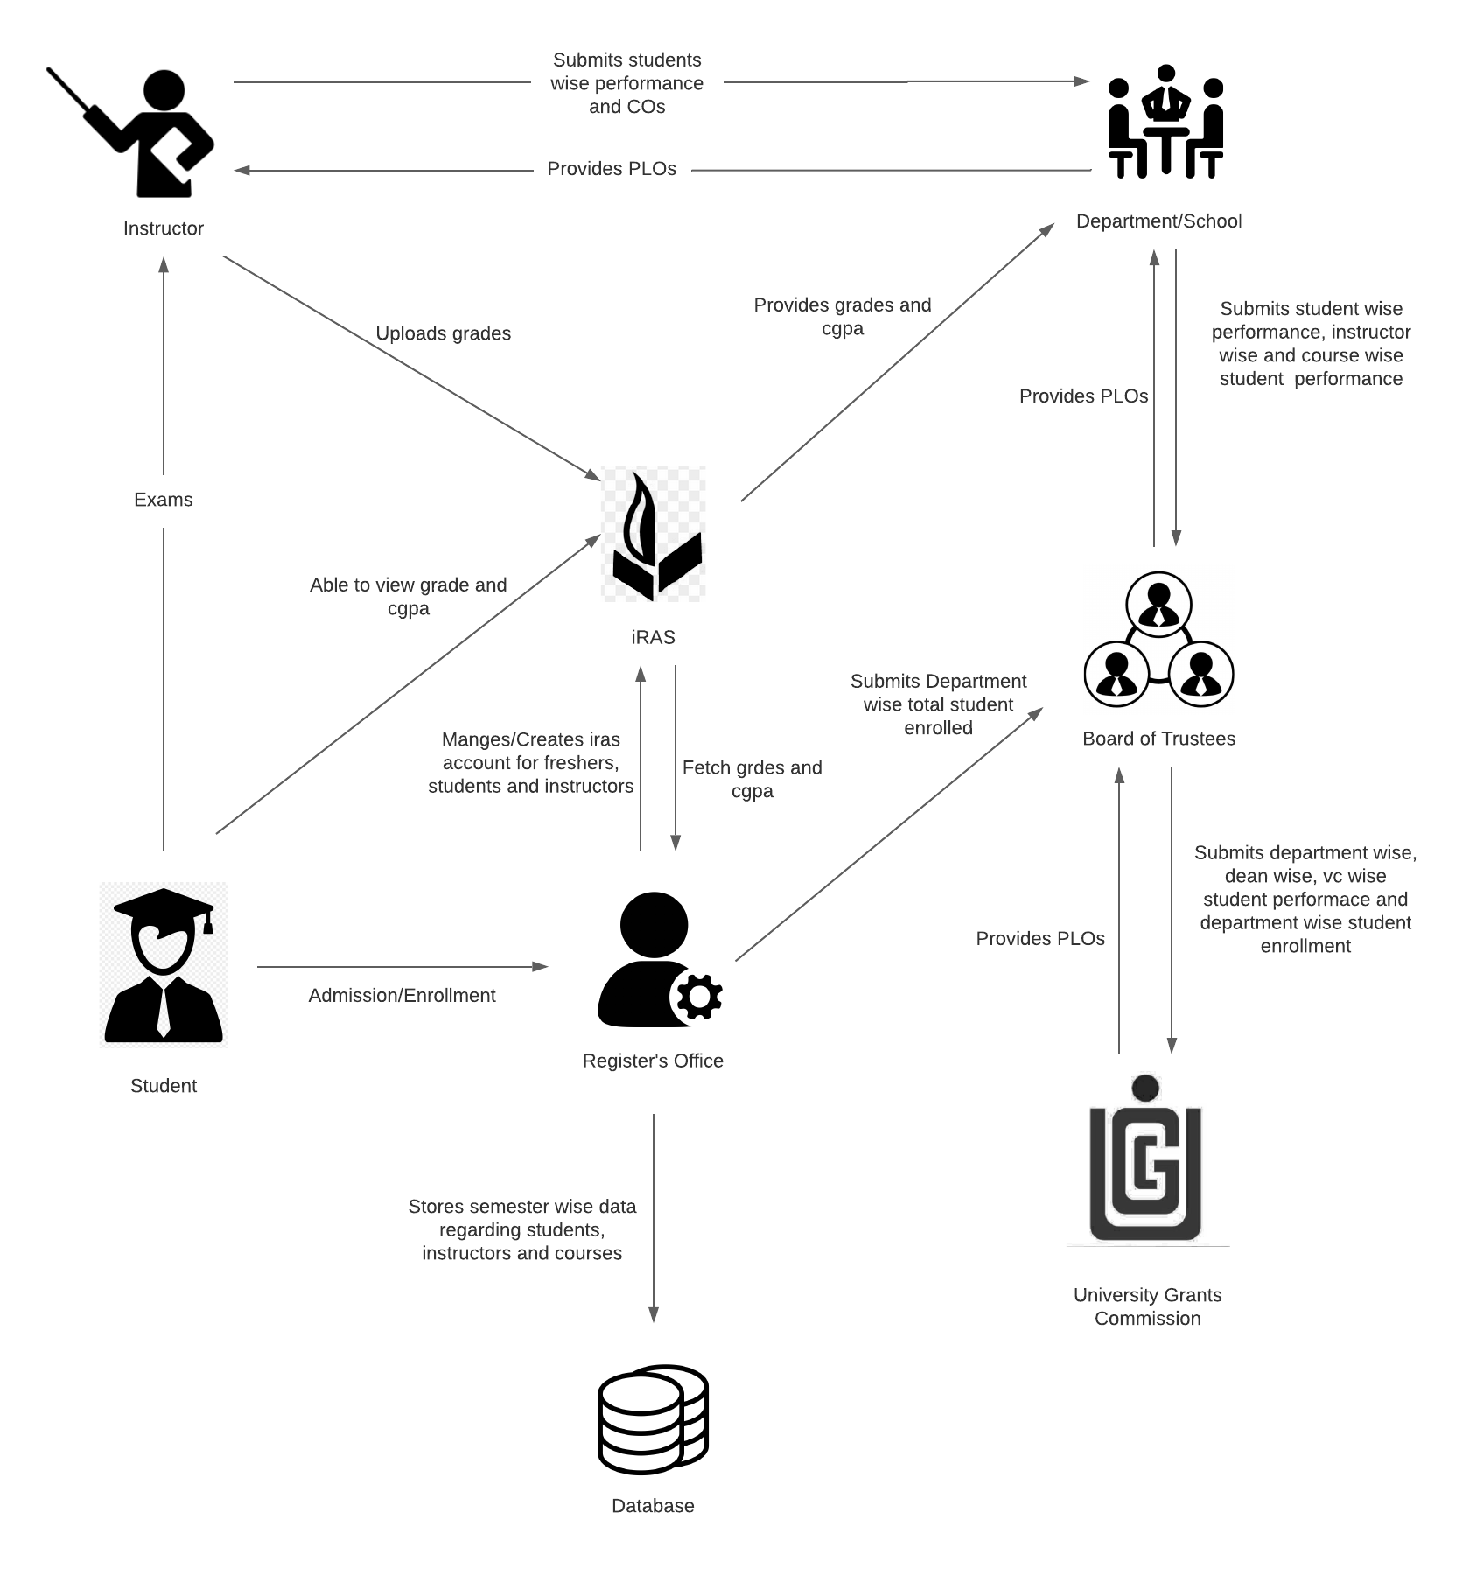

|  |  |  |  |  |  |  |
| --- | --- | --- | --- | --- | --- | --- |
| **Process** | **System Roles** | | | | | |
| **Human** | **Non-Comp**  **Hardware** | **Computing**  **Hardware** | **Software** | **Database** | **Network &**  **Commination** |
| Prepare question paper, time and venue | **Instructors**  1) Prepare question for the students  2) Give a particular time and date for the exam  3) Mange a classroom with chairs for all students  4) Prepare SODs and invigilators  **Students**  1) Attempt the examination | **Stationery**  1) Pen and paper for attempting the exam.  2) Compass, ruler and other stationery for drawing diagrams  **Classroom**  1) A space for conducting the exams  **Stapler**  1) For attaching all the extra paper, rough work and answers | **Computer/**  **Laptop**  1) Some courses require a computer for coding or open book exam.  **Calculators**  1) Some exams require the use of calculators  **Printers & photocopy machine**  1) Instructors use it for printing question papers | **Microsoft Word**  1) Typing the question and generating a printable pdf.  **Microsoft PowerPoint**  1) Used for giving lectures  **Adobe Acrobat Reader**  1) For viewing the question paper in pdf format | **Microsoft Excel**  1) Used for storing exam marks and calculating final grade | **Internet**  1) Used by faculties to upload marls and grade to online excel sheets |

|  |  |  |  |  |  |  |
| --- | --- | --- | --- | --- | --- | --- |
| **Process** | **System Roles** | | | | | |
| **Human** | **Non-Comp**  **Hardware** | **Computing**  **Hardware** | **Software** | **Database** | **Network &**  **Commination** |
| Maintain and Create account for freshers, instructors and students. Also, this information in database and provide to board of trustees | **Admin**  1) Create new iras account for fresher.  2) Maintain accounts in case of probations or semester drop or system login issues | **Stationery**  1) Pen and paper, in case a student needs manual registration. | **Computer/Smart devices**  1) For login into the system, maintaining system and maintaining records | **iRAS**  1) Provides graphical user interface for ease of use  2) Board of trustees/ admins can login to find out number student enrolled | **iRAS database server**  1) iRAS database server is used for student registration, add/drop, grades submission and faculty evaluation submission  **Registration office storage**  1) Stores all the hardcopies and softcopies of semester wise student performance | **Internet**  1) Internet is need to access iras software |

|  |  |  |  |  |  |  |
| --- | --- | --- | --- | --- | --- | --- |
| **Process** | **System Roles** | | | | | |
| **Human** | **Non-Comp**  **Hardware** | **Computing**  **Hardware** | **Software** | **Database** | **Network &**  **Commination** |
| UGC approved curriculum based on PLO | **UGC**  1)Arrange a meeting and set a curriculum and standard  2)Review the curriculum and make any changes, if necessary  3) Send the approved curriculum to the board of trustees  **Board of Trustees**  1) Receives the approved curriculum from UGC and sends it to the departments and dean | **Paper**  1) For keeping and send hard copies of the curriculum | **Computer**  1) For creating softcopies or pdf files of the curriculum  2) For sending out the curriculum to the board of trustees via email or other methods  **Printers & photocopy machine**  1) Used for printing the curriculum and making copies | **Microsoft Word**  1) Used for creating softcopies of the curriculum  **Adobe Acrobat Reader**  1) Used for viewing the curriculum in pdf format |  | **Internet**  1) Used for sending the curriculum via email or other applications |

|  |  |  |  |  |  |  |
| --- | --- | --- | --- | --- | --- | --- |
| **Process** | **System Roles** | | | | | |
| **Human** | **Non-Comp**  **Hardware** | **Computing**  **Hardware** | **Software** | **Database** | **Network &**  **Commination** |
| Viewing grades and transcripts | **Instructors**  1) Instructors have to manually enter the grade  **Students**  1) Students have to log in by manually typing in the student id and password to view their cgpa  2) Students by to click on the transcript button and choose the desired semester to receive a copy of their transcript | **Paper**  1) If a student wants a hardcopy of their transcript | **Computer/**  **Smart Device**  1) A computer or any smart device is required for logging into the system  **Printers**  1) For printing transcripts | **Adobe Acrobat Reader**  1) For viewing the transcript in pdf format  **Operating System**  1) Any operating system may be used windows or Linux or macOS | **iRAS database server**  1) Grades and transcripts are stored in the iras database server | **Internet**  1) Internet is required for gaining access to the system |

|  |  |  |  |  |  |  |
| --- | --- | --- | --- | --- | --- | --- |
| **Process** | **System Roles** | | | | | |
| **Human** | **Non-Comp**  **Hardware** | **Computing**  **Hardware** | **Software** | **Database** | **Network &**  **Commination** |
| Instructors map the CO performance of a student and makes a student performance comparison chart | **Instructors**  1) Instructors manually enter all the marks into the excel sheet and calculates the final grade  2) Instructors then analyses the result of all the students and creates student wise performance chart  3) Instructors maps out the COs  4) Sends the mapped COs and student wise performance analysis chart to the department | **Paper and Pen**  1) All the comparisons, calculation and charts are done on paper | **Computer/**  **Laptop**  1) A computer is required to enter the marks in excel sheet | **Microsoft Excel**  1) Excel is used for storing all the exam marks and calculating the final grade | **Department/**  **Registration office storage**  1) All the charts are stored in the department storage and registration office storage |  |