PROJECT REPORT TEMPLATE

1 INTRODUCTION

1.1 Overview

Event management is the process of creating and maintaining an event. This process spans from the very beginning of planning all the way to post event strategizing.

1.2 Purpose

Event management is the process of creating and maintaining an event. This process of spans from the very beginning of planning all the way to post-event strategizing. At the start, an event manger makes planning designing, such as the time ,location, and theme of their event.

2 Problem definition and design Thinking

2. 1 Empathy Map: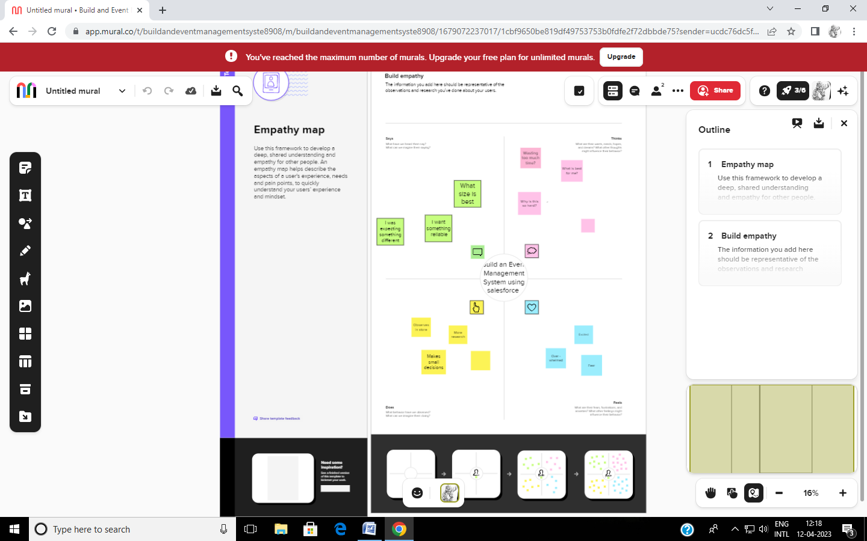

2.2 Ideation & Brainstorming Map:

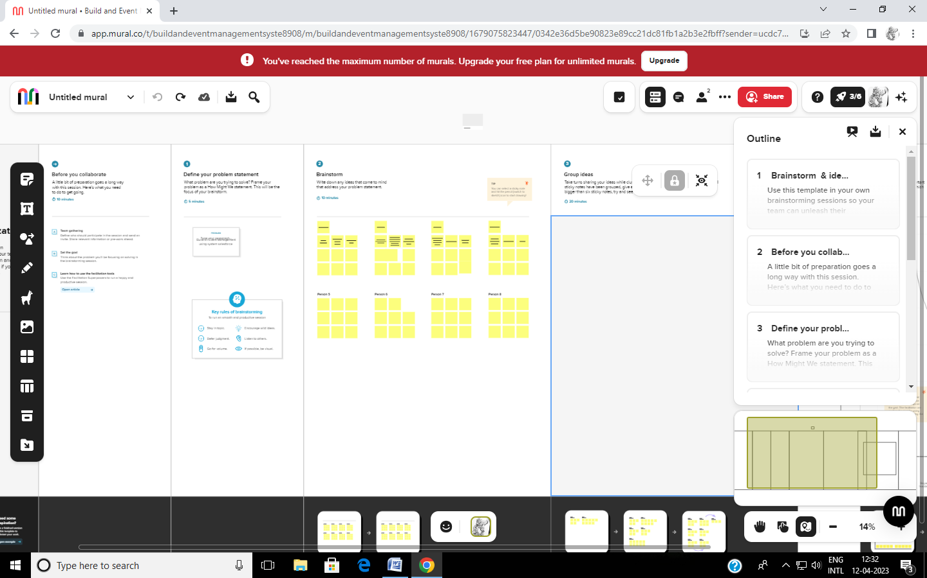

3 RESULT

3.1 Data Model:

|  |  |
| --- | --- |
| Object name | Fields in the object |
| Obj1 | |  |  | | --- | --- | | Field label | Data type | | Event | Text | | Events | Text | |
| Obj2 | |  |  | | --- | --- | | Field label | Data type | | Attendee | Text | | Attendees | Text | |

|  |  |  |  |  |  |  |  |
| --- | --- | --- | --- | --- | --- | --- | --- |
| Obj3 | |  |  | | --- | --- | | Field label | Data type | | Speaker | Text | | Speakers | Text | |
| Obj4 | |  |  | | --- | --- | | Field label | Data type | | Vendor | Text | | Vendors | Text | |

3.2 Activity & Screenshots:

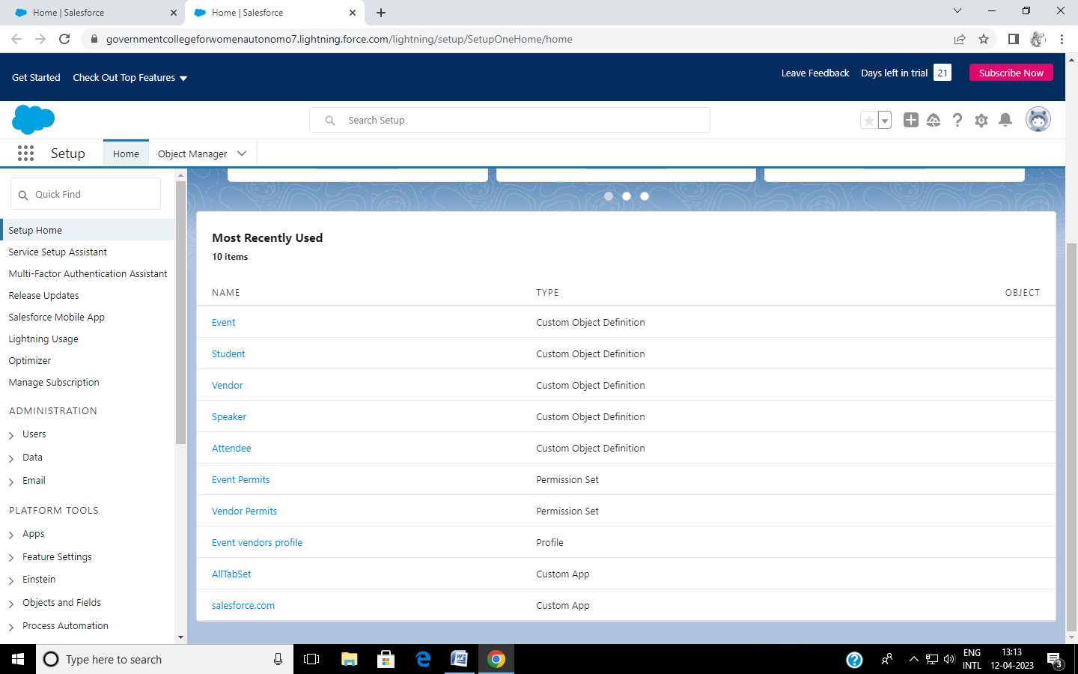

4 Trailhead Profile public URL

Team leader-https://trailblazer.me/id/melanagai

Team member1-https://trailblazer.me/id/gkamaraj2

Team member2-https://trailblazer.me/id/gayag11g

Team member3-https://trailblazer.me/id/eganesan

ADVANTAGES & DISADVANTAGES:

1 .Opportunities for creativity

2 .Ability to work in different events

3.Few educational requirements

4.Unconventional work hours

APPLICATIONS:

Event management is the application of project management to the creation and development f small and/or large scale or corporate events such as festivals, conferences, ceremonies, weddings, formal parties, concerts, or conventions.

CONCLUSION:

Event management system is users friendly and cost effective system, it is customized with activities related to event management life cycle.

It provides a new edge to management industry. Solution Dot always keep your objectives and goals on top priority while dev eloping any plan of work.

FUTURESCOPE:

The scope of event management as a currier in India is vast. It is a thriving industry and is home to a million people. So if you have a knack for creativity and want to redesign the perceptions of society, the event management is all for you.