🇦🇪 Mar 12: Influencers in a soup

In this edition:

- DIFC evacuated
- British tourist held
- Dubai luxury market surges

Spotlight

Bankers go home
What happened? Major international banks and professional services firms began evacuating offices in Dubai and elsewhere in the Gulf after Iran threatened to target US- and Israel-linked economic assets, including banks. Citi told staff to leave its DIFC and Oud Metha offices and work remotely, while Standard Chartered, HSBC, Deloitte, and PwC also took precautionary measures, including branch closures and work-from-home instructions. These moves followed escalating Iranian threats after reported strikes on an Iranian bank.
Why it matters: The disruption hits at the heart of Dubai’s identity as the Gulf’s safest and most reliable financial hub. DIFC had become home to hundreds of banks, hedge funds, wealth managers, and family offices, but this crisis is now testing business continuity, investor confidence, and the city’s safe-haven pitch. If tensions persist, firms may rethink regional staffing, office footprints, and even where they base operations.
Meanwhile: The broader security picture worsened. Drone debris reportedly hit near Dubai airport, injuring four people, while ships near the UAE and in the Strait of Hormuz were struck by projectiles. Gulf energy infrastructure and port operations have also been targeted, adding pressure to oil markets, shipping lanes, and the wider regional economy.

Events
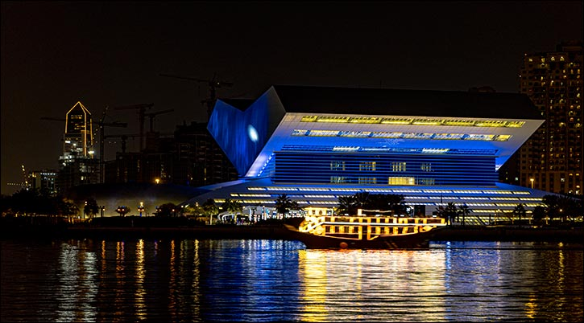
Al Khor Ramadan Nights
An event that brings together culture, community, and creativity along the banks of Dubai Creek. At its heart is a Ramadan Market spotlighting SMEs and homegrown businesses offering thoughtfully curated products, alongside a Ramadan Street Food hub where you can explore diverse culinary offerings and live cooking demonstrations.
11 Mar - 14 Mar, Free entry

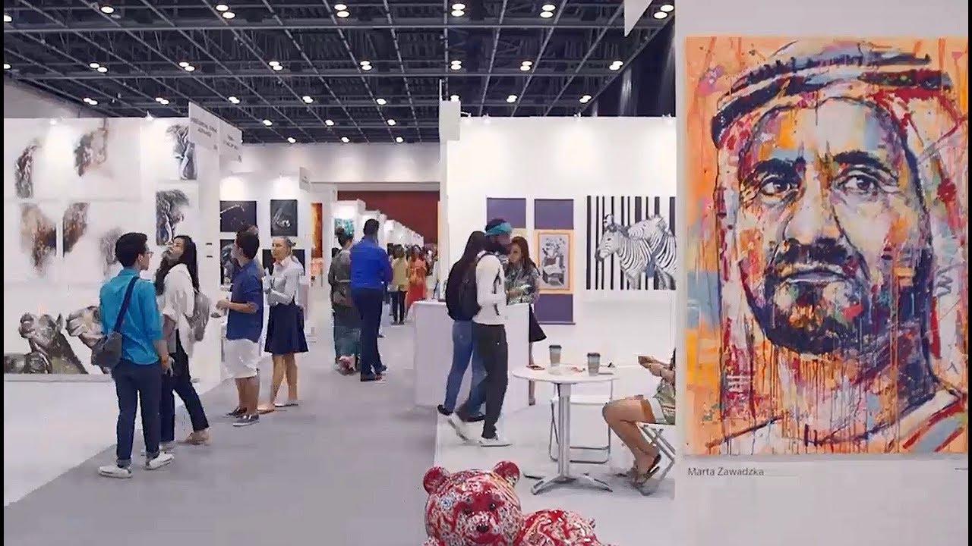
Art Fest International
Head to Taj Dubai for Art Fest International, a curated international art exhibition from India that showcases contemporary artworks by Indian artists and talent from other countries.
13 Mar - 15 Mar, Free entry

Max Amini Live in Dubai
Enjoy an unforgettable night of laughter with Max Amini at Dubai Opera. Expect fresh material, spontaneous crowd moments, and fast-paced stand-up that connects everyday life with global perspectives.
Sun 22 Mar - Mon 23 Mar, Tickets start from 60.93 USD (fast selling)

Where to eat?
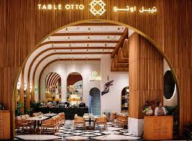

Table Otto is a stylish French-Italian fusion restaurant known for blending Mediterranean flavors with creative twists in a chic brasserie-style setting. The menu highlights brick-oven pizzas, creamy pastas, and inventive dishes such as hot honey pepperoni pizza, penne labneh arrabbiata, short rib musakhan rolls, and chicken fettah salad, along with indulgent desserts like banoffee cheesecake.

Pro tip: Start with the Texas toast beef bites or burrata dishes and pair them with a signature brick-oven pizza.

Career

Senior Finance Manager – Construction Real Estate

On-site
Full-time
AED 8,000 - 11,999/month
A Dubai-based real estate developer and construction company, ABA PRIME / SIBRIS, is looking for a Senior Finance Manager to oversee financial operations across its development and contracting projects. The role involves managing project budgeting, cost control, financial planning, and cash flow forecasting, while ensuring accurate financial reporting and compliance with UAE VAT regulations. Responsibilities include monitoring project profitability, coordinating with auditors, banks, and authorities, and supporting financial control across construction and development activities. Candidates should have over 10 years of finance experience, including at least five years in construction or real estate development within the UAE.

Register here

Meanwhile

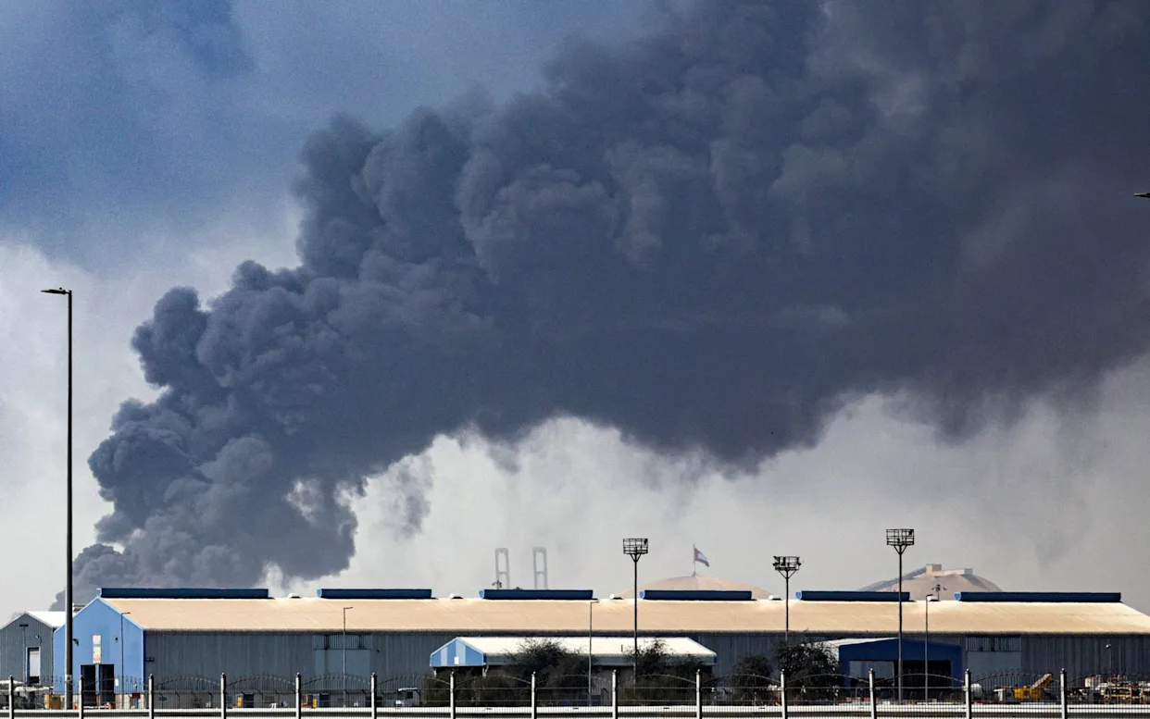

British tourist held
A British tourist has been arrested in Dubai after allegedly filming missiles striking the city and sharing the footage online, an act authorities say violates cybercrime laws. The 60-year-old Londoner faces up to two years in prison for allegedly circulating material that could disturb public security. Officials have also charged 20 others over similar posts, as the UAE warns against sharing content that could incite panic.

Public sector holidays

Dubai Government Human Resources Department announced a four-day Eid al-Fitr break for Dubai public sector employees from March 19 to March 22, with work resuming on March 23. Federal government workers will receive the same dates, while most private-sector employees will be off March 19–21. International Astronomy Centre said the Shawwal crescent is unlikely to be seen on March 18, suggesting Eid will likely fall on March 20.

Amali Island villa record
Dubai's property market saw a landmark Dh220Mn sale of a 58,080 sq ft luxury villa on Amali Island in the World Islands, at Dh3,787 per sq ft, per Dubai Land Department data. The deal underscores robust demand amid 2025's surge: 6,668 luxury transactions worth Dh143.8Bn, up 41% in volume and 45% in value from 2024.

Did you know?
In Dubai and across the UAE, photography can become a legal issue when it touches privacy or security. Taking photos of people without consent, especially women, families, accident victims, or beachgoers, can lead to serious penalties. Certain government and military sites are also off-limits, and even aircraft photography can be restricted. The UAE’s cybercrime law covers privacy violations involving photos, while official guidance clearly warns visitors to ask permission before taking pictures.

Day
Thursday

Date
Mar 12

Temperature
28°C

Preview text
Plus Dubai Eid holiday dates

Image credits
Private Bank or International, Visit Dubai, District, Platinumlist, Table Otto, Khaleej Times

