🇬🇧 Mar 12: Mind the muggers
Mar 12, Thu • AQI 36

In this edition:
- Greener streets fund
- Banking app tech glitch
- David Hockney’s exhibition

Spotlight

Tube thief takedown
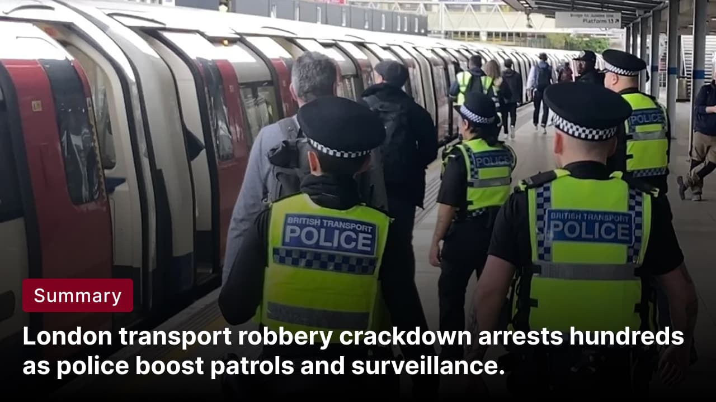

What’s happening? Over the past 12 months, British Transport Police arrested around 462 suspects, many of them teenagers, in a major crackdown on robberies across London’s Tube and rail network. The operation targeted a surge in violent thefts affecting commuters at stations and on trains. Authorities aimed to deter repeat offenders, restore public confidence in the transport system, and prevent violence linked to knife crime.

Policing process: British Transport Police are policing the network through a mix of high-visibility patrols, covert operations, and technology-led enforcement. Plain-clothes officers operate on trains and platforms to identify and arrest suspects. Police are also using live facial recognition cameras during targeted operations to locate wanted individuals. Additional measures include knife-detection arches, search dogs, and rapid-response teams.
How to report incidents? Public can report robberies or suspicious activity on the rail and Tube network by texting 61016, which allows passengers to send details without drawing attention on a train or platform. If the situation is urgent or someone is in immediate danger, the public should dial 999.

Greener streets fund
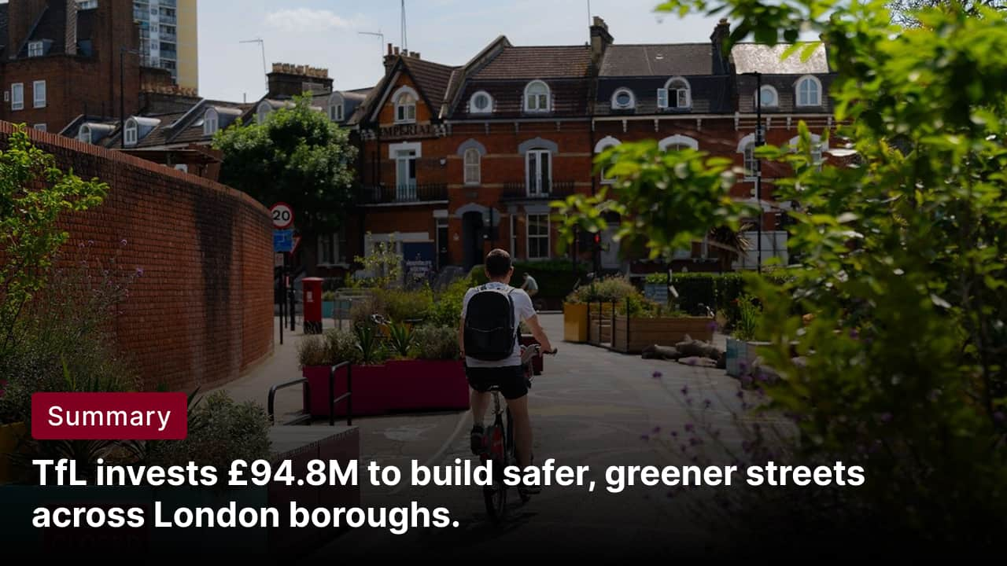

What’s happening? Transport for London will allocate £94.8M to London boroughs in 2026/27 to improve safer, greener streets. The funding will support borough-led projects such as new cycle routes, pedestrian crossings, School Streets, and measures to reduce road danger. It will also help improve bus reliability, expand micromobility and cycle parking, and introduce lower speed limits.

Vision Zero strategy: Vision Zero is London’s long-term road safety strategy aimed at eliminating all deaths and serious injuries from the transport network by 2041. The strategy focuses on redesigning streets and transport systems so that human mistakes do not result in fatal or severe crashes. Key measures include lower speed limits, safer road layouts, protected cycle lanes, improved pedestrian crossings, and stricter enforcement against dangerous driving.

Big picture: The programme also supports climate and air-quality goals by promoting sustainable travel and cutting congestion. Working closely with borough councils ensures projects are tailored to local needs. In the long term, the funding is part of a wider strategy to reshape urban mobility, support economic activity, and make London’s streets healthier, more accessible and environmentally sustainable.

What’s on

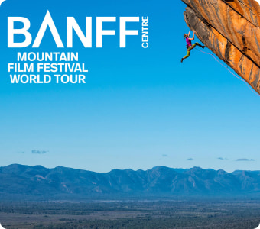
Banff Mountain Film Festival
The Banff Mountain Film Festival (Red Film Programme) features a thrilling selection of films from the most captivating places on earth.
March 14, tickets start at £18.15
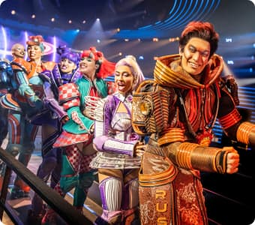
Starlight Express
A West End favorite (9th longest-running), this show raked in 2 Olivier and 6 Tony (including a win) nominations on Broadway.
Multiple dates, tickets start at £34.38

Long story short

Business
An investigation has been launched after a technical glitch in the mobile banking apps of Lloyds Bank, Halifax and Bank of Scotland allowed some customers to see transactions belonging to other users. Lloyds Banking Group apologised and said the problem was quickly identified and resolved, but regulators are currently reviewing the incident. It remains unclear how many customers were affected by the temporary data exposure.

Estée Lauder Companies sued British perfumer Jo Malone over the use of her name in a fragrance collaboration with retailer Zara. The products were sold under Jo Loves, but the packaging used “A creation by Jo Malone CBE,” which Estée Lauder says breaches its trademark rights purchased in 1999. The company claims trademark infringement, breach of contract, and passing off, saying the branding could mislead customers into thinking the products are linked to Jo Malone London.

Art & culture
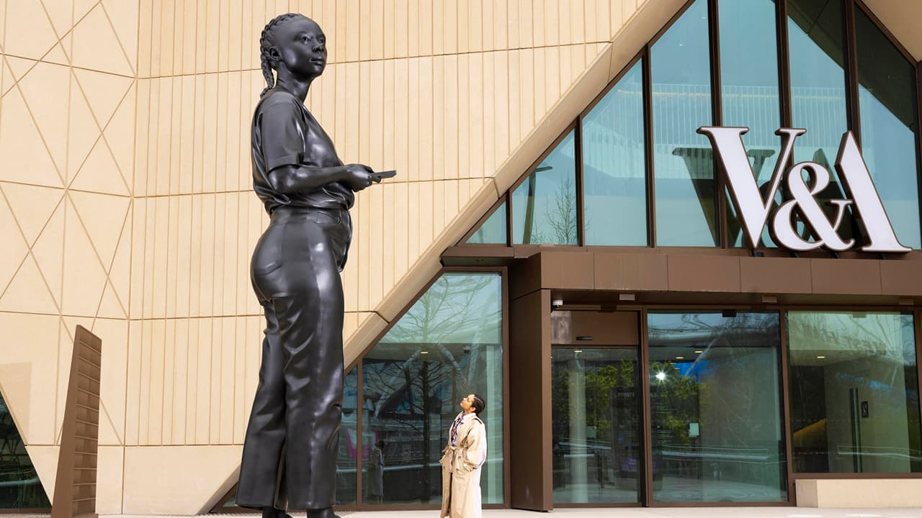

A towering public sculpture by Thomas J Price has been unveiled outside V&A East Museum ahead of the museum’s opening in April. Titled A Place Beyond, the 18-foot bronze statue depicts a casually dressed young person holding a phone, reflecting Price’s signature “everyperson” style. The sculpture aims to make the museum space feel welcoming and representative of everyday people.

An exhibition by David Hockney has opened at Serpentine North Gallery in London, showcasing a series of recent artworks by the 88-year-old painter. Titled David Hockney: A Year in Normandie And Some Other Thoughts About Painting, the exhibition features still life paintings and portraits of people from Hockney’s inner circle, including family members and carers. The show will run from March 12 to August 23.

Sports

Plans have been submitted to redevelop the Crystal Palace National Sports Centre. The proposal includes a major refurbishment of the 1964-built, Grade II-listed complex, upgrading its athletics stadium, indoor arena, and swimming and diving facilities. The redevelopment would add sports amenities such as padel courts, 3x3 basketball courts, five-a-side football pitches, and a multi-sports field.

Ryan Reynolds and Rob McElhenney will provide a special commentary broadcast when Wrexham AFC face Swansea City in the Championship at the Racecourse Ground. The alternative coverage, titled Live From Wrexham with Rob & Ryan, will air on Sky Sports alongside the standard broadcast. The show marks five years since the Hollywood pair bought the club and promises an unconventional commentary style.

Misc
Starmer warned of 'reputational risk' over Mandelson's links to Epstein

Iranian regime releases first statement from new supreme leader

'Weird pinging' sound in Salisbury Cathedral has baffled students during study

Man buries old 737 jet in garden to use as nuclear bunker

Did you know
London's oldest building is the Temple of Mithras constructed around AD 240. Unearthed in 1954, it has been reconstructed at its original site within Bloomberg's European headquarters near the Bank of England.

Image credits
The Standard, London Daily News, Banff Mountain Film Festival, London Theatre, Queen Elizabeth Olympic Park

Preview text
Plus TfL funds to transform London boroughs

