🗽 Mar 12: Data fishing hunt

In this edition:

- Hungary campaign crisis
- US trade probe
- Private WordPress

Spotlight

DHS seeks data
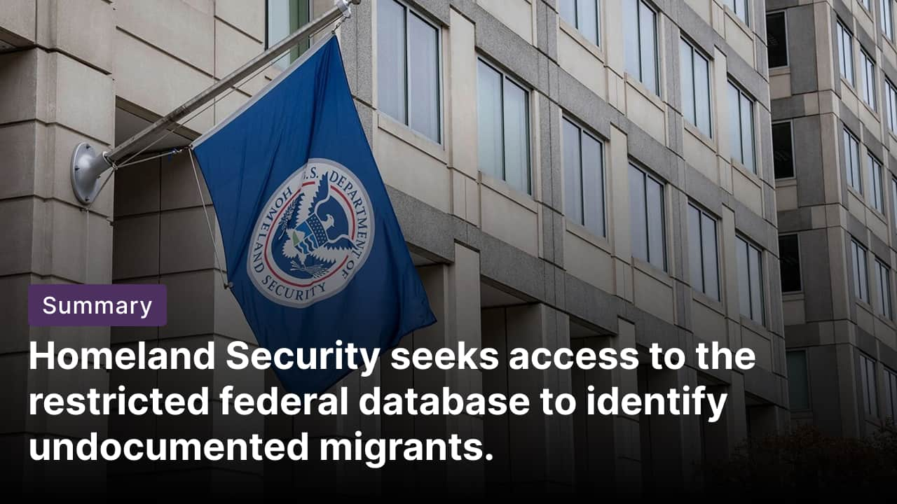

What’s happening? The US Department of Homeland Security (DHS) is seeking access to a child-support database held by the US Department of Health and Human Services that contains employment data. It’s the latest in a series of attempts by the Trump administration to use data stored in various federal agencies to potentially find undocumented immigrants residing in the US.

Background: This follows a pattern of inter-agency data grabs, such as last year's Internal Revenue Service sharing of taxpayer addresses with ICE for 47,000 suspected undocumented individuals. DHS has pursued similar access through memoranda of understanding after Elon Musk's DOGE eyed the same child support database.

Criticism: Critics, including former officials and privacy advocates, warn that the proposal could violate federal law governing the use of such data. Former child support enforcement commissioner Vicki Turetsky said opening the database to immigration authorities could expose information about workers and undermine trust in a system designed to support families.

Hungary election tensions


What’s happening? The war in Ukraine has become a central issue in Hungary’s upcoming parliamentary elections, with PM Viktor Orbán accusing Kyiv of trying to undermine his government. Hungarian officials allege Ukraine could be preparing sabotage attacks and political interference to prevent Orbán’s Fidesz party from winning re-election. The dispute is tied partly to disruptions in the Druzhba oil pipeline following a Russian drone strike in western Ukraine, which halted oil deliveries to Hungary.

Ukraine hysteria in Hungary: Tensions have fueled a wave of anti-Ukraine messaging across the country. Billboards and campaign materials portray Ukrainian President Zelenskyy as pressuring Europe for support, while linking him to opposition leader Péter Magyar of the Tisza Party. Government rallies warn Hungary could be dragged into the war, while the army has been deployed to patrol key energy facilities amid warnings of potential “hybrid attacks.”

Bigger picture: Critics say the government is exaggerating threats to influence voters. Analysts and independent journalists argue the pipeline outage stems from damage caused by Russian strikes rather than deliberate Ukrainian obstruction, while opposition figures accuse Orbán’s administration of spreading fear and disinformation ahead of the April election.

Long story short

Global Affairs

The International Energy Agency is set to release 400mn barrels of oil from global strategic reserves to address the supply disruption triggered by the war in Iran. This move marks the largest such action in the organization’s history. The US will take a lead role by contributing 172mn barrels (strategic oil release).

The US has launched an investigation into unfair trade practices targeting major partners, including the EU, China, India, Japan, South Korea, and Mexico, under Section 301 powers that could lead to fresh import tariffs. The probe follows a US Supreme Court ruling that struck down key elements of President Trump’s earlier tariff policy. It aims to rebuild tariff authority before temporary global duties expire in July (tariff investigation).

Business & Markets
The Pentagon may allow limited continued use of Anthropic AI tools beyond a planned six-month phase-out if deemed vital to national security, according to an internal memo. Exemptions would apply only in “rare and extraordinary” cases, requiring units to submit detailed risk-mitigation plans while the broader ban on the firm’s technology remains in place (exemption window).

Nissan Motor, Uber Technologies, and British startup Wayve have unveiled a partnership to develop robotaxis, targeting a pilot launch in Tokyo by late 2026. The service will use Nissan Leaf electric vehicles fitted with Wayve’s self-driving technology and operate via Uber’s platform. Initial rides will include safety drivers via a licensed taxi partner (robotaxi trio).

UK regulators Ofcom and the ICO demanded that Meta, TikTok, Snap, and YouTube strengthen age checks to block children under 13 and under-16s from accessing harmful content, in line with the Online Safety Act. Platforms must detail plans by April 30 to improve verification, ensure safer feeds, and restrict interactions with strangers, or face fines of up to 10% of their global revenue amid concerns about addictive algorithms (UK child safety).

Science & Tech


WordPress launched my.WordPress.net, enabling full site setup and publishing directly in any web browser without hosting or domains. Private by default and browser-bound, it serves as a personal workspace for writing, journaling, and tools, with an App Catalog and AI integration powered by WordPress Playground. Users can export to public hosts; storage starts at 100MB with easy resets (private WordPress).

Researchers have developed an experimental cellular immunotherapy that may treat Alzheimer’s disease with a single injection. The therapy engineers brain cells called astrocytes with a CAR (chimeric antigen receptor) so they can detect and remove harmful amyloid beta plaques, a key driver of the disease. In mouse studies, the treatment prevented plaque formation when administered early and reduced existing amyloid levels by about 50% (cell therapy).

Whatnot
Jeffrey Epstein’s longtime accountant faced hours of closed-door questioning by the House Oversight Committee (Epstein probe hearing).

Team USA stands on the brink of a shocking World Baseball Classic exit (embarrassing exit).

An explorer confirmed long-rumored “ghost elephants” living deep in Angola (elephant rediscovery).

AltStore PAL adds fediverse support, enabling connections to decentralized networks via ActivityPub (fediverse integration).

Image credits
Politico, Getty Images, WordPress.org

Preview text
Plus robotaxi partnership

