🗽 Feb 5: Uranium? Let’s talk

In this edition:

- Artemis II delayed
- Nike DEI probe
- Gizmo mini apps

Spotlight

US pressures Iran

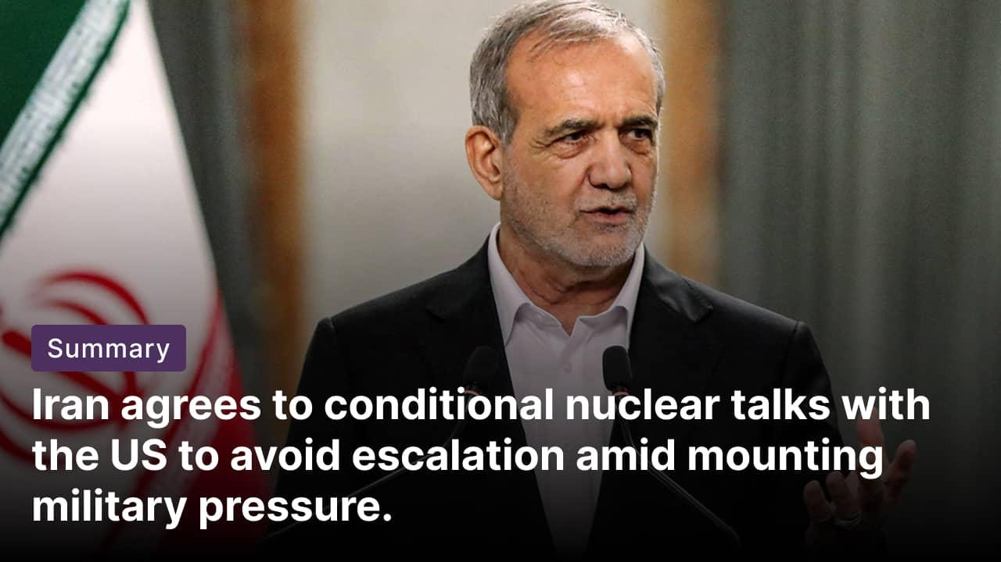

What happened? Iran has conditionally agreed to resume nuclear negotiations with the US. This marks the first meaningful talks since last summer, when the Trump administration carried out airstrikes on three Iranian nuclear sites. The decision comes as Tehran seeks to prevent the risk of further military escalation. President Masoud Pezeshkian has authorized talks under conditions of “dignity” and absence of threats.

US preparedness: Washington has moved into a heightened military and diplomatic readiness posture to reinforce leverage ahead of any Iran talks. It has surged assets into the Middle East, including a carrier strike group, additional air-defense systems, and bomber task-force rotations capable of rapid long-range strikes. Meanwhile, officials have publicly kept military options “on the table” to pressure Tehran, while signaling openness to narrowly scoped nuclear negotiations to test de-escalation.

Conditions for engagement: The Trump administration is reportedly demanding that Iran end all uranium enrichment, accept limits on its ballistic missile programme, and halt support for armed groups in the region. However, Iran's supreme leader has previously refused to abandon its right to enrich uranium.

Lunar mission postponed


What happened? NASA is delaying the launch of its historic Artemis II lunar mission after issues arose during the wet rehearsal (an elaborate launch-day walkthrough) of its rocket. NASA was forced to end the test with around 5 minutes and 15 seconds remaining in the simulated launch countdown. NASA is targeting March for the earliest possible launch of its lunar mission.

Wet dress rehearsal: NASA’s wet dress rehearsal, a full launch-day simulation, involved loading over 700,000 gallons of cryogenic propellant and running the countdown sequence. The test was halted after engineers detected a hydrogen leak at the base of the Space Launch System rocket. They also identified a faulty valve on the Orion capsule, which will house four astronauts during the 10-day Artemis II mission.

Artemis mission: Artemis II is NASA’s first crewed mission beyond Earth orbit since Apollo, sending four astronauts on a 10-day journey around the Moon. The mission will test life-support, navigation, propulsion, and re-entry systems aboard Orion before future lunar landings. This mission will be a critical step toward Artemis III, which aims to land astronauts on the Moon.

Fact: It will be the second flight of NASA’s SLS rocket, after the uncrewed Artemis I mission in 2022, which was also temporarily plagued by hydrogen leaks during tests.

Long story short

Global Affairs

Gunmen killed more than 160 people in attacks on many villages in Kwara State, Nigeria. The attackers torched homes and shops, and abducted residents. This comes after officials confirmed the presence of a small US troop that was in the country to help with intelligence and training amid escalating jihadist and bandit violence (Nigeria village massacre).

Saif al‑Islam Gadhafi, 53, son of the late Libyan dictator, Moammar Gadhafi, was shot dead at his home in Zintan. Four masked gunmen reportedly stormed his residence, disabled security cameras, and fatally shot him in what his advisors described as a deliberate and coordinated attack. His death eliminates one of the most controversial figures from Libya’s fractured political landscape (Gadhafi son killed).

Business & Markets
The Trump administration is prepared to let ByteDance buy Nvidia’s H200 AI chips. Nvidia has not accepted the proposed US conditions, including strict Know‑Your‑Customer rules to block Chinese military entry. The chipmaker said the terms must be commercially viable, as Washington tightens controls on chip exports to China amid broader US-China tech tensions (chip conditions).

Nike faces federal probe over allegations of ‘DEI-related’ discrimination against white workers. The probe, launched through a rare commissioner’s charge, seeks details on layoffs, race data, and DEI programs. Nike says it is cooperating and complying with the subpoena, while the EEOC chair has framed the probe as part of a broader push against race‑conscious workplace policies (diversity policy scrutiny).

TSMC plans to mass-produce advanced 3-nanometre chips in Japan’s Kumamoto prefecture, marking its first overseas production of the technology. The move will support Japan’s AI ambitions as demand surges. Local media reported a $17B funding, with the Japanese government considering additional subsidies to strengthen chip security (TSMC Japan expansion).

Science & Tech
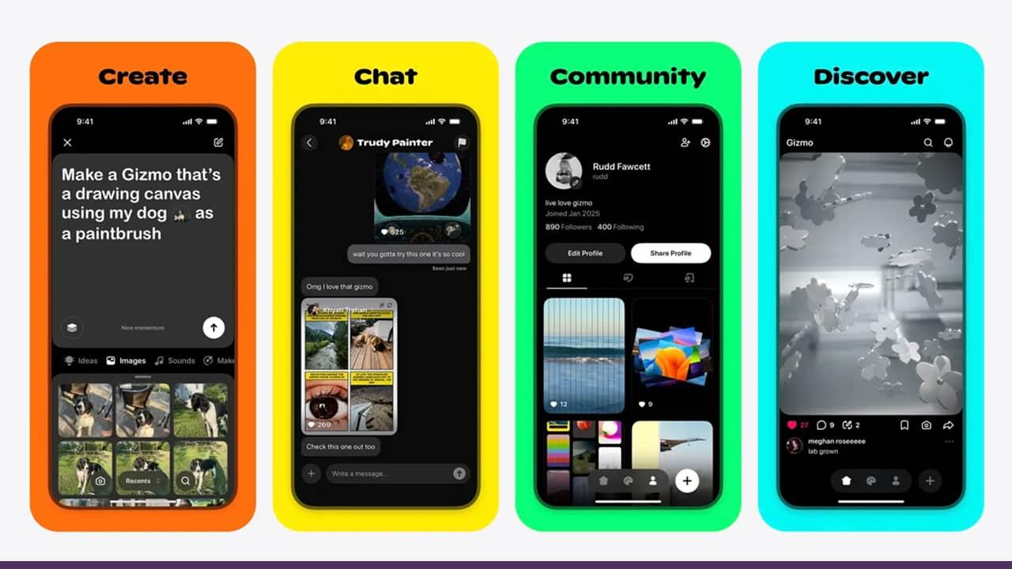

Gizmo, a TikTok-style app, lets users create and play interactive mini-apps in a vertical feed. Instead of watching videos, users tap, swipe, draw, and drag through digital toys, puzzles, art, and memes. Creations are built via AI-generated code from simple text prompts, with remixing, sharing, and moderation built in. Its appeal lies in a simple yet novel idea: making app creation playful, social, and accessible (interactive app feed).

A 25-year Swedish study found that middle‑aged and older people who ate more full‑fat cheese and cream had a lower risk of dementia, particularly among those without genetic risk for Alzheimer’s. The findings challenge decades of low-fat dietary advice but come with important caveats. Researchers caution that the results should not be taken as a reason to eat large amounts of high‑fat dairy, emphasizing balanced diets and lifestyle over single foods (cheese dementia link).

Whatnot
Tinder is launching an AI feature to reduce swipe fatigue and improve match quality (AI chemistry).

Heart disease risk in type 2 diabetes differs between men and women (see why).

Gemini has surpassed 750Mn monthly users, highlighting rapid AI adoption (Google growth).

Robin Hood–costumed thieves looted a Montreal grocery to protest soaring food prices (grocery heist).

Image credits: NBC News, IANS, Gizmo

