🇦🇪 Mar 4: Emergency isn’t entertainment

In this edition:

- Hai Ramadan
- US Embassy services suspended
- Dubai rain alert

Spotlight

Safety before streaming
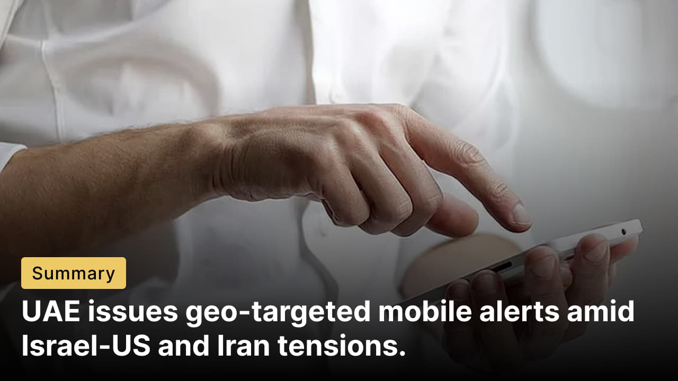

What’s happening? The UAE governemnt have been issuing mobile alerts through the National Early Warning System to keep residents and visitors' informed about the ongoing Israel-US and Iran tensions. The geo-targeted notifications, sent directly to phones, provide real-time safety instructions, including when to seek shelter. Agencies including the National Emergency Crisis and Disaster Management Authority (NCEMA) and the Ministry of Interior say the system is designed to deliver urgent guidance swiftly and ensure public safety.

No filming: Authorities warn against prioritising social media filming over safety during emergency alerts, with violators facing legal accountability. The Ministry of Interior (MoI) reported residents stopping vehicles or leaving homes to record videos post-notification. Authorities emphasised that alerts are issued solely to protect the public, instructing immediate sheltering indoors or in secure locations until an "all clear" signal. Drivers must continue to destinations without roadside stops.

Emergency hotline: The MoI reminded residents that the national emergency hotline 999 is reserved strictly for genuine emergencies. Residents are urged to avoid spreading unverified information online, keep phone lines free for critical cases, and follow updates from official sources to support the country’s coordinated emergency response.

Events

Max Amini Live in Dubai
Enjoy an unforgettable night of laughter with Max Amini at Dubai Opera. Expect fresh material, spontaneous crowd moments, and fast-paced stand-up that connects everyday life with global perspectives.
Sun 22 Mar - Mon 23 Mar, Tickets start from 60.93 USD (fast selling)
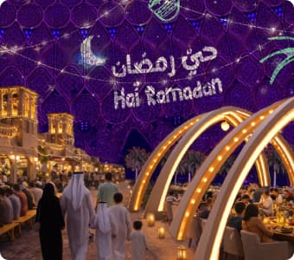
Hai Ramadan
Indulge in Dubai’s flagship Ramadan experience at the Al Wasl Plaza, Expo City Dubai. Enjoy a month-long celebration that beautifully blends tradition, community, and contemporary culture.
Tue 03 Mar - Sun 15 Mar, Tickets start from 42.51 USD

Arabic Classics by Firdaus Orchestra
Experience an evening where heritage, harmony, and heartfelt performance at the House of Arts, Expo City, Dubai. In the spirit of sisterhood, every woman’s ticket includes a complimentary ticket for a female friend, inviting you to share this musical journey side by side.
Sat 07 Mar, Tickets start from 21.25 USD

Where to eat?


Bubbalicious Brunch is a lavish all-you-can-eat brunch experience at Mina's Kitchen in The Westin Dubai Mina Seyahi Beach Resort & Marina, Al Sufouh 2. It offers an extravagant global buffet spread. The menu bursts with live cooking stations featuring sushi, seafood, carved meats, Indian curries, Chinese dim sum, Italian pastas, desserts, and unlimited beverages, including champagne.

Pro tip: Hit the seafood station first for king crab legs and pair with unlimited fizz; arrive early for poolside seats.

Career

AI Engineer / Automation Engineer

Remote
Full-time
AED 4,000 - 5,999/month
Adamantium AI, a Dubai-based AI consultancy specializing in intelligent automation and AI-powered workflows, is looking for an AI Engineer / Automation Engineer. The role focuses on designing and deploying practical AI systems for client businesses, including chatbots, workflow automation, sales automation tools, and AI integrations with CRMs and marketing platforms. Candidates should have experience with Python or JavaScript, API integrations, prompt engineering, and automation tools such as Zapier, Make, or n8n. Experience with LangChain, RAG systems, vector databases, or production AI deployments is a plus.
Register here

Meanwhile
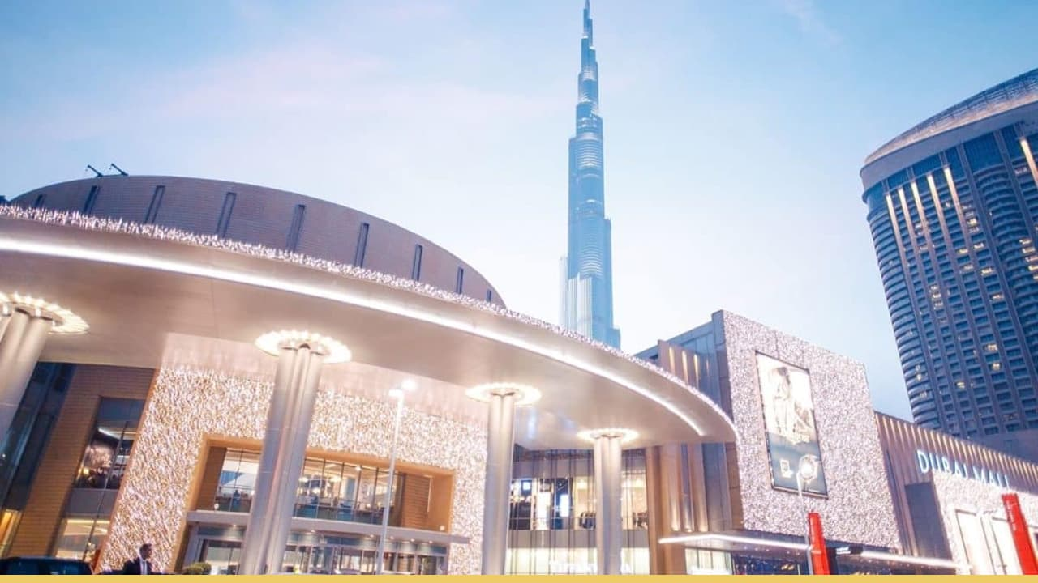

Consular services halted
The US Embassy in Abu Dhabi and the US Consulate General in Dubai are closed, and services cannot be provided in those facilities until further notice. Major attractions like Dubai Parks and Resorts, Global Village, and Ain Dubai remain closed due to regional security concerns from US-Israeli strikes on Iran. Malls, including Dubai Mall, and essential services operate normally; no public holidays today.

Tracks of preparedness
Etihad Rail, coordinating with Abu Dhabi’s ADCMC, operated three exceptional passenger trains from Al Ghuwaifat Station (bordering Saudi Arabia) to Al Faya Station, safely transporting over 350 UAE residents home amid regional travel disruptions. The service, running ahead of the official passenger rail launch, adhered to full safety protocols without affecting freight operations, showcasing the UAE’s emergency transport readiness.

Dubai cools down
Dubai faces partly cloudy to cloudy skies with chances of scattered rainfall and cooler temperatures peaking at 34°C, dipping to 23°C overnight. Light to moderate winds may freshen, causing blowing dust and reduced visibility, with fog alerts in place. Rough seas are expected in the Arabian Gulf, with wave heights reaching up to 7 feet.

Did you know?
In the Mirbah area of Fujairah, an Emirati man feeds hundreds daily during Ramadan. Ali Al Kaabi prepares and distributes traditional Harees and other iftar dishes from after Dhuhr until Maghrib, turning a personal act of charity into a powerful symbol of community unity and Emirati heritage.

Day
Wednesday

Date
Mar 4

Temperature
26°C

Preview text
Plus UAE rail lifeline activated

Image credits
Pexels, Expo City Dubai, Variety, The National, Abu Dhabi Night, Emaar

