🌍 Mar 4: Pentagon’s wallet hit

In this edition:

- China’s next phase
- US intervention legacy
- What is Juche philosophy?

Spotlight

$2B war damage
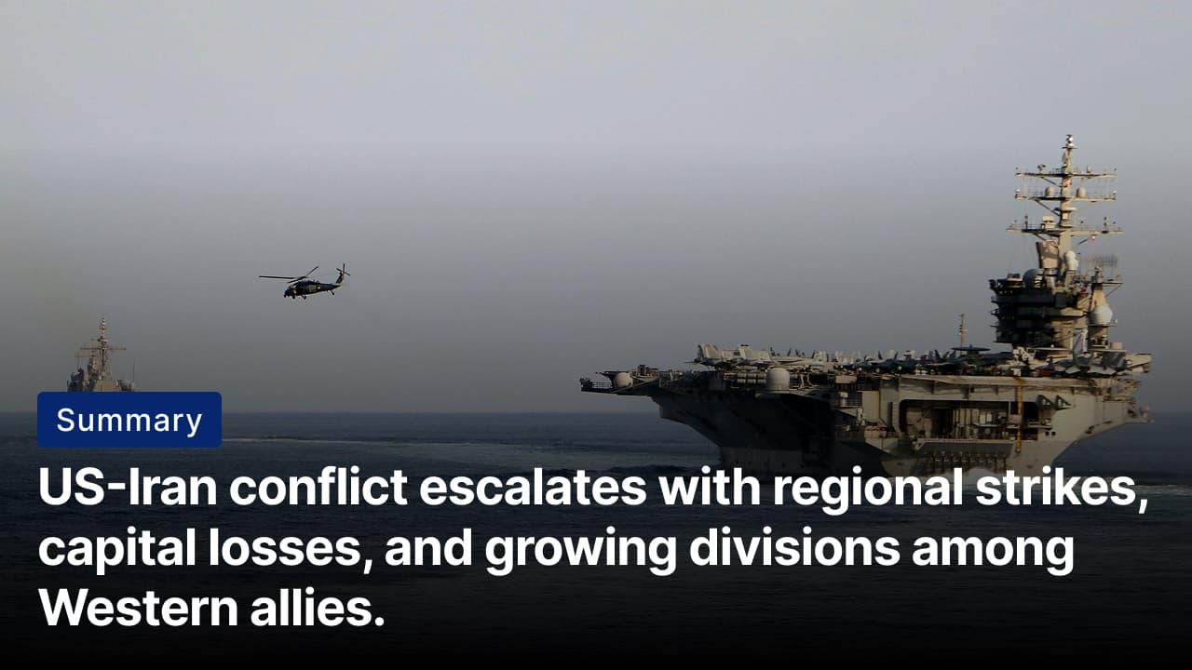
What happened? The US has lost nearly $2B worth of military equipment amid its attacks against Iran since Saturday. The most significant loss was a $1.1B early-warning radar at Al Udeid Air Base in Qatar. Other damage included satellite terminals in Bahrain, a THAAD radar in the UAE, and three F-15E jets lost over Kuwait, as strikes also hit US bases and diplomatic sites.
On the ground: Iran launched waves of missiles and drones toward Israel as the US-Israel war with Iran entered its fifth day. Iranian forces targeted a consulate in Dubai, a CIA station in Saudi Arabia, and a US base in Qatar. Meanwhile, Israel carried out airstrikes across Tehran and other Iranian cities targeting military and security facilities. At least 787 people have been killed across Iran in joint US-Israeli attacks.
Meanwhile: Spain has said the US is not using its joint military bases on Spanish territory for operations against Iran and that Madrid will not authorize their use for such attacks. PM Pedro Sánchez condemned the US-Israeli strikes on Iran as unjustified and dangerous. While Spain has also criticised Iran’s retaliatory attacks in the Gulf, its refusal to support military operations from its bases sets it apart from several European allies that have backed US actions.

China’s next phase
Summary: China unveils five-year plan focusing on tech self-reliance, consumption growth, and drones.
What’s happening? China will unveil its 15th Five-Year Plan (2026–2030) during the National People’s Congress (NPC) in Beijing. The plan is expected to focus on industrial self-reliance, technological innovation, renewable energy, and consumption-led growth. It will also address challenges such as the US trade war, slowing domestic demand, and weak consumer confidence. Premier Li Qiang will present China’s annual work report and might set economic growth targets around 5%.
Low altitude economy: This will be one of the key concepts discussed at the NPC. China’s “low-altitude economy” refers to the development and commercial use of airspace below about 1,000 meters to support logistics systems. The strategy focuses on technologies such as delivery drones, electric vertical take-off and landing (eVTOL) aircraft, aerial taxis, agricultural drones, and surveillance or inspection systems. Regulators are expected to introduce updated airspace management rules, infrastructure, and safety standards at the NPC.
Big picture: Chinese officials face the difficult task of shifting the economy toward consumption-led growth. Economists expect policies to boost domestic demand, expand services, and reduce urban–rural wage gaps. A proposed “Law on Promoting Ethnic Unity and Progress” seeks to strengthen a shared national identity across China’s 56 ethnic groups, potentially increasing cultural and political assimilation.

Analysis

US intervention legacy
Summary: US strikes highlight America’s long history of regime-changing interventions abroad.
What happened? President Trump initially framed the US-Israeli strikes on Iran as eliminating Tehran’s nuclear and military threat and potentially removing the ruling clerical regime. However, officials, including Defense Secretary Pete Hegseth, later denied that the conflict is intended as a regime-change war. The debate reflects a long US history of interventions aimed at reshaping governments abroad.
US interventions: US interventions abroad have taken many forms, including covert operations, military invasions, and support for opposition groups to influence political outcomes. During the Cold War, the US intervened to counter communism, including the 1953 coup in Iran and the 1965 intervention in the Dominican Republic. Later operations included invasions of Grenada (1983) and Panama (1989). In the 21st century, major interventions occurred in Afghanistan in 2001, Iraq in 2003, and Libya in 2011.
Outcomes: US interventions abroad have produced mixed results. In some cases, they successfully removed targeted leaders or regimes and reshaped political systems. However, many interventions created power vacuums, weakened institutions, and prolonged instability. Over time, these operations have also shaped global perceptions of US foreign policy, fueling debates about sovereignty, legitimacy, and the effectiveness of military-led political change.

Worldwide
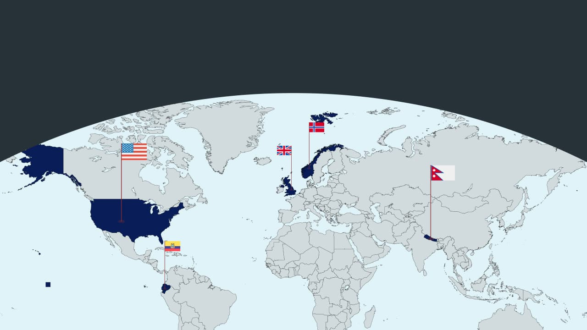

🇳🇵 Nepal - Ready for election. Nepal is heading to a general election on 5 March, its first national vote since youth-led protests last September. Nearly 19Mn voters will choose a 275-member parliament, with 165 lawmakers elected directly and 110 through proportional representation. Traditional parties such as the Nepali Congress and Communist Party of Nepal (Unified Marxist–Leninist) face a challenge from the newer Rastriya Swatantra Party led by reformist candidate Balendra Shah (scripting the future).

🇪🇨 Ecuador - Operation against drugs. Ecuador and the US have launched joint military operations targeting drug-trafficking groups that authorities describe as “narco-terrorist” organizations. They aim to disrupt cocaine trafficking networks operating through Ecuador’s ports and territory. Ecuadorian forces are carrying out the ground operations, while US personnel provide planning, intelligence, and logistical support (no to drugs).

🇳🇴 Norway - Additional charges. Prosecutors in Norway have filed additional charges against Marius Borg Høiby, the son of Crown Princess Mette-Marit. The 29-year-old faces 40 charges, including rape, reckless behaviour, and violating a restraining order. Høiby denies some of the allegations, particularly four rape counts involving a woman allegedly asleep or incapacitated. Prosecutors say he has admitted some offences (more drama).

🇬🇧 UK - Visa restrictions. ⁠The UK said it will end study visas for students from Afghanistan, Cameroon, Myanmar, and Sudan, and work visas for Afghans. The Home Office said applications from these groups increased by more than 470% between 2021 and 2025. Officials described the measure as an “emergency brake” to prevent misuse of the visa system while maintaining protection for genuine refugees (recalibration).

🇺🇲 US - War insurance. President Trump announced that the US government will provide political risk insurance for ships traveling through the Gulf. The insurance will be offered through the United States International Development Finance Corporation to help shipping companies continue operating despite rising security risks. Trump also said the United States Navy may escort oil tankers through the strait if necessary (US assures).

Foundations

What is Juche philosophy?
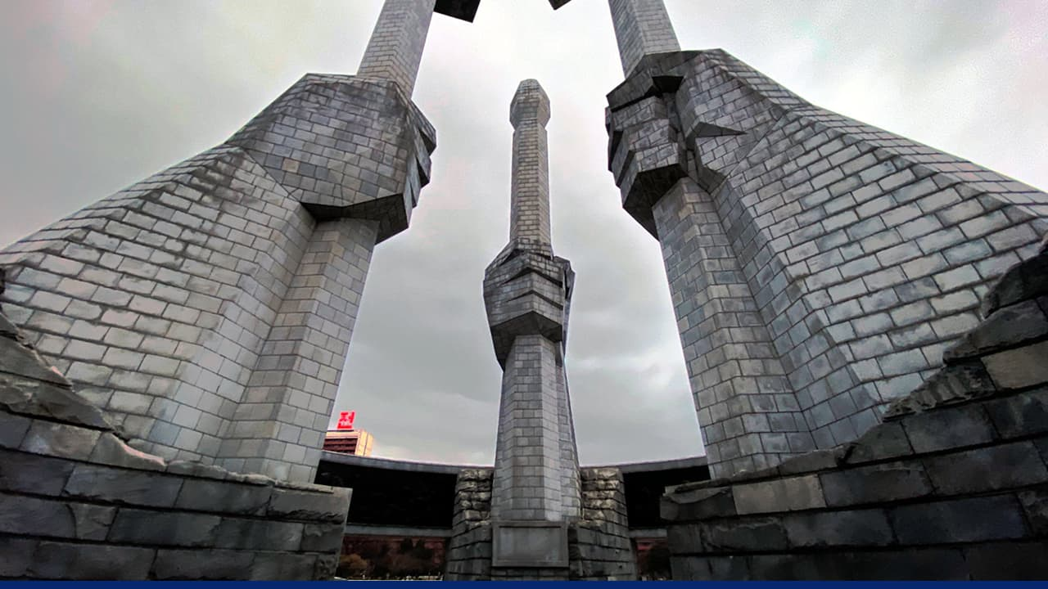

Ideology: Juche is North Korea’s official state ideology, created by Kim Il Sung and later expanded by his son Kim Jong Il. Juche is often described as “self-reliance,” meaning a nation should rely on its own strength and shape its own future. It calls for independence in all aspects, including political, economic, and ideological. It is core to socialist construction.

Principle: Juche holds that people, not material conditions, are the main force in revolution and state-building. It rejects materialist determinism (the idea that human actions are fully shaped by economic or material conditions) and argues that political will can surpass objective constraints. It also prioritizes national sovereignty.

Roots: Juche emerged from Marxism-Leninism. North Korea’s ruling Workers’ Party began within the communist movement, but its leaders argued that Korea needed a model suited to its own history. North Korean theorists say Juche develops Marxism to a “higher level” by emphasizing national independence and rejecting strict Soviet-style socialism. Kim Jong Il described Juche as a creative form of Marxism adapted to Korea’s experience.

See a brief video about the ideology here.

Image credits
Reuters, North Korea Travel

Preview text
Plus China’s five-year plan

