🇬🇧 Mar 4: Hate report card
Mar 4, Mon • AQI 60

In this edition:
- Faiths fast together
- TfL Art Map
- KSI buys English football team

Spotlight

School antisemitism review


What’s happening? Britain’s government has launched an independent review into antisemitism in England’s schools and colleges. The review will evaluate how schools identify, prevent, and respond to antisemitic behaviour, examine incident-handling policies, and assess how external factors, such as protests and geopolitical tensions, affect student conduct within educational environments. The review will also evaluate the training and guidance provided to teachers and staff.

Why? The Community Security Trust recorded 204 antisemitic incidents linked to education settings in 2025. Nationally, reported antisemitism rose 4% that year, the second-highest total on record. Jewish students and teachers have raised concerns about hostility, harassment, and a lack of effective responses when incidents occur.

Big picture: Since the Gaza war began after Hamas’s October 7 attacks, antisemitic incidents have risen in several Western countries, raising fears about the safety of Jewish communities and the resilience of social cohesion. In Britain, classrooms have become a focal point where political debates, protests, and online narratives spill into student behaviour. Government review aims to curb antisemitism while balancing debate and school safety.

Faiths fast together



What’s happening? For the first time since 1993, the Islamic holy month of Ramadan and the Christian season of Lent have begun at roughly the same time. In London, communities of different faiths are observing their respective practices while recognising similarities. Muslims fast daily from sunrise to sunset during Ramadan, breaking the fast with iftar meals, while Christians observing Lent focus on prayer, fasting, and acts of self-discipline over 40 days leading to Easter.
Similarities: Ramadan and Lent share several spiritual and social similarities. Both are periods of fasting, prayer, reflection, and self-discipline. Observers are encouraged to practice humility, charity, and compassion toward others. Both traditions emphasise spiritual growth over physical sacrifice, reminding believers to focus on gratitude, forgiveness, and moral responsibility. Community also plays a key role, with people gathering for prayers, meals, and acts of service.

Big picture: The overlap of Ramadan and Lent highlights how different religions often share similar spiritual practices and values. In diverse cities like London, this coincidence has become an opportunity for interfaith dialogue and cultural understanding. At a time of global tensions and religious divisions, the simultaneous observance of these traditions serves as a reminder that many faiths share similar goals of compassion, humility, and spiritual renewal.

What’s on

The Mousetrap - Play
Join a global phenomenon with The Mousetrap in London, the world’s longest-running theatre show, which has been performed over 28,000 times in the West End.
Multiple dates, tickets start at £31.25
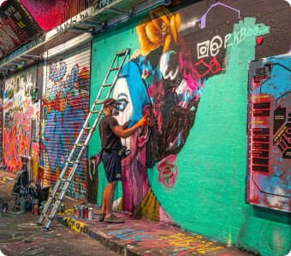
Graffiti Workshops at Leake Street Arches
Marc Craig has curated an experience that will guide you through the process of making your own graffiti masterpieces.
Multiple dates, tickets start at £40

Long story short

Business
IRD Railway Services Limited, a long-standing supplier of specialist track-related products and services to the UK railway industry, entered voluntary liquidation. The decision was approved at a shareholder meeting where members passed resolutions to wind up the company. Insolvency specialists Gareth Howarth and Philip Lawrence from AMS Business Recovery were appointed as joint liquidators to oversee the process.

Britain’s financial regulator, the Financial Conduct Authority, is preparing a compensation scheme for drivers affected by the UK’s mis-sold motor finance scandal. If approved, lenders will have three to five months to compensate customers. A review in 2021 found many brokers and dealers used discretionary commission arrangements, increasing loan interest rates without clearly informing customers to earn higher commissions.

Art & culture
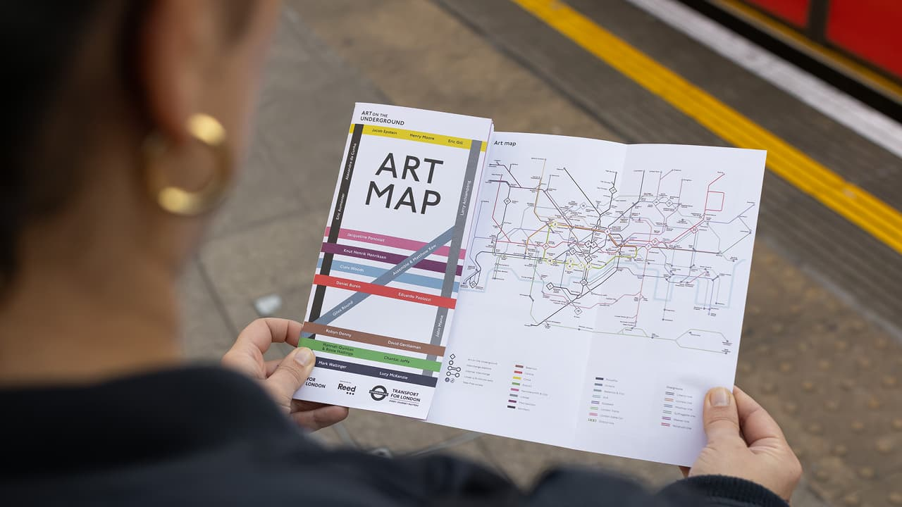

Transport for London has updated the Art Map for its Art on the Underground initiative, highlighting permanent artworks across the Underground network. The programme, launched in 2000, brings site-specific artworks into Tube stations to connect art with everyday travel. The map includes commissions installed since 2016 and guides visitors to 26 permanent works across the network.

The Ashmolean Museum has returned a 16th-century bronze idol of Thirumangai Alvar to India after research showed it had been stolen from the Soundararaja Perumal Temple in Tamil Nadu. After an independent researcher identified photographs linking the sculpture to the temple in 2019, the museum worked with the Indian High Commission and authorities to confirm its provenance. Following a formal ceremony in London, the artefact will be sent to India for verification before being restored to the temple.

Sports

England began their 2027 Women’s World Cup qualifying campaign with a dominant victory over Ukraine in Antalya, Turkey. After a frustrating goalless first half, England took control in the second half with braces from Alessia Russo and Georgia Stanway. Jess Park also scored twice to seal a comfortable victory. The match was played in Turkey because Ukraine cannot host games at home due to the ongoing war with Russia.

KSI has become a shareholder and strategic partner in non-league football club Dagenham & Redbridge FC. The investment follows the recent takeover of the club by Happy Fan Group LLC. KSI said he hopes to help rebuild the club and eventually guide it up the football pyramid, aiming for long-term growth and renewed fan excitement. The club currently plays in the sixth tier of English football.

Misc
UK's first visa ban in asylum crackdown

What should stranded Britons know as flights back to UK begin

Keir Starmer Says Trump's Bombing Of Iran Is Illegal

David Beckham Shares Sweet Post On Son Brooklyn's Birthday

Did you know

The London Underground has about 40 abandoned stations, sometimes called “ghost stations.” Some are used for movie sets and training exercises.

Image credits
Reuters, Getty Images, London Theatre Tickets, Secret London, TfL

Preview text
Plus KSI buys English football team

