🗽 Mar 4: Middle East mayhem

In this edition:

- Global breast cancer surge
- Banks brace for cyber risk
- NASA detects ‘dark galaxy’

Spotlight

Gulf strikes intensify
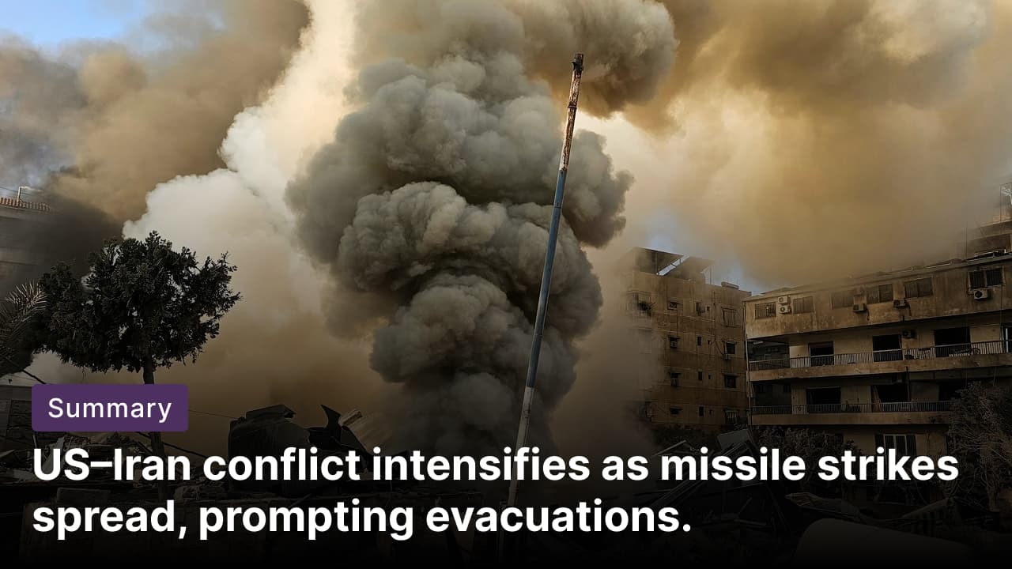

What’s happening? Strikes in the Middle East have intensified as Iran and joint Israeli-US forces launched new waves of missile and drone attacks. Iranian-backed militias targeted US assets across Gulf countries. The US State Department is advising its citizens in 14 countries, including Saudi Arabia, the UAE, Israel, and Qatar, to depart immediately as security warnings put embassies on lockdown.

On the ground: A consulate in Dubai, a CIA station in Saudi Arabia, and a US base in Qatar all sustained hits. The US has lost nearly $2B worth of military equipment amid its military operations against Iran in the first 4 days of strikes against Iran. Losses include SATCOM terminals, F-15E Strike Eagles, and radar equipment. Six US service members died in retaliatory strikes. Iran repeatedly targeted Erbil International Airport in Iraq, hosting US forces.

What’s next? The US State Department is arranging military and charter flights to evacuate American citizens from the Middle East. US Secretary of State Marco Rubio warned that the most severe US military actions are still to come, with the next phase expected to be even more punishing for Iran. Meanwhile, Iran’s Islamic Revolutionary Guard Corps said recent leadership losses have strengthened its resolve, vowing its enemies will no longer be safe anywhere.

Fact: Between 500,000 and 1Mn US nationals are estimated to be living in the Middle East.

Rising breast cancer burden
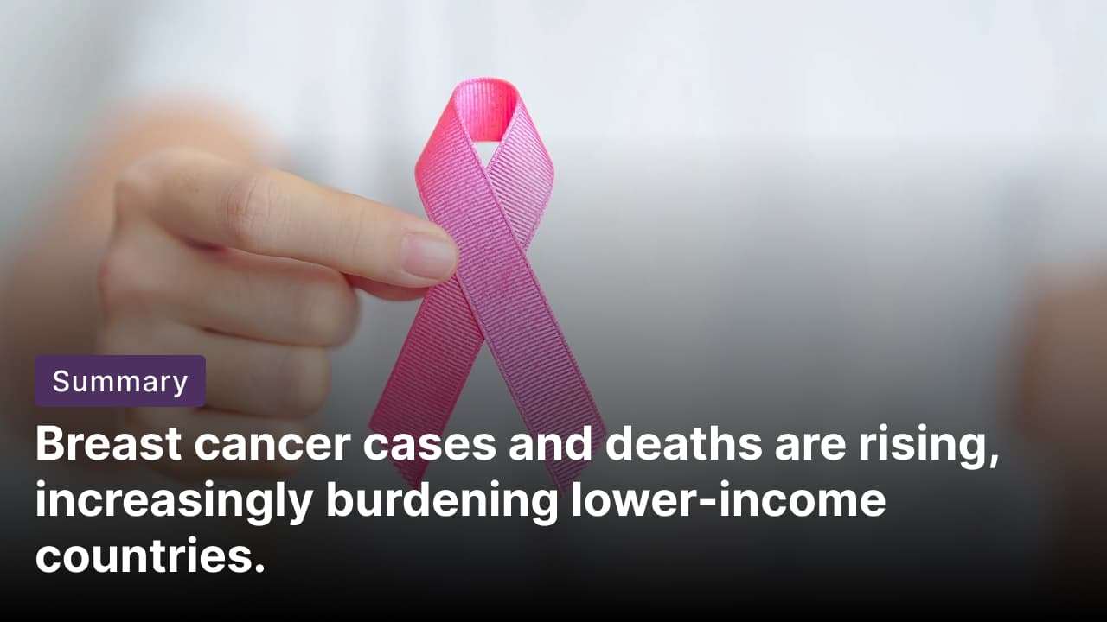

What’s happening? Breast cancer remains the most common cancer among women worldwide, with annual cases expected to reach over 3.5Mn by 2050. Similarly, yearly deaths from the disease are projected to surge to 1.4Mn. In 2023, 2.3Mn breast cancers were diagnosed worldwide (1.67Mn cases occurring in high- and upper-middle-income countries) and 764,000 resulting deaths (300,000 deaths occurring in low- and lower-middle-income countries).

Cause: Rising obesity and shifts in reproductive patterns (earlier puberty, delayed childbirth, and later menopause) are reshaping breast cancer risk. Lifestyle and behavioral factors accounted for 28% of the global disease burden in 2023. High red meat intake accounts for 11%, followed by tobacco use, high blood sugar, high BMI, alcohol consumption, and physical inactivity. The burden is increasingly shifting to lower-income countries with limited screening, later diagnoses, and higher mortality.

Prevention: Maintaining a healthy lifestyle, including not smoking, getting sufficient physical activity, lowering red meat consumption, and having a healthy weight, may prevent over a quarter of healthy years lost to illness. The US Preventive Services Task Force recommends mammograms every two years for women aged 40–74. Those with higher risk, such as a family history of breast cancer or obesity, should consult a primary care provider.

Fact: Breast cancer accounted for around one-in-four cancer diagnoses in 2023.

Long story short

Global Affairs

Canadian PM Mark Carney called US-Israeli strikes on Iran a failure of the international order, urging rapid de-escalation and renewed diplomacy. He said Iran remains a source of regional instability and has not curbed its nuclear program despite years of negotiations. Carney backed efforts to prevent nuclear proliferation while stressing civilian protection and broader political solutions (Canada urges de-escalation).

European allies are deploying warships, anti-drone systems, and jets to Cyprus after a drone struck RAF Akrotiri over the weekend amid US-Israeli strikes on Iran. The UK sends HMS Dragon and helicopters; France dispatches frigate Languedoc; Greece provides F-16s and frigates. Britain said its jets downed an Iranian drone over Jordan. Cyprus insists it is not involved in the conflict, amid scrutiny over base security (allies bolster Cyprus).

Business & Markets
US financial firms are on heightened alert for potential Iran-linked cyberattacks as conflict escalates in the Middle East. Executives warn of possible low-level disruptions, including DDoS attacks by pro-Iranian hacktivists targeting critical infrastructure such as payments and trading systems. Analysts say indirect risks, including higher oil prices, also loom, while agencies caution Tehran could expand cyber operations against Western banks (cyber threat alert).

OpenAI is developing a code-hosting platform to rival ​Microsoft's GitHub. The move follows recent service disruptions affecting engineers. The early-stage product may eventually be offered to OpenAI customers, though completion is months away. If launched, it would pit OpenAI against its major backer, Microsoft (code hosting challenge).

US defense contractors, including Lockheed Martin, are expected to remove Anthropic tools after President Trump ordered a Pentagon-wide ban. The administration plans to label Anthropic a national security supply chain risk. Lawyers say contractors will likely comply to protect federal contracts, even as Anthropic prepares to challenge the decision in court (contractors ditch Anthropic).

Science & Tech
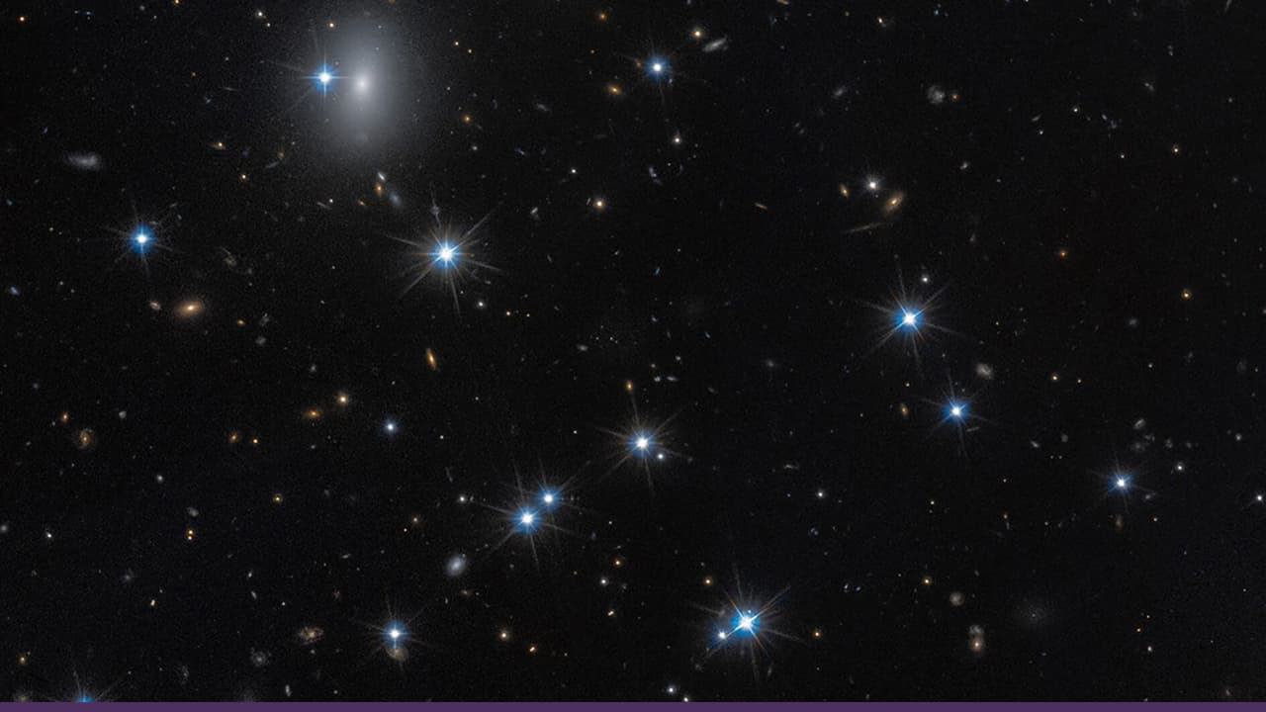

Astronomers using the Hubble, Euclid, and Subaru telescopes have identified Candidate Dark Galaxy-2 (CDG-2). It is an ultra-faint galaxy about 300Mn light-years away that may consist of 99.9% dark matter, orbiting globular clusters in the Perseus Cluster. Likely stripped of star-forming gas. It represents an "almost-dark galaxy," providing insights into dark matter behavior (dark galaxy).

Anthropic has launched Voice Mode for Claude Code, introducing hands-free coding via spoken commands. Users can toggle it with "/voice," then issue instructions like "refactor the authentication middleware," which the AI coding assistant executes seamlessly. Live for 5% of users with a broader rollout ahead, it enhances conversational workflows for developers. This builds on Claude's existing voice capabilities, streamlining interactions without keyboard input (Claude gets voice).

Whatnot

Disney inks $5.25B short-term credit pact (replaced agreement).

US TikTok access hit by Oracle infrastructure problem (posting lag).

World's largest acidic geyser in Yellowstone erupts after 6 years (see why).

US Commerce Secretary to testify about Epstein ties (Lutnick testimony).

Image credits
Getty Images, Shutterstock, NASA

Preview text
Plus OpenAI challenges GitHub

