🇦🇪 Feb 12: The great drug shield

In this edition:

- Lake in the dunes
- Seamless travel tech
- No Ramadan hikes

Spotlight

Pharma security push

Summary: FNC backs reforms to secure medicines, cut prices, boost local pharmaceutical production.

The Federal National Council approved 18 recommendations to strengthen national security in the UAE’s pharmaceutical and health supplies sectors. The council urged lower medicine prices and greater transparency by publishing banned drug lists, while prioritising pharmaceutical sustainability, improved access to health supplies, and stronger contributions to public health.

The key attributes of the recommendations include five-year stockpiling of key ingredients, global supply partnerships, and support for local biologics and generics. They also call for faster approvals under Federal Decree-Law No. 38 of 2024 and reduced medicine prices. Further initiatives include mandating coverage for domestically produced medicines, increasing funding for pharmaceutical research, harmonising regulations with international standards, offering targeted incentives to attract funding, and tightening supervision of herbal and alternative remedies.

The Federal National Council recommendations would strengthen drug security, reduce dependence on imports, and stabilise medicine prices. Faster approvals and local manufacturing incentives could improve availability of affordable treatments. Enhanced regulatory alignment and research funds would boost global competitiveness, while greater transparency and oversight would build public trust and improve overall healthcare resilience.

Lake in the dunes

Summary: Dubai unveils Al Layan Oasis, blending eco-tourism, conservation, and desert leisure infrastructure.

Dubai has officially launched Al Layan Oasis, a 10-Mn-square-foot eco-tourism destination in the Al Marmoom desert. Announced by Sheikh Mohammed bin Rashid Al Maktoum, the project blends large-scale environmental planning with curated leisure infrastructure. The site will accommodate up to 330,000 visitors annually, balancing tourism growth with conservation thresholds.

At the heart of the development is a 2.5-Mn-square-foot man-made lake, forming the oasis’s ecological and visual centerpiece. It will feature landscaped greenery, shaded areas, and native planting designed to protect the desert while improving visitor comfort. Critical infrastructure includes 14 km of walking and cycling tracks (with 4 km elevated for panoramic views), 1,000 parking spaces, and a visitor and environmental education center.

Located about 50 minutes from central Dubai, the oasis acts as a bridge between urban Dubai and the natural desert corridor. It serves as a key pillar in Dubai’s sustainability agenda, combining ecological restoration, active mobility, and immersive tourism in a single integrated destination.

Event
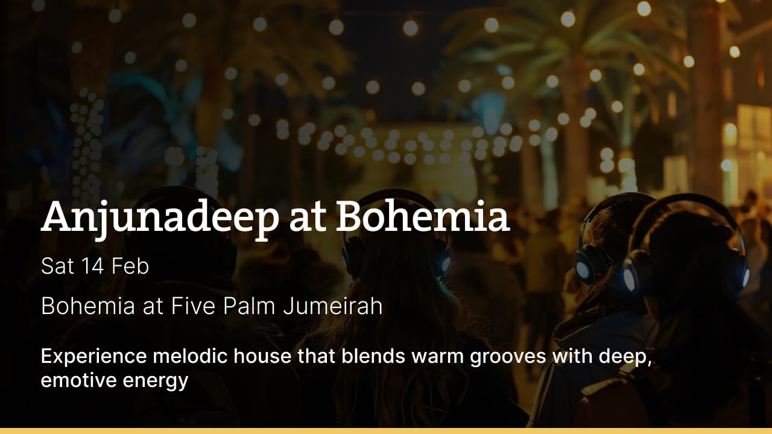

Where to eat?

Goose & Gander → Located in Holiday Inn Express, DIC, this British-inspired gastropub blends classic comfort food with a lively social atmosphere. Known for hearty roasts, fish and chips, and elevated pub plates, it delivers traditional flavors with a modern twist. The interiors channel vintage London charm: dark woods, leather seating, and a warm, convivial vibe. It’s popular for after-work drinks, weekend brunches, and live sports screenings

Pro tip: Visit on a quiz night or match screening day.

Career

Sales Executive

On-site
Full-time
AED 4,000-5,999 /month
Summary → Strategic Technology Solutions is looking to hire a sales executive. This is a full-time job which is targeted at enterprise clients. Responsibilities include generating leads and closing deals as well as managing the relationship with clients. The candidates are required to have 2-5 years of experience in the UAE, ideally in the channel sales positions with Etisalat or DU.

Register here

Meanwhile

Seamless travel tech

Dubai International Airport is rolling out a suite of AI-driven passenger technologies aimed at eliminating friction across the travel journey. The key upgrade is a smart checkout system that links purchases to flight data and alerts passengers if boarding time is near. It complements new AI-powered security scanners that eliminates the need to take laptops, liquids, or aerosols out of hand baggage.

Beyond driving school

Emirates Driving Company is rebranding as Emirates Mobility, marking a strategic shift from a traditional driver training institute to a diversified mobility platform. The company will transition into a holding and supervisory platform overseeing a diversified portfolio of mobility-centric businesses. Under the new structure, it will consolidate transportation operations, strategic funding entities, and electric vehicle infrastructure assets, including Excellence Premier Investment Group, Mwasalat Holding, and ChargePoint, into a unified mobility ecosystem.

No Ramadan hikes

The UAE Ministry of Economy has confirmed that prices of nine essential food items will not increase during Ramadan 2026. These staples include rice, bread, wheat, cooking oil, eggs, dairy, sugar, poultry and legumes. Minister Abdullah bin Touq Al Marri said daily inspections will be conducted to prevent unjustified price hikes. Retailers violating regulations face fines ranging from Dh500 to Dh100,000.

Did you know?
Dubai produces luxury chocolate made from camel milk. For example, the brand ‘Al Nassma’ is famous for this unique desert inspired treat.

Day
Thursday

Date
Feb 12

Temperature
26°C

Preview text
Plus Ramadan price freeze

