🌍 Feb 12: Digital jihad disrupted

In this edition:

- Islamic Revolution anniversary
- Bangladesh goes to the polls
- Why is Central Asia so uniquely shaped?

Spotlight

Online IS network
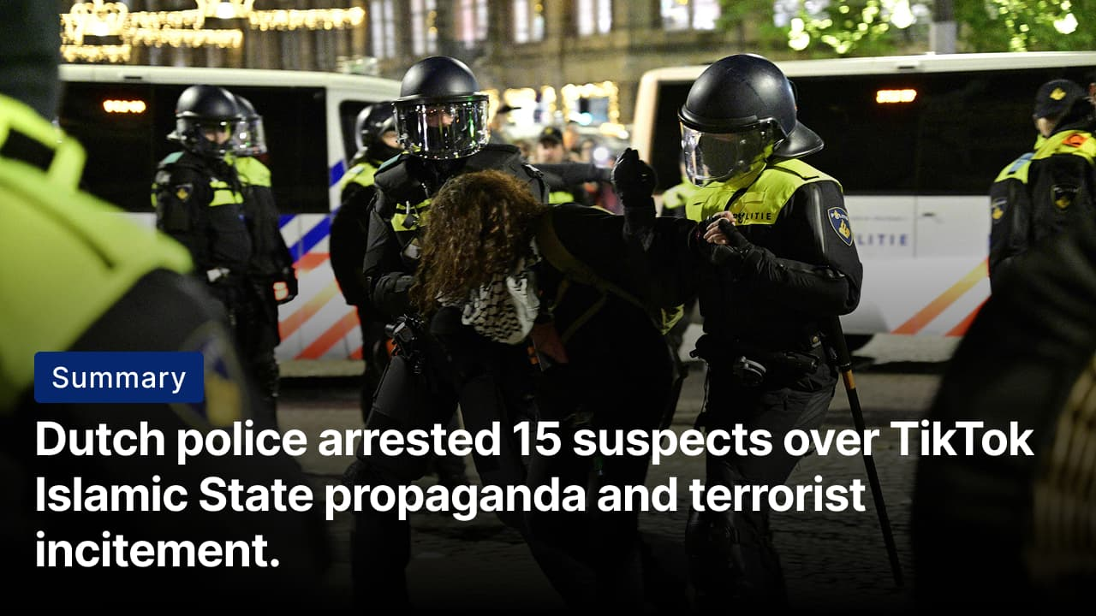
Thirteen of the suspects have Syrian nationality. Three others have Dutch citizenship, and four suspects are minors. Credits: Reuters
The what: Dutch police arrested 15 people suspected of spreading Islamic State (IS) propaganda on TikTok. The group allegedly shared videos praising ISIS, promoting “martyrdom,” and encouraging others to commit terrorist acts. The suspects range in age from teenagers to people in their fifties. Suspects were detained on charges including incitement to commit terrorist offences and dissemination of extremist material.
The how: The probe began after authorities identified a TikTok account distributing Islamic State propaganda with Dutch subtitles. The probe, launched in August 2025, led to a nationwide operation targeting individuals allegedly involved in spreading or supporting the content. A main suspect had already been arrested earlier in January in connection with the case. Further arrests have not been ruled out.
The implications: The arrests underscore growing European concern over the role of social media in amplifying extremist narratives. Platforms such as TikTok can rapidly disseminate propaganda to wide audiences, including minors, increasing the risk of online radicalization and self-directed violence. The case signals that Dutch authorities are prepared to treat digital dissemination of terrorist content as a prosecutable security threat.

Islamic Revolution anniversary
Summary: Iran marks revolution anniversary amid protests, nuclear tensions, and renewed US military pressure.
The what: Iran marked the 47th anniversary of its 1979 Islamic Revolution with large state-backed rallies. Crowds gathered in Tehran’s Azadi Square, waving flags and chanting against the US, while other protesters shouted “death to the dictator” from rooftops and balconies, challenging the authorities. President Masoud Pezeshkian used the occasion to reject US nuclear demands, defend Iran’s atomic programme as peaceful, and apologise to citizens affected by recent unrest.
The history: The 1979 Islamic Revolution overthrew Iran’s last monarch, Mohammad Reza Pahlavi, ending a pro-Western monarchy that had ruled since 1953. Anger over political repression, corruption, inequality, and the Shah’s close ties to Washington fueled nationwide protests in 1978. Strikes and mass demonstrations paralyzed the country, forcing the Shah to flee in January 1979. A referendum later that year created the Islamic Republic, replacing the monarchy with clerical rule under a Supreme Leader.
The US threat: President Trump has repeatedly signalled that military options against Iran remain on the table if Tehran refuses to negotiate its nuclear programme and other demands. He has reinforced the US military presence in the Middle East, warning that consequences could escalate sharply if diplomatic efforts collapse. However, Trump has held indirect talks with Iran in Oman, signalling diplomacy remains the preferred path.

Analysis

Bangladesh goes to the polls
Summary: Post-Hasina Bangladesh faces ideological crossroads in landmark election.
The what: Bangladesh’s February 12 election is the most unusual in its recent history. The long-dominant Awami League is banned from contesting; its leader, Sheikh Hasina, remains in exile; and its iconic “boat” symbol is off the ballot. In that vacuum, a Jamaat-e-Islami–led Islamist alliance has emerged as a serious contender, running neck and neck with the Bangladesh Nationalist Party (BNP). For the first time since independence, Islamist forces could achieve their strongest electoral performance.
Key factors: The student-led National Citizen Party, constrained by minimal nationwide organizational capacity, entered into a strategic alliance with an Islamist bloc to enhance its electoral viability. Meanwhile, debates surrounding secularism, the constitutional status of Islam, women’s political representation, and systemic corruption have intensified. With no major political party currently led by a woman and reform efforts progressing unevenly, institutional continuity continues to exert considerable influence over the country’s political trajectory.
Big picture: With the Awami League sidelined, the long-standing binary competition has fractured, accelerating a shift toward right-leaning and Islamist forces. The contest between the Bangladesh Nationalist Party and a Jamaat-led alliance reflects deeper ideological recalibration over secularism, constitutional identity, and governance norms. This election will determine not just who leads, but also how the state defines itself.

Worldwide
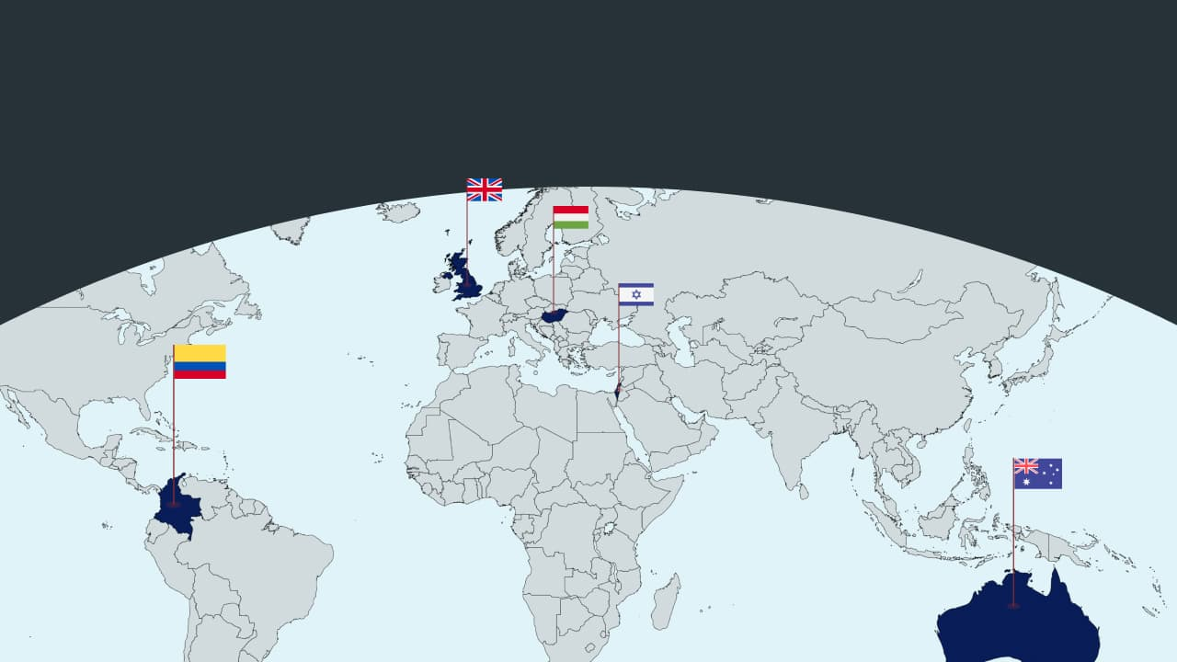

🇭🇺 Hungary - Rivals make promises. Hungary’s April 12 election pits Prime Minister Viktor Orbán and his ruling Fidesz against Péter Magyar’s centre-right Tisza Party. Tisza has strengthened its governing credentials by recruiting senior figures with prior government and multinational experience, including energy expert Anita Orbán. The party promises to re-anchor Hungary firmly within Western alliances, recalibrate EU diplomacy, diversify energy away from Russia, and end confrontational veto tactics (April will tell).

🇨🇴 Colombia - Assassination plot. Colombian President Gustavo Petro narrowly escaped an assassination attempt while flying in a helicopter with his daughters. Petro said his helicopter had been diverted over the sea for hours before, with naval support, before landing at an alternate site and revising his security arrangements. The incident occurred amid rising violence ahead of the March legislative and May presidential elections (presidential problems).

🇦🇺 Australia - Spying for China. Two Chinese nationals face charges in Australia for “reckless foreign interference” for allegedly spying on the Guan Yin Citta Buddhist group in Canberra on behalf of China’s Public Security Bureau. Authorities allege they worked with another accused individual to covertly collect information about the group, which Beijing considers a cult. This case is the second under Australia’s 2018 foreign interference laws (snooping on diaspora).

🇮🇱 Israel - PM meets Trump. President Trump said he insisted that negotiations with Iran continue during talks at the White House with Israeli PM Benjamin Netanyahu. The meeting focused on Iran’s nuclear programme, missile capabilities, and regional influence. Netanyahu pushed for a broader deal restricting uranium enrichment, ballistic missiles, and Tehran’s support for groups like Hamas and Hezbollah (nuclear brinkmanship).

🇬🇧 UK - Doubles troops to Norway. The UK will double its military presence in Norway by sending 2,000 troops. This aims to counter rising Russian activity in the Arctic and North Atlantic. Royal Marines will participate in NATO exercises to defend key infrastructure and train in challenging conditions. This move strengthens NATO’s northern flank, enhances Arctic security, and addresses threats from Russian bases, submarines, and undersea networks (double duty).

Foundations

Why is Central Asia so uniquely shaped?
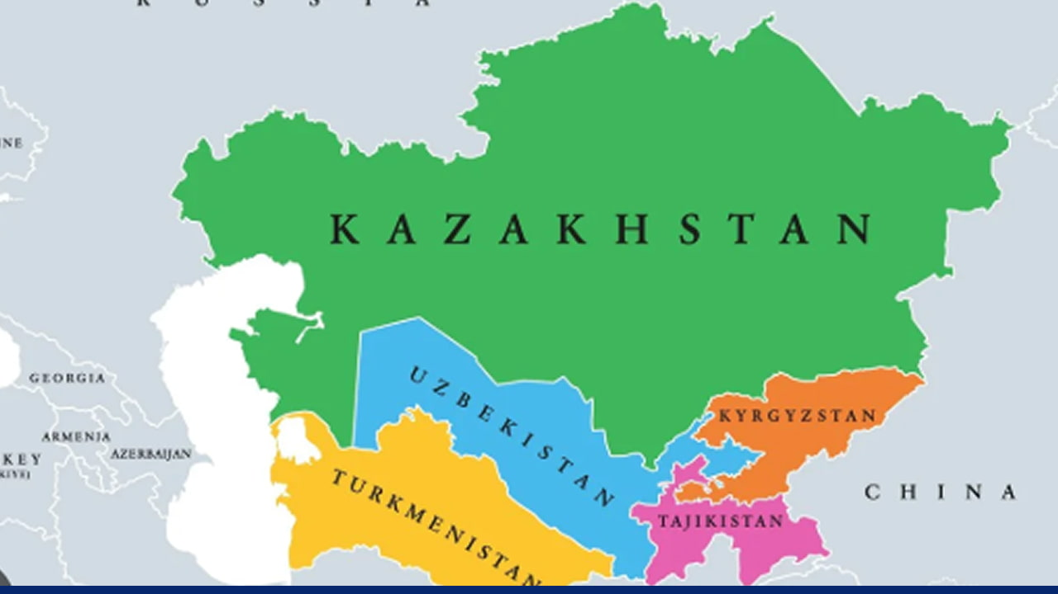
Spanning approximately 4Mn square kilometers, this landlocked region sits at the intersection of Europe, Asia, and the Middle East. Credits: Getty Images

The geography: Central Asian countries are known for distinctive borders and shapes, which stem from the region's geography, history, and politics. Central Asia is surrounded by mountain ranges such as the Hindu Kush, the Tien Shan, and the Altai, which serve as natural barriers. The region also includes large deserts, such as the Karakum and Kyzylkum. The Caspian Sea also serves as a barrier.

The Soviet legacy: The current borders were largely drawn by the Soviet Union, often disregarding ethnic and cultural lines. Many population transfers occurred during the Soviet era, making the division and conquest of territories easier. This tactic makes it harder for resistance and independence movements to emerge if there are enough regional disputes. Many of Central Asia's current regional and social issues, as well as those in other former Soviet countries, stem from these transfers.

The crossroads: Central Asia has experienced the rise and fall of many empires throughout history. It was part of the Persian Empire and the Mongol conquests. The Silk Road trade routes from the East and West went straight through. So for centuries, this region has been a crossroads for cultures and ethnicities. The region has many nomadic groups, such as the Kazakhs, Uzbeks, and Turkmen, whose identities are distributed across multiple regions and overlap significantly.

Preview text
Plus UK doubles troops to Norway

