🇬🇧 Feb 9:
Feb 9, Mon • AQI 28

In this edition:

- £40bn Parliament revamp
- Cyclist priority at green lights
- Hole in the wall museum

Spotlight

Falcons stall £450m office

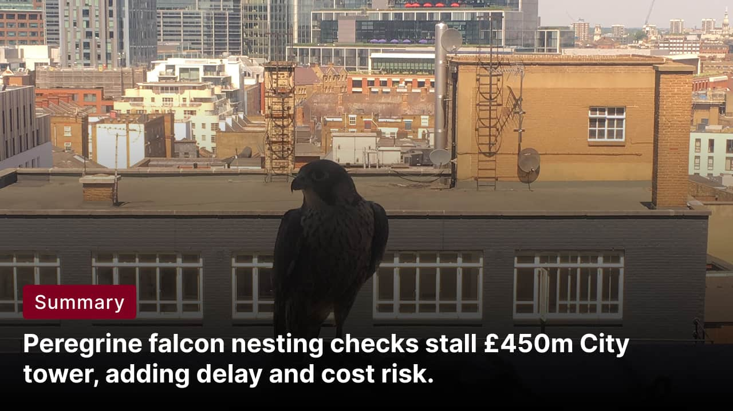
What happened: Plans for a £450m, 21-storey office tower at 1 Silk Street, beside the Barbican, have run into an unexpected planning hurdle: peregrine falcons may be nesting nearby. That triggers protected-species checks and mitigation requirements before work can properly move forward, which can slow timelines even when the site is otherwise ready to roll.
Why it matters: Peregrines are protected under UK wildlife rules, so this is not a case of “shoo them off and carry on”. Developers may need surveys, monitoring, and restrictions on noisy work during sensitive periods. It is also a very London story: the City wants new office space and investment, but the capital is increasingly strict about biodiversity, heritage, and environmental compliance.
What to watch: If nesting is confirmed, expect seasonal constraints, potential design or lighting tweaks, and longer ecological monitoring. In a Barbican-adjacent scheme that already attracts scrutiny, extra delay risk can translate into higher costs and a tougher planning path.
Fun fact: peregrine falcons are the fastest animals on Earth, hitting 300+ km/h in a hunting dive.

Goal: reverse brexit
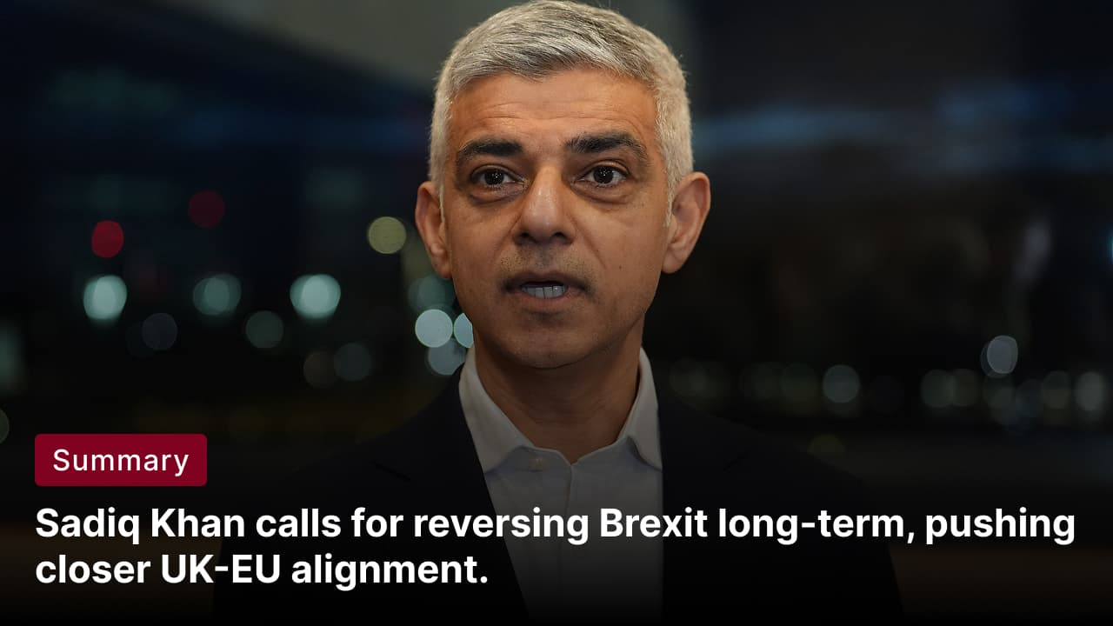
What happened: London Mayor Sadiq Khan said his “ultimate goal” is to reverse Brexit, arguing the UK should move back toward much closer alignment with the EU over time. He framed it as a long-term direction of travel rather than a quick, immediate switch, stressing practical steps that reduce friction for trade, business, and movement.
But why: Khan’s case is economic. London’s core strengths, finance, tech, universities, tourism, and high-end services, benefit when cross-border rules are simpler and talent can move more easily. He’s effectively pitching “make the UK more investable” by narrowing the gap with the EU first, then letting politics catch up later.
Official context: Brexit decisions sit with Westminster, not City Hall, so this is narrative and political signalling rather than an actionable mayoral policy. Still, it matters: the Mayor of London is a loud megaphone for business sentiment, and statements like this keep Brexit’s economic trade-offs in the public debate.

What’s on

Rocky Horror Show
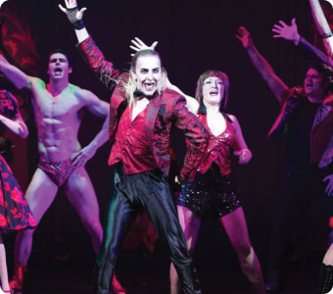
Cult musical chaos at Churchill Theatre, Bromley, feathers and all.
9 to 14 Feb, tickets vary
The Africa Centre: new free display
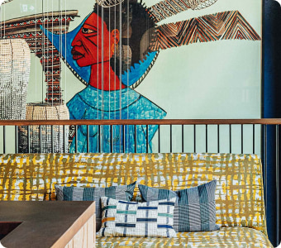
A free mini-exhibition at The London Archives on the Africa Centre’s cultural legacy.
From 9 Feb to July 2, Free

Long story short

Politics & Crown
The London Assembly passed a motion warning that repeated Government policy U-turns are creating damaging uncertainty for London’s economy, investment prospects, and household finances. It cites 14 U-turns in 19 months across areas like tax, benefits, business rates relief for pubs, welfare, winter fuel payments, and other high-profile pledges. The Assembly urges the Mayor to press ministers for clearer, more stable decisions. The motion passed 10–9.

Northern political leaders are urging the government to back a multi-city Olympic and Paralympic bid for 2040, arguing it could accelerate regeneration, rebalance the economy, and shift perceptions of the region. Greater Manchester mayor Andy Burnham said it would not be fair for London to host again so soon after 2012, and framed a northern Games as “what Britain needs”. Supporters cite the IOC’s growing openness to multi-city hosting and the north’s sporting heritage and venues, while also stressing they would avoid London 2012’s costly, gentrification-heavy legacy.

Business
UK markets sold off as political turmoil hit Downing Street: the pound fell, gilts weakened (with 30-year yields at their highest since November), and the FTSE 100 dipped, led by banks. Pressure on PM Keir Starmer intensified after his communications director resigned a day after his chief of staff quit, tied to controversy around Peter Mandelson. Investors began pricing in higher leadership-change risk.

Living Rent’s Gorgie/Dalry members confronted The Social Hub at a Fountainbridge public consultation over a proposed £200m student accommodation and hotel project, arguing it fails locals facing a social-housing crisis. They pressed developers to admit the scheme would not be affordable for many students, with rooms estimated around £1,400 per month, and criticised the “community” pitch as marketing that displaces residents and drives up rents. The group urged Edinburgh council to block further PBSA developments and promoted a survey to build opposition.

Art & culture
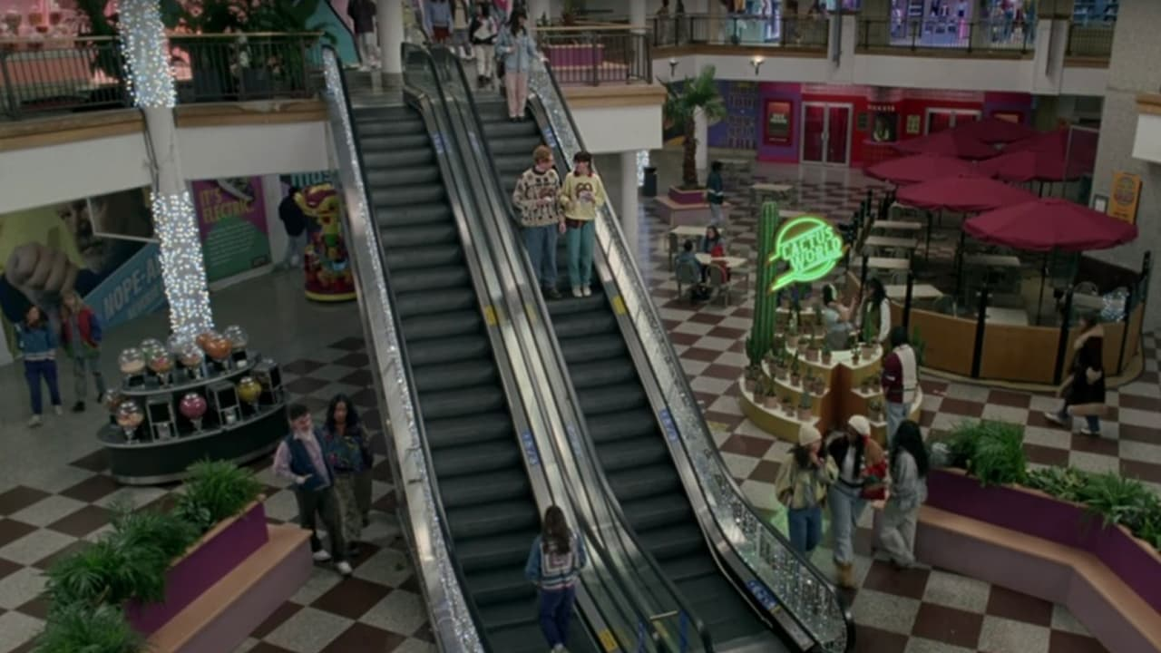
Londoners reacted to Taylor Swift’s Croydon-shot “Opalite” video with a mix of jokes, pride, and nostalgia. Londonist says the expected Croydon-bashing showed up, but was largely drowned out by locals celebrating the Whitgift Centre’s heyday and defending it from headlines calling it “derelict” or “abandoned”. Social media posts ranged from fact-checking and Westfield-debacle references to playful business ideas and cheeky digs at neighbouring areas.
Tate Modern will stage Tracey Emin: A Second Life from 27 Feb to 31 Aug 2026, billed as a landmark show spanning 40 years of her work. It will mix painting, video, textiles, neons, writing, sculpture, and installation, pairing iconic pieces like My Bed with works not previously exhibited. The exhibition focuses on Emin’s confessional approach to love, trauma, the body, and healing, and highlights her ongoing commitment to painting, including recent work. Tickets are £20, free for members.

Misc
“Galentines day” ideas in London

Medieval haunted pub just an hour away from Lonon (Google Maps)
Valentines day idea: escape to this postcard perfect forest village
Fire-juggling unicyclist caught performing on crossing

Did you know
A lot of London is built on “lost rivers.” The Fleet, Tyburn, Walbrook and others still flow underground like a soggy secret.

Image credits
User ch-s on reddit, The Times, TfL, Londonist, The Standard, The Royal Household, The Guardian, Time Out, City Hall, The Independent

Preview text
Plus Valentine's Day ideas

