🇦🇪 Happening: Snow much running

In this edition:

- Dance of couture
- Soul of Cavo
- Ethihad summer fares

Spotlight

Snow run returns


The DXB Snow Run returns on 17 May at Ski Dubai, in partnership with the Dubai Sports Council, offering a unique -4°C running experience under the “Growing in Unity” theme for the UAE Year of Family.

The seventh edition welcomes participants aged 13–70+ across 3km and 5km categories, either individually or in teams of five. With medals for finishers, podium prizes, spectator access, and a strong focus on inclusion, the event blends sport, community, and family connection in a snowy setting.

🔗Link: DXB Snow Run
📅When: May 17, Sunday | Event starts at 08:00 pm
💸Cost: Starts from AED 120
📍Where: Ski Dubai

Elegance in motion


On 17 May 2026, internationally acclaimed ballerina Svetlana Zakharova returns with MODANSE, a one-night double bill featuring the Bolshoi Theatre ensemble. The programme opens with Come Un Respiro, set to Handel and choreographed by Mauro Bigonzetti, followed by Gabrielle Chanel, a tribute exploring Coco Chanel’s life through movement, music, and couture costumes by CHANEL.

Blending ballet, fashion, and expressive storytelling, the performance celebrates transformation, elegance, and artistic freedom through two distinct contemporary choreographic works.

🔗Link: Svetlana Zakharova - Gabrielle Chanel Ballet
📅When: May 17, Sunday at 08:00 pm
💸Cost: Tickets start from AED 190.28
📍Where: Dubai Opera

Live events

Ghamed Ein Fateh Ein
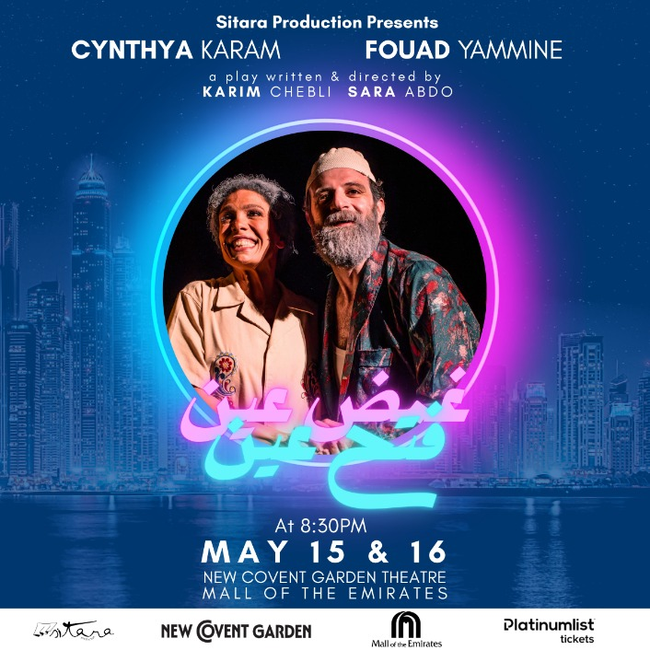

Ghamed Ein Fateh Ein makes an emotional return to Dubai, blending humor, heartbreak, and nostalgia in a moving story set inside a quiet Beirut apartment. The acclaimed play explores love, resilience, loneliness, and the enduring search for human connection.

📅When: May 15 - May 16 | Tickets start from AED 72.27
📍Where: The New Covent Garden Theatre

Carmen in Concert by UAE National Orchestra
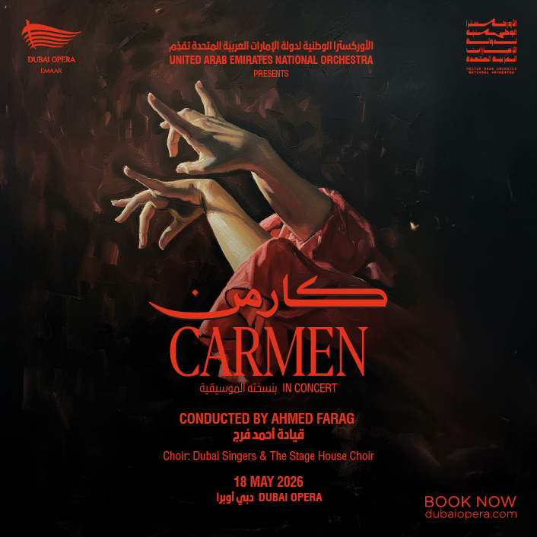

Carmen comes alive in a powerful symphonic concert by the UAE National Orchestra, featuring iconic arias and orchestral highlights from Bizet’s legendary opera. Joined by Dubai Singers and The Stage House Choir, the performance captures the passion, drama, and timeless brilliance.

📅 When: May 18 | Tickets start from AED 108.39
📍 Where: Dubai Opera

Shopping

Mompreneur

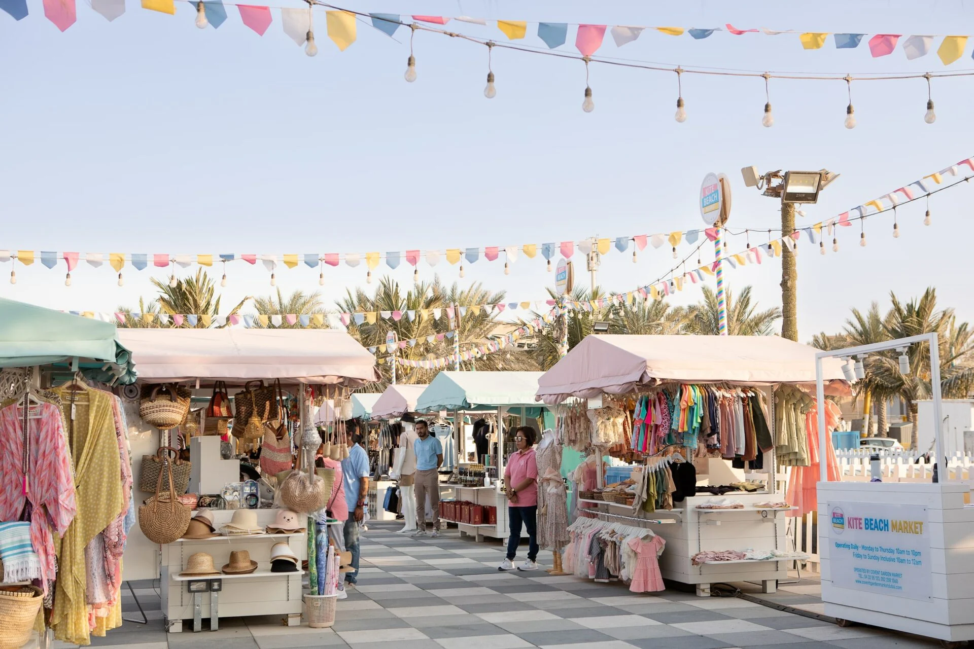

Mompreneur Pop-Up Market returns this May, featuring local brands, including Knit & Snuggle, that showcase handmade creations and provide family-friendly shopping experiences. The community event celebrates women-led businesses, creativity, and entrepreneurship through activities and networking opportunities.

📅 When: May 16 and May 30 | Free entry
📍 Where: Times Square Center & The B1 Mall, Al Barsha

Nightlife

AFROBESSQUE

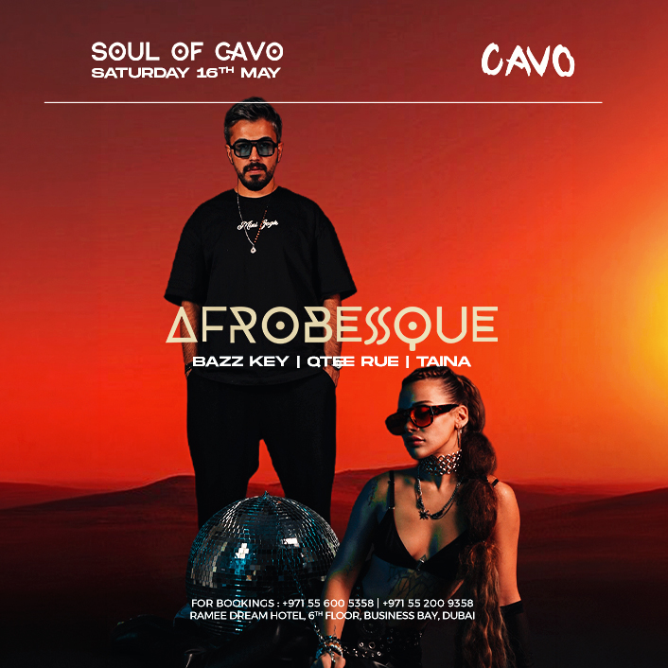

AFROBESSQUE Live in Dubai promises an immersive Afro House experience blending hypnotic beats with live Ney performances and high-energy DJ sets. Featuring AFROBESSQUE alongside Bazz Key, Qtee Rue, and Taina, the event delivers a stylish night of deep rhythms, music, and vibrant nightlife energy.

📅 When: May 16 | Tickets start at AED 72.27
📍 Where: CAVO

Night swimming
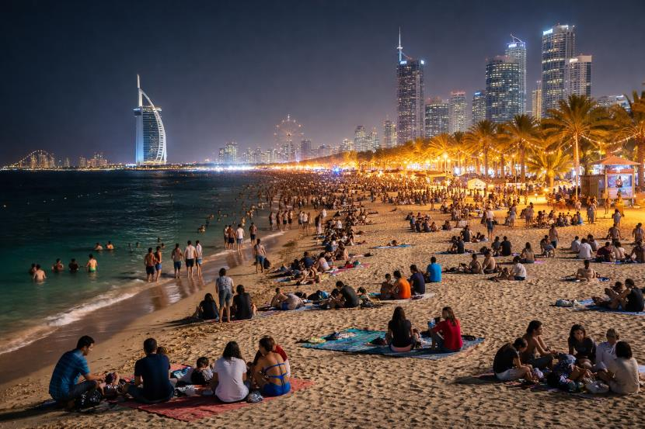

The newly revamped beach is now open, with a 300-meter stretch open nightly for after-dark swimming. Watch the sunset while playing a game of beach volleyball or checking out the padel courts before heading in for a dip.

📅 When: Open 24/7 | Free entry
📍 Where: Al Mamzar

Everything else

Etihad summer fares
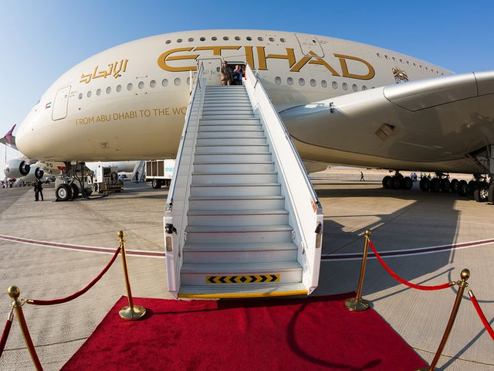

Etihad Airways has launched a limited-time global sale offering up to 30% off Economy fares from Abu Dhabi to more than 40 destinations across Europe, Asia, and the Middle East. The promotion covers travel between June and October 2026.

📅 When: May 14
📍 Where: Airline website

Art Dubai

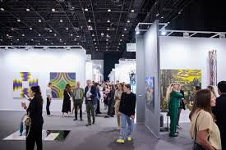

The 20th edition reflects both the fair’s legacy and a renewed focus on regional depth. Expect a dynamic cultural showcase featuring international galleries, large-scale commissions, and thought-provoking institutional collaborations that trace the evolving language of global art through a Middle Eastern lens.

📅 When: May 14 to May 17 | Free entry
📍 Where: Madinat Jumeirah

Image credits
Ski Dubai, The Wonderful, Platinumlist, Platinumlist, The Ethicalist, Platinumlist, Travel and Tour World, Shutterstock, Dubai Media Office

Preview text
Plus things to do this weekend

