🇦🇪 May 14: Eighteen means business
In this edition:

- Vegas meets Yas
- Flydubai schedule shakeup
- Tax waiver window

Spotlight

UAE law reset


What’s happening? The UAE will introduce a Civil Transactions Law from June 1, updating rules on judicial capacity, contracts, civil dealings, guardianship profiles, asset management, and compensation. The biggest change lowers the age of judicial adulthood from 21 to 18, giving 18-year-olds full judicial capacity to manage civil and monetary affairs. The law may also allow minors as young as 15 to manage assets with court approval.

Other updates: Possible contract registration rules, making some agreements valid or enforceable after official registration. The law may also clarify what happens to expat assets in the UAE when someone dies without a will or heirs. It may introduce stronger duties during pre-contract negotiations, especially around disclosure. Buyer protections could also be expanded, allowing people to reject defective goods, seek a reduction, or appeal for replacements.

Big picture: The UAE Civil Transactions Law reflects a wider push to modernise personal, commercial, and monetary rules. The law appears to strengthen safeguards through court oversight, clearer contract rules, stronger buyer protections, and more detailed procedures for inheritance gaps. For residents, businesses, and expats, the changes could make civil dealings more structured and predictable, while also increasing the need to understand registration, disclosure, and judicial responsibility before entering into agreements.

Where to eat?
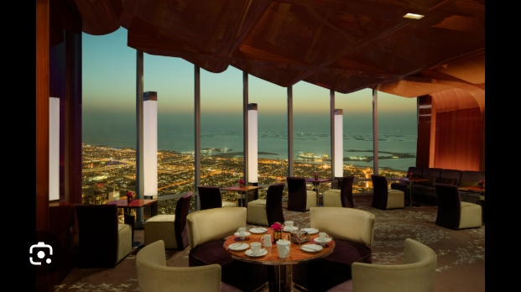

At.mosphere is located on Level 122 of the Burj Khalifa. It provides a unique dining experience that combines modern French cuisine with stunning views of Downtown Dubai and the Gulf. Recognized in the 2024 edition of the MICHELIN Guide Dubai, it stands out as an important culinary destination. The venue serves as both a restaurant and a lounge and bar, catering to a range of moods, from business dinners to casual drinks in the sky.

Pro tip: Book a window seat facing west to catch a spectacular sunset over the skyline view.

Career

Outdoor sales executive

On-site
Full-time
AED 4,000 - 5,999/month
Abdool Auto Spare Parts is hiring an Outdoor Sales Executive for automotive batteries, lubricants, and spare parts. The role involves field sales, client meetings, product promotion, customer relationship management, and closing deals across dealers, retailers, workshops, fleet accounts, and industrial users. Candidates should have 2–5 years of outdoor sales experience, preferably in the UAE automotive sector, plus strong communication, negotiation, market knowledge, and a valid UAE driving licence.

Register here

Meanwhile


Vegas meets Yas
Abu Dhabi will host the first Sphere venue outside the US, with Yas Island confirmed as its location. Sphere Abu Dhabi will be built between Yas Mall and SeaWorld Abu Dhabi, close to the island’s major attractions. The $1.7B venue is expected to be completed by the end of 2029 and will mirror the scale of Sphere Las Vegas, with capacity for up to 20,000 people. It will host immersive Sphere Experiences, concert residencies, brand events, sports, conferences, and product launches.

Flydubai schedule shakeup
Flydubai has revised its flight schedule to Pakistan, and affected passengers have been contacted directly about rebooking and refund options. As of May 13, bookings were unavailable for Islamabad, Lahore, and Peshawar until October 24–25, while flights to other Pakistani cities remained bookable. Flydubai said the changes follow reduced capacity linked to regional military conflict and warned passengers to confirm flight updates before travelling.

Tax waiver window
The UAE Federal Tax Authority says more than 91,000 taxable persons could benefit from its Corporate Tax Late Registration Penalty Waiver initiative. More than 68,600 have already benefited, while over 22,000 remain eligible if they meet the conditions. The waiver applies to late corporate tax registration penalties incurred on or after June 1, 2023, and covers taxable persons and certain exempt persons who registered late.

Did you know?
Flydubai will launch direct Dubai-Benghazi flights from June 17, becoming the first UAE carrier to operate non-stop services on the route.

Day
Thursday

Date
May 14

Temperature
32°C

Preview text
Plus the UAE tax penalty waiver

Image credits
Gulf News, Time Out Dubai, DCT Abu Dhabi

