🇬🇧 Happening: Nordic by nature
In this edition:

- Brick Lane brews
- An Ideal Husband
- Future food feast

Spotlight

Piazza goes Nordic
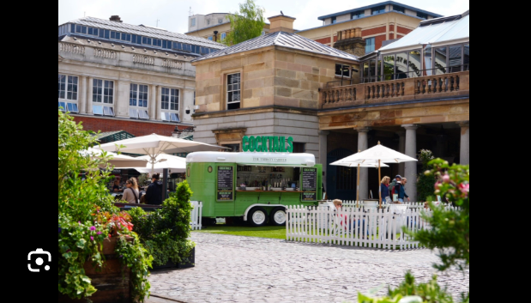

Covent Garden is hosting Passport to Norway, bringing Scandinavian culture to the famous Piazza. The event features Nordic music, Norwegian-inspired food pop-ups, cultural experiences, and live entertainment across the weekend. It also marks Syttende Mai on 17 May, Norway’s Constitution Day, which celebrates independence, heritage, and community.

Visitors can explore the spirit of Norway through curated performances and immersive moments, including a Saturday set from alternative-pop duo amilost, known for mixing electronic sounds with live instrumentation.

The anniversary tour recreates memorable moments from the first film, with house banners, floating hats, and magical details across the studios. A newer feature, Secrets of Sound, also shows how sound effects helped bring spells, creatures, and key scenes on screen.

🔗 Link: Passport to Norway
📅 When: May 14 - May 17
💸 Cost: Open entry
📍 Where: Covent Garden

Brick Lane brews
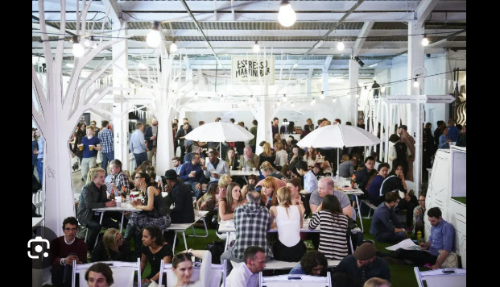

The London Coffee Festival returns this weekend to The Truman Brewery on Brick Lane, celebrating the capital’s specialty coffee scene and creative culture. The event brings together more than 275 artisan coffee and gourmet food brands, offering tastings, barista demonstrations, hands-on workshops, street food, music, and expert-led masterclasses.

Highlights include the global Coffee Masters competition, where top baristas showcase their skills, as well as immersive experiences such as Latte Art Live, The Roasters Village, Brew School, and The Lab. Designed for both coffee professionals and casual drinkers, the festival offers a lively deep dive into London’s coffee culture.

🔗 Link: London Coffee Festival
📅 When: May 14 - May 17
💸 Cost: Tickets start from £39.90
📍 Where: The Truman Brewery

Live events

Kit Kat Cabaret

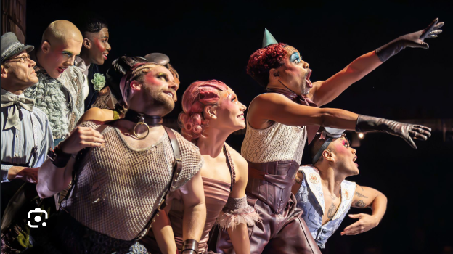

Cabaret at the Kit Kat Club brings 1930s Berlin to London’s Playhouse Theatre with immersive staging, daring performances, Matt Willis as Emcee, acrobats, contortionists, and striking costumes.

📅When: Multiple dates | Tickets start at £122
📍Where: Playhouse Theatre

An Ideal Husband
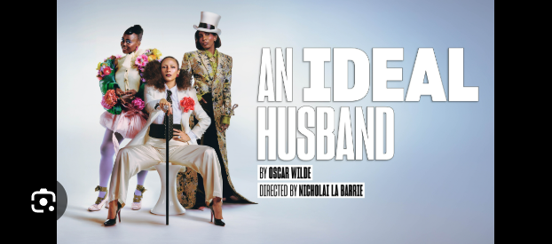

An Ideal Husband is playing at the Lyric Hammersmith, reviving Oscar Wilde’s comedy with political scandal, blackmail, tangled romance, sharp wit, vibrant characters, and modern energy.

📅 When: Multiple dates | Tickets start at £19
📍 Where: Lyric Hammersmith

Shopping

Future food feast
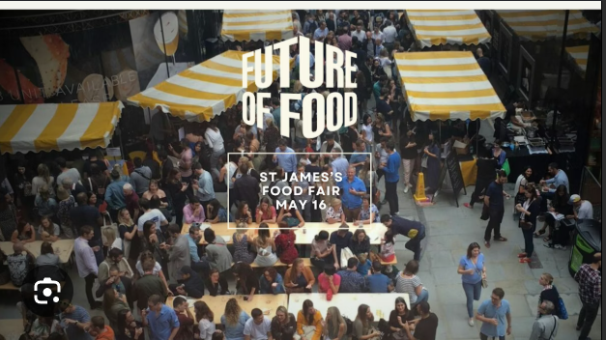

St James’s Food Fair turns St James’s Market into an open-air food celebration with local producers, sustainable suppliers, restaurant stalls, BBQ dishes, tastings, workshops, and masterclasses.

📅 When: May 16, Open entry
📍 Where: St James Market

Nightlife

Thames party cruise
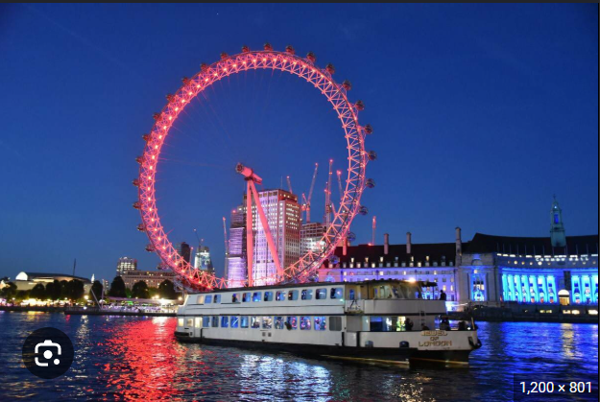

A 4-hour Thames party cruise departs from Festival Pier, offering a live DJ, dancefloor, light buffet, onboard bars, indoor decks, and skyline views for adults only.

📅 When: Multiple dates | Tickets start from £29
📍 Where: Festival Pier

Mamma Mia magic
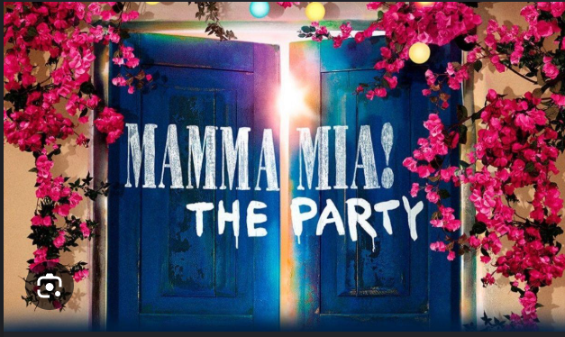

Mamma Mia! The Party at The O2 offers a four-hour immersive Greek taverna experience with a four-course meal, live performance, ABBA music, dancing, and disco.

📅 When: Multiple dates | Tickets start from £120
📍 Where: The 02

Everything else

Borough bites tour
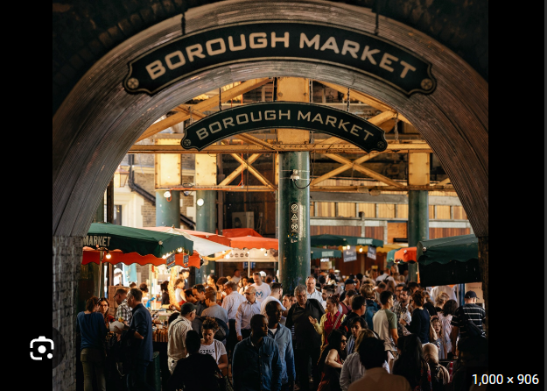

Borough Market Food Tour takes visitors through London’s oldest market with a guide, stall stories, British bites, artisan cheeses, fish and chips, tea, dessert, and a secret dish.

📅 When: Multiple dates | Tickets start from £97.50
📍 Where: Borough Market

Wimbledon art walk
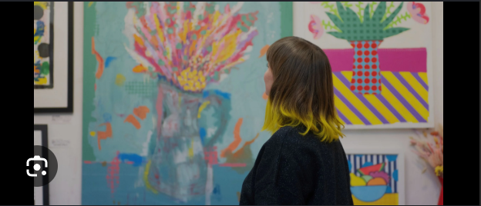

Wimbledon Art Fair opens more than 180 artist studios, offering original, affordable artworks, studio visits, artist conversations, and direct sales from creators.

📅 When: May 14 - May 17 | Open entry
📍 Where: Wimbledon Art Studios

Image credits
Time Out, Evening Standard, Broadway Direct, Official London Theatre, St James’s London, Bottomless Brunch, Visit Greenwich, Borough Market, Wimbledon Art Fair

Preview text
Plus things to do this weekend

