🇬🇧 May 14: The devil wears resignation

In this edition:
- Safer streets app
- JLR annual gains fall
- Intimate lithographs

Spotlight

Streeting sparks storm
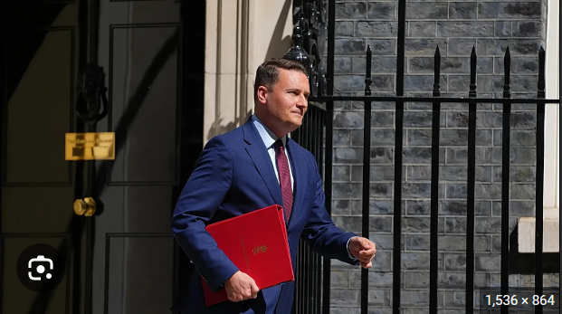

What’s happening? Wes Streeting has resigned as health secretary after saying he no longer has confidence in PM Keir Starmer’s leadership. He did not formally launch a leadership challenge, but allies said he has enough MP support to trigger one. Some MPs who are loyal to Starmer still believe he can survive, while Streeting’s allies say they are waiting to see whether Starmer resigns voluntarily or sets a timetable for leaving.

Details: In his resignation letter, Streeting argued that Starmer would not lead Labour into the next general election and blamed the government’s unpopularity for Labour’s poor election results. Streeting criticised a lack of direction, saying the country needed bold vision and bigger solutions. He said the party needed a broad debate about its future, based on ideas rather than personalities or factional fights.

Big picture: Streeting’s resignation turns Labour’s internal doubts into an open leadership crisis. Starmer is no longer just facing criticism from opponents but also direct pressure from senior figures within his own party. The row shows Labour is struggling to explain its direction after poor election results, with MPs and unions debating whether Starmer can still lead them into the next general election. Streeting’s move also raises the possibility of a wider contest involving figures such as Angela Rayner or Andy Burnham.

Safer streets app
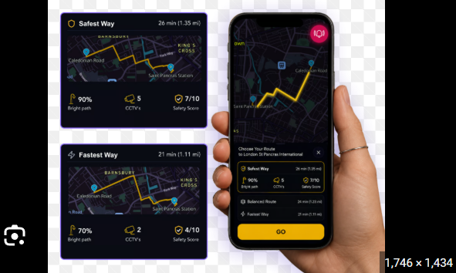

What happened? An app called Safest Way has been launched to help people find the “safest” walking route home. It is currently available in York, London, and Northern Ireland, with plans to expand across the UK. Co-founder Alesja Gilvear said the idea came after she noticed normal navigation apps did not warn users about poorly lit streets. The app is aimed at anyone who wants more confidence while walking, though most users are currently women.

How? The Safest Way app works by combining public and location-based data to rank walking routes by perceived safety. Instead of simply choosing the fastest or shortest route, it considers factors such as street lighting, CCTV coverage, crime statistics, and areas that may feel isolated or risky at night. It requires no registration and is open for use.

Big picture: The Safest Way app reflects a growing push to treat public safety as part of everyday urban design. Earlier this year, a YouGov poll suggested 88% of women feel unsafe walking alone at night. The app may provide reassurance, but it also highlights the need for better-lit streets, safer public spaces, stronger reporting systems, and wider measures to make cities feel safe for everyone.

Long story short

Business
Jaguar Land Rover’s annual gains have fallen by more than 99%, dropping from £2.5B to just £14M in the year to March. The company blamed a difficult year shaped by US car tariffs, weaker demand, tougher competition in China, and a major cyber-attack that forced factories and systems to shut down for weeks. Revenue also fell to £22.9B, more than 20% lower than the previous year.

Spire Healthcare’s board has backed a possible £1B buyout proposal from Toscafund Asset Management, its second-largest shareholder. It values Spire at 250p per share and sent the company’s shares up nearly 50%. Spire runs 38 private hospitals and more than 60 clinics across the UK, with nearly a third of revenue coming from NHS work. Toscafund must make a firm decision by 11 June.

Art & culture
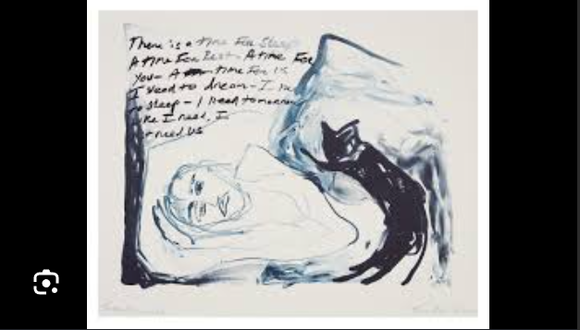

Tracey Emin has unveiled a series of six intimate lithographs called “I Need Tomorrow” at the London Original Print Fair in Somerset House. The prints show Emin in her raw, emotional style and are being displayed alongside her major Tate Modern retrospective, “A Second Life.” Emin said the series began almost accidentally while she was waiting to proof another print, and that it became a personal “gift” to herself.

Kolkata-born filmmaker Soumya Jyoti Pratihari’s documentary Shunya: Being Prafulla Mohanti has bagged the Tongues on Fire Flame Award for best LGBTQIA film at the UK Asian Film Festival. The film had its world premiere at Riverside Studios in London on May 6. It follows 91-year-old Odia artist, writer, architect, and cultural thinker Prafulla Mohanti, tracing his journey from Odisha to Mumbai and later Britain. The documentary explores identity, migration, racism, spirituality, love, ageing, illness, and creativity.

Sports

Jannik Sinner has reached the Italian Open semi-finals after beating Andrey Rublev 6-2, 6-4 and breaking Novak Djokovic’s record for successive ATP Masters 1000 match victories. The triumph was Sinner’s 32nd straight at the Masters level, continuing a dominant run before the French Open. He has reached the semi-finals at each of the first five Masters 1000 events this season, joining Rafael Nadal in that achievement.

The Championship play-off final between Southampton and Hull City may not go ahead as planned on Saturday, 23 May, due to an EFL investigation into a Spygate case involving Southampton. The club has been charged with breaking rules after allegedly observing Middlesbrough’s training session before their semi-final first leg. An Independent Disciplinary Commission hearing will take place by Tuesday, 19 May.

Misc
China issues warning over the government's plan to nationalise British Steel

Nigel Farage bought a £1.4M property after receiving a £5M gift

King visits victims of the Golders Green stabbings

Honda makes its first annual loss in 70 years

Did you know
The Dominion Theatre is located on the site of the Great Beer Flood of 1814, where more than 570 tons of beer from Meux & Co's Horse Shoe Brewery created a 15-foot high wave that flooded the area.

Day
Thu

Date
May 14

AQI
24

Image credits
Euronews, Safest Way, Counter Editions

Preview text
Plus the safest way home

