🇦🇪 May 13: Roads need nerds
In this edition:

- Fees made flexible
- Parking gets smarter
- Banking seat bid

Spotlight

Next mobility quest
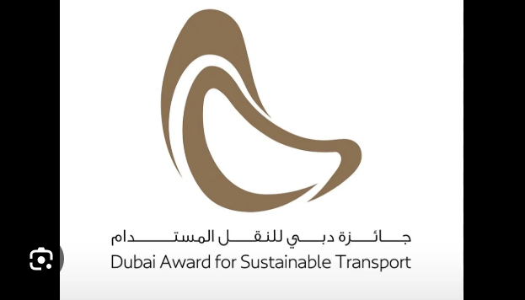

What’s happening? Dubai’s Roads and Transport Authority has opened registration for the 14th Dubai Awards for Sustainable Transport 2026 (DAST 2026). The award invites government bodies, private companies, schools, researchers, transport experts, and students to submit projects, research, or ideas that can improve sustainable mobility. Launched in 2008, DAST rewards innovation in clean, safe, inclusive, and environmentally friendly transport.

Categories: DAST 2026 includes four main categories. Sustainability focuses on green and environmentally friendly transport solutions. Innovation rewards fresh mobility ideas, including student and next-generation projects. Inclusivity recognises safe, accessible, and transport-for-all initiatives. Elite honours the strongest idea, project, or research concept chosen from across all categories by the jury, making it the award’s top recognition.

How to apply? Applicants can register for DAST 2026 through the RTA’s official DAST digital portal. They must first create an account by registering their organisation, whether government, private, or educational, or sign in as an individual researcher. Next, they should choose the award category that best matches their project. Once all details are complete, they can submit the application before the June 2026 deadline.

Where to eat?


Yubi Handroll Bar introduces a refined dining experience at 25 Jump Street in One Central. Created by 7 Management in collaboration with chef Reif Othman, the menu blends Japanese street-food tradition with a hip-hop vibe. The interior features a long bar where diners sit on stools and watch chefs prepare hand-rolls on demand. The design mixes natural wood, soft lighting, textured wall murals, and neon accents, creating a lively blend of street style and elegance.

Pro tip: Sit at the counter for a front-row view of the hand-roll craft and ask the chef for the “chef’s roll.”

Career

Construction Manager

On-site
Full-time
AED 12,000 - 19,999/month
Bjorg Construction is hiring a Construction Manager who can manage construction projects from planning to completion while ensuring timelines, budgets, safety rules, and quality standards are met. It includes supervising site workers, subcontractors, and suppliers, monitoring progress, solving issues, reviewing drawings, maintaining safety compliance, preparing reports, managing costs, and coordinating with clients and stakeholders.

Register here

Meanwhile
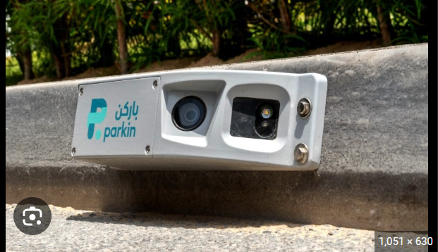

Parking gets smarter
Parkin has started installing AI-enabled cameras across busy areas to automate parking fee collection and monitor parking spaces in real time. The first phase includes more than 500 curb- and pole-mounted cameras in areas such as Burj Khalifa, Trade Centre 1, and Al Corniche, along with 200 more cameras in controlled parking lots. The solar-powered system reads number plates, records entry and exit times, tracks parking duration, and enables automatic payment through the Parkin app and digital wallet.

Fees made flexible
UAE schools are providing flexible payment plans to help families manage rising education expenses and monetary pressure. Several schools are working directly with parents to create tailored fee arrangements, including monthly instalments, deferred payments, sibling discounts, scholarships, and customised support. The focus is on easing short-term pressure, keeping education accessible, and ensuring students continue learning without disruption.

Banking seat bid
The UAE is seeking a seat on the board of Swift, the global messaging network used by banks and monetary institutions for cross-border payments. UAE Banks Federation officials said discussions are underway as the country rises in global rankings for trade-related payment activity. A board seat would give the UAE greater visibility in global payments infrastructure, banking standards, cybersecurity, and cross-border systems.

Did you know?
Dubai government employees will get a nine-day break for Arafah Day and Eid Al Adha 2026, with holidays running from May 25 to May 29, plus weekends. Work resumes on June 1.

Day
Wednesday

Date
May 13

Temperature
33°C

Preview text
Plus school fees made flexible

Image credits
RTA, Yubi Dubai, Gulf News

