🌍 May 13: Airstrike gone wrong

In this edition:

- De-risking gets risky
- Golden Dome doubts
- Why is Switzerland neutral?

Spotlight

Market strike horror
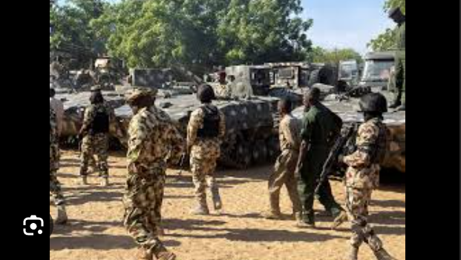

What happened? A Nigerian military airstrike hit Tumfa market in Zamfara State, killing at least 100 civilians, according to Amnesty International. The rights group said many victims were women and girls, and called for an immediate investigation into what it described as reckless attacks on civilians. The Red Cross also confirmed civilian deaths, while local leaders said dozens of injured people were being treated in nearby hospitals. Nigeria’s military denied the reports.

Repeated deaths: Repeated civilian deaths in Nigerian air operations have drawn growing criticism from rights groups and local communities. Amnesty International said the Tumfa market strike follows another deadly market airstrike last month in Jilli, northeastern Nigeria, where around 200 civilians were reportedly killed. The group said civilians in conflict-hit northern regions have too often carried the heaviest burden of military operations, even as security forces target bandits and jihadist-linked groups.

Big picture: Nigeria’s fight against bandit gangs and jihadist-linked groups is increasingly putting civilians at risk. In northern regions, armed groups often operate near villages, roads, and markets, making it difficult for civilians to avert danger. Rights groups say repeated civilian deaths show the need for stronger intelligence, clearer accountability, and better protection for ordinary people.

De-risking gets risky
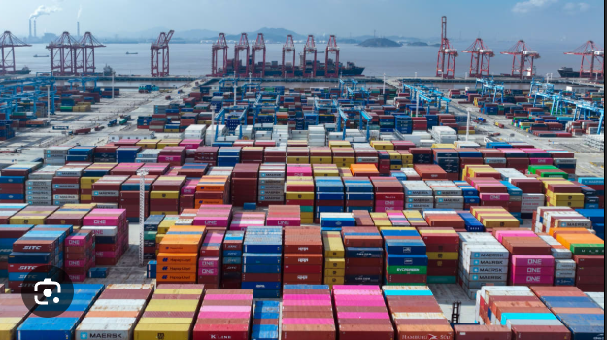

What happened? China is making it harder for Western firms to reduce dependence on Chinese supply chains. Beijing recently blocked Meta’s $2B takeover of AI startup Manus, even though the company is based in Singapore, because it has strong Chinese roots. China also introduced the latest supply chain security rules that could punish foreign firms for moving production to countries such as India or Vietnam, for reshoring factories, or for following US and EU sanctions against Chinese entities.

Supply chain rules: China’s Regulations on Industrial and Supply Chain Security give Beijing wider power to push back against Western de-risking. Firms could also face fines or supply chain blacklisting if they comply with US or EU sanctions and export controls targeting Chinese entities. Analysts say the rules are designed to make decoupling harder and to keep foreign companies dependent on China’s technology, manufacturing, and critical-mineral supply chains.

What is de-risking? De-risking means reducing dependence on China without fully cutting ties. Western governments and companies use it to make supply chains safer by relocating some production, sourcing parts from other countries, or reshoring key industries. Since the pandemic, the US and EU have pushed harder to reduce reliance on China for critical goods, technology, and minerals. But Beijing sees this as a threat to its economic influence.

Analysis

Golden Dome doubts
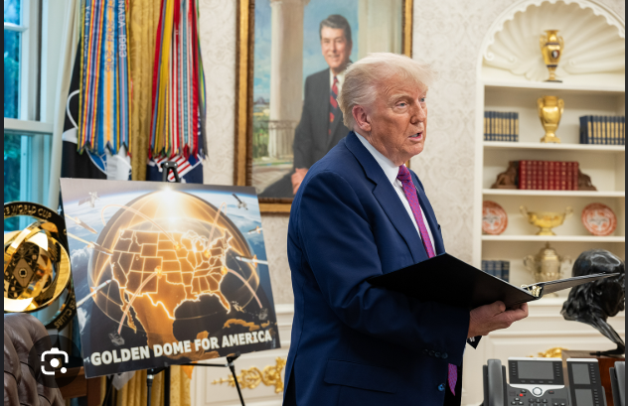

What happened? The US Congressional Budget Office (CBO) says President Trump’s proposed “Golden Dome” missile defense system could cost about $1.2T over 20 years, far above the earlier $175B estimate. The system is designed to protect the US from ballistic, cruise, and next-generation missile threats using land, sea, and space-based technology. However, the CBO warned it may still be overwhelmed by a major attack from Russia or China.

Why? The Golden Dome may struggle against Russia or China because both have large, advanced missile arsenals designed to overwhelm defense systems. A full-scale attack could involve countless ballistic missiles, cruise missiles, hypersonic weapons, decoys, and drones launched from different directions. Even a highly advanced shield may not track, target, and intercept every threat in time. Space-based sensors and interceptors could also become targets themselves, especially in a conflict with a major power.

Contracts: SpaceX and Lockheed Martin have secured contracts worth up to $3.2B to develop space-based missile-interceptor prototypes for the Golden Dome system. But the contracts are still for prototypes, not a finished shield. That means major questions remain over expenses, feasibility, reliability, and whether such technology can work at scale against advanced missile attacks from countries like Russia or China.

Worldwide
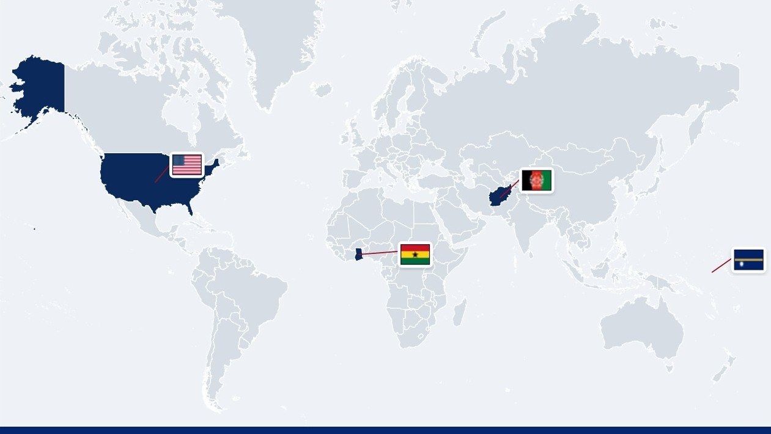

🇳🇷 Nauru - Name change. Nauru will hold a referendum on changing its official name to “Naoero,” after parliament passed a constitutional amendment backing the move. The government says “Nauru” came from foreign mispronunciation of the island’s native name and sees the change as a way to reclaim its heritage, language, and identity. The name Naoero comes from “Dorerin Naoero,” the native language spoken by many citizens alongside English (island identity).

🇦🇫 Afghanistan - EU invites members. The European Commission has invited Taliban representatives to Brussels for talks on deporting Afghan nationals who were refused permission to stay in the EU. Officials said the meeting would be a follow-up to earlier technical talks in Afghanistan and does not mean the EU recognizes Taliban rule. The push came after 20 EU and Schengen countries complained that just 2% of Afghans issued return orders in 2024 were actually sent back (Taliban talks).

🇬🇭 Ghana - Evacuates South Africans. Ghana says it will evacuate 300 citizens from South Africa after a wave of protests and alleged xenophobic attacks targeting foreign nationals. FM Samuel Okudzeto Ablakwa said the Ghanaians had registered with the embassy in Pretoria and would be rescued after a safety advisory. South Africa has denied reports of attacks, saying some viral videos were fake, but President Cyril Ramaphosa acknowledged protests and criminal acts against foreigners (embassy rescue).

🇺🇲 USA - Defends subpoenas. Acting US Attorney General Todd Blanche has defended issuing subpoenas to journalists in investigations into leaks of classified information. Blanche said prosecuting leakers who share national secrets with reporters is a priority, arguing such leaks risk national security and soldiers’ lives. President Trump also attacked media coverage of the war, calling some reporting “virtual treason.” Press groups and The Wall Street Journal’s publisher criticized the subpoenas (press pressure).

Foundations

Why is Switzerland neutral?
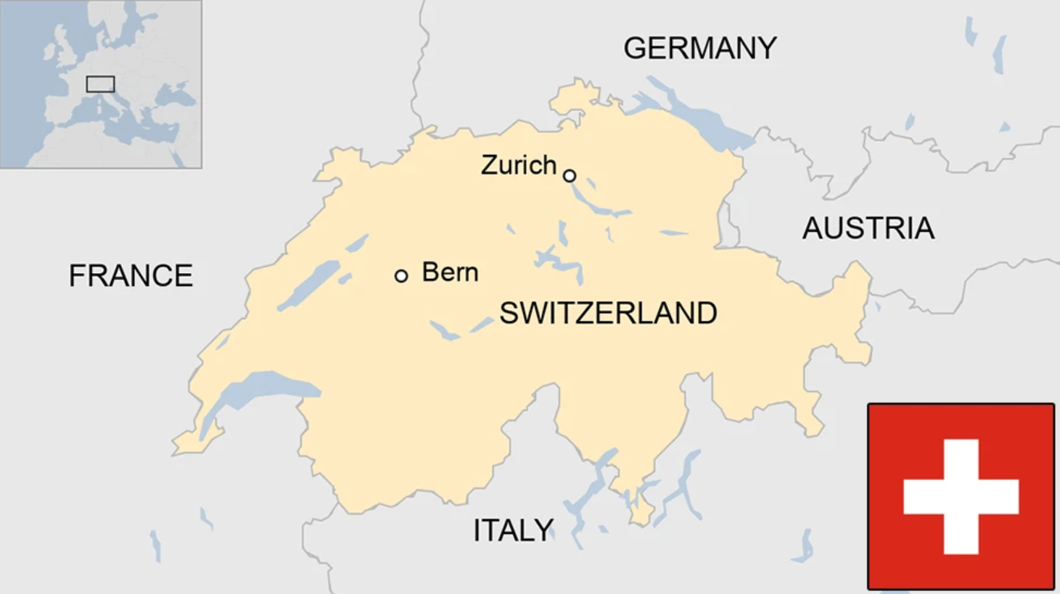

Status: Switzerland’s neutrality stems from both history and strategy. After the 1515 Battle of Marignano, the Swiss Confederation chose to refrain from foreign wars. This policy was formally recognized in 1815 at the Congress of Vienna, where European powers agreed that a neutral Switzerland would help maintain continental stability. Neutrality preserved unity among Switzerland’s diverse linguistic and religious groups and allowed it to prevent military entanglement.

On the ground: Switzerland upholds its neutral stance through diplomacy, military readiness, and strict non-alignment. It has a well-trained military to defend its borders if needed. Switzerland refrains from joining military alliances such as NATO. This practical approach has enabled Switzerland to play a distinctive role in global diplomacy by hosting international institutions in Geneva and mediating conflicts worldwide.

Criticisms: Some critics argue that remaining neutral doesn't take a clear stance on human rights violations, aggression, or breaches of international law. Switzerland was criticized for banking with both sides during the Second World War. Moreover, Switzerland’s neutral stance may be outdated in the current context, especially amid hybrid threats following the Russia-Ukraine war.

Image credits
Reuters, CNBC, Department of War, BBC

Preview text
Plus China makes de-risking risky

