🇬🇧 May 13: King’s speech therapy

In this edition:
- London’s cultural crown
- UK’s Eurovision performance
- World Cup fare reduction

Spotlight

Reform roadmap rolls
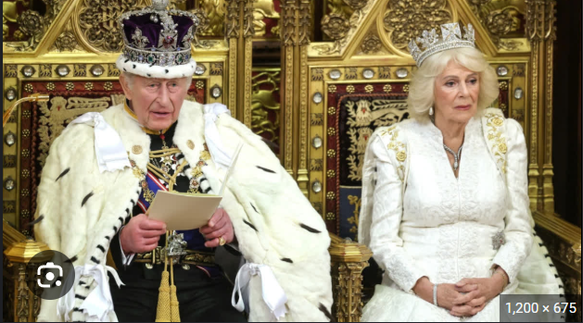

What’s happening? Keir Starmer has set out the UK government’s agenda for the next year through the King’s Speech. The plan includes major bills on public services, housing, immigration, the economy, and Europe. The government also wants closer alignment with the EU, faster innovation rules, tougher measures on late payments, and housing protections.

Details: Plans include closer UK-EU cooperation, full nationalisation of British Steel, faster innovation rules, and tougher penalties for late-paying firms. Public service changes include abolishing NHS England, reforming special educational needs, and limiting some jury trials. Housing reforms target leaseholds, right-to-buy rules, and unsafe cladding, while immigration proposals would tighten asylum and refugee protections.

What’s missing? The King’s Speech did not include a standalone welfare reform bill, despite earlier expectations that the government might return to the issue. Instead, ministers said they would respond to the Milburn review and the Timms review, which are expected later this summer and autumn. The speech said that the government would continue to reform welfare to help young and disabled people flourish in work.

London’s cultural crown
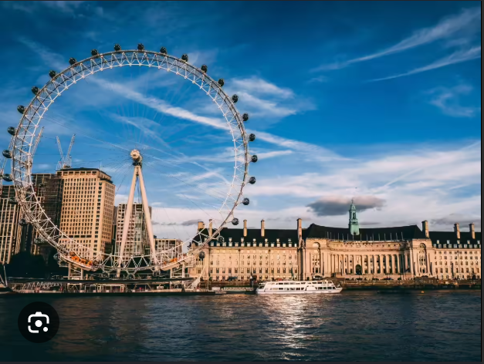

What happened? London has been named the best city in the world for culture by Time Out, ahead of Paris and NY. The ranking was based on a survey of more than 24,000 city residents worldwide, along with input from Time Out experts and editors. Officials said culture is central to London’s identity and economy, while artists highlighted the city’s mix of world-class institutions, open museums, and smaller creative spaces.

Why? The city provides everything from major institutions like the Tate Modern and the National Opera to grassroots music venues, comedy clubs, literary events, street performances, and local art spaces. Time Out also highlighted affordability, with 90% of Londoners praising the capital as a gateway to art. Officials said this openness is central to London’s triumph because culture is not restricted to tourists or elites.

Big picture: London’s ranking shows how culture has become one of the city’s strongest global assets. Beyond tourism, the creative sector supports jobs, local businesses, neighbourhood identity, and international influence. For London, culture is not just entertainment. It is part of its economy, soft power, and civic identity.

Long story short

Business
Nissan CEO Ivan Espinosa has said the company may build cars for other manufacturers at its Sunderland factory, including possibly China’s Chery. Espinosa said the plant remains viable, but needs more volume to stay strong. The plant, the UK’s largest car factory, employs about 6,000 workers but is facing weaker demand. The move comes as European carmakers increasingly consider sharing underused factories with growing Chinese EV brands.

Datacentres are putting increasing pressure on the UK’s electricity supply, with research showing they consume 5.9% of national electricity. That is far above the UK government’s early 2025 estimate of 2.5%, and demand is expected to keep rising as AI infrastructure expands. The strain is already showing in grid delays: in the first half of 2025, the queue for datacenter grid connections grew by 460%.

Art & culture
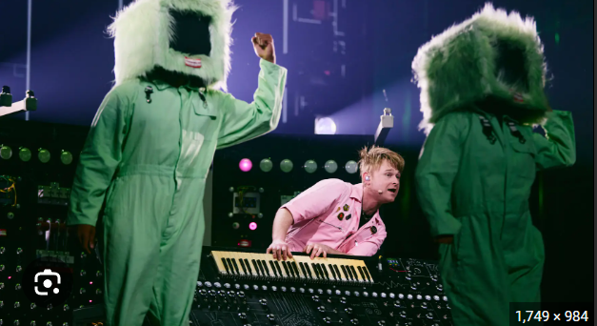

The UK’s Eurovision entrant, Look Mum No Computer, will perform his song Eins, Zwei, Drei in Vienna this week. The musician, whose real name is Sam Battle, said preparing for the contest has been “a lot of work,” especially after recently becoming a father. He promised a distinctive live performance featuring a “mega synthesiser” built specially for the stage. The UK will compete in Thursday’s semi-final, with the Eurovision final taking place on May 16.

Conan O’Brien will return as Oscars host for the third year in a row in 2027. He will lead the 99th Academy Awards on March 14, 2027, at the Dolby Theater in Los Angeles. The Academy also confirmed that executive producers Raj Kapoor and Katy Mullan will return after producing the last two ceremonies. O’Brien’s return brings continuity during a period of major Oscars changes.

Sports

Train and bus fares to World Cup matches at MetLife Stadium in NJ have been reduced after criticism from fans. Train tickets from Manhattan to the stadium have dropped from $150 to $98, while shuttle bus fares have fallen from $80 to $20. MetLife Stadium will host eight matches, including the final and one England group game. Officials said sponsorship helped lower market values without using NJ taxpayer currency, though fans in Boston still face major transport hikes.

Michael Carrick is expected to be recommended as Manchester United’s permanent manager by senior club executives. Chief executive Omar Berrada and director of football Jason Wilcox reportedly believe Carrick is the right choice after his successful caretaker spell. Since taking charge in January after Ruben Amorim’s dismissal, Carrick has triumphed in 10 of 15 matches, lifted United from seventh to third, and secured Champions League qualification.

Misc
Allies of Wes Streeting say that the health secretary is preparing to resign

More UK flights cancelled this month as jet fuel uncertainty grows

London traders hit by 'king of mangoes' shortage

Eagles to play in London during the 2026 NFL season

Did you know
Shakespeare’s Globe is the sole building in London allowed to have a thatched roof since the Great Fire of 1666.

Day
Wed

Date
May 13

AQI
24

Image credits
AP Photo, TOI, PA Media

Preview text
Plus London tops culture rankings

