🇦🇪 Happening: Laugh till it hurts

In this edition:

- Kadura Rally returns
- Metal Fest III
- Fideles at Be Beach Dubai

Spotlight

Standup stars unite
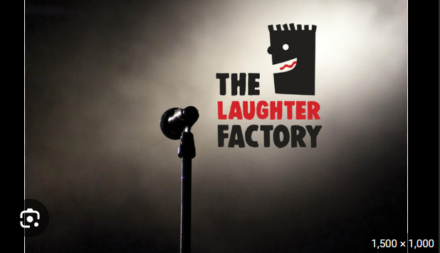

Summary: Laughter Factory returns with global comics delivering sharp, high-energy, unforgettable comedy nights.

The Laughter Factory is back with a high-energy lineup, bringing together a mix of international stars and regional favourites for a night of sharp, unapologetic comedy. Headlining the show is Netflix star Robbie Collins, joined by British comic John Hague, Dubai-based performer Valentina Danubio, and poet-storyteller Viswajit Dilip.

Known for its lively atmosphere and consistently strong lineups, The Laughter Factory promises an evening packed with quick wit, engaging storytelling, and moments that will keep audiences laughing long after the show ends.

🔗Link: The Laughter Factory
📅When: April 11 and April 12
💸Cost: Starts from AED 175
📍Where: Multiple venues

Kandura Rally returns
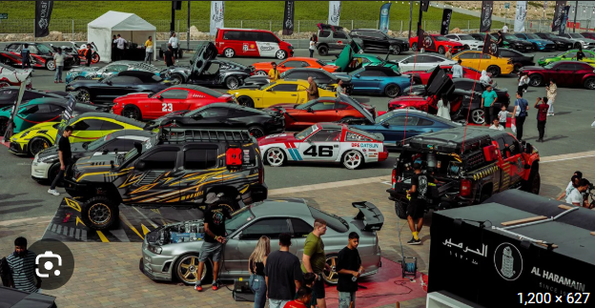
Summary: Kandura Rally returns with 500 vehicles celebrating Dubai’s vibrant automotive culture.

The fifth edition of the Kandura Rally returns to Dubai Festival City, promising a vibrant celebration of automotive culture. Drawing over 500 cars and bikes, the event brings together enthusiasts, collectors, and industry players for a dynamic motor show and competition.

Attendees can explore a diverse showcase of cutting-edge models, vintage classics, luxury vehicles, modified sports cars, electric vehicles, off-road machines, and high-performance superbikes.

🔗Link: Kandura Rally
📅When: April 11, 11 am
💸Cost: Starts from AED 25
📍Where: Dubai Festival City Mall

Live events
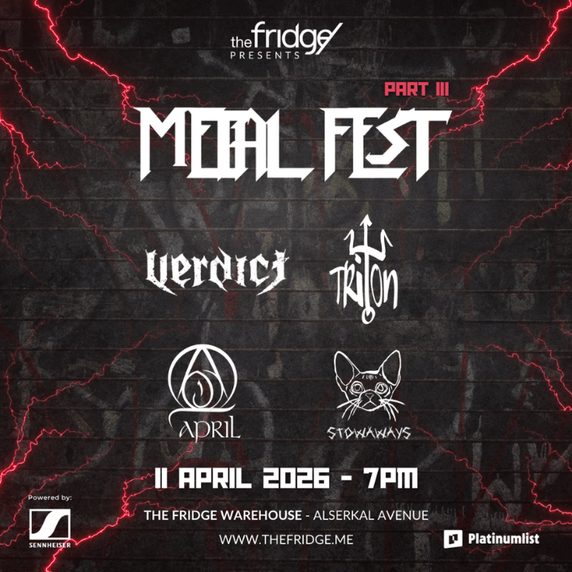

Metal Fest III

Dubai's metal community returns for the strongest edition of Metal Fest yet. The event features Verdict, Triton, April, and Stowaways, blending progressive intensity, rising momentum, and a decade of raw, high-energy live performances.

📅When: 6:00 pm on April 11, Saturday | Tickets start from 24.09 USD
📍Where: The Fridge Warehouse, Alserkal Avenue

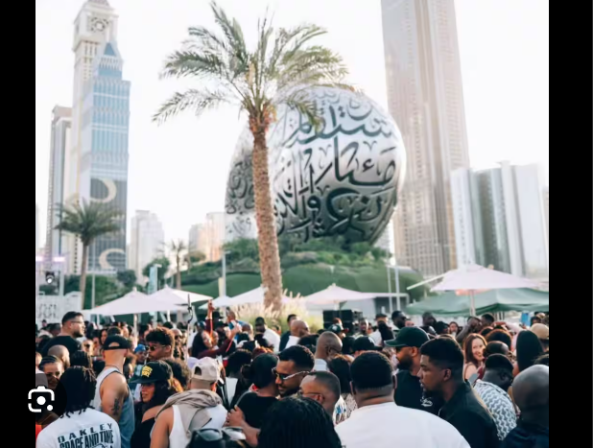

The Cookout!

The Cookout! at 25hours Hotel Dubai blends Caribbean BBQ, Jamaican flavours by Miss Lily’s, DJ Crownprince’s old-school hits, and games like Jenga, UNO, and dominoes in a lively afternoon-to-evening social experience.

📅 When: April 11 | Tickets start from AED 105
📍 Where: 25hours Hotel Dubai One Central

Shopping
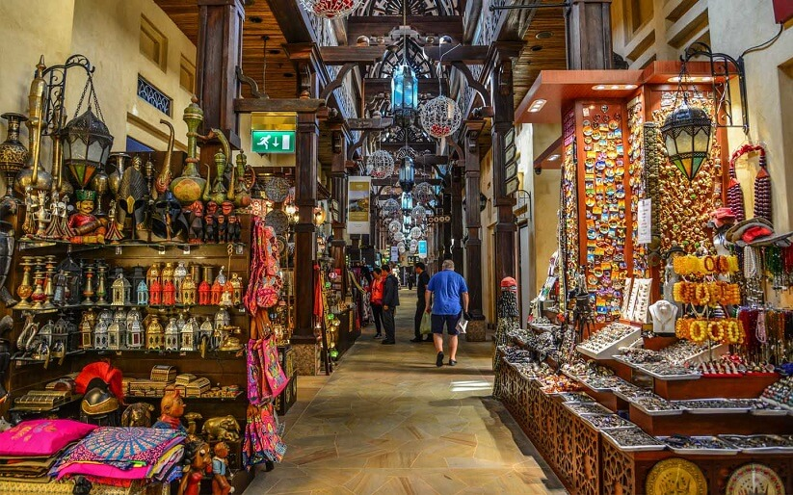

Meena Bazar

Step into Meena Bazaar for a lively old-world market experience, featuring vibrant streets and a rich mix of South Asian fashion, jewellery, textiles, and handicrafts.

📅 When: Open daily 10 am-1 pm, 4 pm-10 pm @ Bur Dubai, Al Fahidi | Free entry

Nightlife
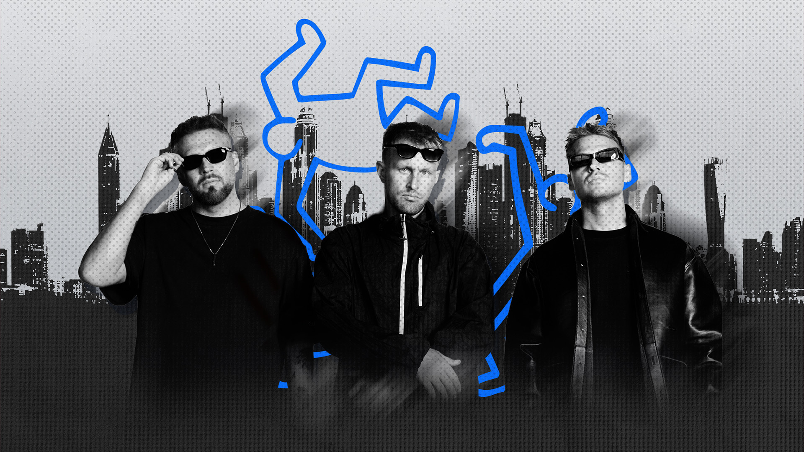

Tripolism

Skyline Saturdays is set to host the Copenhagen trio shaping global club circuits. Expect deep grooves, seamless transitions, and a driving set designed to keep the dancefloor moving all night.

📅 When: 10:00 pm onwards on April 11, Saturday | Tickets start at 56.68 USD
📍 Where: The Penthouse, FIVE Palm Jumeirah

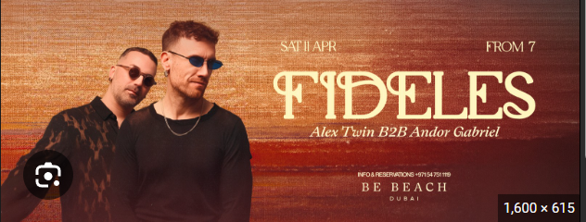

Fideles at Be Beach Dubai

Fideles is a melodic techno duo by Daniele Aprile and Mario Roberti, known for hypnotic, euphoric productions and global performances at iconic venues and festivals.

📅 When: April 11 @ Be Beach | Tickets start from AED 100

Everything else
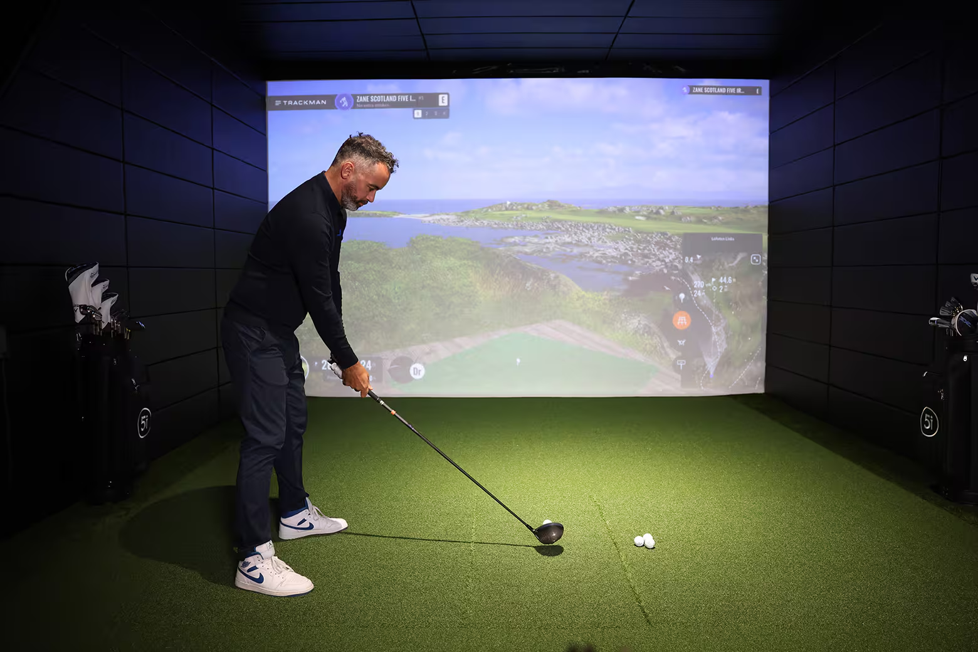

Five Iron Golf

Five Iron serves up unlimited free mini-golf, giving families endless rounds on a nine-hole course to practice swings, improve skills, and enjoy a fun day out.

📅 When: Mon-Thu 7 am-1 am, Fri-Sat 7 am-2 am @ The Westin Dubai Mina Seyahi Beach Resort & Marina

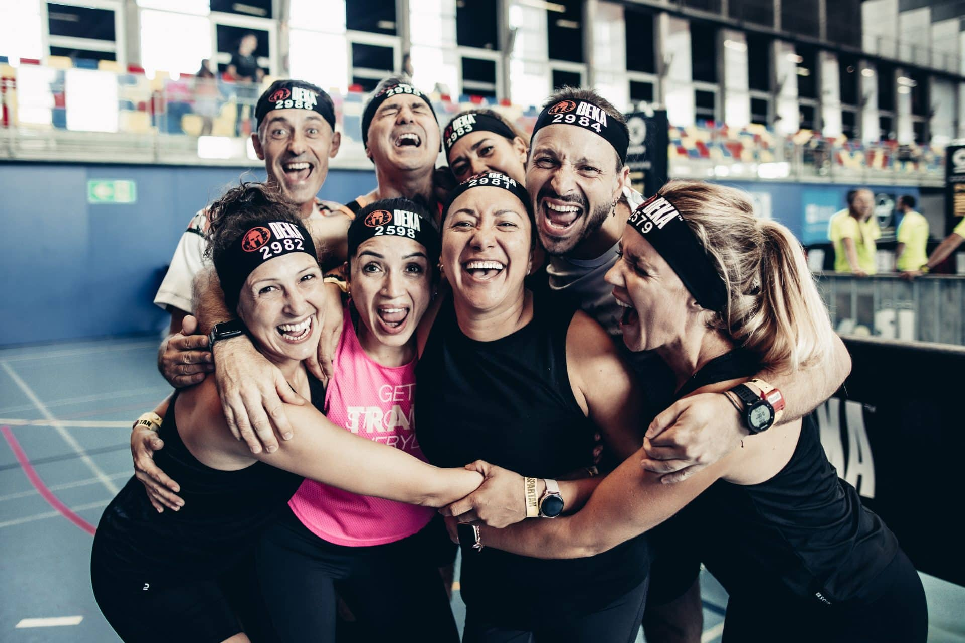

DEKA STRONG

DEKA STRONG roadshow challenges competitors with 10 strength-focused zones, including sled pulls, SkiErg, and lunges, testing endurance and power without running in a high-intensity format.

📅 When: April 12, Sun @ Al Quoz | Tickets start at Dhs120 (teams), Dhs165 (individual)

Image credits
Time Out, What’s On, Platinumlist, Time Out, Dubai Desert Safari, The Penthouse, Visit Dubai, Deka

Preview text
Plus things to do this weekend

