🇬🇧 Happening: Enter the toybox
In this edition:

- Stop motion magic
- Journey beyond Earth
- Fossil outlet sale

Spotlight

Pixar comes alive
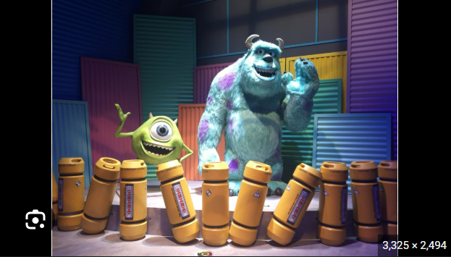
Summary: Mundo Pixar brings interactive, life-sized film worlds to the London experience.

An immersive Pixar exhibition, “Mundo Pixar,” has opened in London’s Wembley Park, marking its first UK appearance after touring Europe. The experience features 14 life-size, interactive sets inspired by iconic Pixar films like Toy Story, Up, Coco, Cars, and Finding Nemo.

Spanning 3,500 square metres, the exhibition offers a one-way walkthrough with detailed environments, soundscapes, and photo opportunities. A London-exclusive room recreates Sunnyside Daycare from Toy Story. The exhibition blends storytelling, design, and interactivity to bring Pixar’s worlds to life.

🔗 Link: Mundo Pixar
📅 When: February 13 to June 28
💸 Cost: Starts from £29
📍 Where: Fulton Road, Wembley

Stop motion magic
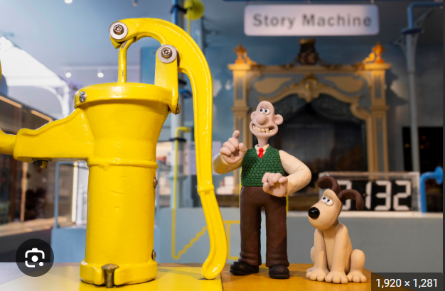
Summary: Young V&A showcases Aardman’s animation legacy through interactive, behind-the-scenes exhibits.

London’s Young V&A is hosting Inside Aardman: Wallace & Gromit and Friends, celebrating 50 years of Aardman Animations. The exhibition offers a behind-the-scenes look at beloved creations like Wallace & Gromit, Shaun the Sheep, Morph, and Chicken Run.

Featuring over 150 archival items, including original sketches, storyboards, and film props, it traces the full stop-motion production pipeline. Designed as an interactive experience, visitors can experiment with animation techniques, lighting, and character design

🔗 Link: Inside Aardman: Wallace & Gromit and Friends
📅 When: February 12 to November 15
💸 Cost: Starts from £12.50
📍 Where: Young V&A

Journey beyond Earth
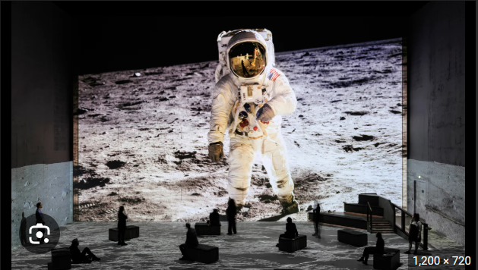
Summary: Tom Hanks narrates an immersive NASA journey from Apollo's past to Artemis' future.

The Moonwalkers: A Journey with Tom Hanks is an immersive exhibition in Lightroom that brings NASA’s space exploration history to life through large-scale projections and cinematic storytelling.

Narrated by Tom Hanks, the experience showcases original Apollo mission footage, remastered imagery, and insights into NASA’s upcoming Artemis programme. Created with writer Christopher Riley and composer Anne Nikitin, the 50-minute show combines state-of-the-art visuals and sound to deliver a detailed, behind-the-scenes journey of humanity’s past and future missions to the moon.

🔗 Link: The Moonwalkers
📅 When: Thursday to Saturday (10 am and 8 pm), and Sunday to Wednesday (2 pm and 6 pm)
💸 Cost: Starts from £25
📍 Where: Lightroom

Live events


Romeo and Juliet

A high-energy adaptation of Romeo and Juliet at Shakespeare's Globe, directed by Lucy Cuthbertson, reimagines the classic for young audiences with action, intensity, and modern relevance.

📅When: April 9 - April 12 | Tickets start at £5
📍Where: Globe Theatre

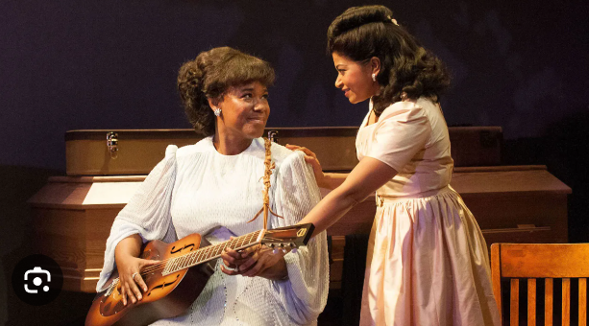

Marie & Rosetta

A vibrant musical about Sister Rosetta Tharpe and Marie Knight, starring Beverley Knight, celebrating their groundbreaking influence on rock, gospel, and music history.

📅 When: April 9 - April 11 | Tickets start at £37
📍 Where: Soho Place

Shopping


JD Sports Spring Sale

JD Sports’ Spring Sale offers up to 50% off men’s clothing, footwear, and accessories, featuring major brands like Nike and PUMA, with limited-time deals on everyday and streetwear essentials.

📅 When: Multiple dates, Online only

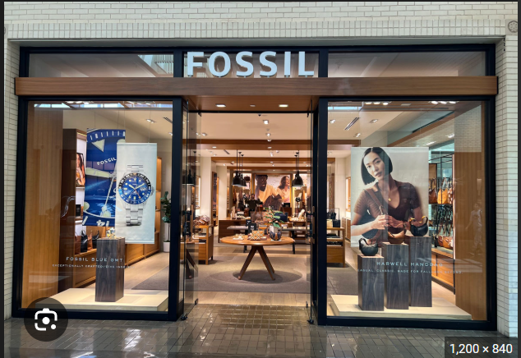

Fossil Outlet Sale

Fossil Outlet Sale offers up to 50% off watches, bags, and accessories, with free delivery over £75, making it a great opportunity to shop premium styles and timeless gifts for less.

📅 When: Multiple dates, Across all outlets,

Nightlife
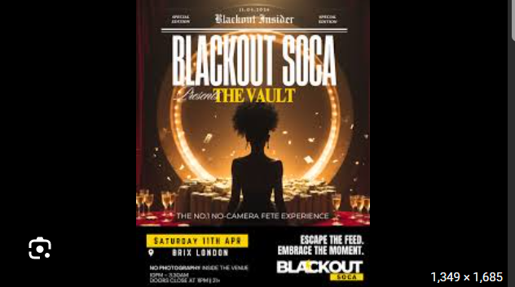

The Vault - Restricted Access

The Vault is an exclusive, no-cameras soca night blending luxury, mystery, and high-energy vibes, accessible only via ticket code, promising surprises and a premium bacchanal experience for true insiders.

📅 When: April 11 @ BRIX LDN | Tickets start from £15.87

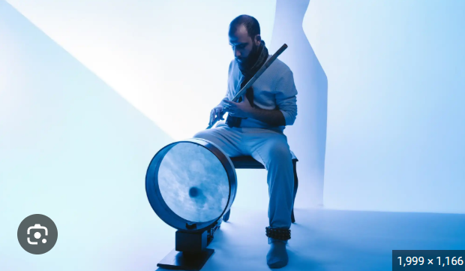

Britland

Britland celebrates UK music culture with rap, grime, garage, and house, delivering a high-energy, phone-free rave experience

📅 When: April 11 @ Oslo Hackney | Tickets start from £6.13

Everything else
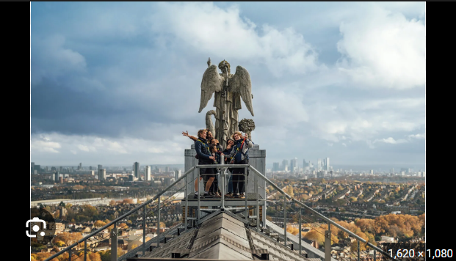

Summit at Alexandra Palace

Experience the Alexandra Palace Summit rooftop walk with guided climbs, 360° views, iconic landmarks, and unique history, offering daytime, sunset, or night adventures high above London’s skyline.

📅 When: Multiple dates | Tickets start from £28

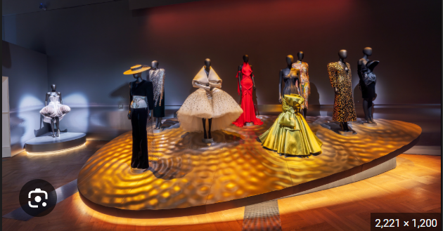

Schiaparelli: Fashion Becomes Art

Schiaparelli: Fashion Becomes Art at London’s Victoria and Albert Museum showcases surrealist couture, featuring collaborations with Salvador Dalí and Jean Cocteau, tracing the designer’s transformative influence on fashion and art.

📅 When: Till November 8 | Tickets start from £28

Image credits
Belga News Agency, Aardman, The Guardian, Theatre and Tonic, The Hollywood Reporter, T3, Fossil, Soco, Resident Advisor, Alexandra Palace, Wallpaper Magazine

Preview text
Plus things to do this weekend

