🇦🇪 Happening: Drama in bite-size

In this edition:

- Roblox skills lab
- Boris Grebenshikov's Dubai debut
- Techno night

Spotlight

Little play festival


Short+Sweet Dubai is back, this time bigger, bolder, and bursting with energy. Experience a thrilling lineup of 10-minute plays spanning comedy, drama, romance, and unexpected twists, all in one fast-paced evening. With fresh talent, bold storytelling, and audience voting, every show feels alive and unpredictable.

From laugh-out-loud moments to gripping drama, it’s a vibrant celebration of theatre where every second counts and no two nights are ever the same. Whether you’re a theatre fan or just exploring, it delivers big entertainment in small, unforgettable bursts.

🔗Link: Short+Sweet Dubai 2026
📅When: April 18 to May 23
💸Cost: Starts from 22.67 USD
📍Where: New Covent Garden

Build your game


The Roblox Master Builder program offers an interactive pathway into game development, teaching participants how to create their own games using Roblox Studio. Designed for kids and young adults, it covers coding, 3D design, animation, and scripting through hands-on learning.

Participants also explore how to monetize their creations on the platform. Now available online, the program combines creativity, technical skills, and collaboration to help learners build playable games, design avatars, and gain practical experience in digital creation.

🔗Link: Roblox Master Builder
📅When: Classes run every Saturday till May 16
💸Cost: Starts from $1,175.01
📍Where: Alserkal Avenue

Live events

Nandagovindam Vishu Kaineettam 2026
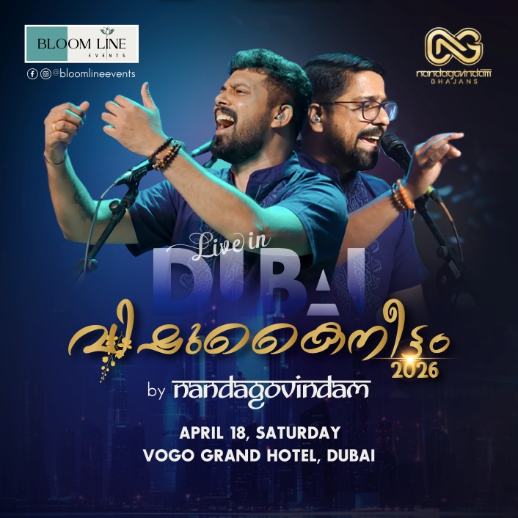

Celebrate Vishu, the Malayalam New Year, in an enchanting way as Kerala’s renowned musical ensemble Nandagovindam Bhajans brings an intimate, baithak-style bhajan evening to Dubai.

📅When: 6:00 pm on April 18, Saturday | Tickets start from 85.01 USD
📍Where: Vogo Grand Hotel

Boris Grebenshikov

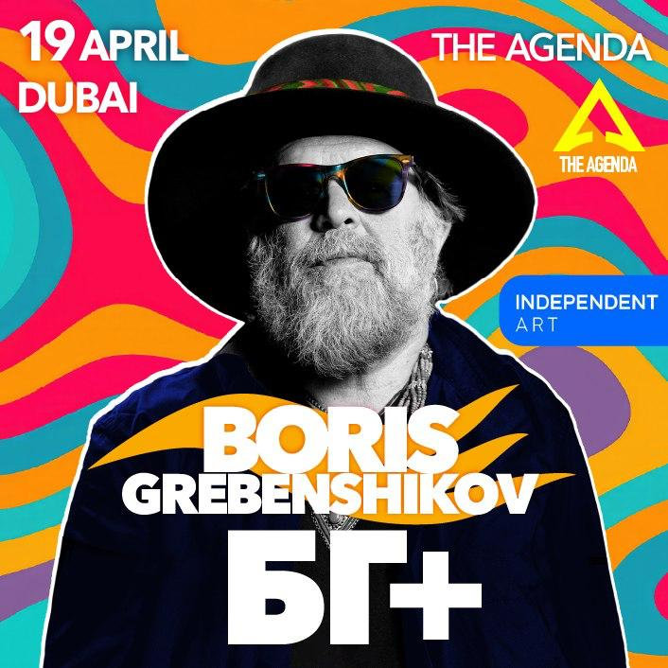

Boris Grebenshchikov brings his first Dubai performance, blending legendary Russian rock classics with a fresh 2026 program. The concert promises a powerful, poetic, and deeply soulful live experience.

📅 When: April 24, Friday | Tickets start from 99.18 USD (fast selling)
📍 Where: The Agenda

Shopping

ACE clearance sale

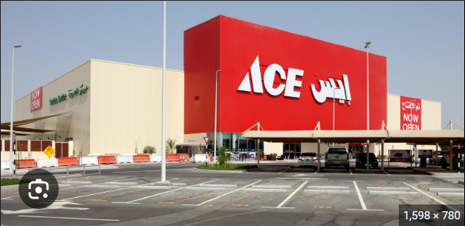

Get up to 50% off on outdoor furniture, garden essentials, appliances, power tools, safes, paints, and more.

📅 When: limited time, ACE online
📍 Where: Online

Nightlife

Spaceman Room – Techno Night

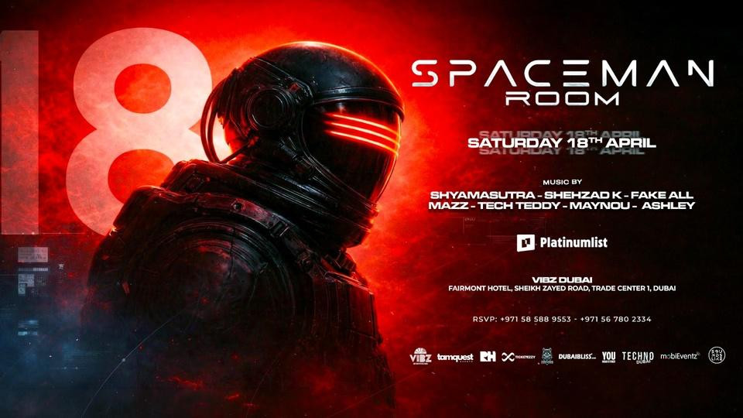

Step into Spaceman Room, a fresh techno experience driven by deep, atmospheric sounds and immersive visuals. Expect hypnotic rhythms, powerful drops, and a dark, high-energy vibe, crafted as a full sonic journey for true underground music lovers.

📅 When: 10:00 pm onwards on April 18, Saturday | Tickets start at 28.34 USD
📍 Where: Vibz Club, Fairmont Sheikh Zayed Road

Blockbuster Dubai Edition



Turn up the energy with DJ Ganesh spinning chart-toppers, desi anthems, and global hits. Expect a vibrant crowd, electric vibes, and a night where music meets atmosphere. Dress sharp, come ready, and step into a party delivering nonstop beats and standout moments.

📅 When: 09:00 pm onwards on April 23, Thursday | Tickets start from 56.68 USD
📍 Where: Surf Club

Everything else

Al Ahli SC (QAT) vs Al Hussein SC (JOR)



Get ready for a high-stakes showdown as Al Ahli SC faces Al Hussein SC in a thrilling AFC CL 2 quarter-final clash. Expect intense action, passionate fans, and top-tier football as both sides battle for a place in the semi-finals.

📅 When: 09:00 pm onwards on April 19, Sunday | Tickets start from 5.67 USD
📍 Where: Zabeel Stadium

Expo City Dubai Half Marathon 2026



Lace up for the Expo City Half Marathon, where runners unite for a high-energy race through stunning, futuristic surroundings. Smooth routes, vibrant crowds, and an electrifying atmosphere make every stride feel powerful and unforgettable.

📅 When: 06:00 am onwards on April 19, Sunday | Tickets start at AED 150
📍 Where: Jubilee District

Image credits
Platinumlist, Studio Krew, Platinumlist, The Agenda, Ceramic City, Platinumlist, Platinumlist, Platinumlist, Platinumlist, Promo Seven Sports

Preview text
Plus things to do this weekend

