🇦🇪 Apr 15: Corridor of fortune
In this edition:

- Wasl’s green landmark
- Government AI training drive
- Hayat health initiative

Spotlight

UAE–Azerbaijan CEPA
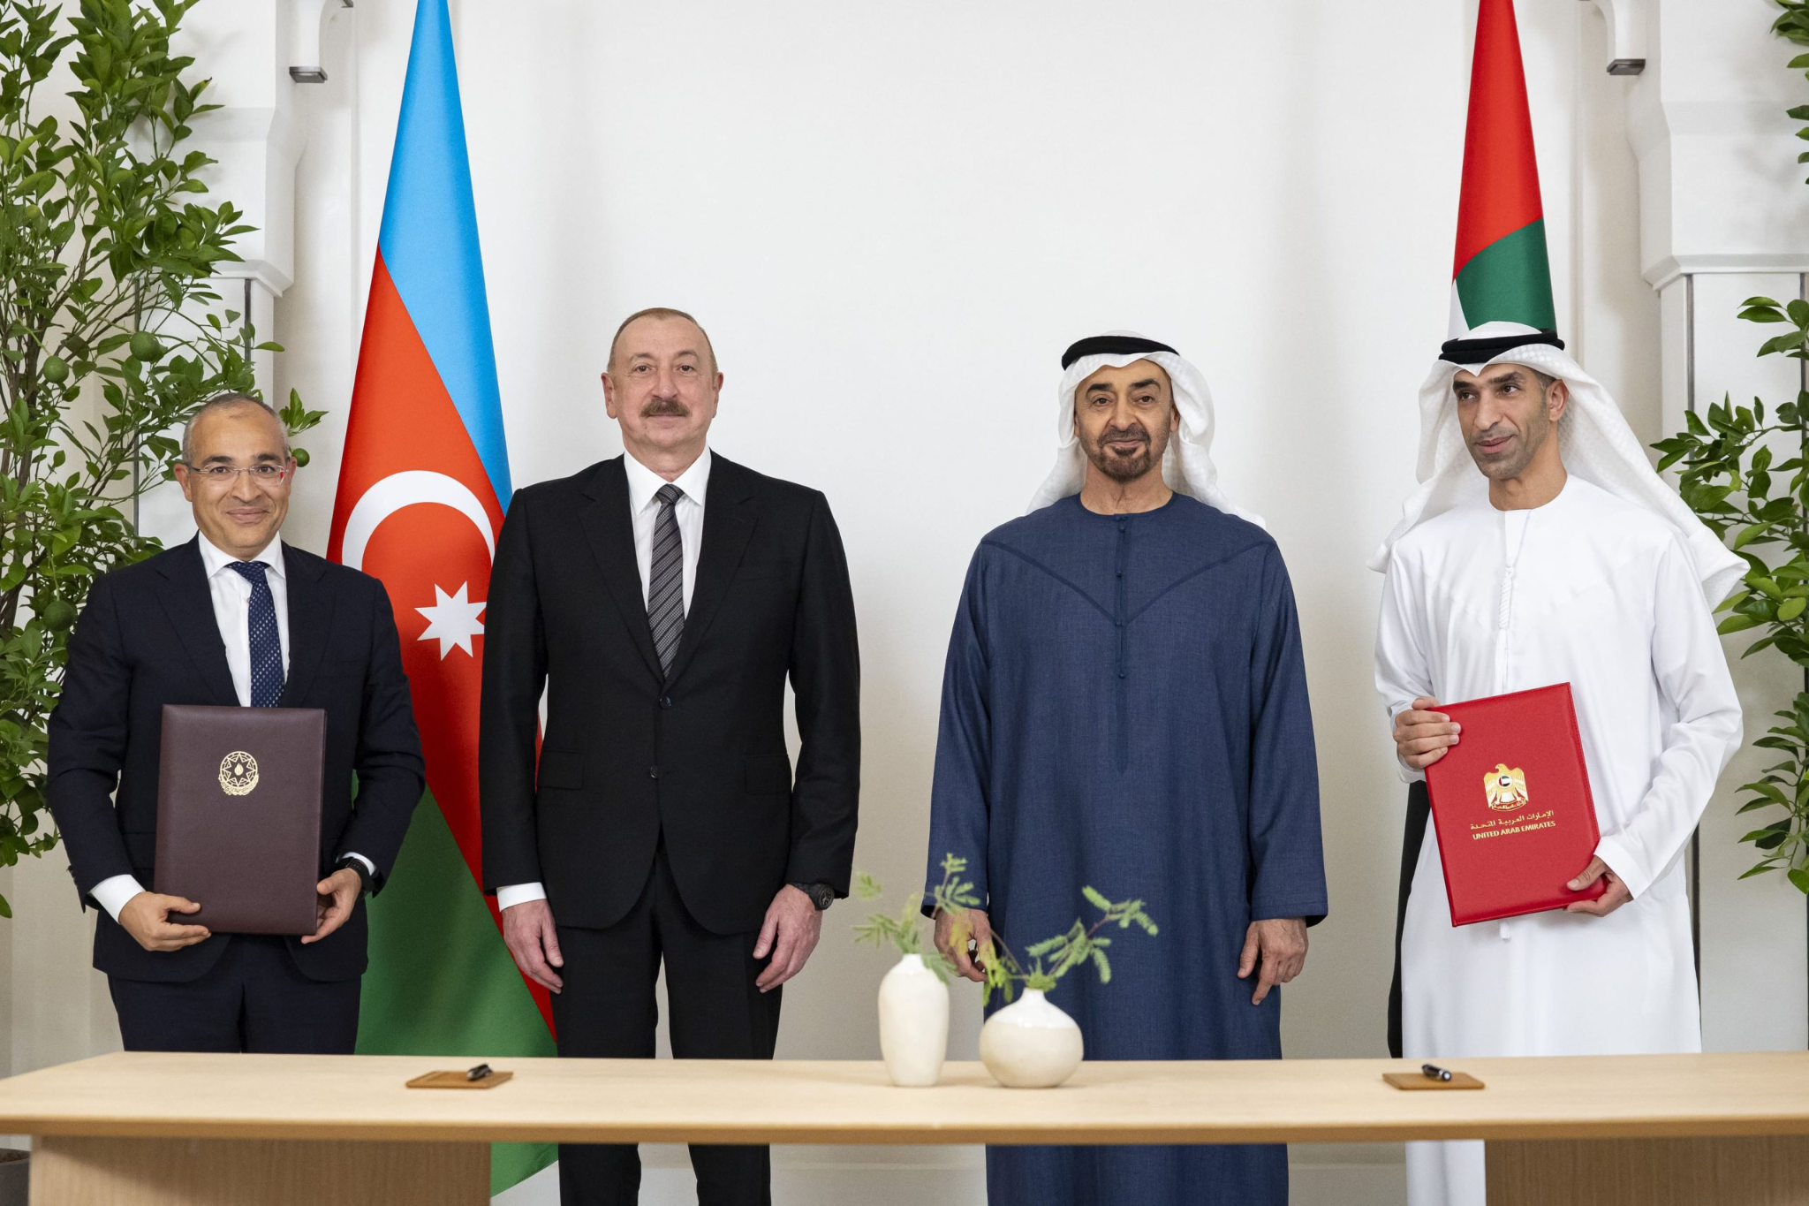

What happened? The UAE has brought into force a new Comprehensive Economic Partnership Agreement (CEPA) with Azerbaijan. This opens the door to lower tariffs, easier market access, and fresh investment opportunities for businesses in the Emirates. Non-oil trade between the two countries has grown 31.4% over the past two years, exceeding $2.2B in 2025.

Details: This CEPA is a key pillar of the UAE’s economic transformation, targeting $1T in non-oil trade and over $800B GDP by 2031. Azerbaijan’s position along emerging North–South corridors linking Central Asia, the Caucasus, and Europe enhances connectivity. The UAE is currently Azerbaijan’s largest Arab trading partner, accounting for about 40 percent of its trade with the Middle East and North Africa region.

Fact: The agreement is Azerbaijan’s first trade pact to include a dedicated services chapter, creating specific new openings for UAE professional services firms expanding overseas.

Bigger picture: Since launching the CEPA program in 2021, the UAE has signed agreements with India, Indonesia, Israel, Turkey, Cambodia, Georgia, Costa Rica, Colombia, Mauritius, South Korea, and the Republic of Congo. Several more negotiations are underway with key partners across Asia, Africa, and Latin America.

Where to eat?
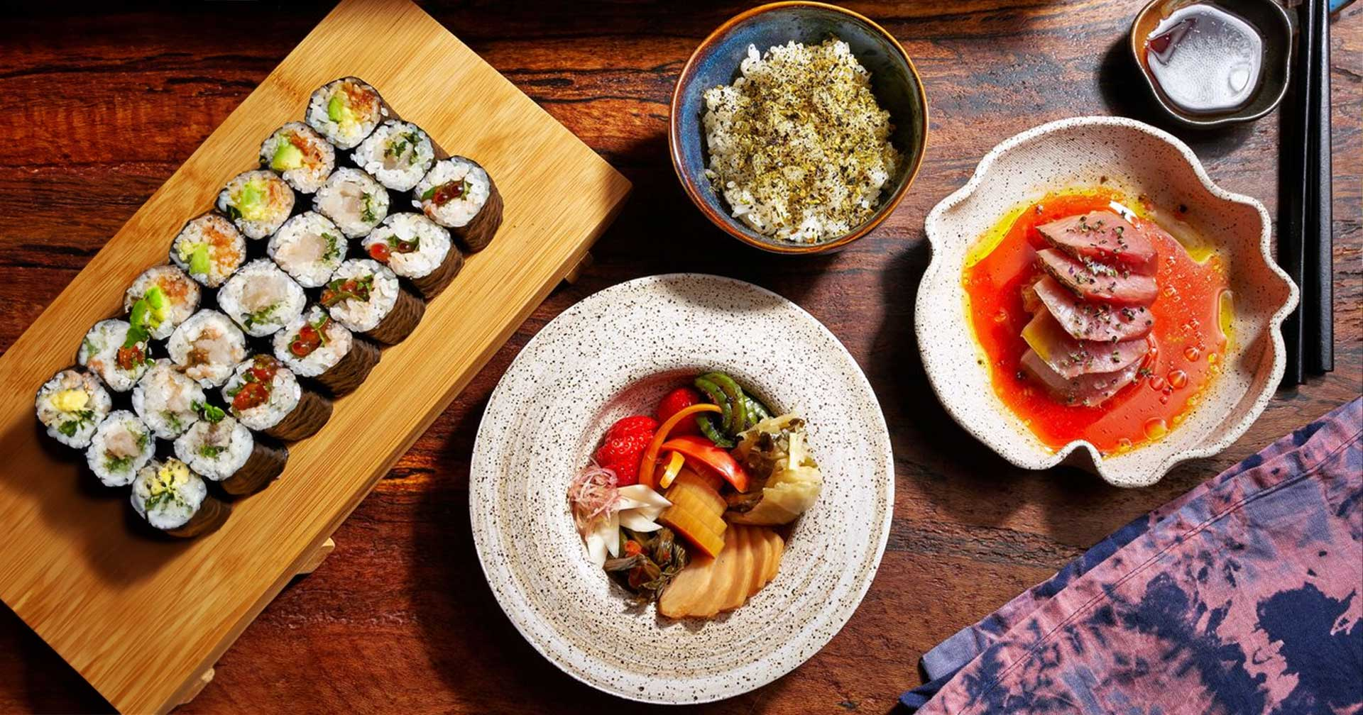

Kinoya is a Dubai-born ramen house, celebrated for its deeply flavorful broths and izakaya-style comfort food. The restaurant is known for its focus on process, quality, and authentic flavors, with signature dishes like ramen, donabe, omurice, dashi, and onsen tamago. It offers a thoughtful, mid-range take on Japanese comfort food.

Pro tip: Try the signature shoyu ramen paired with wagyu gyoza.

Career

Senior Specialist - Drivers & Institutes Licensing Regulation

On-site
Full-time
Salary: Unspecified
The Roads and Transport Authority is looking for a Senior Specialist - Drivers & Institutes Licensing Regulation to oversee policy, legislation, and regulatory frameworks governing driver licensing and training institutes. The role involves drafting laws, managing agreements, conducting compliance audits, and developing performance standards. Candidates should have 6–8 years of relevant experience, strong knowledge of traffic laws, stakeholder management, and expertise in regulatory policy and research. UAE nationals only.

Register here

Meanwhile
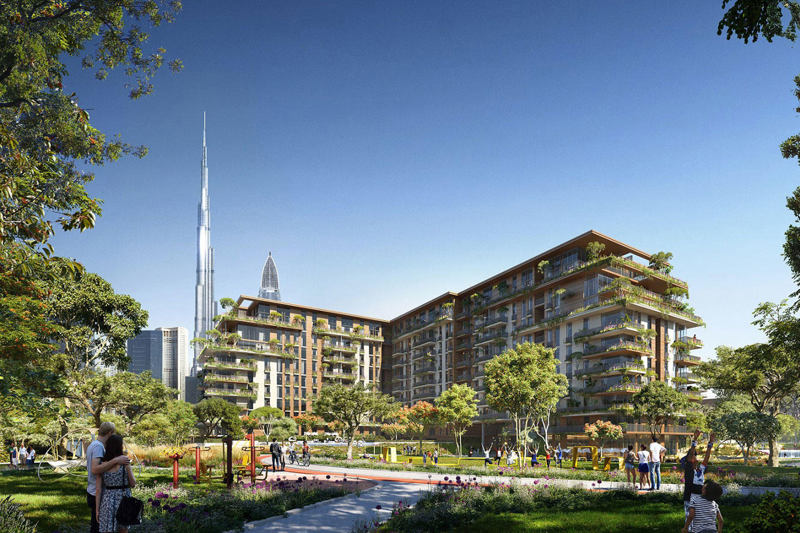

Jebel Ali green space
Dubai has unveiled its own “Central Park,” with Wasl Group opening an 82,700-sq-m green space in Jebel Ali. The park is open to residents and the public. It features tracks, sports courts, and leisure zones, reflecting a push toward community-centric, sustainable urban living. The project underlines Dubai’s push toward more liveable, community-focused neighborhoods.

AI skills drive
Dubai has launched a major AI training drive to upskill 50,000 government employees under the AI Workforce Transformation Program. Led by Digital Dubai and partner entities, the initiative will teach staff how to use AI in daily work, improve productivity, and deliver faster services. Training will be tailored by role, from senior leaders to frontline teams, to make AI part of government operations.

Structured care campaign
Dubai has launched “Hayat,” a three-month public health initiative aimed at improving understanding of obesity through structured medical collaboration. Backed by Eli Lilly, True Body USA, and Elegant Hoopoe, the program focuses on education rather than promotion and will cover the biology of obesity, metabolism, and long-term care. Officials say the effort promotes responsible, evidence-based management under clinical supervision

Did you know?
In the UAE and other Gulf nations, falcons are highly revered symbols of heritage and are frequently issued official, government-recognized passports to travel in aircraft cabins.

Day
Thursday

Date
Apr 16

Temperature
25°C

Preview text
Plus Dubai’s Central Park

Image credits
Gulf Time, Michelin Guide, Time Out Dubai

