🌍 Apr 16: All pledge, no peace

In this edition:

- Erasmus is back
- Turkey digs deep
- How was modern China founded?

Spotlight

Berlin backs Sudan
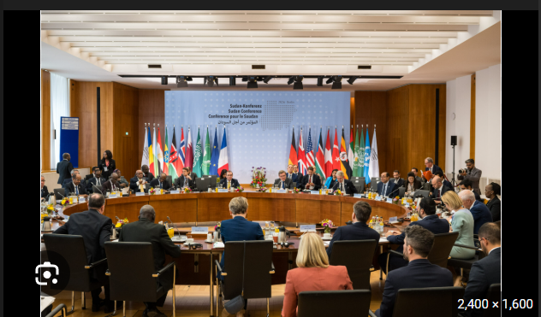

What happened? Germany hosted an international conference in Berlin to raise funds for people affected by Sudan’s civil war. German Foreign Minister Johann Wadephul said donors pledged €1.3B, surpassing last year’s total. Germany announced €212M in additional humanitarian aid, while the UK and Norway also made newer commitments.

Continuous fighting: Sudan’s war has entered its fourth year with no sign of peace, despite mounting deaths, hunger, and displacement. Fighting between the Sudanese army and the Rapid Support Forces has shattered hopes of a democratic transition after Omar al-Bashir’s fall. The country is divided, with the army holding key northern and eastern areas while the RSF controls much of Darfur and parts of the south and west.

Big picture: Sudan is no longer just a domestic civil war but a regional and global failure with widening consequences. Its spillover is destabilizing neighboring states through refugee flows, hunger, and insecurity. At the same time, weak diplomacy and shrinking aid budgets show the limits of international crisis response.

Erasmus is back
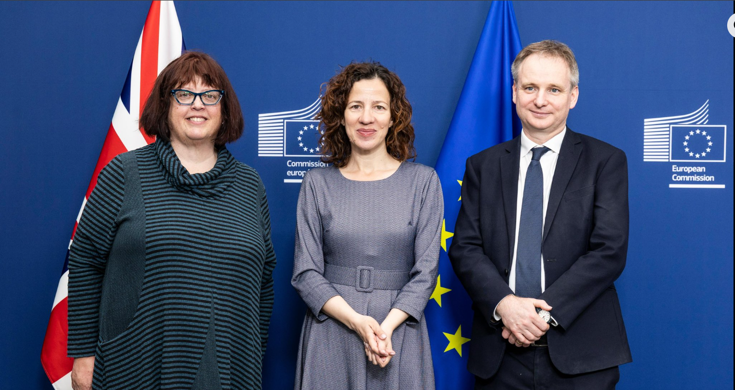

What happened? Britain and the EU have finalized an agreement for the UK to rejoin Erasmus+ from January 1, 2027, marking a symbolic post-Brexit rapprochement. The initial agreement will run for one year, with Britain contributing £570M toward the scheme in 2027. The UK government says more than 100,000 people could benefit through study, training, apprenticeships, volunteering, youth exchanges, and sport.

Why did they exit? After formally leaving the EU, the UK had the option to remain in the program by contributing to it, but Boris Johnson’s government decided the expense was too high. Ministers argued the UK was not getting good value because far more EU students came to Britain through Erasmus than British students went abroad. The government instead chose to launch its own replacement, the Turing Scheme, which it said would provide more global opportunities beyond Europe.

What is Erasmus+? Erasmus+ is the European Union’s flagship education and mobility program, designed to let people study, train, work, volunteer, and take part in exchanges across Europe and partner countries. It began in 1987 as a university exchange scheme but has since expanded to include school pupils, teachers, apprentices, youth groups, sports participants, and adult learners. Participants can spend up to a year abroad while remaining enrolled at their home institution.

Analysis

Turkey digs deep
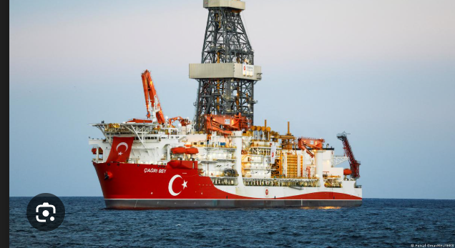

What happened? Turkey has begun a major oil exploration push in Somalia, sending its deep-sea vessel Cagri Bey to waters off Mogadishu to drill to depths of 7,500 meters in three large abroad blocks. The move follows a wider Turkey-Somalia defense and economic partnership and is being framed by Somali leaders as a potential turning point for a country long held back by conflict and underused natural resources.

Building trust: Turkey first built trust in 2011 by delivering large-scale humanitarian aid during a devastating drought. From there, it expanded into hospitals, infrastructure, education, and business, gradually becoming one of Somalia’s most visible foreign partners.

Security cooperation deepened the relationship further, with Turkey training Somali forces, opening its largest overseas military base in Mogadishu, and later signing a 10-year defense and economic pact. By the time oil entered the picture, Turkey had already positioned itself as a reliable ally, investor, and protector.

Concerns: Critics worry Somalia may become too dependent on Turkey. Some analysts argue that Turkey sits too close to Somalia’s strategic assets and revenue flows, making the partnership unequal. There are also fears about how future oil wealth will be managed in a fragile state with a history of conflict, weak institutions, and political divisions. If revenues are mismanaged, the project could fuel corruption or instability instead of development.

Worldwide
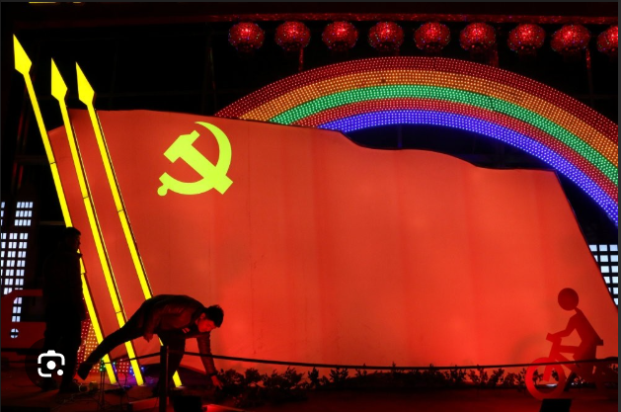

🇷🇺 Russia - Drone strike. Russia launched a large overnight missile and drone assault across Ukraine, killing at least 16 people and injuring dozens in strikes that hit civilian areas in Kyiv, Odesa, and Dnipro. In Kyiv, four people, including a 12-year-old child, were killed. Odesa suffered at least nine deaths, and Dnipro saw two killed and 27 injured, five critically. Ukrainian authorities warned the toll could rise as rescue efforts continued. Ukraine’s air force said it intercepted 31 missiles and 636 drones (missile terror).

🇨🇳 China - Xi met Russian officials. China’s President Xi Jinping met Russian Foreign Minister Sergey Lavrov in Beijing and called for “closer and stronger strategic coordination” between China and Russia. Xi said both countries should defend their interests and protect the unity of the Global South amid global instability. Lavrov said Russia could help offset China’s energy shortages (axis tightened).

🇿🇦 South Africa - Appoints US ambassador. South African President Cyril Ramaphosa has appointed Roelf Meyer as the country’s ambassador to the US, filling a post that had been vacant since Ebrahim Rasool was expelled last year. Meyer, 78, is a former minister in South Africa’s last apartheid-era government and later became a key negotiator in the talks that ended apartheid alongside Ramaphosa (tactical pick).

🇮🇳 India - Voter list concern. More than 9Mn people in West Bengal have lost voting rights after the Election Commission of India completed a controversial voter roll revision ahead of the state’s April 23 and 29 assembly polls. Many affected voters, especially Muslims and women, say their names were removed over spelling mismatches, nickname differences, missing residential proof, or post-marriage surname changes, even after voting in past elections (deleted voices).

Foundations

How was modern China founded?


Background: Modern China was officially founded on October 1, 1949, when Mao Zedong declared the establishment of the People’s Republic of China (PRC) in Beijing. Sun Yat-sen and the Nationalist Party’s revolutionary efforts led to the end of the Qing dynasty in 1912. However, corruption and weak control provided a gateway for foreign exploitation, especially by Japan, whose invasions devastated China.

During this period, Mao Zedong’s Communists gained strength through guerrilla tactics and peasant support. After World War II, the civil war between the Nationalists and the Communists resumed. By 1949, the Communists defeated the Nationalists, who retreated to Taiwan.

Factors: Many people were unhappy with the Qing dynasty. Foreign invasions, internal rebellions, and social inequality caused problems and led to revolutionary movements. Sun’s Three Principles, Marxism-Leninism, and Maoism brought forth the changes in politics and society. Military struggle, civil war, and political mobilization were major factors in uniting the nation and strengthening the Communist Party's power.

Challenges: Despite its successes, such as its economic growth and rise as a major world power, the country still faces numerous challenges, especially in the realm of political dissent, which is tightly controlled. There are other concerns persisting over Taiwan’s status, ethnic minority rights, and social inequalities in the country. China faces the challenge of balancing rapid modernization with environmental sustainability and social pressures.

Image credits
EUObserver, Erasmus+, DW, Daily Sabah

Preview text
Plus the UK joins Erasmus+

