🇬🇧 Happening: Earthy and unmissable
In this edition:

- Crown in couture
- Avenue Q
- Camden Market Food Tour

Spotlight

Art meets Earth
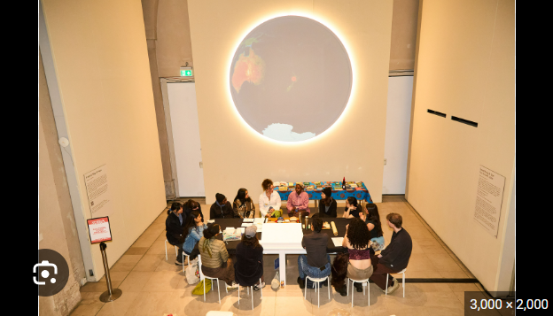

Somerset House hosts a three-day Earth Day Weekender, offering a lively mix of art, ideas, and interactive experiences focused on our relationship with the planet. Across talks, workshops, and immersive installations, visitors can explore themes that stretch from the depths of the ocean to the richness of the soil beneath us.

Highlights include a free drop-in screen-printing workshop with Jealous Print Studio, centered on sustainable making. Visitors can also join Dr. Masharu, founder of the Museum of Edible Earth, for a distinctive geophagy session that challenges people to think differently about the earth they inhabit.

🔗 Link: Earth Day Weekender
📅 When: April 16 to April 18
💸 Cost: Open entry
📍 Where: Somerset House

Crown in couture
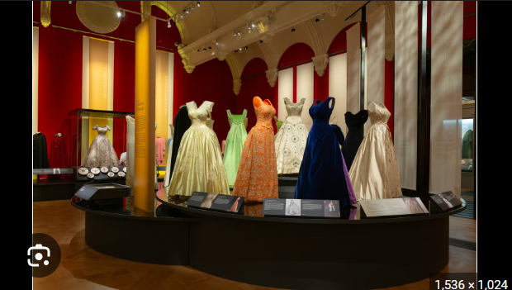

Queen Elizabeth II: Her Life in Style at The King’s Gallery celebrates the centenary of Britain’s longest-reigning monarch with the most extensive exhibition ever devoted to her fashion legacy. Featuring more than 200 items, many of which are displayed publicly for the first time, the show traces her style from early princess years to her role as a sovereign icon.

Visitors can see couture evening gowns, elegant daywear, and historic royal garments that shaped the public memory of her reign. Highlights include her wedding dress, coronation gown, and the retired royal christening robe.

🔗 Link: Queen Elizabeth II: Her Life in Style
📅 When: April 10 to October 18
💸 Cost: Starts from £22
📍 Where: The King's Gallery

Live events

Sip local on Saturday

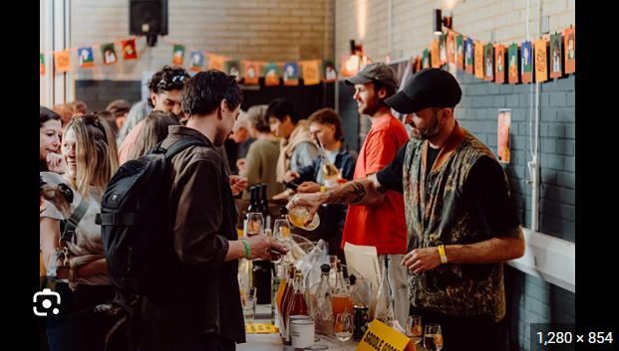

Hackney Bridge’s Pour Choices Wine Fair brings together UK-grown wines, low-intervention pours, artisan food, workshops, talks, and DJs for a relaxed day of tasting, discovery, and easy-going energy.

📅When: April 18 | Tickets start at £22
📍Where: Hackney Bridge

Avenue Q



Avenue Q returns to London’s West End in 2026, bringing riotous puppetry, sharp songs and adult humour to Shaftesbury Theatre, where lovable misfits tackle jobs, purpose and messy city life.

📅 When: Multiple dates | Tickets start at £31.25
📍 Where: Shaftesbury Theatre

Shopping

Antique & Art Shopping Experience
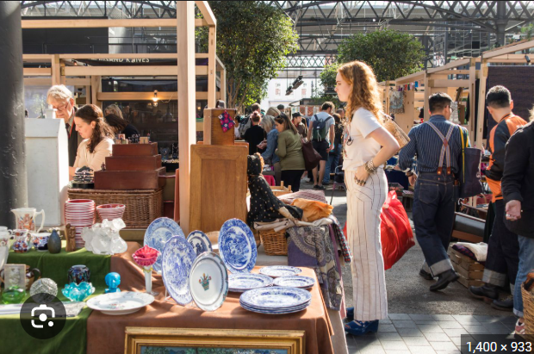

This private antique and art experience offers a bespoke four-hour journey through London’s top markets, galleries, and specialist dealers, with expert guidance, rare finds, and optional luxury transport for a seamless day.

📅 When: Multiple dates, Tickets start from £1,550

Camden Market Food Tour

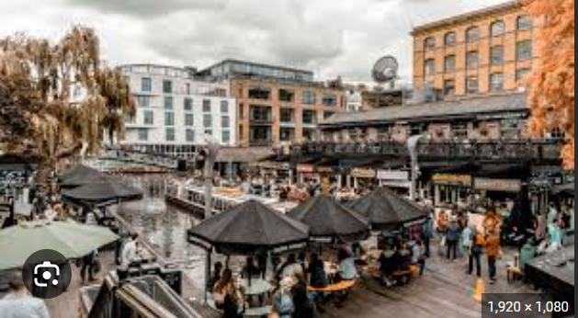

This Camden Market food tour serves up bold street food, artisanal drinks, and local stories, blending birria tacos, British cheese, and gin tastings with the market’s famously rebellious creative energy.

📅 When: Multiple dates, Tickets start from £92

Nightlife

River Thames Party Boat Cruise

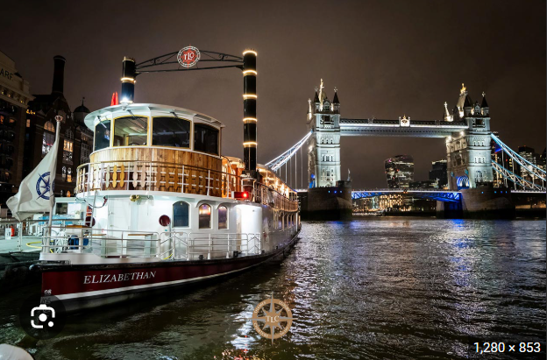

This four-hour Thames party cruise combines skyline views, a live DJ, buffet bites, and a lively dancefloor, offering an upbeat adults-only night out.

📅 When: April 18 @ River Thames | Tickets start from £29

Magic Mike Live!

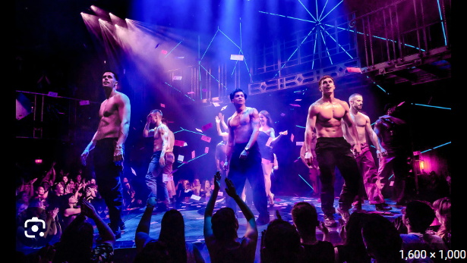

Magic Mike Live! delivers a bold, high-energy West End night with immersive choreography, acrobatics, and audience interaction.

📅 When: Multiple dates @ The Hippodrome Casino | Tickets start from £70

Everything else

Vaisakhi on the Square 2026

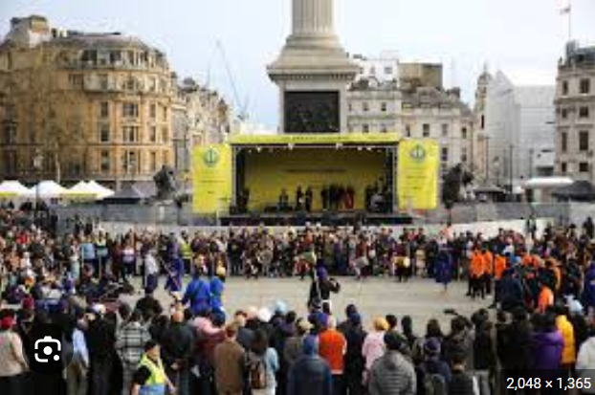

Vaisakhi on the Square brings Trafalgar Square alive with Sikh music, dance, free food, and family-friendly activities, celebrating heritage, community, and the founding spirit of the Khalsa.

📅 When: April 18 | Open entry

Paradox Museum

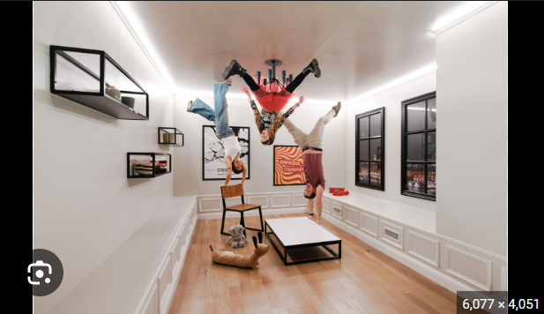

Paradox Museum delivers a playful, mind-bending adventure through illusion-filled rooms, from gravity-defying spaces to dizzying tunnels, turning perception into the main attraction and every corner into a photo-worthy surprise.

📅 When: Multiple dates | Tickets start from £29

Image credits
Somerset House, The Conversation, Beastmag, Playbill, Secret London, Things to do in London, Thames Luxury Charters, London Theatre Tickets, Mayor of London, Paradox Museum

Preview text
Plus things to do this weekend

