🇬🇧 Apr 16: Degrees of debt

In this edition:
- Shakespeare’s site fixed
- V&A East Museum launch
- Man City captain will leave the team

Spotlight

Student debt shock
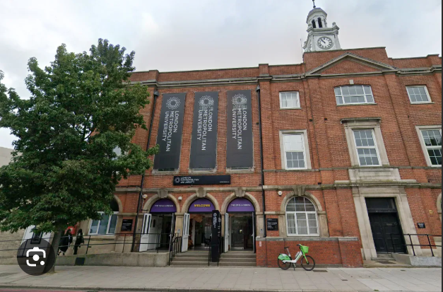

What happened? Nine universities have launched judicial measures against the UK government after around 22,000 students in England were told to repay maintenance loans and childcare grants that had already been approved. Universities say the decision was abrupt, unfair, and damaging. Many affected students are close to finishing their three-year courses and were shocked to receive letters demanding repayment on an accelerated basis.

Background: Although students had originally been approved for maintenance loans, tuition support, and, in some cases, childcare grants, officials later ruled that the courses they enrolled for counted as distance learning. Under existing funding rules, that meant the courses were never actually eligible for that support. The government argues that universities either misunderstood the regulations or abused the system.

Comments from the universities: Universities said the government’s decision was abrupt, given minimal notice, and had caused serious financial distress for students. They argued they had acted in good faith when these courses were approved for funding and strongly rejected the claim that in-person, timetabled weekend teaching should count as distance learning. They said that it also disproportionately harms students from underrepresented and lower-income backgrounds.

Shakespeare’s site fixed
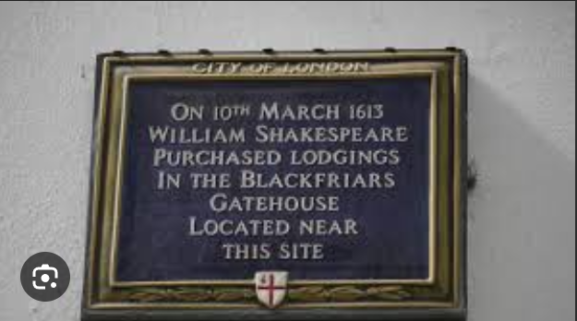

What’s happening? Researchers have pinpointed the exact location of William Shakespeare’s known London property in Blackfriars, using a newly identified floor plan and supporting archival documents. The discovery also reveals the property was larger and more substantial than previously understood. Scholars say this could reshape assumptions about Shakespeare’s later years, suggesting he may have spent more time in London and possibly even worked from the house after buying it in 1613.

Details: The breakthrough came after Professor Lucy Munro identified three overlooked documents, including a 1668 post-Great Fire plan that mapped the size and position of Shakespeare’s Blackfriars property. The house was part of the Great Gate at the entrance to the former Dominican friary and stretched across what are currently Ireland Yard, Burgon Street, and parts of nearby later buildings. Two additional records traced the property’s sale by Shakespeare’s granddaughter in 1665.

Big picture: Historians had often treated the Blackfriars purchase as a late investment made before he withdrew to Stratford. But the newly identified floor plan suggests the property was larger, more valuable, and more closely tied to his theatrical world than once thought. That makes it easier to imagine Shakespeare still actively living, writing, or managing business in London after 1613.

Long story short

Business
The UK government is preparing contingency plans for a worst-case food supply shock if the Iran conflict leads to a prolonged closure of the Strait of Hormuz. Officials are particularly concerned about disruptions to carbon dioxide supplies, which are essential for food preservation and animal slaughter. Industry leaders are split on the likely impact: some warn more about inflation than outright shortages, while others want full contingency planning.

The UK’s Financial Conduct Authority has overhauled its short-selling rules. From July 13, the FCA will stop publicly identifying individual investors with net short positions and instead publish only aggregated company-level data. The regulator says the new framework is simpler and more workable while still preserving enough oversight to keep markets fair.

Art & culture


London is opening a major cultural institution this weekend as the V&A East Museum launches in Stratford’s East Bank. The museum is designed to feel more accessible and rooted in East London than the V&A’s South Kensington site, with local young people and creatives helping shape its identity. It's free permanent galleries mix historic and contemporary objects, while its first paid exhibition, The Music is Black, explores 125 years of black British music and culture.

Young Vic will stage the world premiere of Thelma & Louise: A New Musical as part of its 2026/27 season, bringing the iconic 1991 road movie to the London stage. Callie Khouri, who wrote the original film, has adapted it for the theatre, with music and lyrics by Grammy-nominated singer-songwriter Neko Case and direction by Trip Cullman. Rachel Tucker and Amy Lennox will star as the lead pair.

Sports

Manchester City captain Bernardo Silva has confirmed he will leave the club when his contract expires at the end of the season. The 31-year-old Portugal midfielder departs after 451 appearances, 76 goals, 77 assists, and 15 major trophies, including six Premier League titles, a Treble, a domestic quadruple, and the 2017-18 Centurions campaign. Silva thanked fans in an emotional farewell message, saying he leaves not just as a player but as a lifelong supporter of the club.

The draw for the 2026 World Snooker Championship has set up Ronnie O’Sullivan against China’s Crucible debutant He Guoqiang in the first round. O’Sullivan, chasing a record eighth modern-era world title, will begin his campaign on Tuesday and finish on Wednesday. The tournament starts Saturday at Sheffield’s Crucible, where 32 players will compete over 17 days.

Misc
Pope attacks 'tyrants' spending billions on 'killing and devastation'

Europe has 'six weeks of jet fuel left', energy head warns

Ex-Arsenal and Liverpool goalkeeper Alex Manninger dies after a tragic car accident

Samsung's £320 Galaxy Watch is free with this S26 upgrade

Did you know
London’s population significantly decreased due to the Black Death pandemic (1348-1349) and the Great Plague of London (1665-1666). There are numerous plague pit burial grounds across the city beneath underground stations, modern buildings, public parks and streets.

Day
Thu

Date
Apr 16

AQI
36

Image credits
Evening Standard, AP Photo, Broad Sheet

Preview text
Plus Man City captain to leave the team

