🗽 Apr 16: Fed and furious
In this edition:

- Geelong blaze impact
- Jury targets ticketing giant
- Gemini goes native

Spotlight

Powell under pressure
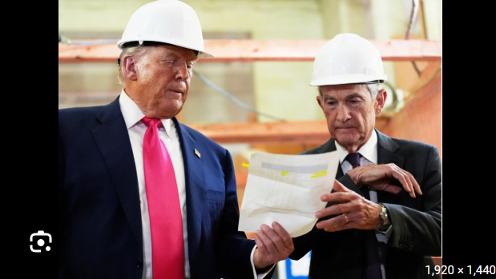

What’s happening? President Trump escalated his fight with Federal Reserve Chair Jerome Powell, saying he could fire Powell if he remains on the Fed’s Board of Governors after his term as chair ends on May 15. Trump linked the threat to a continuing Justice Department probe into cost overruns and management of the Fed’s headquarters renovation, which prosecutors are still pursuing.

Why? President Trump is escalating the situation for three overlapping reasons: he wants lower interest rates, he wants tighter control over the Fed’s leadership, and Powell’s exit has become entangled in the investigation into the Fed’s headquarters renovation. Trump has long argued the Fed is too cautious on rate cuts, while Powell has resisted political pressure. At the same time, Kevin Warsh’s confirmation to replace Powell is being slowed by Senate opposition tied to that probe.

Probe: The Justice Department probe focuses on the Federal Reserve’s $2.5B headquarters renovation, which critics say was plagued by cost overruns and poor management. Investigators have examined whether Jerome Powell misled Congress or mishandled the project. But the inquiry has faced setbacks: a judge blocked subpoenas, and prosecutors previously acknowledged they had found no evidence of criminal wrongdoing.

Geelong blaze impact
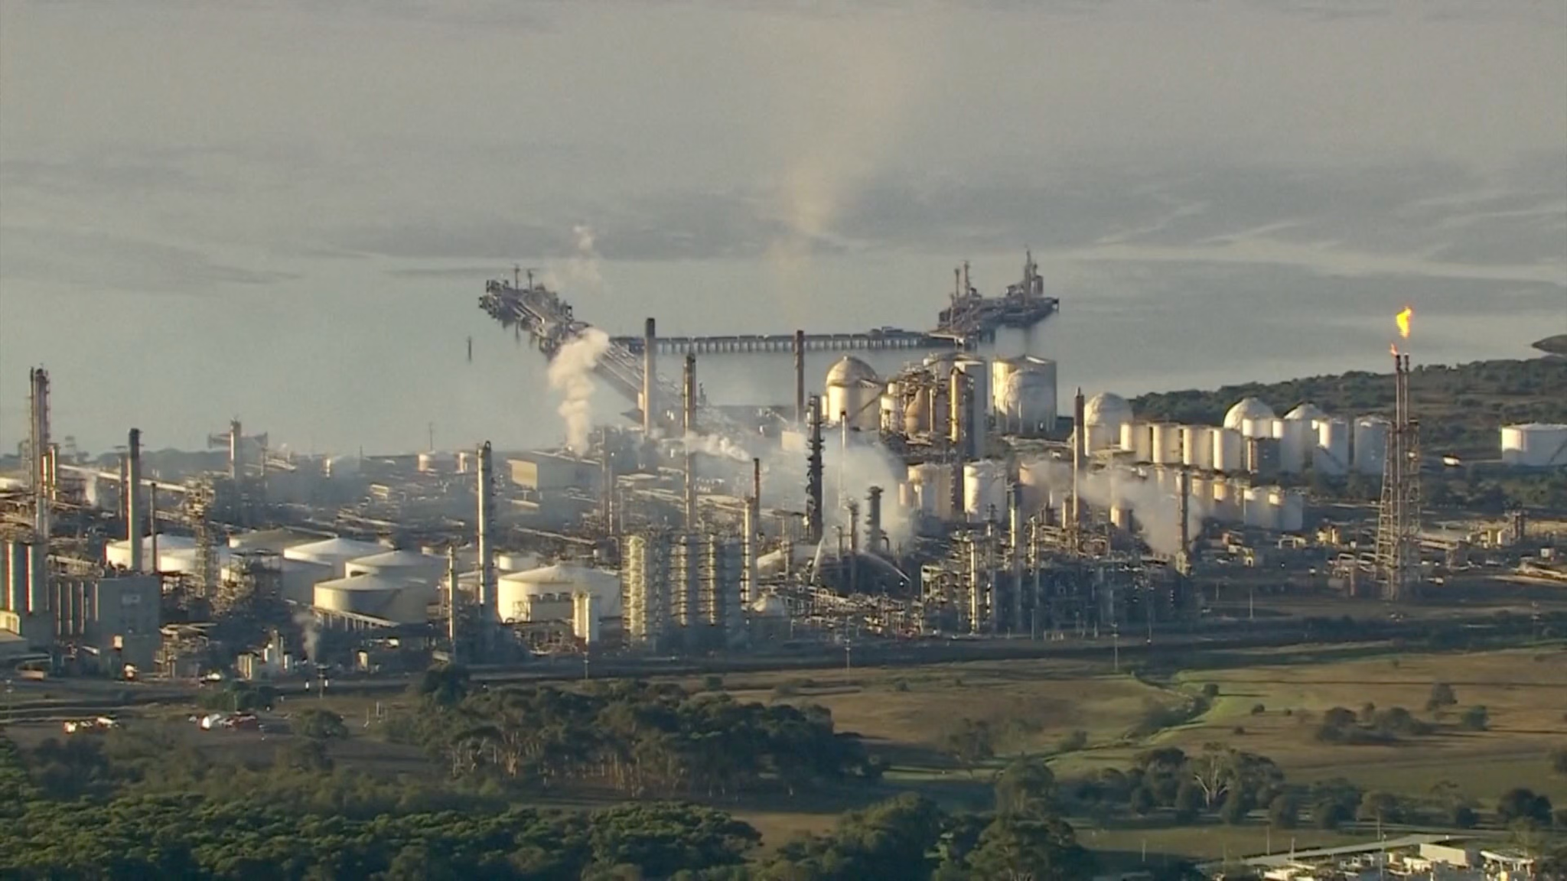

What happened? A major fire at Viva Energy’s Corio refinery in Geelong, one of only two oil refineries in Australia, has been extinguished after burning for 13 hours. The blaze, reportedly caused by equipment failure, forced the evacuation of dozens of workers, though no injuries were reported. The refinery remains partially operational, but two petrol production units were damaged, raising concerns over fuel output.

Impact: With Viva’s Geelong refinery supplying about 50% of Victoria’s fuel and 10% nationally, damage to petrol units tightens an already stressed market. Petrol, diesel, and jet fuel output may stay constrained until operations safely recover. The incident also exposes Australia’s vulnerability to relying on just two domestic refineries and imported refined fuel.

Big picture: Even though the Geelong fire may not trigger an immediate shortage, it exposes the shortcomings of the system. Australia should rely heavily on shipments from Singapore, South Korea, and Malaysia to keep petrol, diesel, and jet fuel flowing. This model puts pressure on the system as the Iran war has resulted in shipping disruptions and market value fluctuations.

Fact: Australia consumes roughly 1.15Mn barrels of oil per day.

Long story short

Global Affairs

The US and Hamas held their first direct talks since the Gaza ceasefire, as efforts to move the fragile truce forward stalled. US adviser Aryeh Lightstone met Hamas negotiator Khalil al-Hayya in Cairo, with discussions focused on Israel’s phase-one commitments, including halting strikes and allowing more aid, alongside Hamas disarmament, an international force, and an Israeli withdrawal from Gaza (truce deadlock).

Germany’s far-right AfD pledged a manifesto packed with hardline promises ahead of September’s Saxony-Anhalt election. The party backs “remigration,” mass deportations, and a sharp anti-immigration shift, while also calling for Russian language lessons and an end to sanctions on Moscow. The proposals underscore AfD’s shift from fringe movement to a serious political force reshaping Germany’s debate (far-right manifesto).

Business & Markets
An NY jury found that Ticketmaster and its parent company, Live Nation, held illegal monopolies in key US live-event markets. The verdict follows allegations that the company used its power over venues and artists to overcharge fans. Live Nation now faces potential penalties, including forced divestiture and damages sought by states (antitrust blow).

Cadence Design Systems and Nvidia are partnering to speed up AI development for robotics. The companies will combine Cadence’s physics engines with Nvidia’s AI models to train robots in simulation, reducing dependence on real-world testing. The collaboration aims to speed up robot training through more accurate virtual environments (robot training).

Monarch Tractor’s collapse has ended with its assets acquired by Caterpillar, closing a turbulent chapter for the startup. Founded in 2018 to build autonomous electric tractors, Monarch raised more than $200M but later faced layoffs, dealer lawsuits, and the loss of its manufacturing partner. The agreement follows a failed pivot to software and growing doubts over the company’s core technology (startup shutdown).

Science & Tech


Google has launched a native Gemini app for macOS, bringing its AI assistant directly to Mac users. The app enables quick access via shortcuts, real-time screen sharing for contextual help, and support for analyzing files, charts, and documents. It also includes image and video generation tools, expanding Gemini’s capabilities across productivity and creative tasks (Gemini hits Mac).

A long-term study has found that staying mentally active throughout life may help reduce the risk of Alzheimer’s by 38%. Researchers found that people who regularly read, write, learn languages, and stay intellectually engaged developed the disease later than those with the lowest mental stimulation. The findings suggest lifelong learning may support brain health, though the study shows association, not proof (brain health boost).

Whatnot
Mark Mobius, 'Indiana Jones of emerging markets,' dies at 89 (investing pioneer dies).

Scientists identify a breakthrough method to block a virus carried by 95% globally (virus halt).

A Chinese man was jailed for smuggling over 2,200 live ants (ant trafficking).

The Rock & Roll Hall of Fame inductees list for 2026.

Image credits
Al Jazeera, Reuters, Google

Preview text
Plus native Gemini app for macOS

